Appendix A: Model resolutions
The model resolution is defined as the proportional difference between the solution found and the best theoretical objective function.¹ The model was run at a resolution of 0.2% up to a maximum of 100 hours, after which the model was automatically terminated. Table A.1 lists the model resolutions or all biofuel production levels. A resolution of 0% indicates the model obtained the best theoretical objective function.
Table A.1:Model resolutions for all biofuel production levels
Biofuel production level (PJ a⁻¹) | Resolution
 | Base scenario | Reduced maximum capacity | Centralized only | Distributed only | No integration benefits | Low biomass supply | High competing demand | Road only
1 | 0% | 0% | 0% | 0% | 0% | 0% | 0% | 0%
5 | 0% | 0% | 0% | 0% | 0% | 0% | 0% | 0%
10 | 0% | 0% | 0% | 0% | 0% | 0% | 0% | 0%
15 | 0% | 0% | 0% | 0% | 0% | 0% | 0% | 0%
30 | 0% | 0% | 0% | 0% | 0% | 0% | 0% | 0%
50 | 0% | 0% | 0% | 0.20% | 0% | 0% | 0% | 0.20%
75 | 0.17% | 0.19% | 0.11% | 0.17% | 0% | 0.26% | 0.27% | 0.80%
100 | 0.23% | 0.19% | 0.20% | 0.51% | 0.20% | 0.20% | 0.22% | 0.92%
150 | 0.47% | 0.20% | 0.18% | 0.65% | 0.18% |  |  | 0.53%

Appendix B: Techno-economic input data
Table B.1 shows the techno-economic input data for selected input capacity. The production costs are calculated using a discount rate of 10%, plant lifetime of 20 years (annuity factor: 0.11746) and a load factor of 90%. Figure B.1 shows the scaling curve for a centralized plant. The scaling curve was approximated by a piecewise linear function which breaks at the maximum input capacity of a HTL reactor (2.75 PJ a⁻¹, 87 MW) and an SMR (39.3 PJ a⁻¹, 1246 MW).
Table B.1: Input data
Cost item | Unit | Distributed supply chain |  |  |  |  |  |  | Centralized supply chain |  |  | Scaling factor | Source
 |  | HTL conversion  Reference capacity: 2.75 PJ_{in}/yr (87 MW_{in}) |  |  |  | Upgrading  Reference capacity: 2.18 PJ_{in}/yr (69 MW_{in}) |  |  | Conversion and upgrading  Reference capacity: 2.75 PJ_{in}/yr (87 MW_{in})
Host site |  | Forestry terminal | Pulp mill | Sawmill | District heating | Natural gas grid | LNG terminal | Refinery | Natural gas grid | LNG terminal | Refinery
Input |  | Biomass | Biomass | Biomass | Biomass | Biocrude | Biocrude | Biocrude | Biomass | Biomass | Biomass
Output |  | Biocrude | Biocrude | Biocrude | Biocrude | Biofuel | Biofuel | Biofuel | Biofuel | Biofuel | Biofuel
Production data
Yield | GJ_{out} /GJ_{in}⁻¹ | 0.79 | 0.79 | 0.79 | 0.79 | 1.06 | 1.06 | 1.06 | 0.84 | 0.84 | 0.84 |  | ²
Electricity production^{i} | GJ GJ_{out}⁻¹ | 0.065 | 0.065 | 0.065 | 0.065 |  |  |  | 0.034 | 0.034 | 0.061 |  | ^{2,3}
Electricity consumption^{i} | GJ GJ_{out}⁻¹ | 0.072 | 0.072 | 0.072 | 0.072 | 0.014 | 0.014 | 0.007 | 0.083 | 0.083 | 0.083 |  | ^{2,3}
Net electricity requirement | GJ GJ_{out}⁻¹ | 0.007 | 0.007 | 0.007 | 0.007 | 0.014 | 0.014 | 0.007 | 0.049 | 0.049 | 0.021
Natural gas requirement | GJ GJ_{out}⁻¹ |  |  |  |  | 0.16 | 0.16 |  | 0.06 | 0.06
Hydrogen requirement | GJ GJ_{out}⁻¹ |  |  |  |  |  |  | 0.15 |  |  | 0.15
Steam production^{i} | GJ GJ_{out}⁻¹ |  | 0.10 | 0.10 | 0.10 |  |  |  |  |  | 0.09 |  | ^{2,3}
CAPEX
Feedstock handling | M€ | 0.29 | 0.29 | 0.29 | 0.59 |  |  |  | 0.59 | 0.59 | 0.59 | 0.77 | ⁴
Biomass conditioning | M€ | 3.59 | 3.59 | 3.59 | 3.59 |  |  |  | 3.59 | 3.59 | 3.59 | 0.70 | ²
HTL reactor | M€ | 6.82 | 6.82 | 6.82 | 6.82 |  |  |  | 6.82 | 6.82 | 6.82 | 0.70
Hydrotreater | M€ |  |  |  |  | 8.86 | 8.86 | 8.86 | 8.86 | 8.86 | 8.86 | 0.60
Hydrocracker | M€ |  |  |  |  | 3.28 | 3.28 | 3.28 | 3.28 | 3.28 | 3.28 | 0.60
Hydrogen plant | M€ |  |  |  |  | 3.55 | 3.55 |  | 3.55 | 3.55 |  | 0.79
Utilities^{i, v} | M€ | 4.32 | 4.32 | 4.32 | 4.32 | 0.72 | 0.72 |  | 2.88 | 2.88 | 2.88 | 0.70
Missing equipment (10%) | M€ | 1.50 | 1.50 | 1.50 | 1.53 | 1.64 | 1.64 | 1.21 | 2.96 | 2.96 | 2.60
Total purchased equipment cost (TPEC) | M€ | 16.53 | 16.53 | 16.53 | 16.85 | 18.05 | 18.05 | 13.35 | 32.52 | 32.52 | 28.62
Lang factor^{ii} |  | 4.98 | 4.62 | 4.62 | 4.98 | 4.98 | 4.98 | 4.62 | 4.98 | 4.98 | 4.62 |  | ⁵
Total capital investment (TCI) | M€ | 82.3 | 76.4 | 76.4 | 83.9 | 89.8 | 89.8 | 61.7 | 161.9 | 161.9 | 132.3
Total CAPEX^{iv} | € GJ_{out}⁻¹ | 4.44 | 4.12 | 4.12 | 4.53 | 4.58 | 4.58 | 3.15 | 8.26 | 8.26 | 6.75
OPEX
Electricity^{i,v} | € GJ_{out}⁻¹ | 0.09 | 0.09 | 0.09 | 0.09 | 0.17 | 0.17 | 0.09 | 0.59 | 0.59 | 0.26 |  | ^{2,6}
Catalyst and chemicals^{v} | € GJ_{out}⁻¹ | 0.25 | 0.25 | 0.25 | 0.25 | 0.28 | 0.28 | 0.28 | 0.51 | 0.51 | 0.51 |  | ²
Waste disposal^{v} | € GJ_{out}⁻¹ | 1.34 | 1.34 | 1.34 | 1.34 |  |  |  | 1.26 | 1.26 | 1.26 |  | ²
Labor cost^{vii} | € GJ_{out}⁻¹ | 0.43 | 0.25 | 0.25 | 0.43 | 0.26 | 0.26 | 0.15 | 0.65 | 0.65 | 0.38 |  | ^{5,7}
Other^{ix} | € GJ_{out}⁻¹ | 0.12 | 0.11 | 0.11 | 0.12 | 0.04 | 0.04 | 0.03 | 0.17 | 0.17 | 0.13 |  | ^{5,7}
Hydrogen^{vi} | € GJ_{out}⁻¹ |  |  |  |  |  |  | 2.92 |  |  | 2.92
Natural gas^{vi} | € GJ_{out}⁻¹ |  |  |  |  | 1.26 | 1.26 |  | 0.46 | 0.46
CAPEX-dependent OPEX^{viii} | € GJ_{out}⁻¹ | 4.09 | 3.80 | 3.80 | 4.17 | 4.22 | 4.22 | 2.90 | 7.61 | 7.61 | 6.22 |  | ^{5,7}
Total OPEX | € GJ_{out}⁻¹ | 6.31 | 5.83 | 5.83 | 6.39 | 6.23 | 6.23 | 6.37 | 11.24 | 11.24 | 11.68
Total production cost (OPEX + CAPEX) | € GJ_{out}⁻¹ | 10.7 | 10.0 | 10.0 | 10.9 | 10.8 | 10.8 | 9.5 | 19.5 | 19.5 | 18.4
Scale-independent production costs | € GJ_{out}⁻¹ | 2.2 | 2.0 | 2.0 | 2.2 | 2.0 | 2.0 | 3.5 | 3.6 | 3.6 | 5.5 |  | ²
Scale-dependent production costs | € GJ_{out}⁻¹ | 8.5 | 7.9 | 7.9 | 8.7 | 8.8 | 8.8 | 6.0 | 15.9 | 15.9 | 13.0
- In the reference study, which is based on a centralized supply chain, offgases from the HTL process are used as a feed for hydrogen production and anaerobic digestion (AD) is used to produce steam for electricity production (11 MW @ 2000 Mg biomass input per day) and heating the HTL unit, reformer and upgrading areas.² When the HTL conversion and upgrading are disconnected, HTL and AD offgases can be fully utilized to produce electricity and heat, which is both used to heat the process and export to host industries. Similar to the reference study, it is assumed for forestry terminals, PPM, sawmills, district heating (all distributed) and refineries (centralized only) that the AD offgas can be utilized to heat the HTL process and generate 11 MW of electricity. Based on the HTL offgas composition reported in Zhu et al.² and an assumed conversion rate to electricity of 30%, electricity generation from HTL offgases was approximated to be 8.9 MW. Furthermore, it was assumed that 1.5 units of exportable heat are produced per unit of electricity. Hence, for a reference HTL plant of 2000 t biomass input/day we assume 19.9 MW of electricity generation and 29.9 MW of exportable heat. As the offgases are also not used at the refinery sites (centralized supply chain design), increased electricity generation (19.9 MW) is also assumed here. Electricity consumption is distributed over the HTL conversion (22.2 MW) and upgrading (4.6 MW) according to the OPEX split reported in Tews et al.³ (see also note v). Electricity consumption is assumed to be similar to the reference study. We assume the electricity consumption for the upgrading plant remains the same
- The CAPEX for utilities for distributed supply chains (which include waste water treatment, electricity generation and steam production) was adapted from Zhu et al.² For HTL conversion, CAPEX was inflated by a factor 1.5 to account for the increased electricity and steam production. For natural gas sites and LNG terminals 25% of the costs was used to cover the steam generation unit. For refineries no utility costs were allocated as only the hydrotreatment occurs on site.
- The Lang factor was adjusted for sites where co-location synergies exist (i.e. pulp mills, sawmills and refineries).⁵
- The capital recovery factor (0.118) was calculated assuming a 10% discount rate, 20 years plant lifetime and 90% load factor.
- Allocation factors for Electricity use (83%, 9%, 8%), Waste disposal cost (100%,0%,0%) and Catalyst and chemicals (46%, 54%, 0%) cost are used to distribute the total OPEX over HTL conversion, upgrading and hydrogen plant. The allocation factors are calculated based on the OPEX distribution in Tews et al.³
- Hydrogen requirement for refinery sites (1.35 kg hydrogen per GJ biocrude) and natural gas requirement for natural gas and LNG terminal sites in centralized supply chains were taken from Zhu et al.² For natural gas and LNG terminal sites in distributed supply chains, the amount of natural gas (0.1649 GJ natural gas per kg hydrogen) required to satisfy the hydrogen consumption for upgrading was determined using the NREL H2A study (Central Natural Gas design).⁸ In centralized supply chains part of the hydrogen is generated from offgases from HTL conversion, explaining the lower natural gas consumption relative to distributed supply chains.
- Labor costs were determined according to Wessel’s method at a capacity of 388 MW biomass input or 307 MW biocrude input. Labor costs were reduced for sites where co-location synergies exist (i.e. pulp mills, sawmills and refineries).⁵ Swedish hourly wages were taken from Eurostat.⁹
- The CAPEX-dependent OPEX cost items include maintenance and repairs, operating supplies, local taxes, and insurance.^{5,7} This cost is calculated in the model as a factor (0.102) of TCI and thus scales with capacity.
- Other includes distribution and marketing and patents and royalties fees, which amount 5.5% of total OPEX.

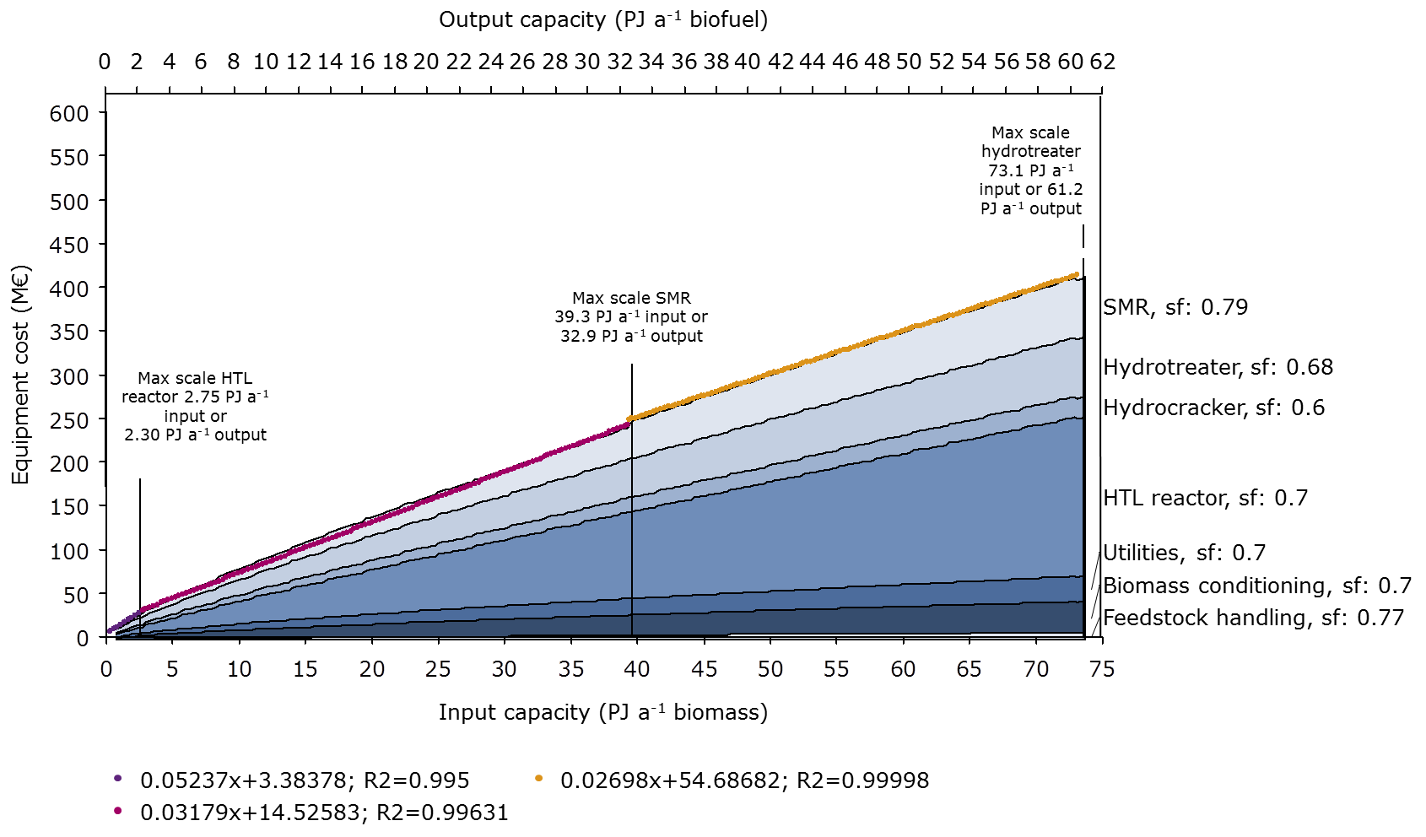
Figure B.1: Equipment costs for an centralized supply chain (at natural gas pipeline and LNG terminals) at different scales. Linear lines were fitted to the non-linear scaling curve and consequently inserted in the model. The scaling factors (sf) are listed for each piece of equipment. The cost item ‘missing equipment’ is not shown.

Appendix C: Transport cost
Table C.1 shows the input data used to calculate the transport cost. Figure C.1 shows the transport network and intermodal terminals in Sweden. The transhauling terminals are similar to the forestry terminals.^{10,11}
Table C.1: Input parameters for calculation of the transport cost
Parameter | Unit | Road^{i} |  | Rail^{i} |  | Sea^{ii,iii}
 |  | Solids | Liquids | Solids | Liquids | Solids | Liquids
Load capacity | Mg | 22 | 22 | 465 | 864 | 9600 | 9600
Net load capacity roundtrip | % | 50% | 50% | 75% | 75% | 94% | 94%
Average speed | km h⁻¹ | 50 | 50 | 70 | 70 | 32 | 32
Time cost (per vehicle) | € km⁻¹ | 0.63 | 0.63 |  |  | 9.39 | 12.36
Labor cost (per vehicle) | € km⁻¹ | 1.19 | 1.19
Variable cost (per vehicle) | € km⁻¹ | 0.36 | 0.36 | 3.83 | 4.06 | 14.73 | 24.46
Fuel cost (per vehicle) | € km⁻¹ | 1.37 | 1.37 | 2.26 | 2.91 | 33.54 | 33.54
Total transport cost (per vehicle) | € km⁻¹ | 3.55 | 3.55 | 6.09 | 6.98 | 57.66 | 70.37
Total transport cost | € Mg⁻¹ km⁻¹ | 0.162 | 0.162 | 0.013 | 0.008 | 0.006 | 0.007
Transport cost
Forestry residues and Stumps (chipped) | € GJ⁻¹ km⁻¹ (€ Mg⁻¹ km⁻¹) | 0.0097 (0.162) |  | 0.0008 (0.013) |  | 0.0004 (0.006)
Industrial by-products (IBS, IBP and sawmill chips) | € GJ⁻¹ km⁻¹ (€ Mg⁻¹ km⁻¹) | 0.0097 (0.162) |  | 0.0008 (0.013) |  | 0.0004 (0.006)
Sawlogs and pulpwood | € GJ⁻¹ km⁻¹ (€ Mg⁻¹ km⁻¹) | 0.0097 (0.162) |  | 0.0008 (0.013) |  | 0.0004 (0.006)
Biocrude | € GJ⁻¹ km⁻¹ (€ Mg⁻¹ km⁻¹) |  | 0.005 (0.162) |  | 0.0002 (0.008) |  | 0.0002 (0.007)
Biofuels | € GJ⁻¹ km⁻¹ (€ Mg⁻¹ km⁻¹) |  | 0.004 (0.162) |  | 0.0002 (0.008) |  | 0.0002 (0.007)
Loading/unloading^{iv}
Forestry residues and Stumps (chipped) | € GJ⁻¹ (€ Mg⁻¹) | 0.31 (5.11) |  | 0.53 (8.93) |  | 0.29 (4.85)
Industrial by-products (IBS, IBP and sawmill chips) | € GJ⁻¹ (€ Mg⁻¹) | 0.16 (2.71) |  | 0.53 (8.93) |  | 0.39 (6.48)
Sawlogs and pulpwood | € GJ⁻¹ (€ Mg⁻¹) | 0.12 (1.99) |  | 0.48 (8.04) |  | 0.39 (6.48)
Biocrude | € GJ⁻¹ (€ Mg⁻¹) |  | 0.04 (1.39) |  | 0.10 (3.26) |  | 0.35 (11.53)
Biofuels | € GJ⁻¹ (€ Mg⁻¹) |  | 0.03 (1.31) |  | 0.08 (3.08) |  | 0.27 (10.89)
- Based on Athanassiadis et al. (2009) ¹², transport of wood chips. Liquid bulk assumed similar to dry bulk. Diesel cost: 0.7 € L⁻¹, excise duty: 0.46 € L⁻¹, VAT: 25%.
- Dry bulk rail freight rates and load based on the Heuristics Intermodal Transport Model Calculation System (Floden 2011) ¹³, Medium case, electric engine. Liquid bulk calculated from dry bulk and NEA (2004) ¹⁴. Electricity price: 0.075 € kWh⁻¹.
- Short sea shipping > 7500 dwt dry and wet bulk international/continental. Based on NEA (2004) ¹⁴. Fuel oil price: 694 € Mg⁻¹.
- Loading and unloading cost are assumed to be similar.

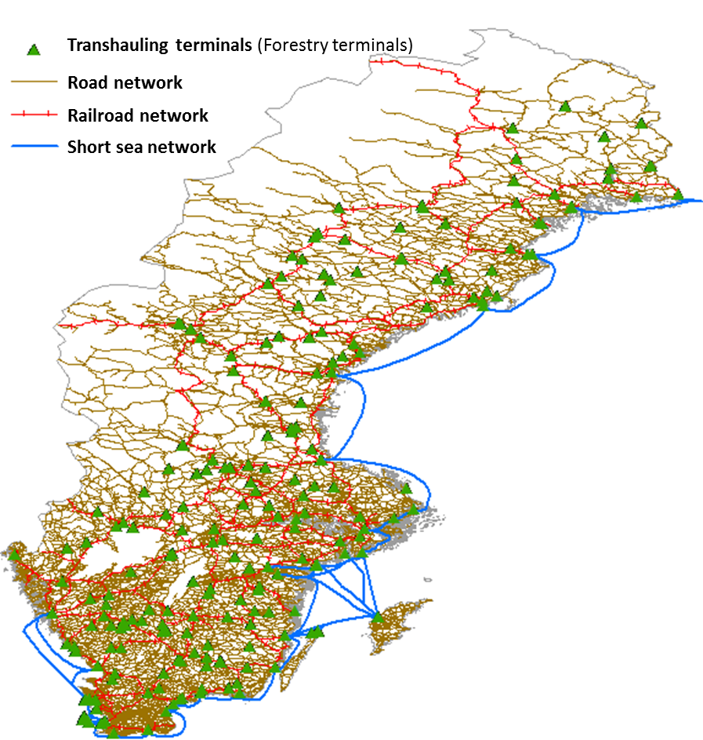
Figure C.1: Transport network

Appendix D: Unit conversion
Monetary values were normalized to €₂₀₁₅ using the yearly EU harmonized index of consumer prices.¹⁵ Values in US$ were converted to € using the euro-dollar exchange rate for the respective year.¹⁶ A similar approach was followed for the conversion of SEK to €.
Table D.1 shows the lower heating value and density for biomass, biocrude and biofuel as employed in this study.
Table D.1: Lower heating value and density for biomass, biocrude and biofuel
 | Unit | Biomass | Biocrude | Biofuel
Energy density (volume)¹⁷ | GJ m⁻³ | 7.41 | - | -
Energy density (mass)³ | GJ Mg⁻¹ (dry) | 16.7 | 32.7 | 40.3

Appendix E: Feedstock price distribution
Figure E.1 shows the feedstock price distribution for pulpwood, sawlogs and forestry residues. Industrial by-products are homogenously priced across Sweden.
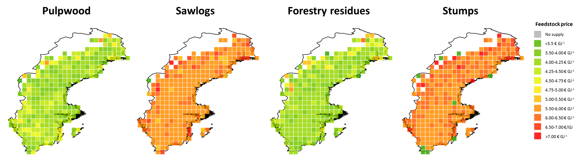
Figure E.1: Feedstock price distribution.

Appendix F: Examples of site layouts with and without integration
Figure F.1 shows the site layouts for a sawmill (top) and refinery (bottom) with and without integration with biofuel production. Integration with a pulp mill is similar to the example of a sawmill.

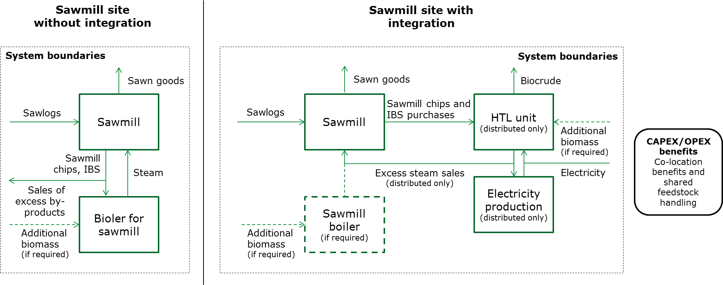
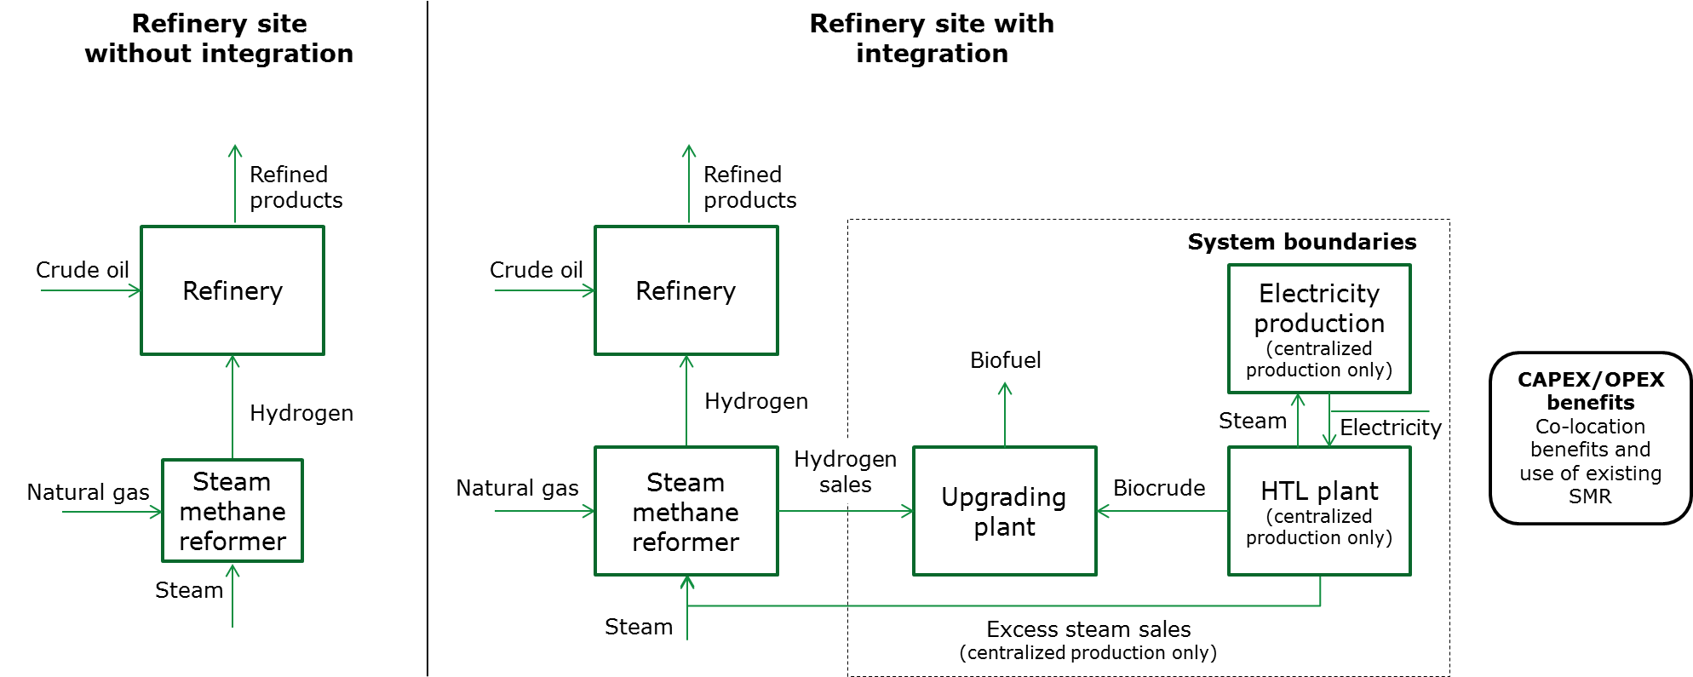
Figure F.1: Example site layouts for a sawmill (top) and refinery (bottom) with and without integration with biofuel production.

References
1. GAMS, GAMS Documentation 24.8 - Optcr. [Online]. Available at: https://www.gams.com/latest/docs/userguides/mccarl/optcr.htm(2017) [February 24 2017].
2. Zhu Y, Biddy MJ, Jones SB, Elliott DC and Schmidt AJ, Techno-economic analysis of liquid fuel production from woody biomass via hydrothermal liquefaction (HTL) and upgrading. Appl Energy 129:384–394 (2014).
3. Tews IJ, Zhu Y, Drennan CV, Elliott DC, Snowden-Swan LJ, Onarheim K et al., Biomass direct liquefaction options: technoeconomic and life cycle assessment. Pacific Northwest National Laboratory, Richland, US (2014).
4. Consonni S, Katofsky RE and Larson ED, A gasification-based biorefinery for the pulp and paper industry. Chem Eng Res Des 87:1293–1317 (2009).
5. de Jong S, Hoefnagels R, Faaij A, Slade R, Mawhood B and Junginger M, The feasibility of short-term production strategies for renewable jet fuels – a comprehensive techno-economic comparison. Biofuel, Bioprod Biorefining 9:778–800 (2015).
6. Eurostat, Electricity prices for industrial consumers, from 2007 onwards - bi-annual data (nrg_pc_205). [Online]. Available at: http://appsso.eurostat.ec.europa.eu/nui/show.do?dataset=nrg_pc_205&lang=en [June 25 2016].
7. Ereev SY and Patel MK, Standardized cost estimation for new technologies (SCENT) - methodology and tool. J Bus Chem 9 (2012).
8. Ramsden T, Ruth M, Diakov V, Laffen M and Timbario T, Hydrogen Pathways: Cost, Well-to-Wheels Energy Use, and Emissions for the Current Technology Status of Seven Hydrogen Production, Delivery, and Distribution Scenarios. National Renewable Energy Laboratory, Golden, US (2013).
9. Eurostat, Labour cost levels (lc_lci_lev). [Online]. Available at: http://appsso.eurostat.ec.europa.eu/nui/show.do?dataset=lc_lci_lev&lang=en [May 10 2016].
10. Kons K, Bergström D, Eriksson U, Athanassiadis D and Nordfjell T, Characteristics of Swedish forest biomass terminals for energy. Int J For Eng 25(3):238–246 (2014).
11. Athanassiadis D, Personal communication. (2013).
12. Athanassiadis D, Melin Y, Lundström A and Nordfjell T, Marginalkostnader för skörd av grot och stubbar från föryngringsavverkningar i Sverige. Umeå, Sweden (2009).
13. Flodén J, The Heuristics Intermodal Transport Model Calculation System. [Online]. Available at: https://gupea.ub.gu.se/handle/2077/25879(2011) [September 4 2016].
14. NEA, Factor costs of freight transport: an analysis of the development in time (in Dutch: Factorkosten van het goederenvervoer: Een analyse van de ontwikkeling in de tijd.). Commissioned by Adviesdienst Verkeer en Vervoer, Rijswijk, the Netherlands (2004).
15. Eurostat, HICP (2015 = 100) - annual data (average index and rate of change). (2015).
16. OFX, Historical Exchange Rates. [Online]. Available at: https://www.ofx.com/en-us/forex-news/historical-exchange-rates/(2016) [February 2 2016].
17. Pettersson K, Wetterlund E, Athanassiadis D, Lundmark R, Ehn C, Lundgren J et al., Integration of next-generation biofuel production in the Swedish forest industry – A geographically explicit approach. Appl Energy 154:317–332 (2015).

