- Supplementary material

SM A: Full list of criteria used to construct the bio-physical suitability map
 | Criterion | Unit/description | Suit. Class 5 (Perfect) | Suit. Class 4 (High) | Suit. Class 3 (Suitable) | Suit. Class 2 (Moderate) | Suit. Class 1 (Marginal) | Suit. Class 0 (Not suitable) | Dataset used
Climate | Annual Precipitation | mm/m2 | 2000-2500 | 1750 - 2000 | 1500 - 1750 | 1250 - 1500 | 1000 - 1250 | <1000 | WorldClim (Hijmans et al., 2005)
 |  |  | 2000-2500 | 2500-2875 | 2875-3250 | 3250 -3625 | 3625-4000 | >4000
 | Annual Precipitation on well-drained soils | mm/m2 | <4000 | 4000- 4250 | 4250 - 4500 | 4500 - 4750 | 4750 - 5000 | >5000
 | Number of dry months | monthly precipitation <100 mm/m2 | 0 | 1 | 2 | 3 | 4-5 | 0
 | Average Annual Temperature | ° Celsius | 24.0 – 33.0 | 21.6 – 24.0 | 20.4 - 21.6 | 19.2 - 20.4 | 18.0 - 19.2 | <18.0
 |  |  | 24.0 – 33.0 | 33.0 - 34.0 | 34.0 - 35.0 | 35.0 - 36.0 | 36.0 - 38.0 | >38
Soil | Pre dominant soil texture type | Soil texture classification | Clay loam  Sandy clay loam  Silty clay loam | Sandy loam  Silt loam  Silt | Loam | Clay (heavy)  Loamy sand | Sand |  | HWSD (Nachtergaele et al., 2012)
 | Other problematic site features | Permanently waterlogged zones considered unsuitable | - |  |  |  |  | Wetlands | MODIS (Friedl et al., 2010)
Topography | Slope | Sloping degrees | 0 – 25 |  |  |  |  |  | NASA SRTM (NASA, 2010)
 | Elevation | Meters | 0-1500

SM B: Suitability maps for each bio-physical criterion: (a) Average annual temperature, (b) temperature of the coldest month, (c), annual precipitation, (d) length of the dry season, (e) soil, (f) elevation, (g) slope.
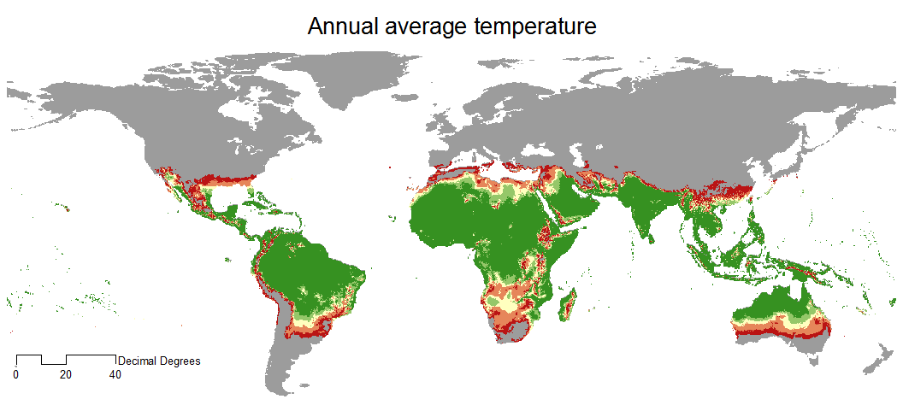  (a) | (b) | 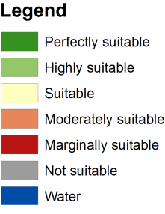
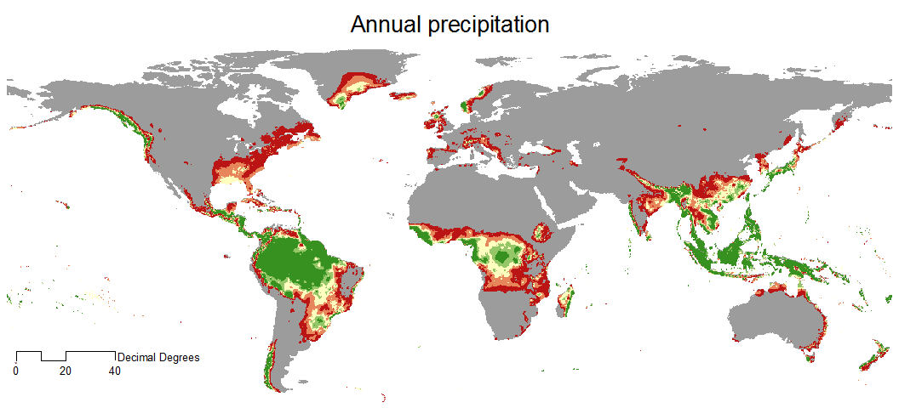  (c) | (d)
(e)
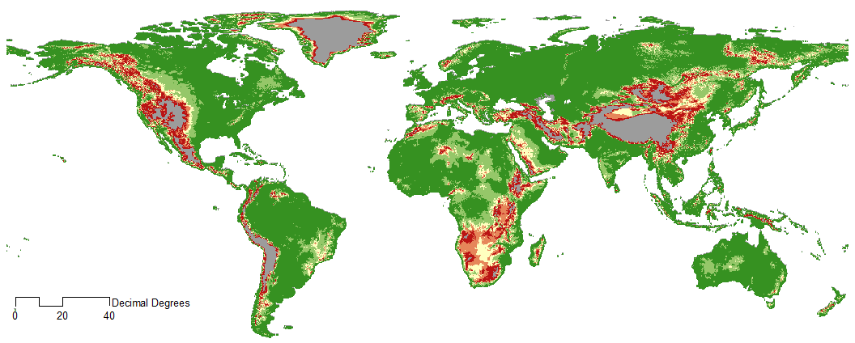  (f) | 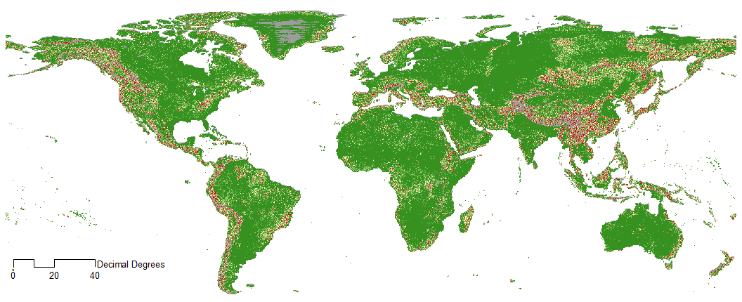  (g)
SM C: Review of criteria used for construction of oil palm suitability maps.
Source | Study region | Climate |  |  |  |  |  | Topography |  | Soil
 |  | Rainfall | Temperature | Seasonality indicator | Water deficiency | Solar radiation | Wind speed | Elevation a.s.l. | Slope | Soil type | Soil depth | Soil drainage | Soil texture | Soil fertility | Soil erosion risk | Level of the water table | Other soil property
Latin America
Ramalho Filho et al., 2010 | Legal  Amazon /  Brazil | X | X | X |  | X |  |  | X |  | X | X | X | X | X
Yui & Yeh, 2013 | Pará State /  Brazil | X | X |  |  |  |  |  | X |  |  | X | X
Gutiérrez-Vélez et al., 2011 | Peru |  |  |  |  |  |  | X | X
Inter-American Development Bank, 2012 | Colombia | X | X |  |  | X | X |  | X |  | X | X | X
Fernandez Vargas, 2010 | Nicaragua | X | X | X |  | X |  | X |  |  | X | X |  |  |  | X
INIFAP, 2008 | Mexico | X |  |  |  |  |  | X | X |  |  |  | X
Africa
Wyrley-Birch et al, 1982 | South-West Cameroon |  |  |  |  | X | X |  |  |  |  | X |  |  |  |  | X
Feintrenie ,2014 | Republic of Congo | X | X
Asia
Mantel et al., 2007 | Kalimantan /  Indonesia | X | X |  |  | X | X | X | X |  |  |  |  |  |  |  | X
Harris et al., 2013 | Indonesia,  Malaysia,  Papua  New-Guinea | X | X |  |  |  |  | X | X | X
Gingold et al., 2012 | Kalimantan and Papua  / Indonesia | X |  |  |  |  |  | X | X | X | X | X |  | X
Global
van Velthuizen et al., 2007 | Global | X | X | X | X |  |  |  | X |  | X | X | X |  |  |  | X
Stickler et al., 2007 | Global | X | X | X |  |  |  |  |  |  |  |  |  |  |  |  | X

SM D: Available land (green) and other suitable land (dark yellow) for the twelve countries harboring the most available land. Note the scale-break between Brazil and the other countries.
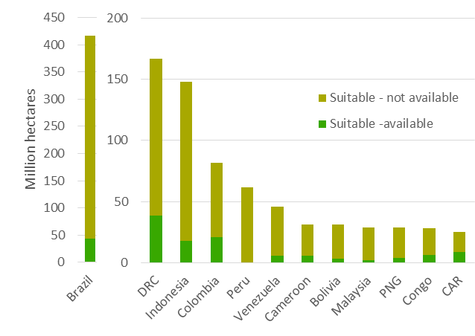

SM E: Available land per country and suitability class.
 | Highly suitable area | Other suitable area | Urban | PA's | Cropland & pasture | Palm concessions | Logging Concessions | Biodiversity priority | IFL | AGB >100t | Peatlands | Potentially available
Brazil | 110.27 | 306.70 | 0.52 | 222.80 | 361.89 | 0 | 0 | 9.17 | 227.06 | 321.32 | 0 | 43.36
DRC | 58.28 | 108.67 | 0.27 | 22.45 | 154.26 | 0.00 | 14.04 | 6.22 | 62.06 | 122.31 | 14.04 | 38.86
Indonesia | 60.72 | 87.34 | 1.21 | 16.23 | 114.95 | 14.09 | 24.91 | 22.33 | 25.96 | 111.38 | 24.91 | 18.19
Colombia | 28.49 | 53.44 | 0.19 | 11.26 | 69.51 | 0 | 0 | 6.29 | 32.69 | 57.78 | 0 | 21.09
Peru | 27.01 | 34.74 | 0.08 | 27.50 | 60.82 | 0 | 0 | 15.95 | 48.40 | 60.48 | 0 | 0.26
Venezuela | 7.62 | 38.01 | 0.04 | 30.23 | 39.78 | 0 | 0 | 7.99 | 24.97 | 34.06 | 0 | 5.89
Cameroon | 1.36 | 29.79 | 0.08 | 4.04 | 29.10 | 0.39 | 7.56 | 3.30 | 5.15 | 24.99 | 7.56 | 5.51
Bolivia | 1.18 | 29.90 | 0.01 | 9.03 | 29.88 | 0 | 0 | 5.59 | 8.82 | 25.41 | 0 | 3.65
Malaysia | 13.73 | 15.19 | 0.51 | 5.77 | 24.18 | 0 | 0 | 5.42 | 1.57 | 25.27 | 0 | 2.15
PNG | 10.55 | 18.19 | 0.03 | 0.48 | 27.69 | 0 | 0 | 2.10 | 10.11 | 23.61 | 0 | 3.78
Congo | 0.34 | 28.22 | 0.03 | 9.29 | 25.68 | 0.04 | 12.91 | 0 | 12.10 | 19.64 | 12.91 | 6.31
CAR | 0.82 | 24.41 | 0.02 | 2.75 | 24.58 | 0 | 3.44 | 0 | 0.87 | 15.68 | 3.44 | 8.91
Gabon | 2.64 | 20.48 | 0.03 | 4.57 | 21.78 | 0.08 | 6.24 | 1.00 | 8.71 | 20.87 | 6.24 | 1.62
Philippines | 2.22 | 20.28 | 0.48 | 3.32 | 11.42 | 0 | 0 | 8.29 | 0.25 | 11.57 | 0 | 5.77
Nigeria | 0.28 | 19.99 | 0.45 | 3.26 | 11.19 | 0 | 0 | 0.53 | 0.28 | 5.17 | 0 | 11.88
Cote d'Ivoire | 0.37 | 17.09 | 0.16 | 4.94 | 10.84 | 0 | 0 | 2.50 | 0.45 | 5.76 | 0 | 8.46
Guyana | 4.54 | 10.22 | 0.02 | 0.62 | 14.39 | 0 | 0 | 0.87 | 10.37 | 13.95 | 0 | 0.41
Suriname | 8.90 | 4.75 | 0.02 | 2.11 | 13.48 | 0 | 0 | 0 | 10.44 | 13.02 | 0 | 0.20
Ghana | 0.00 | 11.91 | 0.13 | 2.37 | 5.80 | 0 | 0 | 0 | 0 | 3.10 | 0 | 7.16
Ecuador | 3.05 | 7.15 | 0.01 | 3.40 | 8.97 | 0 | 0 | 2.69 | 4.15 | 9.20 | 0 | 0.54
South Sudan | 0.00 | 10.09 | 0.00 | 1.35 | 9.91 | 0 | 0 | 0 | 0 | 2.09 | 0 | 6.81
Liberia | 5.92 | 3.27 | 0.02 | 1.19 | 8.79 | 0.53 | 0 | 8.43 | 0.47 | 8.71 | 0 | 0.17
Viet Nam | 0.16 | 8.66 | 0.10 | 1.31 | 3.73 | 0 | 0 | 0.16 | 0.05 | 3.45 | 0 | 1.61
Thailand | 1.75 | 6.73 | 0.09 | 1.80 | 3.20 | 0 | 0 | 0 | 0.48 | 5.03 | 0 | 2.28
Nicaragua | 4.54 | 3.44 | 0.01 | 4.05 | 4.55 | 0 | 0 | 0 | 0.95 | 6.78 | 0 | 0.68
Uganda | 0.00 | 7.31 | 0.05 | 0.64 | 3.14 | 0 | 0 | 0.00 | 0 | 0.51 | 0 | 6.09
French Guiana | 5.25 | 1.95 | 0.01 | 4.11 | 7.18 | 0 | 0 | 0 | 6.10 | 7.10 | 0 | 0.03
Mexico | 1.70 | 4.86 | 0.04 | 0.90 | 2.66 | 0 | 0 | 0.00 | 0.30 | 3.46 | 0 | 1.91
Panama | 0.99 | 5.34 | 0.02 | 1.80 | 4.35 | 0 | 0 | 0.49 | 1.19 | 3.78 | 0 | 2.08
Cambodia | 0.10 | 5.60 | 0.00 | 1.78 | 2.80 | 0 | 0 | 0 | 0 | 2.08 | 0 | 1.08
Sierra Leone | 0.28 | 5.29 | 0.03 | 0.46 | 4.47 | 0 | 0 | 0.76 | 0 | 2.76 | 0 | 2.41
Guatemala | 0.71 | 4.38 | 0.01 | 2.44 | 3.44 | 0.07 | 0 | 0.00 | 0.35 | 3.46 | 0 | 0.77
Madagascar | 1.65 | 3.04 | 0.00 | 0.44 | 1.92 | 0 | 0 | 4.67 | 0.16 | 2.55 | 0 | 0.01
Honduras | 0.88 | 3.78 | 0.01 | 2.03 | 3.66 | 0 | 0 | 0.08 | 0.63 | 3.73 | 0 | 0.70
India | 0.06 | 3.81 | 0.06 | 0.76 | 2.95 | 0 | 0 | 1.30 | 0.07 | 2.77 | 0 | 0.58
Angola | 0.00 | 3.79 | 0.00 | 0.00 | 3.69 | 0 | 0 | 0 | 0 | 1.26 | 0 | 2.52
Costa Rica | 0.65 | 3.01 | 0.00 | 1.12 | 1.95 | 0 | 0 | 0.05 | 0.03 | 2.34 | 0 | 0.88
Sri Lanka | 0.36 | 2.20 | 0.07 | 0.48 | 1.28 | 0 | 0 | 1.25 | 0 | 1.80 | 0 | 0.17
Equatorial Guinea | 0.54 | 1.97 | 0.00 | 0.55 | 2.47 | 0 | 0.70 | 0.00 | 0.37 | 2.45 | 0.70 | 0.01
Solomon Islands | 0.83 | 1.30 | 0.01 | 0.03 | 2.10 | 0 | 0 | 1.64 | 0.61 | 0.15 | 0 | 0.40
Dominican Republic | 0.23 | 1.80 | 0.00 | 0.22 | 0.74 | 0 | 0 | 1.60 | 0 | 1.17 | 0 | 0.09
Guinea | 0.17 | 1.80 | 0.00 | 0.14 | 1.67 | 0 | 0 | 0.52 | 0 | 0.51 | 0 | 1.24
Myanmar | 0.00 | 1.82 | 0.00 | 0.42 | 1.48 | 0 | 0 | 0 | 0.33 | 1.30 | 0 | 0.37
Belize | 0.13 | 1.52 | 0.00 | 0.65 | 1.45 | 0 | 0 | 0 | 0.35 | 1.36 | 0 | 0.22
Fiji | 0.58 | 0.92 | 0.00 | 0.03 | 1.17 | 0 | 0 | 1.49 | 0 | 0 | 0 | 0.01
Togo | 0.00 | 1.45 | 0.01 | 0.14 | 0.76 | 0 | 0 | 0 | 0 | 0.11 | 0 | 1.14
Haiti | 0.10 | 1.27 | 0.00 | 0.00 | 0.10 | 0 | 0 | 1.01 | 0 | 0.39 | 0 | 0.18
Benin | 0.00 | 1.04 | 0.00 | 0.09 | 0.56 | 0 | 0 | 0 | 0 | 0.00 | 0 | 0.88
Timor-Leste | 0.00 | 1.01 | 0.00 | 0.13 | 0.51 | 0 | 0 | 0 | 0 | 0.36 | 0 | 0.52
United Republic of Tanzania | 0.00 | 0.92 | 0.00 | 0.15 | 0.59 | 0 | 0 | 0.00 | 0 | 0.07 | 0 | 0.61
Cuba | 0.00 | 0.92 | 0.00 | 0.17 | 0.52 | 0 | 0 | 0.61 | 0 | 0.53 | 0 | 0.11
Vanuatu | 0.25 | 0.62 | 0.00 | 0.04 | 0.82 | 0 | 0 | 0 | 0.04 | 0 | 0 | 0.78
Jamaica | 0.07 | 0.75 | 0.00 | 0.08 | 0.52 | 0 | 0 | 0.04 | 0 | 0.51 | 0 | 0.24
Paraguay | 0.00 | 0.81 | 0.00 | 0.00 | 0.75 | 0 | 0 | 0 | 0 | 0.43 | 0 | 0.37
Bangladesh | 0.00 | 0.76 | 0.00 | 0.04 | 0.53 | 0 | 0 | 0 | 0 | 0.51 | 0 | 0.12
China | 0.00 | 0.71 | 0.01 | 0.02 | 0.21 | 0 | 0 | 0.03 | 0 | 0.08 | 0 | 0.43
Puerto Rico | 0.09 | 0.57 | 0.08 | 0.03 | 0.36 | 0 | 0 | 0.62 | 0 | 0.43 | 0 | 0.02
New Caledonia | 0.02 | 0.58 | 0.00 | 0.26 | 0.55 | 0 | 0 | 0.42 | 0 | 0 | 0 | 0.16
Ethiopia | 0.00 | 0.60 | 0.00 | 0.15 | 0.40 | 0 | 0 | 0 | 0 | 0.10 | 0 | 0.27
Brunei Darussalam | 0.44 | 0.10 | 0.00 | 0.23 | 0.52 | 0 | 0 | 0 | 0.19 | 0.50 | 0 | 0.02

SM F: National objectives for oil palm planting area and available land for sustainable expansion.
Country | Acreage objective | Available land [ha] | Source
Indonesia | 18 Mha | 18.2Mha | The Jakarta Post (2009)
Cameroon | Increase of 0.05 Mha ha in addition to the currently existing 0.160 Mha | 5.51 Mha | Palm oil strategy of Cameroon, forthcoming; Hoyle and Levang, (2012)
Republic of Congo | 0.1 Mha | 6.3 Mha | INDC of the Republic of Congo (Ministry of forest economy and sustainable development (MEFD, 2014; Republic of Congo, 2015)

SM G: Comparison of this suitability map with the GAEZ product. Green - agreement between both products; Orange – disagreement where the GAEZ product is present only; Yellow – disagreement where our product is present only.

Note: The estimate of 160,000 ha of current planting area in Hoyle and Levang (2012) differs significantly from FAO (2014).

