electronic supplementary material

water use in lca

**The WULCA consensus characterization model for water scarcity footprints: Assessing impacts of water consumption based on available water remaining (AWARE)**

**Anne-Marie Boulay1 • Jane Bare2 • Lorenzo Benini3 • Markus Berger4 • Michael J. Lathuillière5 • Alessandro Manzardo6 • Manuele Margni1 • Masaharu Motoshita7 • Montserrat Núñez8 • Amandine Valerie Pastor9,10 • Bradley Ridoutt11,12 • Taikan Oki13 • Sebastien Worbe14 • Stephan Pfister15**

Received: 12 December 2016 / Accepted: 3 May 2017

© Springer-Verlag Berlin Heidelberg 2017

Responsible editor: Sarah McLaren

1CIRAIG, Polytechnique Montreal, Montreal, Canada

2 USEPA, Office of Research and Development, National Risk Management Research Laboratory, Sustainable Technology Division, Cincinnati, OH, USA

3 European Commission, Joint Research Centre – Sustainability Assessment Unit, Ispra (VA), Italy

4 Technische Universität Berlin, Chair of Sustainable Engineering, Germany

5 Institute for Resources, Environment and Sustainability, University of British Columbia, Vancouver, Canada

6 CESQA, University of Padova, Department of Industrial Engineering, Italy

7 National Institute of Advanced Industrial Science and Technology, Tsukuba, Japan

8 Irstea, UMR ITAP, ELSAELSA Research group & ELSA-PACT Industrial Chair, 361 Rue Jean François Breton, 34196, Montpellier, France

9 IIASA, International Institute of Applied Systems Analysis, Austria

10 Wageningen University, Earth System Science, Wageningen, The Netherlands

11 Commonwealth Scientific and Industrial Research Organisation (CSIRO), Clayton, Victoria, Australia

12 University of the Free State, Department of Agricultural Economics, Bloemfontein, South Africa

13 Institute of Industrial Science, The University of Tokyo, Tokyo

14 Veolia Research & Innovation, Maisons-Laffitte, France

15 ETH Zurich, Zurich, Switzerland

 Anne-Marie Boulay

[anne-marie.boulay@polymtl.ca](mailto:anne-marie.boulay@polymtl.ca)

Table of Contents

I- Process 2

II- Alternatives considered 7

III- Sensitivity of cut-off choices and EWR in AWARE 9

IV- Spatio-temporal Sensitivity 10

V- Comparison with other models. 12

VI- Monthly results 14

VII- Sensitivity to EWR 16

VIII- Applicability 17

IX- References 18

## Process

The three proposals identified during the workshops were calculated and analyzed. A first pre-selection criterion was identified to pursue the analysis only with indicators that the group considered relevant. A second set of four consensual selection criteria were then identified, including a stakeholder consultation on the remaining options (DTAX and 1/AMD). These criteria guided the preliminary recommendation. Decisions were made during regular working group meetings. Members who could not participate had the opportunity to follow recordings of on-line meeting and provide their input via email or at the following meeting. Consensus was considered as “more than a simple majority, but not necessarily unanimity”. When unanimity was not reached, statements including the diverging opinions were included in the paper.

*The three indicators options* that emerged from the preliminary expert workshops are:

1. DTAA (Eq.S1a and S1b): is based on a demand-to-availability (DTA) ratio but includes a filter for arid regions (A) (where the value of the factor is set to the maximal model value (e.g. 1 for a range 0-1), as suggested by Berger et al. (Berger et al. 2014). Arid regions are defined as regions where the potential evapotranspiration (PET) is greater than five times the precipitation (P) (1997).

${DTA}_{A}=\frac{Demand}{Availability}$ for PET<5P Eq. S1a ${DTA}_{A}=Max$ 
 for PET>5P Eq. S1b

Where Demand refers to the sum of human water consumption and environmental water requirements, and Demand and Availability are calculated in m3/month and area in m2.

1. DTAx (Eq.S2): is the product of two parameters: one representing the relative availability (DTA) and one representing absolute availability (AAv) per unit of surface (the inverse of area-specific availability, area/availability). In order to set an equal contribution of both parameters at the global level to the resulting DTAx indicator, an exponent (x) of 0.34 was applied to the AA factor. This value was found by adjusting the exponent in order to obtain equal correlation of both parameters with the final result over all (sub)watersheds.

${DTA}_{x}=\left(\frac{Demand}{Availability}\right)×{\left(\frac{Area}{Availability}\right)}^{0.34}$ Eq.S2

1. 1/AMD (Eq.S3a and S3b): the Availability-Minus-Demand indicator is based on the inverse of the difference between availability and demand instead of the ratio. When the value of the demand is equal to or larger than the availability (negative AMD), the factor is set to be maximal since the equation would no longer be continuous nor hold the same meaning.

$1/{AMD}=\frac{Area}{Availability-Demand}$ for Demand < Availability Eq.S3a

$1/{AMD}=Max$, for Demand ≥ Availability Eq.S3b

1. Stakeholders acceptance

Stakeholders’ acceptance should be as broad as possible and coming from different sectors (academia, industry/consultants, and government). Experts contributing to WULCA were consulted on the acceptability of the remaining options and on their preference. 33 answers were received, with 29 reporting a preference. It should be noted that this poll was based on expertise with individuals who expressed interest in contributing to WULCA, and although all continents are represented, it does not constitute a geographically balanced poll.

Table S1: Poll distribution by sector and region

|  |  |  |  |
| --- | --- | --- | --- |
|  | **SECTOR** | **REGION** | **PREFERENCE** |
| 1 | Academia | Europe | 1/AMD |
| 2 | Consultant | Europe | 1/AMD |
| 3 | Academia | Europe | 1/AMD |
| 4 | Academia | North America | 1/AMD |
| 5 | Industry | Europe | 1/AMD |
| 6 | Consultant | Europe | 1/AMD |
| 7 | Industry | Europe | 1/AMD |
| 8 | Academia | Africa | 1/AMD |
| 9 | Consultant | Europe | 1/AMD |
| 10 | Academia | Middle East | 1/AMD |
| 11 | Consultant | Europe | No Preference |
| 12 | Academia | Europe | No Preference |
| 13 | Academia | Asia and South Pacific | 1/AMD |
| 14 | Government | Europe | 1/AMD |
| 15 | Public-Private partnership | South America | 1/AMD |
| 16 | Industry | Europe | 1/AMD |
| 17 | Academia | South America | 1/AMD |
| 18 | Academia | Asia and South Pacific | 1/AMD |
| 19 | Academia | Europe | 1/AMD |
| 20 | Academia | North America | 1/AMD |
| 21 | Academia, Consultant, NGOs | Europe | 1/AMD |
| 22 | Industry | Europe | 1/AMD |
| 23 | Academia | Europe | DTAx |
| 24 | Academia | Europe | DTAx |
| 25 | Consultant | North America | 1/AMD |
| 26 | Academia, Consultant | Europe | DTAx |
| 27 | Consultant | Europe | No Preference |
| 28 | Industry | Europe | 1/AMD |
| 29 | Consultant | Middle East | No Preference |
| 30 | Academia | North America | 1/AMD |
| 31 | Academia | South America | 1/AMD |
| 32 | Consultant | Europe | 1/AMD |
| 33 | Academia | North America | 1/AMD |

1. Robustness of the indicator using analysis of closed basins

In water use impact assessment, unfortunately no measurable information exists to validate a model on the potential of depriving other users of water in a region or potential impacts from water consumption at such an early stage in the impact pathway (midpoint). However, the concept of closed basins can help in identifying problematic areas. A basin is said to be closing when, for part of the year, river discharge no longer accomplishes basic functions such as flushing out sediments, diluting polluted water, controlling salinity intrusion and sustaining estuarine and coastal ecosystems, and closed if this is the case for the whole year (Molle et al. 2010). Another definition describes a closed basin when “no usable water leaves it” because all runoff have been consumed or polluted (Oel et al. 2011). Despite no official list of closed or closing basins exists due to a qualitative rather than quantitative definition, there seems to be agreement that some basins in the world fit this definition as found in the literature on closed or closing basins: the Yellow, Colorado, Indus, Murray-Darling, Jordan, Cauvery, Ganges, Nile, Amu Darya and Syr Darya, Orange and Limpopo (Falkenmark and Molden 2008; Molle 2008; Molle et al. 2010; Oel et al. 2011). However, the closed basins identified are normally major river basins, and less consideration is given to the smaller ones. Once a basin is closing or closed, the potential to cause harm by using additional water is high, and hence the chosen method should show higher values for these basins. The methods were compared both for the ranking and for the value percentile of the maximum. Basins were associated with a method (DTAx or 1/AMD) in Table 1 when they showed a higher ranking (when compared with all basins) and a higher percentile of the maximum value (10 in DTAx and 100 in 1/AMD) for this method compared to the other one.

1. Minimization of normative choices

Normative choices are often unavoidable when modeling impacts in LCA, but they should be transparent and relevant to best of the available knowledge. Modeling should be based on scientific and quantifiable knowledge; estimates or value choices should only be included as a last resort (ISO (ISO 14044 2006)). The more uncertain they are, the less influential they should be on the result.

1. Physical meaning

A clear physical meaning is desired to express the environmental relevance and understanding of the indicator, meaning being translated into units that you can explain. In the absence of a physical meaning, a conceptual one could be used if sufficiently explained.

## Alternatives considered

Below are the maps of the three options that were first considered.

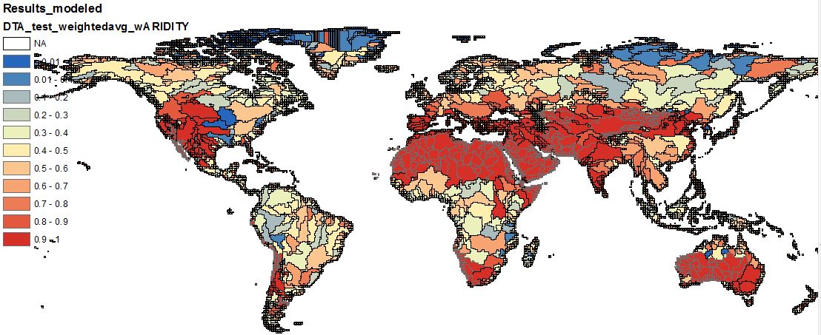***Figure S1: DTAA***

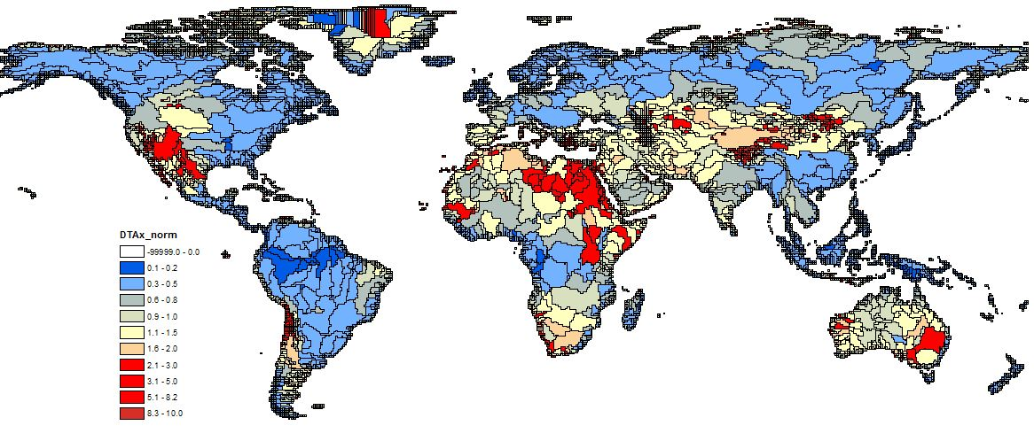***Figure S2: DTAx, normalized with world average***

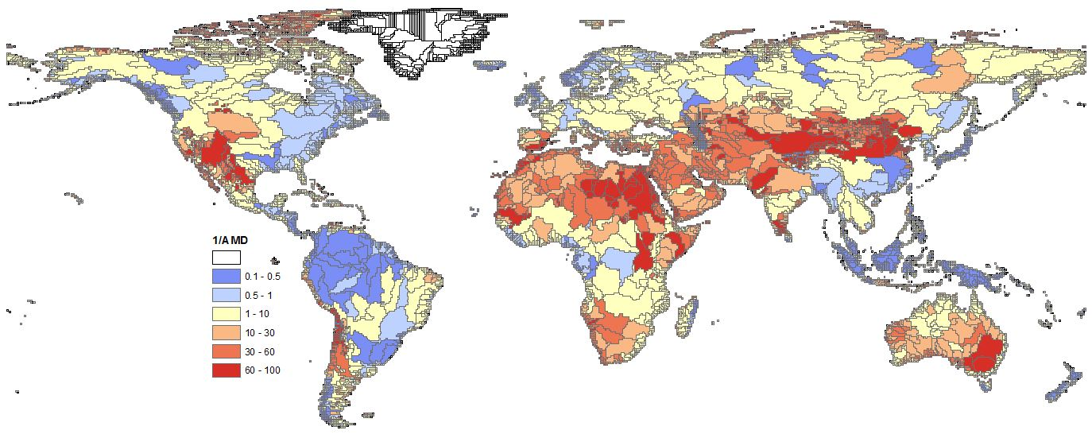

***Figure S3: 1/AMD, normalized with world average***

## Support of minority for recommending DTAx as well as 1/AMD

As stated in the text, a minority would have preferred to recommend both indicators. Among the points discussed, the fact that DTAx includes a ratio representing relative water scarcity (% of the availability for which users are competing) was seen as a benefit since 1/AMD does not explicitly represent this. Additionally, 1/AMD requires a cut-off choice at the point of discontinuity (D>A) which is influential in some regions, whereas the cut-off applied in DTAx was not mathematically required. Lastly, the assumption described below Equation 5 in the text: “This assumes that consuming water in two regions with the same amount of regional remaining water per m2·month after human and aquatic ecosystem demands were met is considered equal, as no other regional specification is included” was interpreted in different ways and considered an important disadvantage by a member. Even though DTAx is a complex index because of combination of two physical indexes, it may provide users with an additional perspective of the assessment results along with AWARE.

## Sensitivity of cut-off choices and EWR in AWARE

***Table S2: Percentage of the world in terms of water consumption affected by cut-off choices and sensitivity to EWR modeling choices***

|  |  |  |  |  |  |  |
| --- | --- | --- | --- | --- | --- | --- |
|  | ***AWARE*** | | ***AWARE if using EWR x1.5*** | | ***AWARE if using EWR Richter (80%)*** | |
| *For all 12 months* | *For at least one month* | *For all 12 months* | *For at least one month* | *For all 12 months* | *For at least one month* |
| *Cutoff choice AMDworld avg> 100*AMDregion I (100)* | < 1% | 5% | < 1% | 2% | < 1% | < 1% |
| *Modeling choice for Demand> Availability set to maximal value (100)* | 4% | 33% | 10% | 51% | 21% | 50% |
| *Cutoff choice for*  *AMDworld avg< 0.1*AMDregion i set to minimum (0.1)* | < 1% | < 1% | < 1% | < 1% | < 1% | 14% |

***Table S3: Percentage of the world in terms of land surface area affected by cut-off choices and sensitivity to EWR modeling choices***

|  |  |  |  |  |  |  |
| --- | --- | --- | --- | --- | --- | --- |
|  | ***AWARE*** | | ***AWARE if using EWR x1.5*** | | ***AWARE if using EWR Richter (80%)*** | |
| *For all 12 months* | *For at least one month* | *For all 12 months* | *For at least one month* | *For all 12 months* | *For at least one month* |
| *Cutoff choice AMDworld avg> 100*AMDregion I* | <1% | 12% | <1% | 11% | <1% | 2% |
| *Modeling choice for Demand> Availability set to maximal value (100)* | <1% | 12% | 3% | 21% | 5% | 25% |
| *Cutoff choice for*  *AMDworld avg< 0.1*AMDregion i set to minimum (0.1)* | 12% | 18% | 4% | 28% | 12% | 41% |

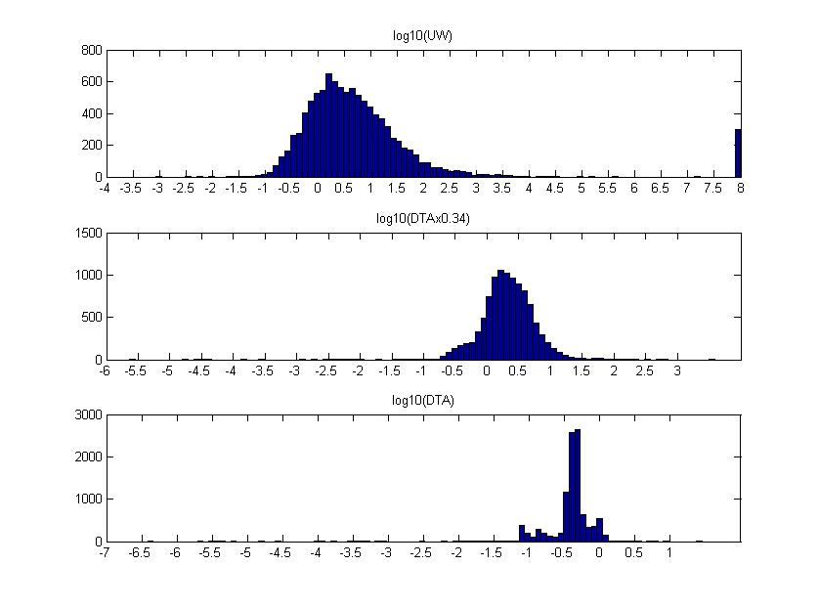

Cutoff at 100

Regions where Demand > Availability

Cutoff at 0.1

***Figure S4: Distribution of AWARE indicator prior to cut-offs, presented on a log scale per watershed***

## Spatio-temporal Sensitivity

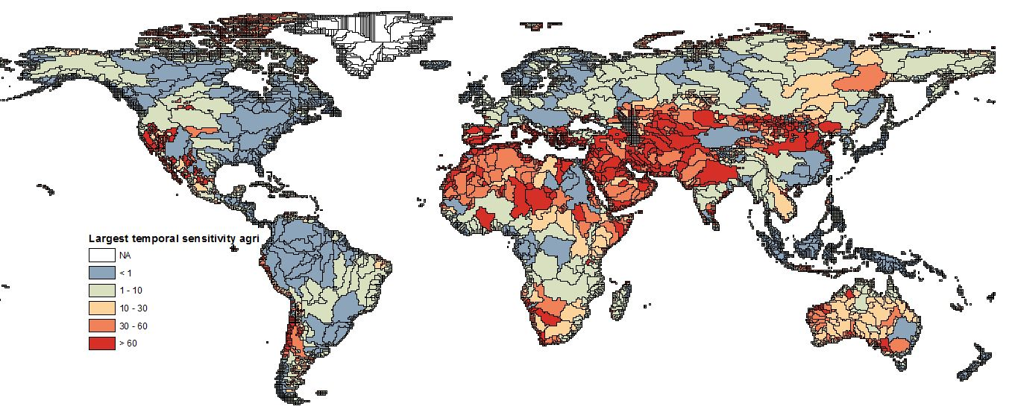

**Figure S5: Largest temporal sensitivity in annual (agri) AWARE CF (highest month minus lowest month)**

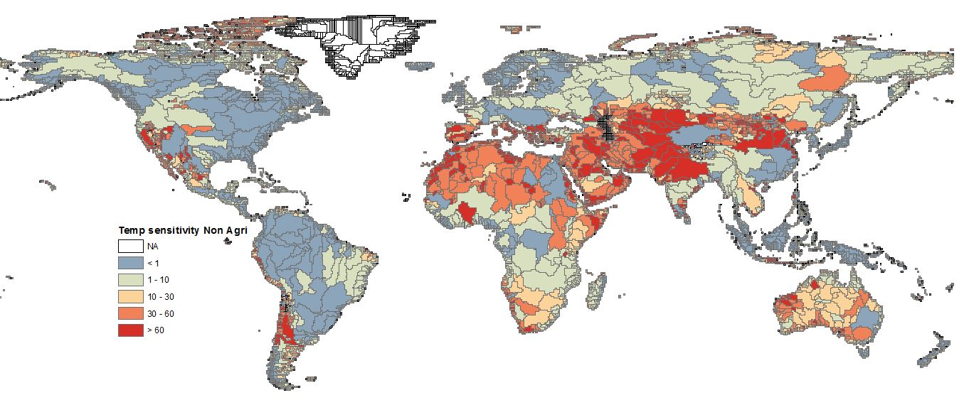

**Figure S6: Largest temporal sensitivity in annual (non-agri) AWARE CF (largest month minus lowest month)**

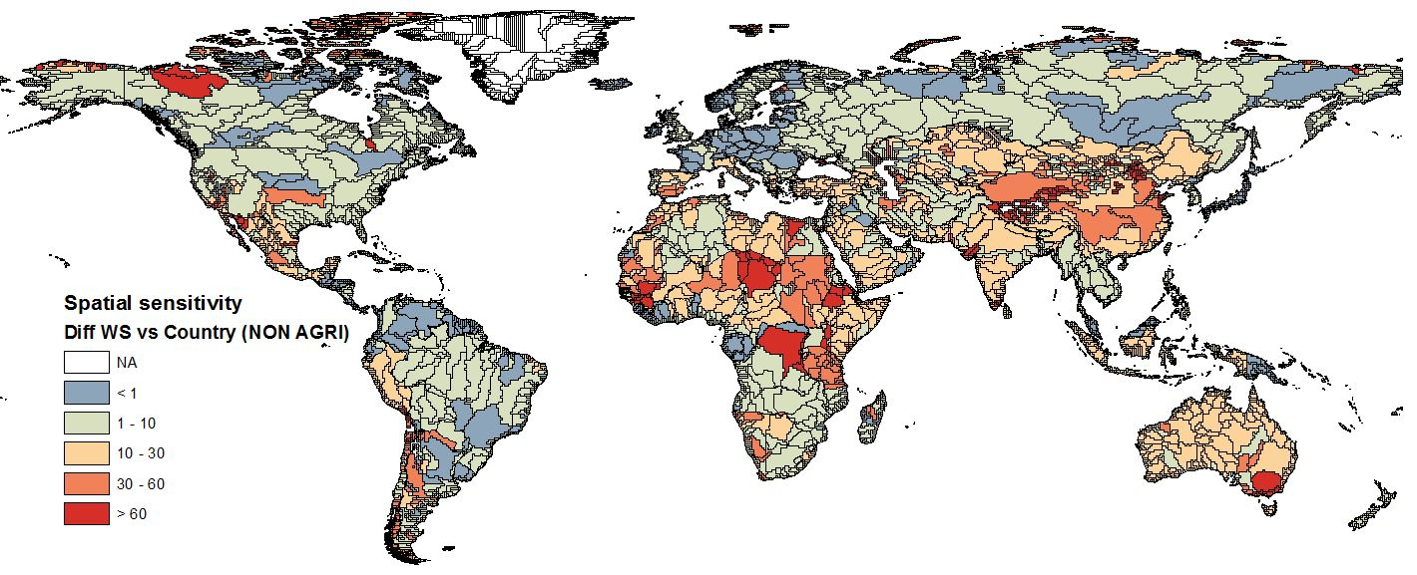

**Figure S7: Spatial sensitivity in annual (non-agri) AWARE CF (absolute difference between country and watershed factors)**

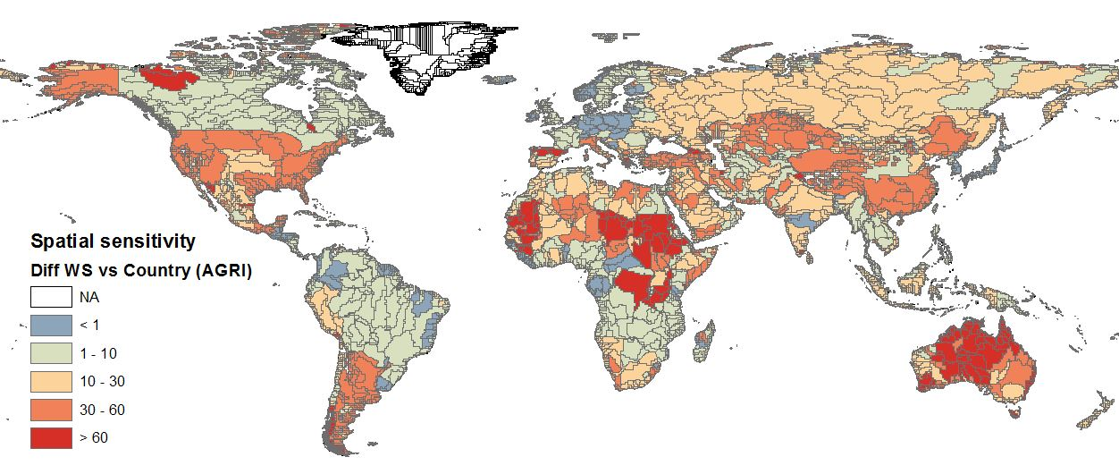

**Figure S8: Spatial sensitivity in annual (agri) AWARE CF (absolute difference between country and watershed factors)**

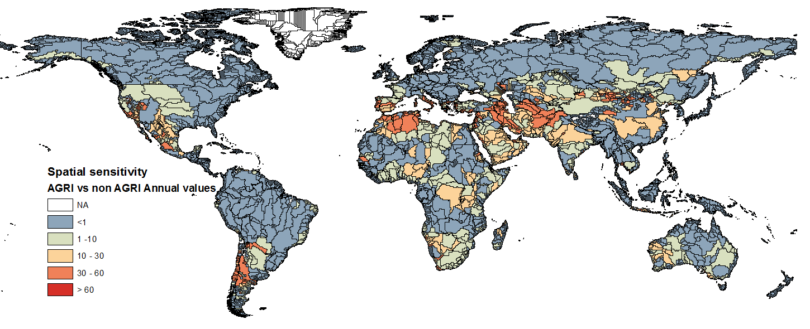

**Figure S9: Difference between annual agri and non-agri AWARE CF**

## Comparison with other models.

To compare the differences in results between AWARE, DTAx and other scarcity methods (WDI (Berger et al. 2014), WSI (Boulay et al. 2011) and WSI (Pfister et al. 2009)), we used the residual error RE (also known as root mean square deviation) on the log. The RE is a measure of the agreement between two compared data sets and is calculated as per Equation S4:

$RE=\sqrt{\frac{\sum_{t=1}^{n}{{(logx_{1,t}-logx_{2,t})}^{2}}}{n}}$ Equation S4

The reference method chosen for all comparisons was AWARE (x1 in the equation above). x2 stands for the method compared. All methods have been normalised by their maximal value to obtain the same scale between 0-1 before calculating RE. The comparison of AWARE with WDI Berger, WSI Boulay and WSI Pfister was done at the country scale (n=212), whereas for AWARE with DTAx, it was done at the watershed scale (n=11050). Furthermore, we calculated the square geometric standard deviation (GSD2) as GSD2=102RE, which defines the 95th confidence interval. Lower values of RE, thus of GSD2, indicate more agreement between methods.

Results show that AWARE and DTAx have a reasonable agreement (GSD2=11.43) and both better differentiate amongst very high values of stress for which the other methods foresee a maximum value of 1 only (Figure S10). The GSD2 from comparing AWARE to the other methods were: 24.44 for AWARE-WSI Pfister, 34.43 for AWARE-HDI Berger and 63.25 for AWARE-WSI Boulay.

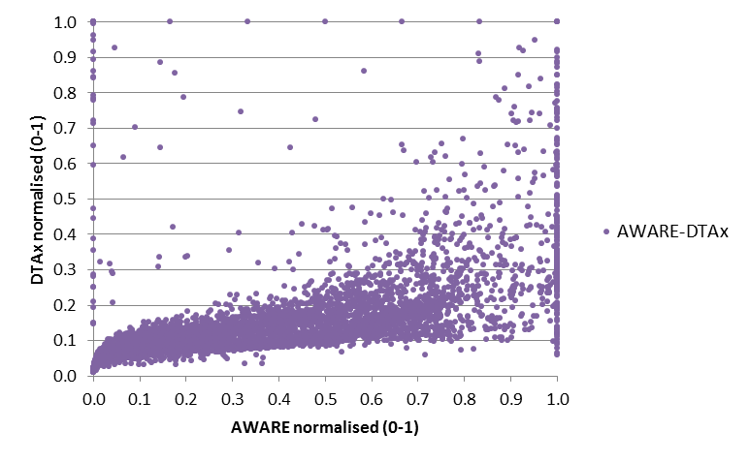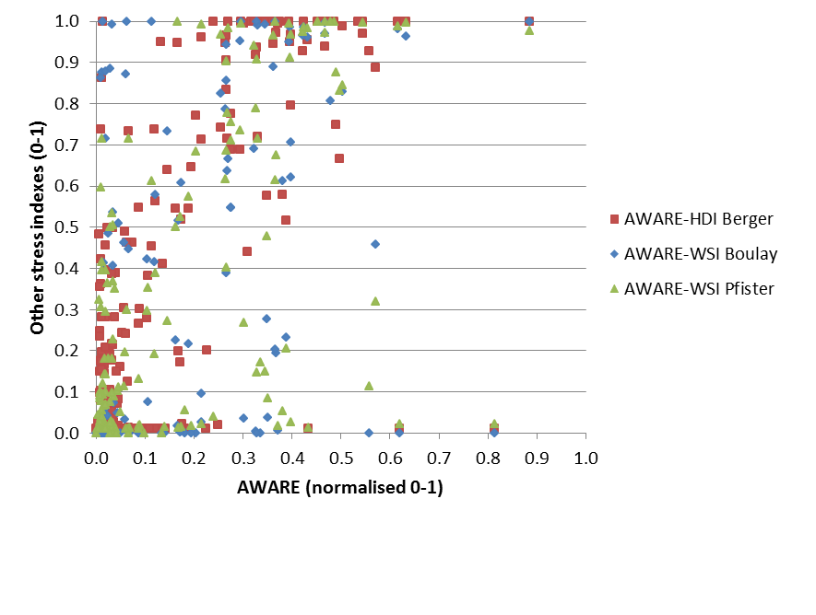

**Figure S10: scattered plots comparing on the left AWARE to other existing stress indexes and on the right AWARE to DTAx.**

## Monthly results

Below are monthly maps and graphs from selected watersheds showing the 12 different months.

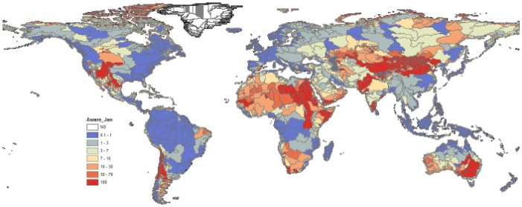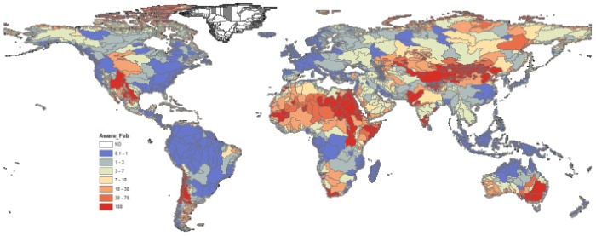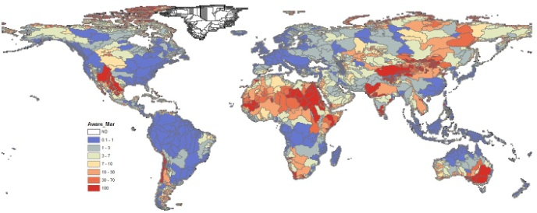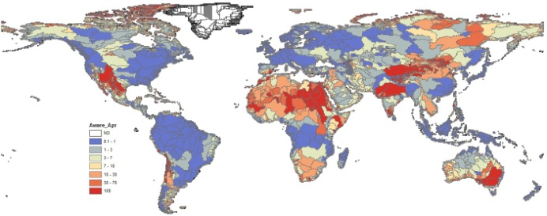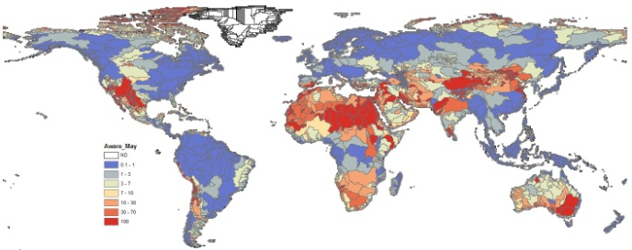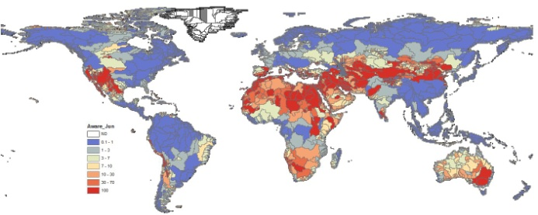

June

May

April

March

January

February

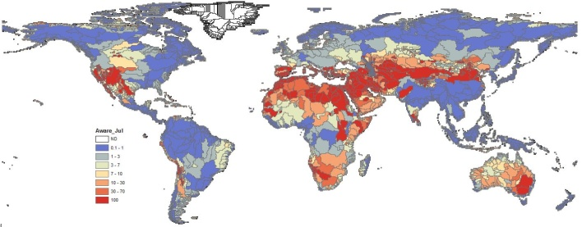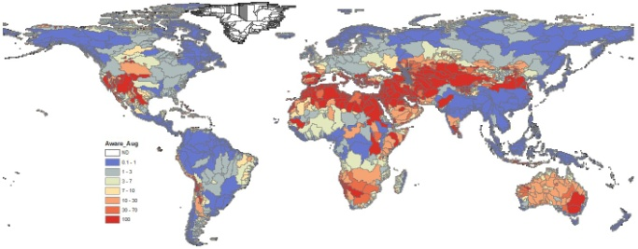

August

July

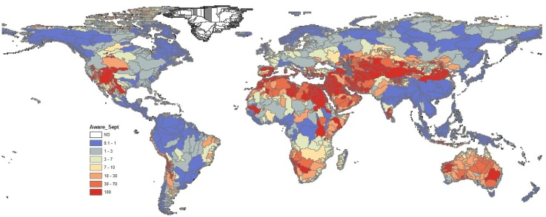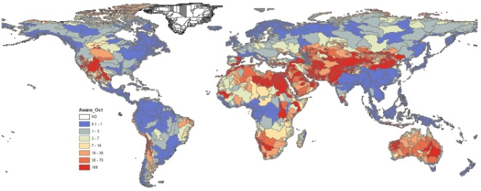

October

September

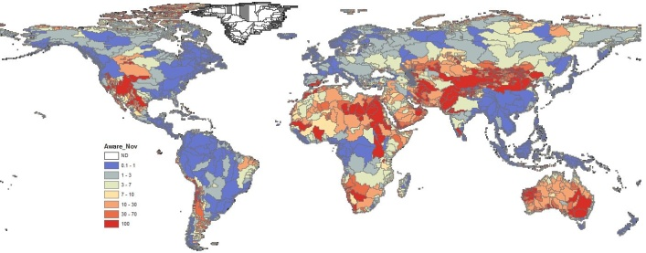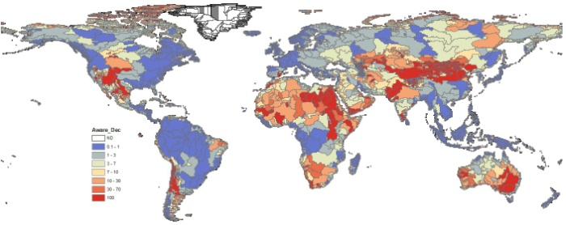

December

November

***Figure S11: Monthly maps for AWARE CF***

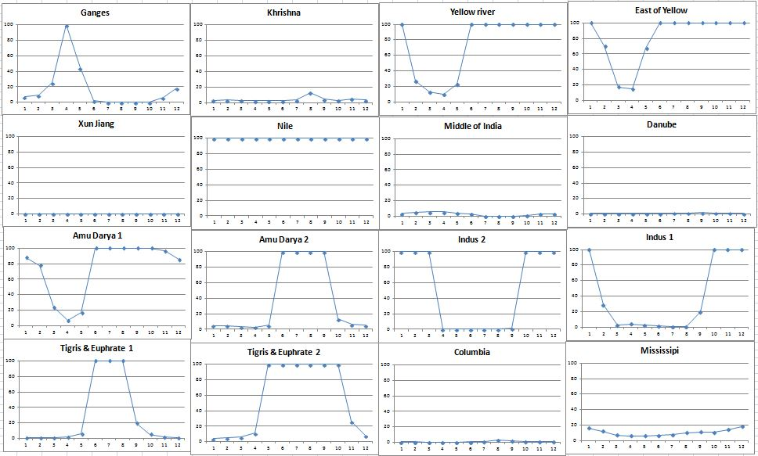***Figure S12: Monthly behavior of the CF for selected watersheds in the world showing different trends***

## Sensitivity to EWR

Analysis of sensitivity to the EWR parameter was performed and the results are shown in Fig. S13 below.



***Figure S13: Evaluation of share of total world consumption associated with AWARE CF and with AWARE_EWR150%, showing the steeper increase in CF values with AWARE_EWR150%.***

## Applicability

An ‘additional intervention’ for water consumption is defined as an additional consumption of water which takes place in a catchment (or country) on top of the other consumptive uses due to other activities, with respect to the reference year for the hydrogeological model used for the assessment. The ‘marginality of the intervention’ for water consumption refers to the negligibility of the ‘additional intervention’ (i.e. additional consumption of water) with respect to the current level of water availability. Negligibility is defined as an additional intervention which leads to a negligible change in the characterization factor. When the analysis is intended for non-marginal interventions (i.e. large inventories) which occurred in the past (e.g. for calculating the normalization factors), and therefore are not additional with respect to the current situation (i.e. reference year for WaterGAP), average factors should be used instead of the marginal-additional ones (see (Huijbregts et al. 2011; Pfister and Bayer 2014; Benini et al. 2015)). The preliminary average factors for AWARE are currently available by contacting the author or soon available online.

Ongoing methodological developments (Benini et al. 2015) are focusing on the quantification of threshold of inventory values (i.e. water consumption) below which the AWARE method can be safely applied. The use of the AWARE factors for interventions which go beyond these safety thresholds is not recommended as it could lead to underestimation of the impacts on potential water deprivation.

As the AWARE characterization factors have been developed for use in marginal-LCA contexts, their use is not fit at the moment for the characterization of normalization inventories. Similarly, if there is a reasonable doubt that the human intervention/s which is/are assessed within the LCA study are of such a large intensity that the resulting impacts are so big to change the reference condition of one or more catchments, then the LCIA results concerning potential deprivation should be discussed in the light of the limited capability of the method of dealing with such large-scale interventions.

## References

Benini L, Boulay A-M, Sala S (2015) Cross-scale consistency in life-cycle impact assessment: the case of water scarcity. In: SETAC Europe 25th Annual meeting

Berger M, van der Ent R, Eisner S et al (2014) Water Accounting and Vulnerability Evaluation (WAVE): Considering Atmospheric Evaporation Recycling and the Risk of Freshwater Depletion in Water Footprinting. Environ Sci Technol 48:4521–4528

Boulay A-M, Bulle C, Bayart J-B et al (2011) Regional Characterization of Freshwater Use in LCA: Modeling Direct Impacts on Human Health. Environ Sci Technol 45:8948–8957

Falkenmark M, Molden D (2008) Wake Up to Realities of River Basin Closure. Int J Water Resour Dev 24:201–215

Huijbregts MAJ, Hellweg S, Hertwich EG (2011) Do We Need a Paradigm Shift in Life Cycle Impact Assessment? Environ Sci Technol 45:3833–3834

ISO 14044 (2006) Management environnemental - Analyse de cycle de vie - Exigences et lignes directrices. 12

Molle F (2008) Why Enough Is Never Enough: The Societal Determinants of River Basin Closure. Int J Water Resour Dev 24:217–226

Molle F, Wester P, Hirsch P (2010) River basin closure: Processes, implications and responses. Agric Water Manag 97:569–577

Oel PR Van, Krol MS, Hoekstra AY (2011) Downstreamness : A Concept to Analyze Basin Closure. 404–411

Pfister S, Bayer P (2014) Monthly water stress: Spatially and temporally explicit consumptive water footprint of global crop production. J Clean Prod 73:52–62

Pfister S, Koehler A, Hellweg S (2009) Assessing the environmental impacts of freshwater consumption in LCA. Environ Sci Technol 43:4098–4104

(1997) World Atlas of Desertification. In: 2nd edn. Arnold, London, p 192