Supplementary Information

Sectoral assessment of greenhouse gas emissions in Pakistan

Kaleem Anwar Mir¹, Pallav Purohit², Shahbaz Mehmood¹

¹ Global Change Impact Studies Centre (GCISC), Ministry of Climate Change, Islamabad, Pakistan.
² International Institute for Applied Systems Analysis (IIASA), Luxemburg, Austria.

Table S1: Net calorific values and CO₂ emission factors by fuel types used for estimation
Fuel | Net Calorific Value  (TJ/kt) | CO₂ Emission Factor  (t CO₂/TJ)
Crude oil | 41.99 | 72.60
Motor gasoline | 44.84 | 68.61
Jet Kerosene | 43.32 | 70.79
Gas/Diesel oil | 44.18 | 73.33
Residual fuel oil | 40.85 | 76.59
LPG | 45.41 | 62.44
Naphta | 44.84 | 72.60
Coking coal | 27.65 | 92.71
Sub bit. Coal | 18.81 | 94.15
Natural gas | 39.77 | 55.82
Source: (HDIP, 2013; IPCC, 1997)

Table S2: GHG inventory comparison between 1994 and 2012
GHG emissions | 1994 | 2012 | CAGR (%)
Carbon dioxide (Tg CO₂eq) | 94.97 | 178.80 | 3.6
Methane (Tg CO₂eq) | 72.27 | 107.27 | 2.2
Nitrous Oxide (Tg CO₂eq) | 11.00 | 80.60 | 11.7
TOTAL (Tg CO₂eq) | 178.24 | 366.67 | 4.1

Table S3: A comparison of emissions by sector between 1994 and 2012
Sectors | 1994 | 2012 | CAGR (%)
Energy (Tg CO₂eq) | 84.31 | 165.13 | 3.8
Industrial Processes (Tg CO₂eq) | 11.30 | 19.41 | 3.1
Agriculture (Tg CO₂eq) | 71.61 | 161.91 | 4.6
Land Use Change and Forestry (LUCF) (Tg CO₂eq) | 6.57 | 9.67 | 2.2
Wastes (Tg CO₂eq) | 4.45 | 10.55 | 4.9
Total (Tg CO₂eq) | 178.24 | 366.67 | 4.1

Table S4: Comparison of per capita emissions and emission intensity
 | 1994 | 2012 | CAGR (%)
Total GHG emissions (Tg CO₂eq) | 178.24 | 366.67 | 4.1
Population (million) | 117.93 | 179.20 | 2.4
Total GHG emissions (tonnes of CO₂ equivalent per capita) | 1.51 | 2.05 | 1.7
GDP at constant factor cost in billion US$ of 2000 | 60.02 | 122.34 | 4.0
Total GHG emissions (kilogram of CO₂ equivalent) per $ GDP in US$ of 2000 | 2.97 | 3.00 | 0.1
Source: (UNFCCC, 2003; MoF, 2011, 2012a-b, 2013, 2014; World Bank, 2012)
Table S5. Main contributors to Pakistan's CO₂ equivalent GHG emissions, 2012
Source categories | Percentage share | Main emission sources
Power generation | 13 | Power (oil); Power (gas)
Manufacturing industries | 10 | Fertilizer; Cement; Brick Kiln; Iron and Steel; General industry
Transport | 10 | Highly dispersed and mobile
Mineral products | 4 | Cement production
Livestock | 23 | Highly dispersed
Synthetic fertilizer use | 20 | Highly dispersed
Solid waste disposal | 2 | Highly dispersed
Other sources | 18 | Varied and dispersed
Total | 100 | As above

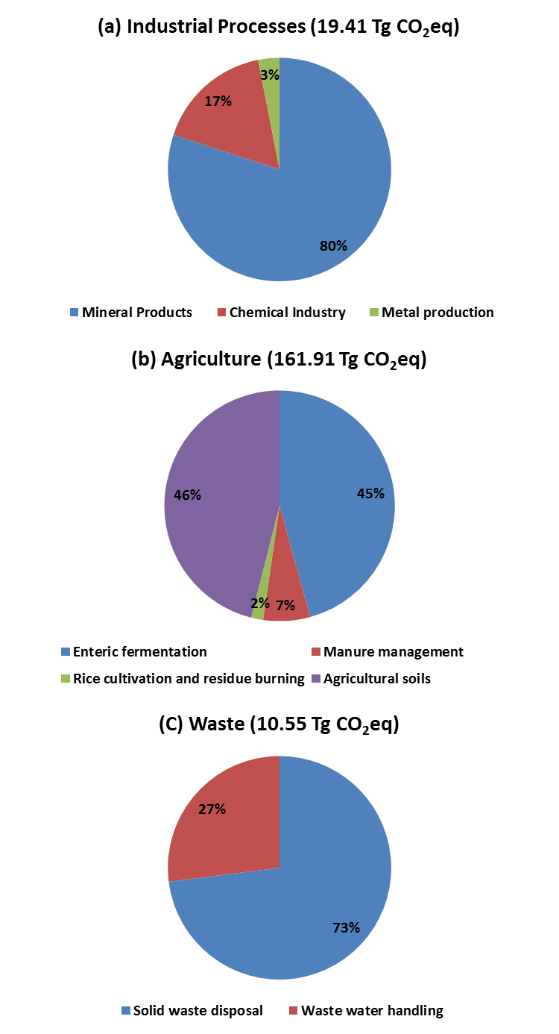
Figure S1: GHG emissions from (a) industrial processes, (b) agriculture, and (c) waste sector

References
HDIP, (2013): Pakistan Energy Yearbook 2012, Hydrocarbon Development Institute of Pakistan, Ministry of Petroleum and Natural Resources, Government of Pakistan, Islamabad.
IPCC, (1997): Revised 1996 IPCC Guidelines for National Greenhouse Gas Inventories [J.T. Houghton, L.G. Meira Filho, B. Lim, K. Treanton, I. Mamaty, Y. Bonduki, D.J. Griggs, and B.A. Callander (eds.)]. Intergovernmental Panel on Climate Change, Meteorological Office, Bracknell, United Kingdom.
MoF, (2011). Annual Report 2010-11 (State of the Economy). Government of Pakistan, Islamabad (Available at: www.sbp.org.pk/reports/annual/).
MoF, (2012a). Annual Report 2011-12 (State of the Economy). Government of Pakistan, Islamabad (Available at: www.sbp.org.pk/reports/annual/).
MoF, (2012b). Pakistan Statistical Year Book 2012, Pakistan Bureau of Statistics, Government of Pakistan, Islamabad (Available at: www.pbs.gov.pk/content/pakistan-statistical-year-book-2012)
MoF, (2013). Annual Report 2012-13 (State of the Economy). Government of Pakistan, Islamabad (Available at: www.sbp.org.pk/reports/annual/).
MoF, (2014). Pakistan Economic Survey (2013-14), Ministry of Finance (MoF), Government of Pakistan, Islamabad (Available at: www.finance.gov.pk/survey_1415.html).
UNFCCC. 2003. Pakistan’s Initial National Communication on Climate Change. United Nations Framework Convention on Climate Change (UNFCCC), Bonn (Available at: unfccc.int/resource/docs/natc/paknc1.pdf).
World Bank, (2012). World Bank National Accounts Data 2012. The World Bank Group, Washington, D.C. (Available at: http://databank.worldbank.org/data/databases.aspx).

