Assessing the macroeconomic impacts of individual behavioral changes on carbon emissions
Leila Niamir ^{a,b,c}, Gregor Kiesewetter ^{b}, Fabian Wagner ^{b}, Wolfgang Schöpp ^{b},
Tatiana Filatova ^{a,d}, Alexey Voinov ^{d}, Hans Bressers ª

ª Department of Governance and Technology for Sustainability, University of Twente
Drienerlolaan 5, 7522 NB Enschede
l.niamir@utwente.nl , t.filatova@utwente.nl , j.t.a.bressers@utwente.nl
^{b} Air Quality and Greenhouse Gases Program, International Institute for Applied Systems Analysis (IIASA)
Schlossplatz 1 A-2361 Laxenburg, Austria
niamir@iiasa.ac.at , kiesewet@iiasa.ac.at , wagnerf@iiasa.ac.at , schoepp@iiasa.ac.at
^{c} Mercator Research Institute on Global Commons and Climate Change (MCC)
EUREF Campus 19, 10829 Berlin, Germany
niamir@mcc-berlin.net
^{d} School of Systems Management and Leadership, Faculty of Engineering and IT, University of Technology Sydney
15 Broadway, Ultimo NSW 2007, Australia
alexey.voinov@uts.edu.au , tatiana.filatova@uts.edu.au

Abstract
In the last decade, instigated by the Paris agreement and United Nations Climate Change Conferences (COP22 and COP23), the efforts to limit temperature increase to 1.5°C above pre-industrial levels are expanding. The required reductions in greenhouse gas emissions imply a massive decarbonization worldwide with much involvement of regions, cities, businesses and individuals in addition to the commitments at the national levels. Improving end-use efficiency is emphasized in previous IPCC reports (IPCC 2014). Serving as the primary ‘agents of change’ in the transformative process towards green economies, households have a key role in global emission reduction. Individual actions, especially when amplified through social dynamics, shape green energy demand and affect investments in new energy technologies that collectively can curb regional and national emissions. However, most energy-economics models – usually based on equilibrium and optimization assumptions – have a very limited representation of household heterogeneity and treat households as purely rational economic actors. This paper illustrates how computational social science models can complement traditional models by addressing this limitation. We demonstrate the usefulness of behaviorally-rich agent-based computational models by simulating various behavioral and climate scenarios for residential electricity demand and compare them with the business as usual (SSP2) scenario. Our results show that residential energy demand is strongly linked to personal and social norms. Empirical evidence from surveys reveals that social norms have an essential role in shaping personal norms. When assessing the cumulative impacts of these behavioural processes, we quantify individual and combined effects of social dynamics and of carbon pricing on individual energy-efficiency and on the aggregated regional energy demand and emissions. The intensity of social interactions and learning plays an equally important role for the uptake of green technologies as economic considerations, and therefore in addition to carbon-price policies (top-down approach), implementing policies on education, social and cultural practices can significantly reduce residential carbon emissions.

Keywords: Behavioral change, Agent-based modeling, Carbon emissions, Macroeconomic impacts, Climate change mitigation, Energy economics, Residential energy

Introduction
The efforts to limit temperature increase to 1.5°C above pre-industrial levels are expanding in line with the ambitions laid down in the UNFCCC process. In order to limit global warming to this critical level, they set an aim to achieve a balance between sources of anthropogenic emission and sinks of greenhouse gases in the second half of this century. Electricity generation from fossil fuels contributes the second largest share (28.4%) of global greenhouse gas emissions. Decarbonization of the economy will require massive worldwide efforts and strong involvement of regions, cities, businesses and individuals in addition to the commitments at the national levels (Grubler et al. 2018). Public climate mitigation efforts should ideally be aligned with private interests to improve the speed and efficiency of this process. Individual actions, especially when amplified through social dynamics, shape green energy demand and affect investments in new energy technologies that collectively can curb regional and national emissions. The importance of social influence, normative feedback and information diffusion on pro-environmental behavior is rooted in different studies (Bass 1980; Festinger 1954; Rogers 1995; Schnelle et al. 1980; Schultz 1998). Individuals are not making decisions in isolation: they are prone to being influenced by peers in their social networks (Abrahamse and Steg 2013; Cialdini 2003; Festinger et al. 1952; Rogers 1975). In fact, individuals conform to social norms to gain social approval or to avoid social sanctions (Cialdini and Goldstein 2004; Keizer et al. 2008; Nolan et al. 2008). Therefore, personal and social norms together may stimulate individual energy-related actions. Serving as primary ‘agents of change’ in the transformative process towards green economies, households play a key role in global emissions reduction. Hence, there is a demand for tools that, next to economic considerations, can assess their cumulative emissions given the diversity of behavior and a variety of psychological and social factors influencing it.
The International Energy Agency (IEA) reported that the global energy-related carbon dioxide emissions stagnated for a third straight year in 2016. This is a result of growing renewable power generation, a switch from coal to natural gas, as well as improvements in energy efficiency and end-user awareness. Subsidies, an emissions trading system, renewable energy standards, and other instruments have been developed to reduce emissions on the supply side of the energy market. Although economic incentives are effective mechanisms to influence energy producers, mechanisms to affect the demand side are less straightforward (Creutzig et al. 2018; Zhang et al. 2017). Given the scale of the impact that households’ choices have on energy consumptions and emissions, it puts them at the epicenter of the international policy and research agenda.
Bin and Dowlatabadi (2005) report that more than 40% of total CO₂ emissions in United States is directly influenced by households’ activities; Baiocchi et al. (2010) show around 52%, or 358 million tones CO₂ emissions come through indirect household consumption in United Kingdom. As households get greater awareness of the value and the need for sustainable energy practices, the public concerns on climate change and energy-related behaviors are slowly growing. Some first rough assessments indicate that behavioral change alone can contribute to 4%-8% (Faber et al. 2012; McKinsey 2009) of overall CO₂ emissions reduction. Gadenne et al. (2011) study the influence of consumers environmental beliefs and attitudes on energy-related behaviors and find that people have been paying more attention to environmental issues nowadays, while many efforts have been made to promote a green consumer lifestyle.
Only limited tools are available to assess their cumulative emissions given the diversity of behavior and a variety of psychological and social factors influencing it beyond pure economic considerations (Niamir et al. 2018a). Many macro models, e.g. general equilibrium models are predominately used to support climate change policy debates, particularly in the economics of climate change mitigation (Babatunde et al. 2017). These models usually assume that economic agents form a representative group(s), have perfect access to information and adapt instantly and rationality to new situations, maximizing their long-run personal advantage. However, in reality people make decisions driven by their diverse preferences, shaped by socio-economic conditions, behavioral biases and social peer influence (Farmer and Foley 2009). Therefore, policymakers require supporting decision tools, that may explore the interplay of economic decision-making and behavioral heterogeneity in households’ energy choices when testing common climate mitigation policies (e.g. carbon pricing) and socio-economic pathways in a world with changing climate (e.g. SSPs).
The aim of this article is to provide such tools through a combination of a new bottom-up simulation method grounded in an empirical survey to extract heuristic rules on energy consumption behavior for individual agents. For this purpose, we use an agent-based model in which the agents – individual households with detailed socio-economic characteristics – are taking decisions about a range of realistic actions related to their household electricity supply while being exposed to economic (e.g. carbon price) as well as psychological and social pressures (e.g. promotion of green electricity).
After introducing the methodology in Section 2, we present in Section 3 results from an analysis of different micro-scenarios of households in a European region (Overijssel, Netherlands) up to the year 2030. We quantify the changes in household electricity demand from conventional and green suppliers when varying psychological as well as economic incentive parameters. While we focus on one region as a proof of concept here, there are several ways to upscale and cover larger areas (Niamir et al. 2018b).

Methodology
The quantitative tools to support energy policy decisions range from assessment of macro-economic and cross-sectoral impacts (Kancs 2001; Siagian et al. 2017), to detailed micro-simulation models for a specific technology (Bhattacharyya 2011; Hunt and Evans 2009). Agent-based modelling (ABM) is a powerful tool for representing the complexities of energy demand, such as social interactions and spatial constraints and processes (Farmer and Foley 2009; Filatova et al. 2013). Unlike other approaches, ABM is not limited to perfectly rational agents or to abstract micro details in aggregate system-level equations. Instead, ABM can represent the behavior of energy consumers – such as individual households – using a range of behavioral theories. In addition, ABM has the ability to examine how interactions of heterogeneous agents at micro-level give rise to the emergence of macro outcomes, including those relevant for climate mitigation such as an adoption of low-carbon behavioral strategies and technologies over space and time (Rai and Henry 2016). The ABM approach simulates complex and nonlinear behavior that is intractable in equilibrium models.
However, this method is actively used in energy applications to study national climate mitigation strategies (Gerst et al. 2013; Gotts and Polhill 2017), energy producer behavior (Aliabadi et al. 2017), renewable energy auctions (Anatolitis and Welisch 2017), consumer adoption of energy-efficient technology (Chappin and Afman 2013; Jackson 2010; Palmer et al. 2015; Rai and Robinson 2015), shifts in consumption patterns (Bravo et al. 2013), changes in energy policy processes (Iychettira et al. 2017), and diffusion of energy-related actions and technology (Ernst and Briegel 2017; Kangur et al. 2017). I many cases ABM still either lacks a theoretical framework (Groeneveld et al. 2017) or relevance to empirical data, especially when studying energy behavior of households (Amouroux et al. 2013).
To assess the impact of individual behavior on carbon emissions, we went beyond classical economic models and the stylized representation of a perfectly informed optimizer. Therefore, we further developed the BENCH agent-based model (Niamir et al. 2018a) by strengthening the alignment of behavioral and economic factors under different climate policy scenarios. We calibrated the BENCH-v.2 model using data on households’ energy-related choices from a survey specially designed for this purpose (section2.3) and administered in a European region of Overijssel, The Netherlands (1383 households). The BENCH-v.2 calculates changes in electricity consumption annually and implied carbon emission -based on the primary source of energy- by simulating individuals’ behaviors (section3).

Overview: individual energy behavior
There is a number of energy-related actions which individuals may pursue to influence their electricity consumption and, consequently, their carbon footprint. We categorize them into three main types of behavioral changes. An individual can make an investment (action A1), either large (such as installing solar panels) or small (such as buying energy-efficient appliances, e.g. A++ washing machine). Alternatively, individuals can save energy by changing their daily routines and habits (action A2) -e.g. by switching off the extra lights and adjusting a thermostat/air conditioner. Finally, households can switch to a supplier that provides green electricity (action A3) (Niamir and Filatova 2017).
A decision is a process through which the selection of one among numerous possible behavior alternatives is performed (Barros 2010; Simon et al. 1997). Individuals are often bounded by their own previous experiences and their cognitive abilities - personal aspect -, the influence of others - social aspect -, and information availability. Empirical studies in psychology and behavioural economics show that individual choices and behaviours often deviate from the assumptions of rationality: there are persistent biases in human decision-making (Frederiks et al. 2015; Kahneman 2003; Niamir and Filatova 2016; Pollitt and Shaorshadze 2013; Stern 2013; Wilson and Dowlatabadi 2007). Driven by the empirical evidence from environmental behavioral studies (Abrahamse and Steg 2011; Bamberg et al. 2007; Bamberg et al. 2015; Mills and Schleich 2012; Onwezen et al. 2013; Steg and Vlek 2009), the BENCH-v.2 model assumes that a decision regarding any of the three actions (A1-A3) is driven by psychological and social factors in addition to the standard economic drivers such as prices relative to incomes (Niamir et al. 2018a). Behavioral factors including personal norms and awareness may either amplify the economic logic behind a decision-making or impede it, serving either as a trigger or a barrier. It is a scientific challenge to combine the behavioral and the economic parts of the decision-making process in a formal model. Here we present the simplest option assigning weights to the behavioral part by calculating households intentions toward a specific energy-related action derived from our household survey dataset.

Survey and empirical data
Our household survey is designed to elicit factors and stages of a decision-making process with respect to the three types of actions that households typically make (A1 investment, A2 conservation and A3 switching). The conceptual framework behind the survey assumes three main steps that lead to one of these actions: knowledge activation, motivation, and consideration (Niamir et al. 2018a). Before considering action, households need to reach a certain level of knowledge and awareness about climate change, energy and the environment. If an individual in a household is aware enough, she might feel guilt. Here personal norms (individual attitudes and beliefs) and subjective norms prevailing in a society add to her motivation. If households get motivated, they feel responsible to do something. Still, none of these factors are enough to provoke an action to change the energy use behavior. A household needs to consider its economic status, its house conditions (e.g. renting of owning), its current habits, and own perception of its ability to perform an action or change behavior. If a household reaches a certain level of intention, it is going to decide or act.
To elicit data on an interplay of behavioral and economic factors, we conducted a survey in a European region (NUTS2 level) in 2016: Overijssel province in The Netherlands (NL21), see Appendix, Figure A2. The data on the behavioral and economic factors affecting household energy choices were collected using an online questionnaire (N= 1383 households in Overijssel) and serve as empirical micro-foundation of agent rules in the BENCH-v.2 model. The variations in socio-demographic and psychological factors among the respondents are further used to initialize a population of heterogeneous agents in the ABM (section2.3). The differentiation per income group also allows to potentially connect with other micro and macro statistical data if needed.

BENCH agent-based model
Compared to its first version (Niamir et al. 2018a), the BENCH ABM has been further developed and modified to investigate the macro impact of cumulative individual behavioral change on carbon emissions. In particular, in this application we extended BENCH by: (a) introducing three representative electricity producers (grey, brown and green); (b) further improving the model engine, which now treats behavioral and economical parts explicitly (section 2.1). In the behavioral part, the psychological and social aspects of a household’s behavior change and decision making are evaluated (section 2.3.1). If there is high intention, household agents proceed with assessing the typical economic utility (section 2.3.2). We combine and harmonize the behavioral and the economic parts of the decision-making process by extending the standard utility function (Eq3, section 2.3.2). Here, an individual may overcome her economic barrier, if the behavioral part outweighs, e.g. the level of knowledge, motivation and intention raise high enough to reconsider the economic tradeoffs. It goes in line with empirical findings revealing that individual willingness to pay for renewable energies, e.g. green electricity, is beyond the economic concept and monetary pay-off (Lee and Heo 2016; Sundt and Rehdanz 2015). In the economic part households’ utilities based on the three actions (A1-A3) are calculated and compared (Figure 1).
Further changes compared to the original BENCH include: (c) improvements in social dynamics and learning algorithms by introducing and simulating two ways of households’ interactions (section 2.3.3); (d) running a carbon price scenario as a top-down strategy to investigate impacts of policies on household behavioral change (section 2.3.4); (e) the results of simulations in terms of CO₂ emissions (tones per capita) to compare between scenarios (section 2.4, 3) to get a better overview on the impacts of individuals’ behavior on carbon emissions over time and space. The role of each action (A1-A3) in these trajectories is also estimated till 2030 (section 3).

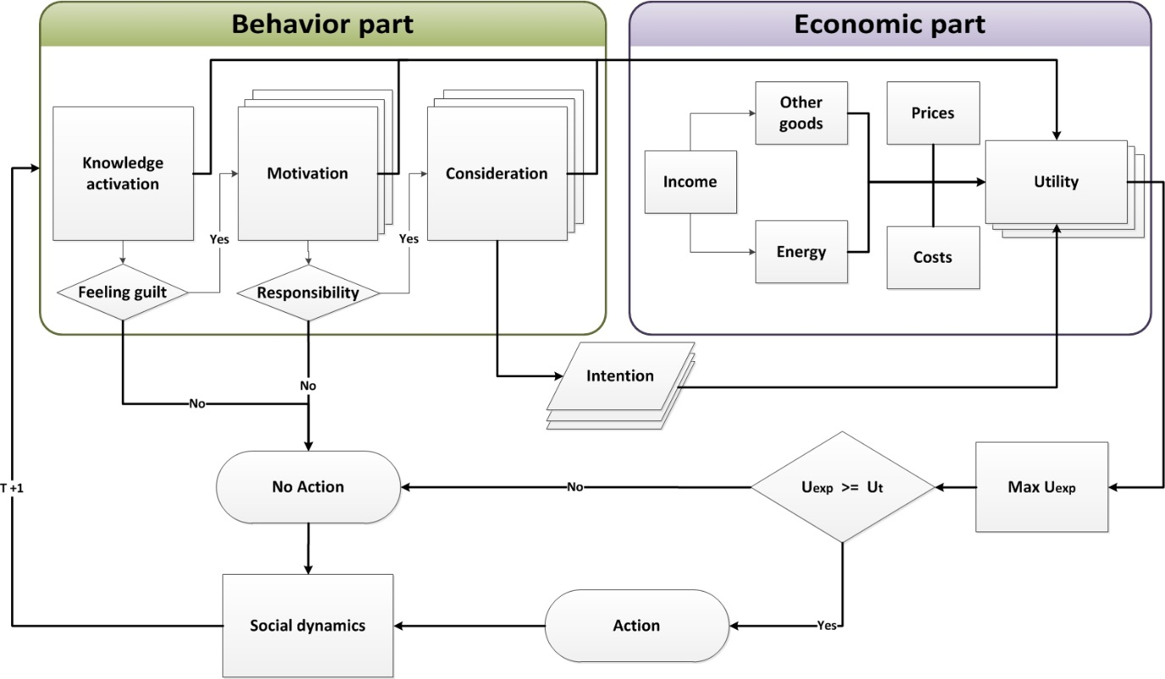
Figure 1: A household’s decision-making algorithm in the BENCH-v.2 agent-based model

Household agents in BENCH-v.2 are heterogeneous in socio-economic characteristics, preferences, and awareness of environment and climate change, so they can pursue various energy-related choices and actions. Namely, they vary in six economic attributes: (1) annual income in euro, (2) annual electricity consumption in kWh, (3) household status in terms of being a grey, brown or green electricity user, (4) dwelling tenure status - owner or renter; (5) energy label of their dwelling varying from A to F; and (6) the household energy use routines and habits measured in the survey in terms of frequency of performing a particular energy-consuming action. Data for all these variables come from the survey. The annual growth value of socio-economic variables representing households’ income, electricity consumption, and consumption of other goods (in 5 quintiles) for the Overijssel province comes from the EXIOMOD computable general equilibrium (CGE) model (Filatova et al. 2014). The behavioral and social aspects impacting households energy decisions also vary among agents and include: (1) personal norms, which are values that people hold (Schwartz 1977), e.g. feeling good when using energy efficient equipment; (2) subjective norms, which are perceived social pressure on whether to engage in a specific behavior motivated by observing energy-related actions of neighbors, family and friends’; and (3) perceived behavioral control (section 2.3.1). These behavioral and social variables are updated over time (annually) through social dynamics and learning procedures (section 2.3.3). Agents’ decision processes closely follow the conceptual framework (Figures 1) behind the household survey and apply to all three types of energy-related behaviors (A1-A3).

Behavior part
Based on different internal and external barriers and drivers, households have different knowledge and awareness levels about the state of the climate and environment, motivation levels to change their energy behavior, and consideration levels when they perform costs and utility assessments. All household attributes are heterogeneous and change over time and space. All the variables in knowledge activation, motivation and consideration are measured in comparable ways using Likert scale, in the range of 1-7 as in the survey. Here 1 stands for the lowest, 7 is the highest level (Niamir et al. 2017).
Niamir et al. (2018a) described how households’ knowledge and awareness (K) and motivation (M_{n}) are measured and calculated at the model initialization stage based on the survey data. In summary, K is based on climate-energy-environment knowledge (CEEK), climate-energy-environment awareness (CEEA), and energy-related decision awareness (EDA) values. If households are aware enough, that is they have a high level of knowledge and awareness above the threshold of 5 out of 7, then they are tagged as “feeling guilt” and proceed to the next step to assess their motivation (M_{n}) for particular actions. Households’ personal norms (PN_{n}) and subjective norms (SN_{n}) are assessed to calculate their motivation (M_{n}). In this paper, motivation may differ for each of the three main actions (n= {1,2,3}). For example, a household may have a high level of motivation for installing solar panels, and is therefore tagged as “responsible” for action1 (investment) and proceeds to the next step (consideration). At the same time, it may not pass the threshold value in motivation for changing energy use habits or switching to another energy supplier, and thus does not go into the consideration step on those two actions. If household agents have a high motivation level and feel responsible, they consider the psychological (e.g. perceived behavior control), structural (housing attributes) and institutional factors (e.g. subsidies) to assess utility and costs of a specific action (section 2.3.2). Then households with high level of consideration are tagged as “high intention”. In the consideration stage, as well as the motivation stage, we differentiate between actions. In investment (A1) for instance, the dwelling ownership status (SF, owner or renter), and perceived behavioral control over the investment (${PBC}_{1}$) are checked and evaluated (δ₁). While the ownership status is not essential in conservation (A2) and switching (A3), δ₂ and δ₃ are calculated just based on perceived behavioral controls (PBC₂ and PBC₃) All this is captured by the following equations:

(1)
$$K=\frac{AVG \left(CEEK, CEEA, EDA\right)}{7} ;$$
$$M_{n}=\frac{AVG ({PN}_{n}, {SN}_{n})}{7} ;$$
$${If (n=1 and SF=1) ( δ}_{1}=\frac{{PBC}_{1}}{7} ) else \left({ δ}_{1}=0\right) ;$$
$${If (n=2 ) ( δ}_{2}=\frac{{PBC}_{2}}{7} ) ; {If (n=3 ) ( δ}_{3}=\frac{{PBC}_{3}}{7} )$$

Economic part
The economic part estimates utility of an individual agent for undertaking any of the three main actions. Energy economics (Bhattacharyya 2011) assumes that households receive utility from consuming energy (E, here green, brown or grey) and a composite good (Z) under budget constraints:
(2)
$$U= Z⋅α+E⋅(1-α)$$
Here α is the share of individual annual income spent on the composite good.
Niamir et al. (2018a) extend this standard utility by including the influence of knowledge and awareness (K) and motivation (M_{n}) and adding actions’ intention ($δ_{n}$) as a weight on the behavioral part:
(3)
$$U=(Z⋅α+E⋅(1-α))⋅\left(1-δ_{n}\right)+\left(K+Mn\right) . δ_{n}$$
This weight is calculated and normalized using the survey data.

Social dynamics and learning
Heterogeneous households engage in interactions and learn from each other. In particular, they can exchange information with neighbors, which may alter own knowledge, awareness, and motivation regarding energy-related behavior. Here we employ a simple opinion dynamics model (Acemoglu and Ozdaglar 2011; Degroot 1974; Hegselmann and Krause 2002; Moussaid et al. 2015) assuming that each agent interacts with a fixed set of nearby neighbors. Agents compare values of their own behavioral factors – knowledge, awareness, and motivation – with those of their eight closest neighbors, and adjust their values for a closer match. In different scenarios (Table 1), we introduce two types of interaction dynamics among households: slow and fast. Following the slow dynamics, households in an active neighborhood interact with maximally two neighbors (households 3 and 4 in Figure 2.a), and a household(s) with lower than average value of the whole neighborhood increases their current value by 5% (Figure 2.a). In the fast dynamics configuration, all households in an active neighborhood exchange of opinions and learn from each other (Figure 2.b, Eq.4). In addition, the related perceived behavior control (${PBC}_{n}$) of a household that already took an action (household 5 in Figure 2) is raised by 5% (Eq.5). Future research may focus on advancing this social dynamics further, by for example differentiating per type of energy-efficiency action (observable or not) or dynamics of diffusion process. Moreover, different channels to establish a social network may be relevant for individual decisions. Understanding how the structure of social networks initiated based on friendship, family and other relationships beyond the spatial distance (Allcott 2011; Jachimowicz et al. 2018) alone is a prominent future research direction, potentially supported by big data form social media. Similarly, future research may focus on assessing the consequences of social network structures – regular, small-world or scale-free networks (Newman, 2003 ; Watts, 2003) – on the aggregated energy and CO₂ emissions dynamics.
1 | 2 | 3
4 | 5 | 6
7 | 8 | 9
1 | 2 | 3
4 | 5 | 6
7 | 8 | 9

(a)
(b)

Figure 2: Social dynamics and learning in an active neighborhood where household “5” undertook an action at time t. (a) Slow dynamics: households 3 and 4 are affected and engage in social learning. (b) Fast dynamics: all households in the neighborhood are affected and engage in social learning

(4)
$$X=\left\{CEEK, CEEA, EDA, {PN}_{n}, {SN}_{n}\right\} , n=\left\{1,…9\right\} ;$$
$$If Max (mean {(X}_{n}^{t}), median {(X}_{n}^{t}))≥ X_{3}^{t} {(X}_{3}^{t+1}= X_{3}^{t}+0.05⋅X_{3}^{t}) ;$$
$$If Max (mean {(X}_{n}^{t}), median {(X}_{n}^{t}))≥ X_{4}^{t} {(X}_{4}^{t+1}= X_{4}^{t}+0.05⋅X_{4}^{t})$$
(5)
$${PBC}_{5}^{t+1}= {PBC}_{5}^{t } +0.05⋅{PBC}_{5}^{t} ;$$

Carbon emissions and pricing
In this research we investigate CO₂ emissions implied by households’ electricity consumption which is supplied from power plants using different kinds of fuels. Carbon dioxide emission factors for electricity have been derived as the ratio of CO₂ emissions from fuel inputs of power plants relative to the electricity delivered. CO₂ emission factors of each fuel type are used as defined in IPCC (2006). Three different kinds of electricity suppliers are considered, between which the households can choose: “grey”, “brown”, and “green”. The assumptions regarding fuel mixes and the resulting net CO₂ emission factors are listed in Appendix, Table A1.
To estimate the impact of climate policies, namely a carbon price, we design and add climate policy scenarios by including carbon price in the utility estimations of households.

End-user scenarios
Traditionally, rational optimization models such as CGE models, have been used to predict household energy consumption under various socio-economic scenarios including Shared Socioeconomic Pathways (SSP). Here the Baseline scenario represents this traditional economic setup where rational and fully-informed households make optimal decisions. Therefore, we use aggregated residential electricity consumption from the EXIMOD model downscaled to the regional level. The Baseline scenario (grey dash-line in Figures 3 and 5) is an output of this CGE model under SSP2 (business as usual).
We use this Baseline scenario as a benchmark to compare the output of our behaviorally rich ABM. Four end-user scenarios in BENCH.v2 are designed to explore the impacts of heterogeneity in household attributes such as income and electricity consumption, social dynamics (bottom-up approach) and carbon price pressure (top-down approach) strategies on the individual and aggregated households behavioral change (Table 1). In all cases, based on the energy behavior change of households, we assess the following macro-metrics at the regional level: the diffusion of each of the three types of behavioral actions (A1-3) among households over time, and the changes in carbon emissions reduction per capita.

Table 1: End-user scenario settings: Climate Policy and Human Behavior scenarios
BENCH.v2 scenarios | Social dynamics | Carbon Price
Scenario SD | Slow dynamics  In an active neighborhood: households interact with maximum two neighbors | -
Scenario FD | Fast dynamics  In an active neighborhood: households interact with all available neighbors | -
Scenario SDC | Slow dynamics  In an active neighborhood: households interact with maximum two neighbors | 25 Euro/ton by 2030
Scenario FDC | Fast dynamics  In an active neighborhood: households interact with all available neighbors | 25 Euro/ton by 2030

Results and discussion
We present the results of the BENCH.v2 simulations by tracking individual and cumulative impacts of behavioral changes on carbon emissions among 1383 individual households in the Overijssel provinces over 14 years (2016-2030). Given the stochastic nature of ABMs, we perform multiple (N=100) repetitive runs of each simulation experiment (Lee et al. 2015).

Behavioral scenarios
In scenario SD the heterogeneous households with various income, electricity consumption, and dwelling conditions go through a cognitive process to decide whether to pursue any behavioral change or not. Figure 3 shows that introducing heterogeneity to the household economic and housing attributes leads to a reduction in carbon emissions resulting from changes in the residential electricity consumption in comparison to the baseline (grey dash-line), CO₂ emissions resulting from residential electricity consumption decrease 5% by 2030 by simply adding heterogeneity in household attributes and preferences. The decrease indicates a difference between a scenario with a representative agent vs the one where we disaggregate a representative consumer assuming a distribution of economic and housing attributes and interactions among households in the neighborhood (Figure 3-black line).
Scenario FD shows what happens if we have more intense social dynamics within a neighborhood – households have more opportunities to interact and learn – therefore the diffusion of information is faster inside society. The blue line in Figure 3 illustrates the impact of fast social dynamics alone, which delivers another 4.3% more reduction in carbon emissions by 2030 compared to scenario SD.
Table 2 shows which actions (A1-A3) contributed the most to the cumulative CO₂ emission savings. Our results indicate that such behavioral changes as investments in solar panels (A1) may deliver between 9%-11%, conserving electricity by using less or changing their daily habits and usage patterns (A2) and switching to brown and green electricity supplier (A3) contribute 26% and 63%-65% in CO₂ reduction correspondingly. Our survey also shows that around 11% of households in Overijssel province already installed solar panels, this indicates households that already made an investment before 2016, are willing to switch to green supplier or save energy through changing their usage pattern. We observe that intensive social learning and diffusion of information (scenario FD) has more impact on A3 and A2.

Table 2: Avoided CO₂ emissions (tons per capita) resulting from households energy-related actions, share of each action is reported in parenthesis; under behavioral scenarios (SD,FD), 2030.
Actions | Scenarios
 | SD | FD
A1: Investment | 0.01 (9.3%) | 0.03 (10.7%)
A2: Conservation | 0.04 (26%) | 0.08 (26.1%)
A3: Switching | 0.10 (64.8%) | 0.20 (63.3%)

Climate scenarios
To assess the impact of climate policies, an introduction of a carbon price in particular, we design the scenario SDC. Here the carbon price is introduced in the year 2017 and increases linearly to 25 euro per ton by 2030 on the grey (primary of coal) and brown (primary of natural gas) assuming 0.0009 ton CO₂ per kWh coal and 0.0003 ton CO₂ per kWh natural gas emission factors. Carbon pricing significantly encourages individual behavioral changes leading to additional 25% of CO₂ reduction in SDC compared to the SD scenario (Figure 3). This indicates that carbon pricing has a significant impact on switching to green suppliers since they are offering electricity at a lower price, and alternatively simply using less electricity to save energy costs. This is confirmed by the detailed breakdown of energy-related actions over time (Table 3).
In the scenario FDC we examine the effects of combining both behavioral heterogeneity, intensive social learning and climate policy on households energy decisions and consequently on their carbon footprint. Figure 3 shows that by combining the carbon price tax (25 Euro per ton) and households behavioral dynamics, we observe a significant reduction in CO₂ emissions of household electricity consumption by 55% in 2030 compared to the baseline.

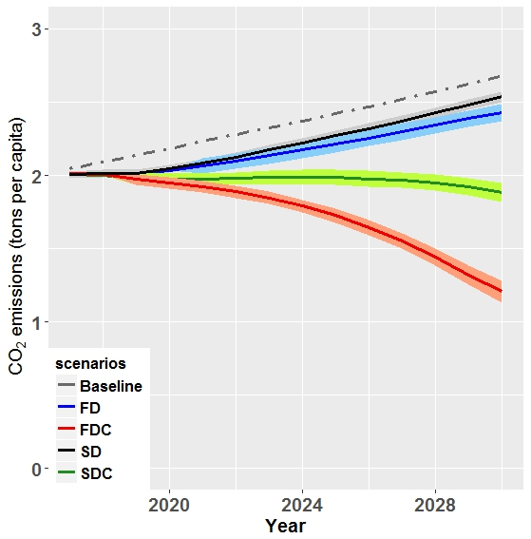
Figure 3: Macro impact of heterogeneous households behavioral change on CO₂ emissions over time. Behavioral scenarios (SD, FD), combining behavioral-climate scenarios: combination of carbon price and slow and fast social dynamics (SDC, FDC), and baseline scenario (2017-2030). The shaded bounds around the curves indicate the uncertainty intervals across 100 runs.

Table 3: Avoided CO₂ emissions (tons per capita) resulting from households energy-related actions, share of each action is reported in parenthesis; under behavioral and climate scenarios (SDC,FDC), 2030.
Actions | Scenarios
 | SDC | FDC
A1: Investment | 0.07 (18.4%) | 0.30 (17.4%)
A2: Conservation | 0.04 (9.6%) | 0.16 (9.0%)
A3: Switching | 0.27 (72%) | 1.27 (73.6%)

As soon as the carbon price is introduced, the number of households’ energy-related actions increases, leading to 1.3-2.1 times more CO₂ emission reduction per capita compared to behavioral scenarios (SD and FD) depending on the slow and fast social dynamics. In a world with slow social dynamics, the carbon price raises the number households choosing to switch from grey/brown electricity to the brown/green one (action A3) significantly to 3.5 times in compared to SD. Yet, as social interactions intensify (FDC), households choose for investments (A1) as the preferred action followed by switching (A3). The number of these two actions raises up to 5.5 and 4.8 times in FDC compared to SD. At the same time, the number of households who are interested in conservation and saving electricity by changing their habits and usage patterns (A2) increases 1.5 times as soon as the carbon price applies; it remains the same under the slow and fast social dynamics (SDC, FDC). Hence, the conservation strategy switches from being the second best strategy in the absence of carbon pricing (26% of the overall CO₂ reduction due to conservation, Table 2) to the third place when market-based mitigation is present (10% of the all CO₂ reduction comes from conservation under carbon pricing, Table 3). This illustrates that the top-down strategy – carbon pricing – activates the monetary part of individuals’ decisions, lead to an increase in investments and switching.

Capturing non-linearities
Figure 4a illustrates that an increase in the intensity of social interactions across all 4 scenarios consistently leads to higher diffusion of actions A1-A3, implying that these behavioral changes deliver more CO₂ savings per capita under fast social learning rather than slow. At the same time, when fast social learning combined with top-down strategies –climate scenario (FDC)– it triggers significant changes in investment and switching, e.g. under FDC scenario investment and switching respectively leading to 4 and 5 times increase in comparison to SDC scenario. It quantitatively confirms that an effectiveness of a market-based climate policy is improved when accompanied by an information provision policy.
The BENCH-v.2 agent-based model gives us this opportunity to simulate complex and nonlinear behavior that is intractable in equilibrium models. In Figure 4b, we reveal that while their combined effect is better than that of social dynamics or carbon price alone, the trend is non-linear. SD and SDC scenarios comparison demonstrates carbon price add more 25% CO₂ emission reduction. Examining SD and FD scenarios shows increasing social interactions alone reduces 4% CO₂ emission. However applying both carbon price and social interactions cuts down CO₂ emissions to 55% (21% more than rational models could estimate).
(a) | 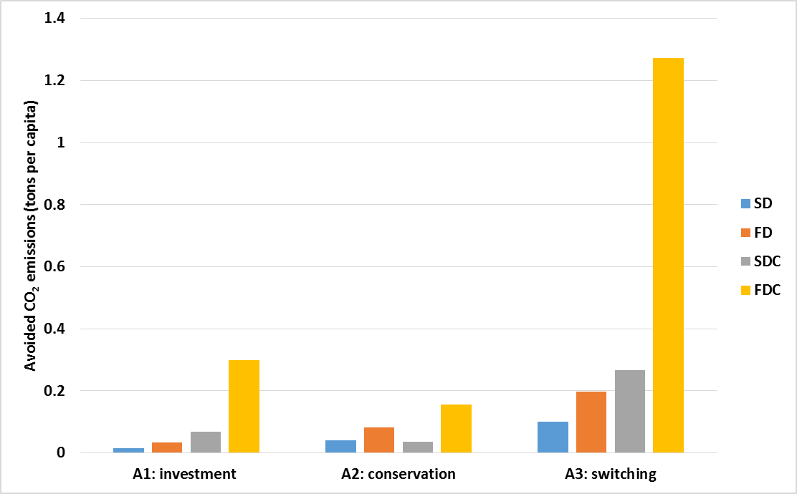
(b) | 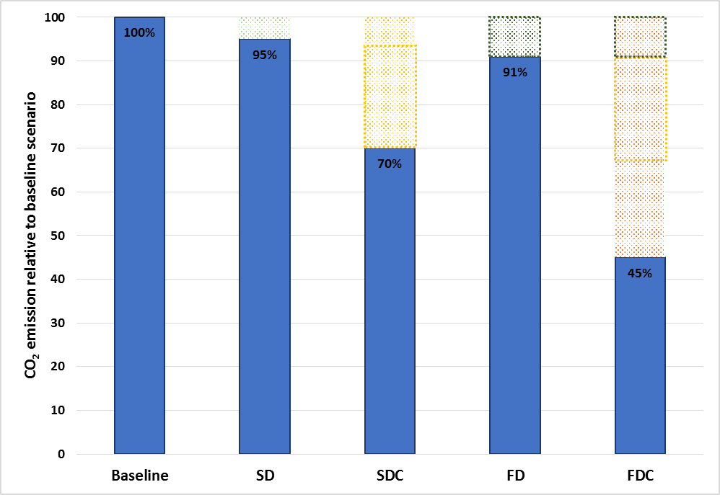
Figure 4: The BENCH-v.2 agent-based model simulated complex and nonlinear behavior that is intractable in equilibrium models. (a) Diffusion of households’ actions under behavioral and climate scenarios. (b) SD and SDC comparison shows carbon price reducing 25% CO₂ emissions (yellow box). FD shows increasing social interactions alone reduces 9% CO2 emissions (green box). However, applying both carbon price and social interactions cuts down CO₂ emissions by 55% (21% more than rational models could estimate).

Sensitivity of emission reduction actions towards carbon price
Acknowledging the debate on the optimal level of a carbon tax, we performed a sensitivity analysis on the carbon price. We ran two additional scenarios – FDC10 and FDC50 – by varying the carbon price from 10 (FDC10) to 50 (FDC50) Euro per ton by 2030. Figure 9 illustrates the CO₂ emissions per capita resulting from individual behavioral changes A1-A3 assuming intensive social interactions under 3 carbon price values: 10 Euro/ton (FDC10), 25 Euro/ton (FDC25) and 50 Euro/ton (FDC50). According to Figure 5, the BENCH-v.2 model is sensitive to the carbon price. As expected, the higher the carbon price the more CO₂ emission reduction is observed.

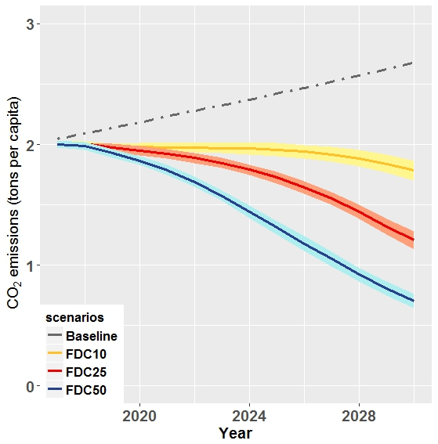
Figure 5: Dynamics of CO₂ emission reduction from individual behavioral changes (A1-A3) under different carbon price scenarios (gradually introduced ‎€10, ‎€25 and ‎€50 per ton). The shaded bounds around the curves indicate the uncertainty intervals across 100 runs.

Conclusions and policy implications
The potential of reducing CO₂ emissions through behavioral change becomes even more important in the light of the Paris agreement. To promote behavioral changes among households, a range of market-based as well as other behavioral nudging policies (e.g. information) could be used. Yet, many models assume that economic agents from a representative group(s), have perfect access to information and adapt instantly and rationally to a new situation. This paper focuses on estimating cumulative impacts of energy-related behavioral changes of individual households on CO₂ emissions by comparing behavioral and climate policy scenarios. In particular, our model integrates both the elements of a rational choice as well as contextual behavioral factors. By accommodating individual preferences, beliefs and social norms, we trace the process of individual decision making from awareness to motivation and to the actual decision making. The computational settings allow us to explicitly model this dynamics and to quantify the aggregated effect of individual behavioral changes in the overall energy transition essential for climate mitigation studies (Creutzig et al. 2016).
Here we apply the BENCH-v.2 ABM to shed light on the effects of individual decisions in the complex climate-energy-economy system and explore the impact of socio-economic heterogeneity, social dynamics, and carbon pricing on their energy-related decisions over time in the Overijssel province of the Netherlands. While this study focuses on a relatively small geographical region, there are no principal barriers to upscale and apply the concept to a larger region, provided that sufficient statistical data are available(Niamir et al. 2018c).
The results indicate that accounting for demand side heterogeneity provides a better insight into possible transitions to a low-carbon economy and climate change mitigation. The model with household heterogeneity represented in socio-demographic, dwelling and behavioral factors, shows rich dynamics and provides more-realistic image of socio-economics by simulating economy through the social interactions of heterogeneous households. We analyzed four end-user scenarios, which vary from the baseline scenario by introducing agent heterogeneity, intensity of social interactions among households (slow or fast) and lack or presence of carbon price (‎€10, €25 or €50 per ton). By comparing the behavioral and climate end-user scenarios, we estimate the relative impact of bottom-up drivers (social dynamics and learning on the diffusion of information) and top-down market policies (carbon price) on carbon emission reduction. The impact of household attributes heterogeneity and social dynamics brings 5%-9% CO₂ emission reduction by 2030. Adding carbon price cuts CO₂ emission down to 55% compared to the baseline scenario, which mimics the traditional economic setup of a rational representative fully-informed household who makes the optimal decision.
It should be noted that in this research we only focus on the demand side of the electricity market and calculated CO₂ emissions caused by residential demand. Future work could focus on integrating this behaviorally rich demand side modeling with dynamics of the electricity production side in the market with detailed modelling of various energy sources.
The results imply that the design of climate mitigation policies aiming at behavioral changes should go beyond making the energy-related alternatives more attractive financially. In a transition to low-carbon economy, individuals become more than just consumers. In order to facilitate this transition, the broader view on social environment, cultural practices, public knowledge, producers technologies and services, and the facilities used by consumers are needed to design implementable and politically feasible policy options (Bressers and Ligteringen 2007). Accordingly, the policy mix should also aim at encouraging and facilitating social interactions between individuals (households) and promoting and diffusing information that they need. Such accompanying information and value based policy instruments have the potential to greatly contribute to the effectiveness of conventional price-based policies. Therefore, the various financial, social and other instruments in the policy mix should be designed as a coherent set to reinforce each other, optimizing the joint effectiveness.

Acknowledgements
This research was developed during the Young Scientists Summer Program (YSSP) 2017 at the International Institute for Applied Systems Analysis (IIASA), Austria. The Netherlands Organisation for Scientific Research (NWO) YSSP grant (No. 0539.600.101) is gratefully acknowledged. This work was also supported by the EU FP7 COMPLEX (Knowledge Based Climate Mitigation Systems for a Low Carbon Economy) project 308601. We are thankful to IIASA library staff for their great support. We would like to thank TNS-NIPO team for their collaboration in running the survey. We also appreciate the participation of survey respondents.

United Nations Climate Change Conferences: COP21-23
The Paris agreement https://unfccc.int/process-and-meetings/the-paris-agreement/the-paris-agreement
U.S. Energy Information Administration (2016). Electricity Explained – Basics https://www.eia.gov/energyexplained/index.php?page=electricity_in_the_united_states
https://www.iea.org/newsroom/news/2017/march/iea-finds-co2-emissions-flat-for-third-straight-year-even-as-global-economy-grew.html
Cities and Climate Change Science Conference, Edmonton-Canada, March 5-7, 2018 https://www.ipcc.ch/meetings/cities/
The Behavioral change in ENergy Consumption of Households (BENCH) agent-based model
Feeling of guilt is one of the components of the Norm Activation Theory. Anticipated pride and guilt cause individuals to behave themselves in a manner that is in line with personal norms (Onwezen, et al., 2013). Guilt is an important pro-social emotion because it results in feeling personal obligations (personal norm) to compensate for the caused damage (Baumeister, 1998, Bamberg et al., 2007)
Within the COMPLEX project funded by the EU FP7 program, the BENCH model was integrated with a CGE EXIOMOD. The EXIOMOD CGE model is developed at TNO in the Netherlands. https://repository.tudelft.nl/view/tno/uuid:3c658012-966f-4e7a-8cfe-d92f258e109b/
Personal norms are attached to the self-concept and experienced as feelings of a moral obligation to perform a certain behavior ((Schwartz 1977))
Subjective norms are determined by the perceived social pressure from others for an individual to behave in a certain manner and their motivation to comply with those people's views ((Ham et al. 2015))
Own perception of her ability to perform an action or change behavior.
An active neighborhood is the one where at least one out of eight neighbors undertakes an energy-related action.
https://tntcat.iiasa.ac.at/SspDb/dsd?Action=htmlpage&page=about

