Supplementary Information for
Acceleration of global N₂O emissions seen from two decades of atmospheric inversion

Supplementary Table 1. Overview of the inversion frameworks. The inversion resolution refers to that of the state vector. The uncertainties are given as the percentage of the prior emission per grid cell (unless otherwise stated). For INV2 spatial correlation was used to define the prior error covariance matrix and the correlation scale lengths over land and sea are given.
Name | ACTM | Method | Res. Horiz. | Vert. Layers | Inversion Res. Spat. | Inversion Res. Temp. | Prior  Uncertainty
INV1 | TOMCAT | 4D-Var | 5.625°×  5.625° | 60 | 5.625°×  5.625° | monthly | 100% prior  no correl.
INV2 | LMDz5 | 4D-Var | 3.75°×  1.875° | 39 | 3.75°×  1.875° | monthly | 100% prior  land: 500 km sea: 1000 km
INV3 | MIROC4-ACTM | Bayesian analytical | 2.813°×  2.813° | 67 | 84 regions | monthly | uniformly by region

Supplementary Table 2. Overview of the prior emission estimates used by each inversion framework.
Name | Anthrop. non-soil | Agricultural soils | Natural soil | Ocean | Biomass burning
INV1 | EDGAR-4.2FT2010 | OCN-1.1 | OCN-1.1 | PlankTOM5 | GFED-4.1s
INV2 | EDGAR-4.3.2 | OCN-1.1 | OCN-1.1 | PlankTOM5 | GFED-4.1s
INV3 | EDGAR-4.2 | EDGAR-4.2 | GEIA | Manizza et al. | none

Supplementary Table 3. Global N₂O budget 1998-2016. The abundances and lifetimes are given as the mean (1998-2016) for the whole atmosphere.
Group | Global  (TgN y⁻¹) | Land  (TgN y⁻¹) | Ocean  (TgN y⁻¹) | Sink  (TgN y⁻¹) | Abundance  (TgN) | Lifetime  (years)
INV1 | 17.4 | 10.2 | 7.2 | 12.9 | 1522 | 118
INV2 | 17.0 | 10.5 | 6.5 | 11.2 | 1452 | 129
INV3 | 16.6 | 13.2 | 3.4 | 12.0 | 1531 | 127

Supplementary Table 4. Regression results and emission factors for N₂O emissions versus N-input to crops and grasslands.
 | Prior |  |  | Posterior
 | EF (%) | R² | p-value | EF (%) | R² | p-value
Global | 0.8 ± 0.3 | 0.31 | 0.025 | 2.3 ± 0.6 | 0.26 | 0.000
USA | 2.1 ± 2.5 | 0.04 | 0.433 | -4.2 ± 3.5 | 0.04 | 0.265
Europe | -1.4 ± 1.4 | 0.06 | 0.381 | -2.4 ± 1.7 | 0.04 | 0.196
China | 1.8 ± 0.2 | 0.82 | 0.000 | 2.1 ± 0.4 | 0.37 | 0.000
Brazil | 0.4 ± 0.2 | 0.21 | 0.071 | 2.6 ± 0.7 | 0.21 | 0.002
S. Asia | 0.3 ± 0.2 | 0.15 | 0.145 | 0.8 ± 0.4 | 0.10 | 0.037

Supplementary Table 5. Regression results for N₂O emissions versus N-surplus to crops.
 | Prior |  | Posterior
 | R² | p-value | R² | p-value
Global | 0.36 | 0.015 | 0.24 | 0.000
USA | 0.08 | 0.275 | 0.01 | 0.574
Europe | 0.004 | 0.826 | 0.02 | 0.404
China | 0.78 | 0.000 | 0.33 | 0.000
Brazil | 0.19 | 0.095 | 0.21 | 0.001
S. Asia | 0.15 | 0.133 | 0.10 | 0.070

Supplementary Figure 1. Map of the N₂O observation sites. INV1 and INV2 used all sites and INV3 used only NOAA sites.

Supplementary Figure 2. Maps of mean 1998-2014 (the overlapping period) prior and posterior N₂O emissions (top and middle rows, respectively) and the posterior-prior differences (bottom row). (Units gN m⁻² y⁻¹).

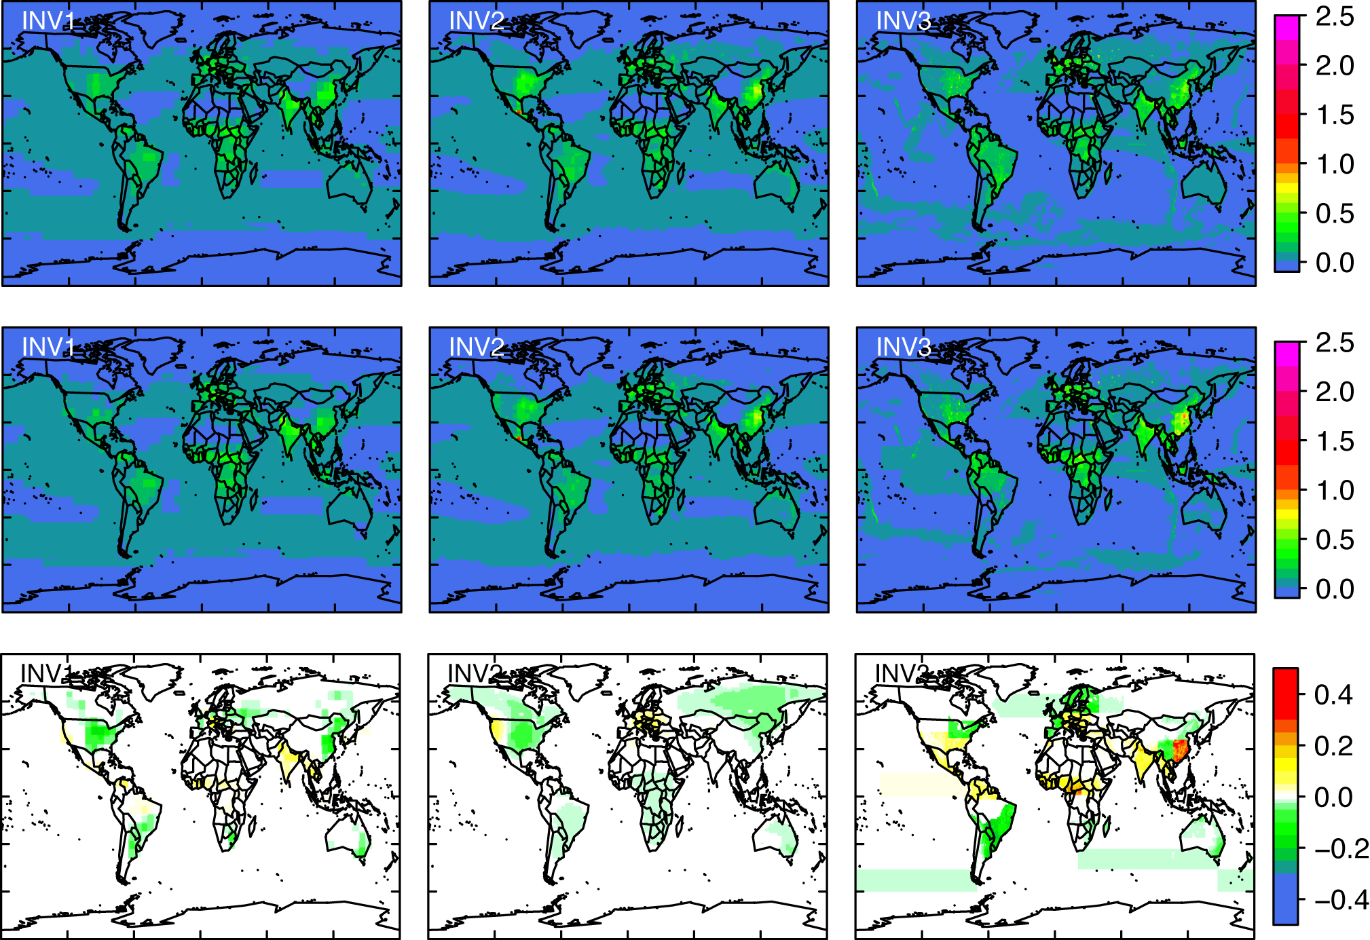

Supplementary Figure 3. Comparison of the modelled mixing ratios with those from CONTRAIL flights from 2005 to 2014. a) Annual mean model-observation differences by latitudinal band for data below 1km. b) Annual mean model-observation differences by altitude (blue = INV1, green = INV2, orange = INV3).

Supplementary Figure 4. Comparison of modelled versus observed annual mean mixing ratios for 2001. Observations from circa monthly NOAA aircraft profiles.

Supplementary Figure 5. Comparison of the prior and posterior annual mean uncertainty (TgN y⁻¹) by region based on INV2.
Supplementary Figure 6. Annual N₂O emissions from the inversions for 1998 to 2016 (units TgN y⁻¹) shown for the remaining regions. Dashed lines show the prior and solid lines the posterior emissions.

Supplementary Figure 7. Annual mean emissions from the non-soil anthropogenic component from EDGAR-v4.32 and GAINS (units TgN y⁻¹).
Supplementary Figure 8. Scatter plots of the N₂O emission anomalies versus N-surplus in the cropping systems (units TgN y⁻¹). The emissions were corrected for the non-soil component and the anomalies were calculated relative to the mean for 1998 to 2013. The symbols are colour-coded by year (circles = INV1, squares = INV2, diamonds = INV3). The solid line shows the regression and the dotted lines the confidence range. In the case that the regression was not significant (p-value > 0.05) a dashed line was used for the regression. (INV1 was excluded for USA for 1998-2005 owing to poor model-observation comparison for this period).

Supplementary Figure 9. NUE (%) for 1995 to 2013 shown for each region in our study.

Supplementary Figure 10. Comparison of N₂O emissions from the inversions (corrected for the non-soil component) with those calculated using the EF approach (units TgN y⁻¹). The inversion results are shown as the mean (black line) and range (grey shading). A scalar value was added to the emissions time series’ so that they matched the inversion mean in the year 2000. The EF results are shown using the IPCC value (blue) and the linear fit from this study (green). Also shown are the results of two non-linear models from literature studies at field scale (purple and cyan), but since these were applied on regional scales with N-input averaged over large areas, the non-linear response may have been dampened. For USA and Europe the regional EFs from this study were not significant so the global EF from this study was used instead. For China, the emissions corrected using GAINS for the non-soil component (instead of EDGAR-v4.32) are also shown (black dotted line).

Supplementary Figure 11. Mean N₂O emission in the USA from the three inversions (black line). Also shown is the area-weighted average precipitation (blue) and PDSI (red) over regions in the USA with non-negligible N₂O emissions. (The grey shading indicates the range over the inversions).

