Supplementary information

Table of Contents
SI-1 Environmental targets from the industry 2
SI-2 Electricity mixes 3
S2.1 Example of calculation 3
S2.2 Electricity mix evolution 4
SI-3 Energy intensity improvements 6
SI-4 Inert anode deployment 7
SI-5 Carbon footprint of different electricity mixes 8
S5.1 Example of calculation of impact of electricity mix 8
S5.1 9
SI-6 Inert anode screening LCA 12
SI-7 Environmental data 13
SI-8 Technological matrix 15
SI-9 Results with 2100 horizon 16
S9.1 CC 16
S9.2 HH 16
S9.3 EQ 17
SI-10 Contribution analysis and geographical developments 18
SI-11 Sensitivity analysis - electricity consumption of inert anode 20
SI-12 Geography 22
SI-13 Sensitivity analysis - Geography distribution 24
SI-14 Total impacts 26
SI-15 Results comparison with LCA 27
References 29

Environmental targets from the industry
Here we quote the climate goals of different aluminium producers obtain from the sustainability report:
- Rio Tinto (2019)
  - “Net zero by 2050 ”
  - ”30% reduction in emissions intensity by 2030”
  - ”15% reduction in absolute emissions by 2030”
  - ”Carbon-neutral growth”
- Alcoa (2019)
  - ”From a 2015 baseline, reduce the intensity of our greenhouse gas footprint (direct and indirect emissions) from our smelting operations by 15 percent by 2025 and 20 percent by 2030”
- RUSAL (2018)
  - ”Reduce direct specific greenhouse gas emissions by 15 % [by 2025] in existing aluminium smelters against the level of 2014. ”
  - ”To reduce direct specific greenhouse gas emissions by 10 % [by 2025] as compared with 2014 by existing alumina production sites. ”
  - ”Reduce the specific electric power consumption by aluminium smelters by 7 % [by 2025] as compared with 2011”

Electricity mixes

Example of calculation
Hypothetical example of a calculation of the electricity mix:
 | Aluminium smelter | SSP
Electricity mix – year 0 | $$z_{coal}^{t=0}=60 \%$$  $$z_{hydro}^{t=0}=40 \%$$  $$z_{solar}^{t=0}=0 \%$$ | $$s_{coal}^{t=0}=75 \%$$  $$s_{hydro}^{t=0}=20 \%$$  $$s_{solar}^{t=0}=5 \%$$
Electricity mix – year 1 | $$s_{coal}^{t=1}=tbd$$  $$s_{hydro}^{t=1}=tbd$$  $$s_{solar}^{t=1}=tbd$$ | $$s_{coal}^{t=1}=50 \%$$  $$s_{hydro}^{t=1}=30 \%$$  $$s_{solar}^{t=1}=20 \%$$

$$d_{i}^{+}= \left\{\begin{matrix} Coal:0\% \\ Hydro:30\%-20\%= 10\% \\ Solar:20\%-5\%=15\% \end{matrix}\right.$$
$$d_{i}^{-}= \left\{\begin{matrix} Coal:75\%-50\%= 25\% \\ Hydro:0\% \\ Solar:0\% \end{matrix}\right.$$

$$∆_{i}^{-}= \left\{\begin{matrix} Coal:25\% / 75\% = 33.3\% \\ Hydro:0\% \\ Solar:0\% \end{matrix}\right.$$
$$∆_{i}^{+}= \left\{\begin{matrix}Coal:0\% \\ Hydro:10\% /(10\%+15\%) = 40\% \\ Solar:15\% /(10\%+15\%) = 60\% \end{matrix}\right.$$

$$x_{i}^{t=1}= \left\{\begin{matrix} Coal:(60\%*33\%)=20\% \\ Hydro:0\% \\ Solar:0\%\end{matrix}\right.$$
$$y_{i}^{t=1}= \left\{\begin{matrix} Coal:0\% \\ Hydro:20\%*40\%=8\% \\ Solar:20\%*60\%=12\%\end{matrix}\right.$$
$$z_{i}^{t=1}= \left\{\begin{matrix} Coal:60\%-20\%=40\% \\ Hydro:40\%+8\%=48\% \\ Solar:0\%+12\%=12\%\end{matrix}\right.$$

Electricity mix evolution

 | SSP2 electricity mix | PRISMAL electricity mix | Legend
Asia | 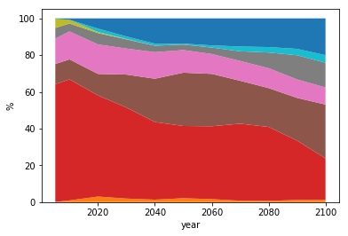 | 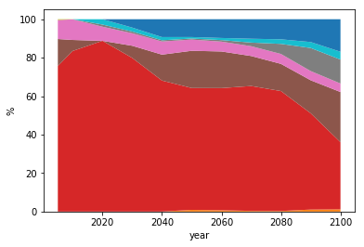 | 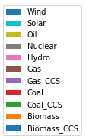
LAM | 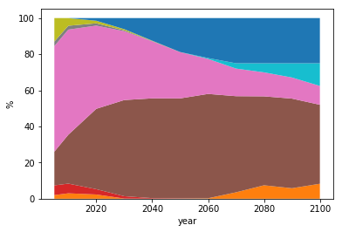
MAF | 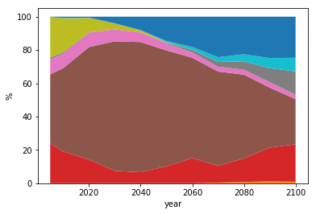 | 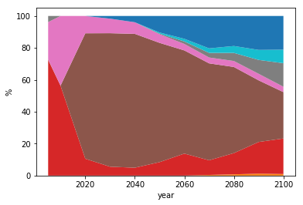
OECD | 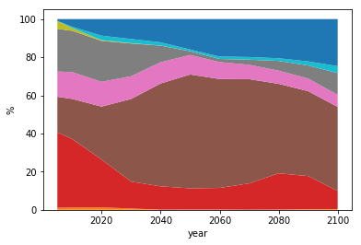 | 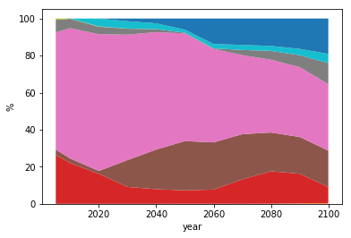
RED | 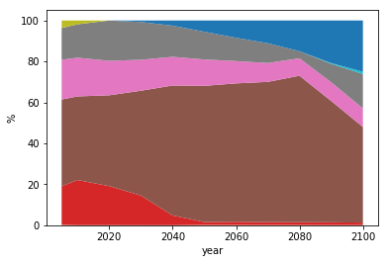 | 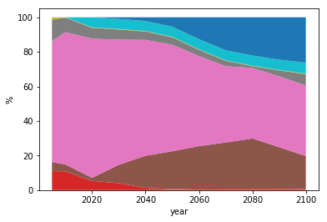 | 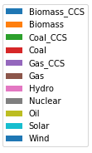
Figure SI-1: Comparison of the evolution of the calculated electricity mixes for PRISMAL scenarios and SSP2 electricity mixes

Energy intensity improvements
The low, high and medium energy intensity evolution is represented in Figure SI-2.

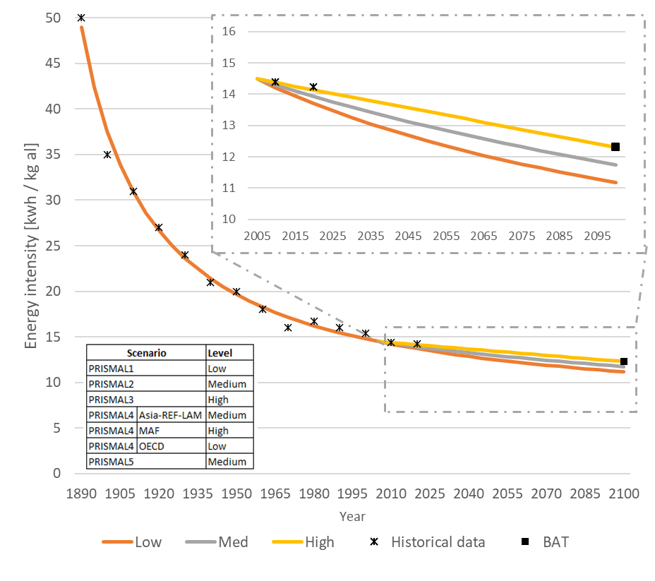
Figure SI-2: Historical and forecasted energy intensity of smelting process projection
Table S1: Energy intensity data used for the smelting process projection
Year | 1890 | 1900 | 1910 | 1920 | 1930 | 1940 | 1950 | 1960 | 1970 | 1980 | 1990 | 2000 | 2010 | 2020
Energy intensity [kWh / kg] | 50.0 | 35.0 | 31.0 | 28.0 | 24.0 | 21.0 | 20.0 | 18.0 | 16.0 | 16.7 | 15.9 | 15.3 | 14.7 | 14.2
Reference | (McGeer, 1986) |  |  |  |  |  |  |  |  | (IAI, 2020)

Inert anode deployment
The inert anode deployment is illustrated on Figure SI-3.
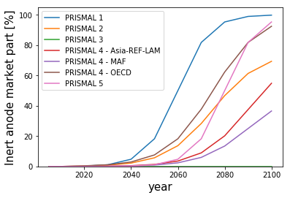
Figure SI-3: Evolution of market share of inert anode smelting technology over time according different scenarios

Table 2: Parameters and numerical values of the evolution of market share of inert anode smelting over time
Scenario |  | Parameters |  |  | Market share
 |  | th | k | A | 2005 | 2010 | 2020 | 2030 | 2040 | 2050 | 2060 | 2070 | 2080 | 2090 | 2100
PRISMAL1 |  | 2060 | 0.15 | 1 | 0% | 0% | 0% | 1% | 5% | 18% | 50% | 82% | 95% | 99% | 100%
PRISMAL2 |  | 2075 | 0.1 | 0.75 | 0% | 0% | 0% | 1% | 2% | 6% | 14% | 28% | 47% | 61% | 69%
PRISMAL3 |  | 2100 | 0 | 0 | 0% | 0% | 0% | 0% | 0% | 0% | 0% | 0% | 0% | 0% | 0%
PRISMAL4 | ASIA-REF-LAM | 2090 | 0.1 | 0.75 | 0% | 0% | 0% | 0% | 1% | 1% | 4% | 9% | 20% | 38% | 55%
PRISMAL4 | MAF | 2090 | 0.1 | 0.5 | 0% | 0% | 0% | 0% | 0% | 1% | 2% | 6% | 13% | 25% | 37%
PRISMAL4 | OECD | 2075 | 0.1 | 1 | 0% | 0% | 0% | 1% | 3% | 8% | 18% | 38% | 62% | 82% | 92%
PRISMAL5 |  | 2080 | 0.15 | 1 | 0% | 0% | 0% | 0% | 0% | 1% | 5% | 18% | 50% | 82% | 95%

Carbon footprint of different electricity mixes

  - Example of calculation of impact of electricity mix

Example of calculation of impact for OECD 2050 baseline:
Table 3: Impact and market share per technology in 2050 for the OECD region
Technology | Impact  [kg CO₂ eq/kWh] | Market share  [%]
Biomass | 1.61E-01 | 0%
Biomass_CSS | -7.76E-01 | 0%
Coal | 1.40E+00 | 7%
Coal_CSS | 3.76E-01 | 0%
Gas | 6.74E-01 | 27%
Gas_CSS | 2.34E-01 | 0%
Hydro | 2.15E-02 | 58%
Nuclear | 1.29E-02 | 0%
Oil | 1.00E+00 | 0%
Solar | 8.73E-02 | 2%
Wind | 1.64E-02 | 6%

Based on the data from Table 3, the calculation of the impact per kWH is the sum of the product for every technology I at a specific time an in a specific region .
$$Impact kWh_{t,r}=\sum_{i}{Impact_{i}*Market share_{i,t,r}}$$

$$Impact kWh_{2050,OECD}=1.4*7\%+0.674*27\%+0.0215*58\%+0.0873*2\%+0.0164*6\%$$

$$Impact kWh_{2050,OECD}=0.295 kg kg CO2 eq / kWh$$

  - Evolution of the impact of the electricity mix

Table 4: Evolution of PRISMAL1 carbon intensity of a kWh of the electricity mix over time according different regions and mitigation scenarios
Climate change [kg CO₂ eq/kWh]
Scenario | Region | 2005 | 2010 | 2020 | 2030 | 2040 | 2050 | 2060 | 2070 | 2080 | 2090 | 2100
PRISMAL1-1.5°C | Asia | 1.16 | 1.21 | 1.25 | 0.72 | 0.06 | 0.04 | 0.05 | 0.05 | 0.04 | 0.02 | -0.01
 | LAM | 0.05 | 0.13 | 0.15 | 0.14 | 0.06 | 0.04 | 0.05 | 0.05 | 0.05 | 0.05 | 0.03
 | MAF | 1.02 | 0.80 | 0.68 | 0.50 | 0.14 | 0.08 | 0.08 | 0.09 | 0.09 | 0.09 | 0.08
 | OECD | 0.41 | 0.34 | 0.26 | 0.10 | 0.04 | 0.03 | 0.02 | 0.01 | 0.01 | -0.01 | -0.01
 | REF | 0.22 | 0.20 | 0.11 | 0.09 | 0.05 | 0.00 | -0.12 | -0.19 | -0.22 | -0.20 | -0.35
PRISMAL1-2.0°C | Asia | 1.16 | 1.21 | 1.25 | 0.99 | 0.62 | 0.32 | 0.13 | 0.09 | 0.07 | 0.07 | 0.08
 | LAM | 0.05 | 0.13 | 0.15 | 0.16 | 0.13 | 0.09 | 0.07 | 0.05 | 0.04 | 0.05 | 0.06
 | MAF | 1.02 | 0.80 | 0.68 | 0.64 | 0.49 | 0.24 | 0.15 | 0.09 | 0.08 | 0.09 | 0.10
 | OECD | 0.41 | 0.34 | 0.26 | 0.20 | 0.13 | 0.07 | 0.03 | 0.02 | 0.02 | 0.01 | 0.03
 | REF | 0.22 | 0.20 | 0.11 | 0.10 | 0.08 | 0.08 | 0.04 | 0.02 | 0.00 | -0.01 | 0.00
PRISMAL1-bl | Asia | 1.16 | 1.21 | 1.25 | 1.19 | 1.19 | 1.08 | 1.03 | 0.98 | 0.83 | 0.75 | 0.76
 | LAM | 0.05 | 0.13 | 0.15 | 0.20 | 0.20 | 0.19 | 0.18 | 0.16 | 0.13 | 0.12 | 0.12
 | MAF | 1.02 | 0.80 | 0.68 | 0.67 | 0.67 | 0.57 | 0.50 | 0.43 | 0.36 | 0.31 | 0.28
 | OECD | 0.41 | 0.34 | 0.26 | 0.23 | 0.23 | 0.21 | 0.21 | 0.20 | 0.19 | 0.17 | 0.15
 | REF | 0.22 | 0.20 | 0.11 | 0.16 | 0.17 | 0.18 | 0.17 | 0.16 | 0.14 | 0.14 | 0.08

Table 5: Evolution of PRISMAL2 carbon intensity of a kWh of the electricity mix over time according different regions and mitigation scenarios
Climate change [kg CO2 eq/kWh]
Scenario | Region | 2005 | 2010 | 2020 | 2030 | 2040 | 2050 | 2060 | 2070 | 2080 | 2090 | 2100
PRISMAL2-1.5°C | Asia | 1.16 | 1.21 | 1.25 | 0.22 | 0.06 | 0.04 | 0.03 | 0.03 | 0.03 | 0.03 | 0.04
 | LAM | 0.05 | 0.13 | 0.15 | 0.10 | 0.03 | 0.00 | 0.01 | 0.02 | -0.01 | 0.03 | 0.04
 | MAF | 1.02 | 0.80 | 0.68 | 0.43 | 0.24 | 0.09 | 0.06 | 0.05 | 0.03 | 0.03 | 0.04
 | OECD | 0.41 | 0.34 | 0.26 | 0.07 | 0.05 | 0.04 | 0.03 | 0.02 | 0.02 | 0.02 | 0.02
 | REF | 0.22 | 0.20 | 0.11 | 0.05 | 0.03 | 0.02 | 0.02 | 0.02 | 0.02 | 0.03 | 0.03
PRISMAL2-2.0°C | Asia | 1.16 | 1.21 | 1.25 | 0.62 | 0.24 | 0.09 | 0.07 | 0.04 | 0.03 | 0.03 | 0.04
 | LAM | 0.05 | 0.13 | 0.15 | 0.17 | 0.15 | 0.07 | 0.06 | 0.01 | -0.01 | 0.00 | 0.03
 | MAF | 1.02 | 0.80 | 0.68 | 0.55 | 0.40 | 0.18 | 0.14 | 0.10 | 0.06 | 0.05 | 0.04
 | OECD | 0.41 | 0.34 | 0.26 | 0.19 | 0.12 | 0.09 | 0.06 | 0.05 | 0.04 | 0.03 | 0.03
 | REF | 0.22 | 0.20 | 0.11 | 0.07 | 0.06 | 0.04 | 0.03 | 0.03 | 0.03 | 0.03 | 0.03
PRISMAL2-bl | Asia | 1.16 | 1.21 | 1.25 | 1.17 | 1.05 | 1.02 | 1.02 | 1.02 | 0.98 | 0.83 | 0.68
 | LAM | 0.05 | 0.13 | 0.15 | 0.21 | 0.23 | 0.23 | 0.26 | 0.24 | 0.23 | 0.24 | 0.22
 | MAF | 1.02 | 0.80 | 0.68 | 0.64 | 0.64 | 0.63 | 0.63 | 0.55 | 0.56 | 0.55 | 0.52
 | OECD | 0.41 | 0.34 | 0.26 | 0.25 | 0.27 | 0.30 | 0.29 | 0.36 | 0.40 | 0.37 | 0.27
 | REF | 0.22 | 0.20 | 0.11 | 0.15 | 0.17 | 0.18 | 0.20 | 0.21 | 0.23 | 0.19 | 0.16

Table 6: Evolution of PRISMAL3 carbon intensity of a kWh of the electricity mix over time according different regions
Climate change [kg CO2 eq/kWh]
Scenario | Region | 2005 | 2010 | 2020 | 2030 | 2040 | 2050 | 2060 | 2070 | 2080 | 2090 | 2100
PRISMAL3-bl | Asia | 1.16 | 1.21 | 1.25 | 1.26 | 1.27 | 1.27 | 1.27 | 1.28 | 1.28 | 1.28 | 1.28
 | LAM | 0.05 | 0.13 | 0.15 | 0.21 | 0.23 | 0.22 | 0.23 | 0.27 | 0.32 | 0.36 | 0.40
 | MAF | 1.02 | 0.80 | 0.68 | 0.68 | 0.70 | 0.72 | 0.75 | 0.82 | 0.91 | 0.98 | 1.05
 | OECD | 0.41 | 0.34 | 0.26 | 0.31 | 0.32 | 0.33 | 0.34 | 0.39 | 0.43 | 0.45 | 0.48
 | REF | 0.22 | 0.20 | 0.11 | 0.11 | 0.13 | 0.16 | 0.17 | 0.19 | 0.20 | 0.21 | 0.22

Table 7: Evolution of PRISMAL4 carbon intensity of a kWh of the electricity mix over time according different regions and mitigation scenarios
Climate change [kg CO₂ eq/kWh]
Scenario | Region | 2005 | 2010 | 2020 | 2030 | 2040 | 2050 | 2060 | 2070 | 2080 | 2090 | 2100
PRISMAL5-2.0°C | Asia | 1.16 | 1.21 | 1.25 | 0.79 | 0.37 | 0.14 | 0.06 | 0.03 | 0.02 | 0.02 | 0.02
 | LAM | 0.05 | 0.13 | 0.15 | 0.18 | 0.11 | 0.04 | 0.03 | 0.03 | 0.03 | 0.02 | 0.01
 | MAF | 1.02 | 0.80 | 0.68 | 0.62 | 0.37 | 0.14 | 0.06 | 0.05 | 0.04 | 0.03 | 0.03
 | OECD | 0.41 | 0.34 | 0.26 | 0.19 | 0.11 | 0.07 | 0.04 | 0.03 | 0.03 | 0.03 | 0.04
 | REF | 0.22 | 0.20 | 0.11 | 0.07 | 0.06 | 0.05 | 0.04 | 0.02 | 0.01 | 0.00 | 0.00
PRISMAL4-bl | Asia | 1.16 | 1.21 | 1.25 | 1.16 | 1.05 | 0.95 | 0.91 | 0.87 | 0.71 | 0.58 | 0.48
 | LAM | 0.05 | 0.13 | 0.15 | 0.20 | 0.20 | 0.19 | 0.17 | 0.15 | 0.13 | 0.12 | 0.11
 | MAF | 1.02 | 0.80 | 0.68 | 0.63 | 0.57 | 0.51 | 0.44 | 0.38 | 0.33 | 0.30 | 0.29
 | OECD | 0.41 | 0.34 | 0.26 | 0.24 | 0.22 | 0.21 | 0.20 | 0.20 | 0.17 | 0.16 | 0.15
 | REF | 0.22 | 0.20 | 0.11 | 0.10 | 0.09 | 0.08 | 0.07 | 0.06 | 0.05 | 0.05 | 0.04

Table 8: Evolution of PRISMAL2 carbon intensity of a kWh of the electricity mix over time according different regions and mitigation scenarios
Climate change [kg CO₂ eq/kWh]
Scenario | Region | 2005 | 2010 | 2020 | 2030 | 2040 | 2050 | 2060 | 2070 | 2080 | 2090 | 2100
PRISMAL5-1.5°C | Asia | 1.16 | 1.21 | 1.25 | 0.68 | 0.15 | 0.01 | 0.01 | 0.02 | 0.02 | 0.03 | 0.03
 | LAM | 0.05 | 0.13 | 0.15 | 0.12 | 0.01 | -0.02 | 0.00 | 0.01 | 0.01 | 0.02 | 0.02
 | MAF | 1.02 | 0.80 | 0.68 | 0.53 | 0.13 | 0.00 | 0.00 | 0.01 | 0.01 | 0.01 | 0.02
 | OECD | 0.41 | 0.34 | 0.26 | 0.10 | 0.02 | 0.01 | 0.02 | 0.03 | 0.04 | 0.04 | 0.05
 | REF | 0.22 | 0.20 | 0.11 | 0.05 | 0.02 | 0.01 | 0.01 | 0.01 | 0.01 | 0.01 | 0.01
PRISMAL5-2.0°C | Asia | 1.16 | 1.21 | 1.25 | 0.79 | 0.37 | 0.14 | 0.06 | 0.03 | 0.02 | 0.02 | 0.02
 | LAM | 0.05 | 0.13 | 0.15 | 0.18 | 0.11 | 0.04 | 0.03 | 0.03 | 0.03 | 0.02 | 0.01
 | MAF | 1.02 | 0.80 | 0.68 | 0.62 | 0.37 | 0.14 | 0.06 | 0.05 | 0.04 | 0.03 | 0.03
 | OECD | 0.41 | 0.34 | 0.26 | 0.19 | 0.11 | 0.07 | 0.04 | 0.03 | 0.03 | 0.03 | 0.04
 | REF | 0.22 | 0.20 | 0.11 | 0.07 | 0.06 | 0.05 | 0.04 | 0.02 | 0.01 | 0.00 | 0.00
PRISMAL5-bl | Asia | 1.16 | 1.21 | 1.25 | 1.25 | 1.27 | 1.28 | 1.28 | 1.24 | 1.11 | 0.91 | 0.68
 | LAM | 0.05 | 0.13 | 0.15 | 0.44 | 0.60 | 0.64 | 0.63 | 0.60 | 0.53 | 0.45 | 0.36
 | MAF | 1.02 | 0.80 | 0.68 | 0.70 | 0.73 | 0.77 | 0.81 | 0.81 | 0.75 | 0.64 | 0.52
 | OECD | 0.41 | 0.34 | 0.26 | 0.39 | 0.54 | 0.62 | 0.63 | 0.63 | 0.61 | 0.56 | 0.50
 | REF | 0.22 | 0.20 | 0.11 | 0.24 | 0.34 | 0.39 | 0.44 | 0.44 | 0.41 | 0.31 | 0.18

Inert anode screening LCA
The process and quantity used to model the inert anode are presented in Table SI-9
Table SI-9: Ecoinvent process used to model inert anode fabrication process
Process | Amount [kg]
Copper {GLO}| market for | Cut-off, U | 0.55
Nickel, 99.5% {GLO}| market for | Cut-off, U | 0.2
Iron pellet {GLO}| market for | Cut-off, U | 0.25
Metal working, average for copper product manufacturing {RoW}| processing | Cut-off, U | 1

A comparison between inert anode and prebaked anode smelting is presented in Figure SI-4. The electricity and alumina consumption have been removed from the comparison. Inert anode has a lower impact in every impact category studied. Numerical values are presented in Table SI-10: Environmental impacts of inert anode production and smelting used by PRISMAL modelTable SI-10.

Figure SI-4: Environmental comparison of inert anode smelting (IN) and prebaked anode smelting (PB) The electricity and the alumina consumed by the process are excluded in the comparison.
Table SI-10: Environmental impacts of inert anode production and smelting used by PRISMAL model
 |  | Anode | Smelting | Total
CC [kg CO₂ eq/kg al] | IN | 1.09E-01 | 7.34E-01 | 8.43E-01
 | PB | 2.32E-01 | 2.21E+00 | 2.44E+00
HH [DALY/kg al] | IN | 2.02E-01 | 2.86E-02 | 2.31E-01
 | PB | 7.25E-02 | 3.13E-01 | 3.85E-01
EQ [pdf*m²*yr/kg al] | IN | 1.29E-06 | 1.11E-06 | 2.40E-06
 | PB | 4.65E-07 | 2.14E-06 | 2.61E-06

Environmental data
Environmental impacts of different life cycle stages used by PRISMAL framework and their associated ecoinvent process are grouped in Table SI-11.
Table SI-11: Ecoinvent processes and environmental data used by PRISMAL model
Life cycle stage | EcoInvent process | Impacts
Aluminium life cyclace stage [ /kg] |  | CC [kg CO₂ eq] | EQ [pdf*m^2*yr] | HH [DALY ]
Bauxite | Bauxite, without water | bauxite mine operation | 6.31E-03 | -2.01E-03 | 7.31E-08
Alumina | Aluminium oxide | production | 1.23E+00 | 1.72E-01 | 7.44E-06
Anode_in | * See Section: S6 Inert anode screening LCA | 7.44E+00 | 1.38E+01 | 8.84E-05
Anode_pb | Anode, prebake, for aluminium electrolysis {RoW}| production | 5.28E-01 | 1.65E-01 | 1.06E-06
Smelting_in | * See Section: S6 Inert anode screening LCA | 7.20E-01 | 2.80E-02 | 1.09E-06
Smelting_pb | Aluminium, primary, liquid| aluminium production, primary, liquid, prebake | | 2.16E+00 | 3.07E-01 | 2.10E-06
Casting | Aluminium, primary, ingot | production | 1.95E-01 | 4.42E-02 | 2.52E-07
Electricity [ /kWh] |  | CC [kg CO₂ eq] | EQ [pdf*m^2*yr] | HH [DALY ]
Biomass | Electricity, high voltage | ethanol production from wood | 1.61E-01 | 2.54E-01 | 6.71E-07
Biomass_CSS | - | -7.76E-01 | 2.54E-01 | 6.71E-07
Coal | Electricity, high voltage | electricity production, hard coal | 1.40E+00 | 1.47E-01 | 1.17E-06
Coal_CSS | - | 3.76E-01 | 1.47E-01 | 1.17E-06
Gas | Electricity, high voltage | electricity production, natural gas, conventional power plant | Cut-off, U | 6.74E-01 | 4.66E-02 | 2.57E-07
Gas_CSS | - | 2.34E-01 | 4.66E-02 | 2.57E-07
Hydro | Electricity, high voltage| electricity production, hydro, reservoir, non-alpine region  Electricity, high voltage| electricity production, hydro, reservoir, alpine region  Electricity, high voltage| electricity production, hydro, reservoir, run-of-river | 2.15E-02 | 3.44E-02 | 1.26E-06
Nuclear | Electricity, high voltage| electricity production, nuclear, boiling water reactor  Electricity, high voltage| electricity production, nuclear, pressure water reactor, heavy water moderated | 1.29E-02 | 2.12E-03 | 4.59E-07
Oil | Electricity, high voltage | electricity production, oil | 1.00E+00 | 1.92E-01 | 9.80E-07
Solar | Electricity, low voltage | electricity production, photovoltaic, 570kWp open ground installation, multi-Si | 8.73E-02 | 1.86E-01 | 2.93E-07
Wind | Electricity, high voltage | electricity production, wind, <1MW turbine, onshore  Electricity, high voltage | electricity production, wind, <1MW turbine, onshore  Electricity, high voltage | electricity production, wind, >3MW turbine, onshore  Electricity, high voltage | electricity production, wind, 1-3MW turbine, onshore | 1.64E-02 | 3.76E-03 | 5.48E-08

Like explain in the article, we calculated the weighted average of different countries and technologies using the regional production volumes provided in ecoinvent to obtain a single impact score. Here is an example of calculation of the impact of casting primary aluminium:
Process: 1 kg Aluminium, primary, ingot | production | Cut-off
Geography | Production volume from ecoinvent [kg] | Market share of production volume | CC  [kg CO2 eq]
UN-OCEANIA | 2.15E+09 | 2.15E+09/4.7E+10 = 5% | 0.1904
IAI Area, South America | 2.02E+09 | 4% | 0.1904
IAI Area, Russia & RER w/o EU27 & EFTA | 4.12E+09 | 9% | 0.1917
IAI Area, North America, without Quebec | 2.22E+09 | 5% | 0.1904
IAI Area, Gulf Cooperation Council | 3.60E+09 | 8% | 0.1904
IAI Area, EU27 & EFTA | 3.93E+09 | 8% | 0.2350
IAI Area, Asia, without China and GCC | 2.99E+09 | 6% | 0.1904
IAI Area, Africa | 1.61E+09 | 3% | 0.1904
CN | 2.18E+10 | 46% | 0.1904
CA-QC | 2.56E+09 | 5% | 0.1976
Total | 4.70E+10 | 100% | -
Single score impact = $\sum_{region}{Market share_{region}*Impact_{region}=0.195}$

Technological matrix
Technological matrix for producing 1 kg of primary aluminium ingot is presented in Table SI-12. The technological matrix shows the recipe to produce different products. For example, to produce 1 kg of alumina you need to consume (negative sign) 2.876 of bauxite. Other example, to produce 1 kg of aluminium ingot, you need to consume 1.02 kg of liquid aluminium and 0.672 kWh of electricity.

Table SI-12: Technological matrix of aluminium ingot production
 | Bauxite [kg] | Alumina [kg] | Anode prebaked [kg] | Anode inert [kg] | Smelting liquid aluminium [kg] | Electricity for casting [kWh] | Casting [kg]
Bauxite [kg] | 1 | -2.876 | 0 | 0 | 0 | 0 | 0
Alumina [kg] | 0 | 1 | 0 | 0 | -1.934 | 0 | 0
Anode prebaked [kg] | 0 | 0 | 1 | 0 | -0.431 | 0 | 0
Anode inert [kg] | 0 | 0 | 0 | 1 | -0.033 | 0 | 0
Smelting liquid aluminium [kg] | 0 | 0 | 0 | 0 | 1 | 0 | -1.02
Electricity for casting [kWh] | 0 | 0 | 0 | 0 | 0 | 1 | -0.0672
Casting [kg] | 0 | 0 | 0 | 0 | 0 | 0 | 1

The inverse of the technological matrix, presented in Table SI-13, shows the full recipe. For example, the last column shows all the input needed to produce 1 kg of casted aluminium.
Table SI-13: Reverse of the technological matrix of aluminium ingot production
 | Bauxite [kg] | Alumina [kg] | Anode prebaked [kg] | Anode inert [kg] | Smelting liquid aluminium [kg] | Electricity for casting [kWh] | Casting [kg]
Bauxite [kg] | 1 | 2.876 | 0 | 0 | 5.563 | 0 | 5.674
Alumina [kg] | 0 | 1 | 0 | 0 | 1.934 | 0 | 1.973
Anode prebaked [kg] | 0 | 0 | 1 | 0 | 0.431 | 0 | 0.439
Anode inert [kg] | 0 | 0 | 0 | 1 | 0.014 | 0 | 0.015
Smelting liquid aluminium [kg] | 0 | 0 | 0 | 0 | 1 | 0 | 1.020
Electricity for casting [kWh] | 0 | 0 | 0 | 0 | 0 | 1 | 0.067
Casting [kg] | 0 | 0 | 0 | 0 | 0 | 0 | 1

Results with 2100 horizon
  - Climate change

Table SI-14: Average global impact values by kilogram of primary aluminum production of climate change (CC) indicator for every PRISMAL scenario with their baseline mitigation scenario.
Impact |  | Climate change [kg CO₂ eq / kg aluminum]
Year |  | 2005 | 2010 | 2020 | 2030 | 2040 | 2050 | 2060 | 2070 | 2080 | 2090 | 2100
Scenario | PRISMAL1-1.5°C | 14.64 | 16.23 | 18.04 | 12.36 | 5.85 | 5.34 | 4.75 | 4.22 | 3.84 | 3.61 | 3.24
 | PRISMAL1-2.0°C | 14.64 | 16.23 | 18.04 | 15.15 | 11.35 | 8.03 | 5.65 | 4.71 | 4.28 | 4.20 | 4.28
 | PRISMAL1-bl | 14.64 | 16.23 | 18.04 | 17.06 | 16.62 | 15.06 | 13.80 | 12.54 | 10.83 | 9.99 | 9.80
 | PRISMAL2-1.5°C | 14.64 | 16.29 | 18.25 | 7.98 | 6.07 | 5.57 | 5.31 | 5.02 | 4.69 | 4.47 | 4.39
 | PRISMAL2-2.0°C | 14.64 | 16.29 | 18.25 | 11.94 | 8.09 | 6.31 | 5.84 | 5.29 | 4.81 | 4.53 | 4.41
 | PRISMAL2-bl | 14.64 | 16.29 | 18.25 | 17.16 | 15.91 | 15.43 | 15.12 | 14.66 | 13.91 | 12.24 | 10.56
 | PRISMAL3-bl | 14.64 | 16.36 | 18.46 | 18.49 | 18.39 | 18.24 | 18.11 | 18.16 | 18.17 | 18.12 | 18.03
 | PRISMAL4-2.0°C | 14.64 | 16.29 | 18.25 | 9.81 | 6.67 | 5.90 | 5.49 | 5.04 | 4.51 | 4.05 | 3.21
 | PRISMAL4-bl | 14.64 | 16.29 | 18.25 | 16.99 | 15.59 | 14.44 | 13.66 | 13.00 | 11.23 | 9.74 | 8.58
 | PRISMAL5-1.5°C | 14.64 | 16.29 | 18.25 | 12.27 | 6.68 | 5.19 | 5.16 | 5.03 | 4.57 | 4.10 | 3.91
 | PRISMAL5-2.0°C | 14.64 | 16.29 | 18.25 | 13.61 | 9.22 | 6.67 | 5.72 | 5.25 | 4.60 | 4.06 | 3.84
 | PRISMAL5-bl | 14.64 | 16.29 | 18.25 | 18.39 | 18.76 | 18.83 | 18.58 | 17.72 | 15.80 | 13.19 | 10.60

  - Human health
Table SI-15: Average global impact values by kilogram of primary aluminum production of human health (HH) indicators for every PRISMAL scenario with their baseline mitigation scenario.
Impact |  | Human Health [10⁻⁵ DALY / kg aluminum]
Year |  | 2005 | 2010 | 2020 | 2030 | 2040 | 2050 | 2060 | 2070 | 2080 | 2090 | 2100
Scenario | PRISMAL1-1.5°C | 3.42 | 3.44 | 3.26 | 2.89 | 2.54 | 2.41 | 2.37 | 2.37 | 2.35 | 2.33 | 2.31
 | PRISMAL1-2.0°C | 3.42 | 3.44 | 3.26 | 3.01 | 2.79 | 2.60 | 2.50 | 2.45 | 2.43 | 2.44 | 2.38
 | PRISMAL1-bl | 3.42 | 3.44 | 3.26 | 3.12 | 3.06 | 2.94 | 2.86 | 2.80 | 2.69 | 2.63 | 2.60
 | PRISMAL2-1.5°C | 3.42 | 3.45 | 3.28 | 2.61 | 2.47 | 2.40 | 2.37 | 2.33 | 2.30 | 2.26 | 2.22
 | PRISMAL2-2.0°C | 3.42 | 3.45 | 3.28 | 2.83 | 2.56 | 2.47 | 2.43 | 2.39 | 2.34 | 2.30 | 2.24
 | PRISMAL2-bl | 3.42 | 3.45 | 3.28 | 3.11 | 2.95 | 2.86 | 2.81 | 2.77 | 2.74 | 2.65 | 2.50
 | PRISMAL3-bl | 3.42 | 3.45 | 3.31 | 3.28 | 3.26 | 3.24 | 3.22 | 3.21 | 3.20 | 3.19 | 3.17
 | PRISMAL4-2.0°C | 3.42 | 3.45 | 3.28 | 2.87 | 2.69 | 2.61 | 2.55 | 2.49 | 2.44 | 2.40 | 2.40
 | PRISMAL4-bl | 3.42 | 3.45 | 3.28 | 3.15 | 3.04 | 2.96 | 2.91 | 2.88 | 2.78 | 2.69 | 2.62
 | PRISMAL5-1.5°C | 3.42 | 3.45 | 3.28 | 2.84 | 2.66 | 2.56 | 2.47 | 2.41 | 2.36 | 2.32 | 2.30
 | PRISMAL5-2.0°C | 3.42 | 3.45 | 3.28 | 2.76 | 2.56 | 2.53 | 2.51 | 2.45 | 2.39 | 2.34 | 2.32
 | PRISMAL5-bl | 3.42 | 3.45 | 3.28 | 3.11 | 3.04 | 3.01 | 3.00 | 2.98 | 2.90 | 2.79 | 2.66

  - Ecosystem quality
Table SI-16: Average global impact values by kilogram of primary aluminum production of ecosystem quality (EQ) indicator for every PRISMAL scenario with their baseline mitigation scenario.
Impact |  | Ecosystem quality [pdf*m²*yr / kg al]
Year |  | 2005 | 2010 | 2020 | 2030 | 2040 | 2050 | 2060 | 2070 | 2080 | 2090 | 2100
Scenario | PRISMAL1-1.5°C | 1.95 | 2.09 | 2.25 | 1.94 | 2.10 | 2.17 | 2.19 | 2.14 | 2.13 | 2.12 | 2.17
 | PRISMAL1-2.0°C | 1.95 | 2.09 | 2.25 | 2.07 | 2.10 | 2.22 | 2.25 | 2.23 | 2.21 | 2.15 | 2.12
 | PRISMAL1-bl | 1.95 | 2.09 | 2.25 | 2.16 | 2.13 | 2.14 | 2.12 | 2.10 | 2.12 | 2.09 | 2.01
 | PRISMAL2-1.5°C | 1.95 | 2.10 | 2.28 | 1.49 | 1.37 | 1.38 | 1.38 | 1.40 | 1.39 | 1.42 | 1.50
 | PRISMAL2-2.0°C | 1.95 | 2.10 | 2.28 | 1.65 | 1.37 | 1.30 | 1.30 | 1.32 | 1.30 | 1.31 | 1.37
 | PRISMAL2-bl | 1.95 | 2.10 | 2.28 | 2.11 | 1.95 | 1.88 | 1.84 | 1.81 | 1.75 | 1.61 | 1.45
 | PRISMAL3-bl | 1.95 | 2.11 | 2.30 | 2.29 | 2.28 | 2.27 | 2.26 | 2.27 | 2.29 | 2.28 | 2.28
 | PRISMAL4-2.0°C | 1.95 | 2.10 | 2.28 | 1.84 | 1.70 | 1.67 | 1.67 | 1.65 | 1.61 | 1.64 | 1.80
 | PRISMAL4-bl | 1.95 | 2.10 | 2.28 | 2.18 | 2.08 | 2.02 | 1.99 | 1.96 | 1.85 | 1.76 | 1.71
 | PRISMAL5-1.5°C | 1.95 | 2.10 | 2.28 | 1.69 | 1.48 | 1.68 | 1.87 | 1.97 | 1.99 | 1.96 | 1.94
 | PRISMAL5-2.0°C | 1.95 | 2.10 | 2.28 | 1.71 | 1.42 | 1.44 | 1.61 | 1.78 | 1.89 | 1.93 | 1.95
 | PRISMAL5-bl | 1.95 | 2.10 | 2.28 | 2.20 | 2.20 | 2.20 | 2.19 | 2.14 | 2.02 | 1.90 | 1.80

Contribution analysis and geographical developments
Contribution analysis of CC emissions until 2100 according PRISMAL2 and 2.0°C is represented on Figure SI-6.
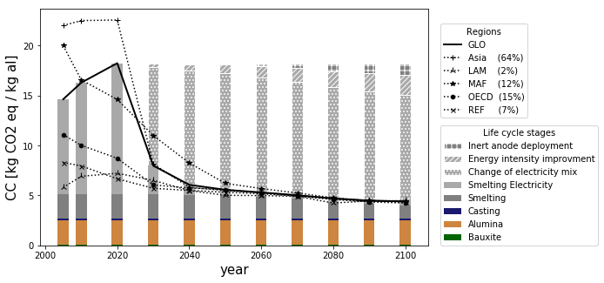
Figure SI-5: Contribution analysis of global (GLO) primary aluminum production for PRISMAL2 and evolution of carbon intensity by region with the 1.5°C scenario. The Hall-Heroult process and its direct emissions is grouped with the anode production into the smelting stage. The numbers in parentheses in the region’s legend represent the market share of each region used from 2020 to 2100
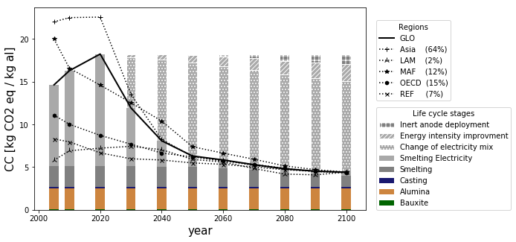
Figure SI-6: Contribution analysis of global (GLO) primary aluminum production for PRISMAL2 and evolution of carbon intensity by region with the 2.0°C scenario. The Hall-Heroult process and its direct emissions is grouped with the anode production into the smelting stage. The numbers in parentheses in the region’s legend represent the market share of each region used from 2020 to 2100

Table 17: Contribution analysis of global (GLO) primary aluminum production for PRISMAL2 according different mitigation scenarios. The Hall-Heroult process and its direct emissions is grouped with the anode production into the smelting stage.
PRISMAL 2 |  | 2005 | 2010 | 2020 | 2030 | 2040 | 2050 | 2060 | 2070 | 2080 | 2090 | 2100
1.5 °C | Bauxite | 0.04 | 0.04 | 0.04 | 0.04 | 0.04 | 0.04 | 0.04 | 0.04 | 0.04 | 0.04 | 0.04
 | Alumina | 2.43 | 2.43 | 2.43 | 2.43 | 2.43 | 2.43 | 2.43 | 2.43 | 2.43 | 2.43 | 2.43
 | Electrolysis | 2.44 | 2.44 | 2.43 | 2.42 | 2.40 | 2.35 | 2.22 | 1.99 | 1.69 | 1.46 | 1.33
 | Electricity for smelting | 9.49 | 11.14 | 13.09 | 2.88 | 1.00 | 0.55 | 0.42 | 0.37 | 0.33 | 0.35 | 0.39
 | Casting | 0.24 | 0.25 | 0.26 | 0.21 | 0.20 | 0.20 | 0.20 | 0.20 | 0.20 | 0.20 | 0.20
2.0 °C | Bauxite | 0.04 | 0.04 | 0.04 | 0.04 | 0.04 | 0.04 | 0.04 | 0.04 | 0.04 | 0.04 | 0.04
 | Alumina | 2.43 | 2.43 | 2.43 | 2.43 | 2.43 | 2.43 | 2.43 | 2.43 | 2.43 | 2.43 | 2.43
 | Electrolysis | 2.44 | 2.44 | 2.43 | 2.42 | 2.40 | 2.35 | 2.22 | 1.99 | 1.69 | 1.46 | 1.33
 | Electricity for smelting | 9.49 | 11.14 | 13.09 | 6.82 | 3.01 | 1.29 | 0.95 | 0.63 | 0.45 | 0.41 | 0.41
 | Casting | 0.24 | 0.25 | 0.26 | 0.23 | 0.21 | 0.20 | 0.20 | 0.20 | 0.20 | 0.20 | 0.20
Baseline | Bauxite | 0.04 | 0.04 | 0.04 | 0.04 | 0.04 | 0.04 | 0.04 | 0.04 | 0.04 | 0.04 | 0.04
 | Alumina | 2.43 | 2.43 | 2.43 | 2.43 | 2.43 | 2.43 | 2.43 | 2.43 | 2.43 | 2.43 | 2.43
 | Electrolysis | 2.44 | 2.44 | 2.43 | 2.42 | 2.40 | 2.35 | 2.22 | 1.99 | 1.69 | 1.46 | 1.33
 | Electricity for smelting | 9.49 | 11.14 | 13.09 | 12.01 | 10.79 | 10.36 | 10.18 | 9.96 | 9.50 | 8.07 | 6.52
 | Casting | 0.24 | 0.25 | 0.26 | 0.25 | 0.25 | 0.25 | 0.25 | 0.25 | 0.25 | 0.24 | 0.23

Sensitivity analysis - electricity consumption of inert anode
The assumption that electricity consumption form inert anode smelting is equal has Hall-Heroult process has been made so far. This sensitivity analysis compares results with an extra consumption of 3 kWh/kg al which is the difference between theorical minimal energy of both technologies, to a scenario with no deployment of inert anode at all and the baseline scenario.
Figure 7 shows that an increase of the electricity could lead to more impact than no deployment at all with baseline scenario. Impact are higher than the assumption of no extra electricity consumption for all scenarios. For 1.5°C and 2.0°C mitigation scenario, the extra electricity doesn’t lead to more impact because the electricity mix has already a very low carbon intensity when inert anode is deployed.
(a)
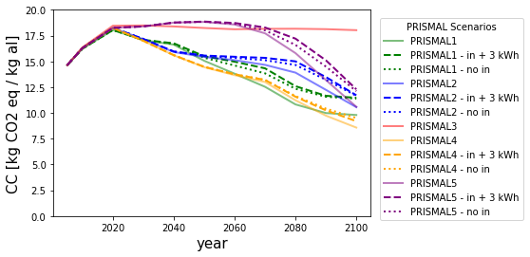
(b)
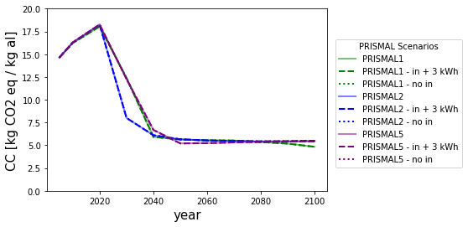
(c)
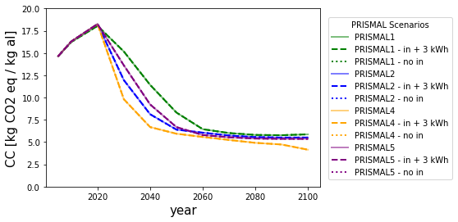
Figure 7: Sensitivity analysis of an increase of 3 kWh for inert anode smelting according (a) baseline scenario (note that axis y start at 8!), (b) 1.5°C mitigation scenario and (c) 2.0°C mitigation scenario

Geography
Evolution of every baseline PRISMAL scenario by region are presented in Figure SI-8 and values are groups in
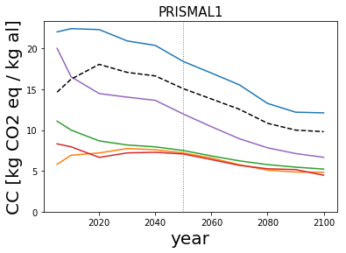 | 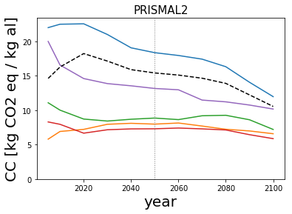
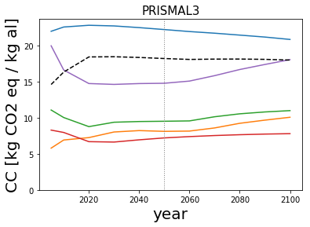 | 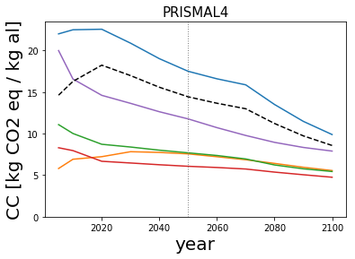
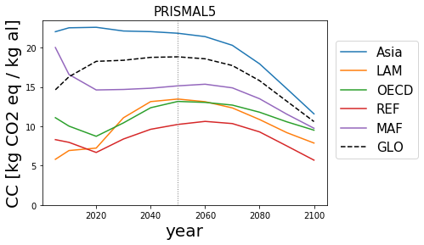
Figure SI-8: Climate change impacts for different regions for each baseline scenario

Table 18: Climate change impacts values for different regions for each baseline scenario
Impact |  |  | Climate change [kg CO₂ eq / kg aluminum]
Year |  |  | 2005 |  | 2010 |  | 2020 |  | 2030 |  | 2040 |  | 2050 |  | 2060 |  | 2070 |  | 2080 |  | 2090 |  | 2100
Scenario | PRISMAL1 | Asia |  | 22.0 |  | 22.4 |  | 22.3 |  | 20.9 |  | 20.4 |  | 18.4 |  | 17.0 |  | 15.5 |  | 13.3 |  | 12.2 |  | 12.1
 |  | LAM |  | 5.8 |  | 6.9 |  | 7.2 |  | 7.7 |  | 7.6 |  | 7.2 |  | 6.6 |  | 5.7 |  | 5.1 |  | 4.9 |  | 4.8
 |  | MAF |  | 20.0 |  | 16.5 |  | 14.5 |  | 14.0 |  | 13.6 |  | 12.0 |  | 10.4 |  | 8.9 |  | 7.8 |  | 7.1 |  | 6.7
 |  | OECD |  | 11.1 |  | 10.0 |  | 8.7 |  | 8.2 |  | 7.9 |  | 7.5 |  | 6.8 |  | 6.2 |  | 5.8 |  | 5.5 |  | 5.2
 |  | REF |  | 8.3 |  | 7.9 |  | 6.6 |  | 7.2 |  | 7.3 |  | 7.1 |  | 6.4 |  | 5.7 |  | 5.3 |  | 5.2 |  | 4.5
 |  | GLO |  | 14.6 |  | 16.2 |  | 18.0 |  | 17.1 |  | 16.6 |  | 15.1 |  | 13.8 |  | 12.5 |  | 10.8 |  | 10.0 |  | 9.8
 | PRISMAL2 | Asia |  | 22.0 |  | 22.5 |  | 22.6 |  | 21.0 |  | 19.1 |  | 18.4 |  | 18.0 |  | 17.4 |  | 16.3 |  | 14.1 |  | 12.0
 |  | LAM |  | 5.8 |  | 6.9 |  | 7.2 |  | 8.0 |  | 8.1 |  | 8.0 |  | 8.1 |  | 7.7 |  | 7.2 |  | 7.0 |  | 6.6
 |  | MAF |  | 20.0 |  | 16.6 |  | 14.6 |  | 13.9 |  | 13.6 |  | 13.2 |  | 13.0 |  | 11.5 |  | 11.2 |  | 10.8 |  | 10.2
 |  | OECD |  | 11.1 |  | 10.0 |  | 8.7 |  | 8.4 |  | 8.7 |  | 8.9 |  | 8.6 |  | 9.2 |  | 9.3 |  | 8.6 |  | 7.2
 |  | REF |  | 8.3 |  | 8.0 |  | 6.7 |  | 7.2 |  | 7.3 |  | 7.3 |  | 7.4 |  | 7.3 |  | 7.1 |  | 6.5 |  | 5.9
 |  | GLO |  | 14.6 |  | 16.3 |  | 18.2 |  | 17.2 |  | 15.9 |  | 15.4 |  | 15.1 |  | 14.7 |  | 13.9 |  | 12.2 |  | 10.6
 | PRISMAL3 | Asia |  | 22.0 |  | 22.6 |  | 22.9 |  | 22.8 |  | 22.5 |  | 22.3 |  | 22.0 |  | 21.8 |  | 21.5 |  | 21.2 |  | 20.9
 |  | LAM |  | 5.8 |  | 6.9 |  | 7.3 |  | 8.0 |  | 8.2 |  | 8.1 |  | 8.2 |  | 8.6 |  | 9.2 |  | 9.7 |  | 10.1
 |  | MAF |  | 20.0 |  | 16.6 |  | 14.8 |  | 14.6 |  | 14.8 |  | 14.8 |  | 15.1 |  | 15.9 |  | 16.7 |  | 17.4 |  | 18.1
 |  | OECD |  | 11.1 |  | 10.0 |  | 8.8 |  | 9.4 |  | 9.5 |  | 9.5 |  | 9.6 |  | 10.2 |  | 10.6 |  | 10.8 |  | 11.0
 |  | REF |  | 8.3 |  | 8.0 |  | 6.7 |  | 6.6 |  | 7.0 |  | 7.2 |  | 7.4 |  | 7.5 |  | 7.7 |  | 7.8 |  | 7.8
 |  | GLO |  | 14.6 |  | 16.4 |  | 18.5 |  | 18.5 |  | 18.4 |  | 18.2 |  | 18.1 |  | 18.2 |  | 18.2 |  | 18.1 |  | 18.0
 | PRISMAL4 | Asia |  | 22.0 |  | 22.5 |  | 22.6 |  | 20.9 |  | 19.0 |  | 17.5 |  | 16.6 |  | 15.9 |  | 13.5 |  | 11.5 |  | 9.9
 |  | LAM |  | 5.8 |  | 6.9 |  | 7.2 |  | 7.8 |  | 7.7 |  | 7.6 |  | 7.2 |  | 6.9 |  | 6.4 |  | 6.0 |  | 5.6
 |  | MAF |  | 20.0 |  | 16.6 |  | 14.6 |  | 13.7 |  | 12.6 |  | 11.8 |  | 10.7 |  | 9.8 |  | 9.0 |  | 8.3 |  | 7.9
 |  | OECD |  | 11.1 |  | 10.0 |  | 8.7 |  | 8.4 |  | 8.0 |  | 7.7 |  | 7.4 |  | 7.0 |  | 6.2 |  | 5.8 |  | 5.4
 |  | REF |  | 8.3 |  | 8.0 |  | 6.7 |  | 6.5 |  | 6.3 |  | 6.1 |  | 5.9 |  | 5.7 |  | 5.4 |  | 5.1 |  | 4.8
 |  | GLO |  | 14.6 |  | 16.3 |  | 18.2 |  | 17.0 |  | 15.6 |  | 14.4 |  | 13.7 |  | 13.0 |  | 11.2 |  | 9.7 |  | 8.6
 | PRISMAL5 | Asia |  | 22.0 |  | 22.5 |  | 22.6 |  | 22.1 |  | 22.0 |  | 21.8 |  | 21.4 |  | 20.3 |  | 17.9 |  | 14.8 |  | 11.6
 |  | LAM |  | 5.8 |  | 6.9 |  | 7.2 |  | 11.1 |  | 13.1 |  | 13.5 |  | 13.1 |  | 12.3 |  | 10.9 |  | 9.2 |  | 7.9
 |  | MAF |  | 20.0 |  | 16.6 |  | 14.6 |  | 14.7 |  | 14.8 |  | 15.1 |  | 15.3 |  | 14.9 |  | 13.5 |  | 11.5 |  | 9.8
 |  | OECD |  | 11.1 |  | 10.0 |  | 8.7 |  | 10.4 |  | 12.4 |  | 13.2 |  | 13.0 |  | 12.7 |  | 11.8 |  | 10.6 |  | 9.5
 |  | REF |  | 8.3 |  | 8.0 |  | 6.7 |  | 8.4 |  | 9.6 |  | 10.2 |  | 10.6 |  | 10.3 |  | 9.3 |  | 7.5 |  | 5.7
 |  | GLO |  | 14.6 |  | 16.3 |  | 18.3 |  | 18.4 |  | 18.8 |  | 18.8 |  | 18.6 |  | 17.7 |  | 15.8 |  | 13.2 |  | 10.6

Sensitivity analysis - Geography distribution
A sensitivity analysis on future geographical market share has been made. The original assumption is continuing the 2020 regional shares in into the future. To perform the sensitivity analysis, we assigned the future aluminium production to specific region according different rules. As Asia and Middle East are two regions where the future production are most likely to increase (Ramkumar, 2014) we build our 3 first scenarios around this assumption.50% in Asia, 50% in MAF (1), 100% in MAF (2), 100% in Asia (3). The fourth scenario is an extreme scenario where all the electricity is produced in the region where the impact of aluminium production is lower: 100% in LAM (4) and last scenario is simply an equally and arbitrary split of the new production in 5 regions (5). Results are shown on Figure SI-9 and in Table SI-19.
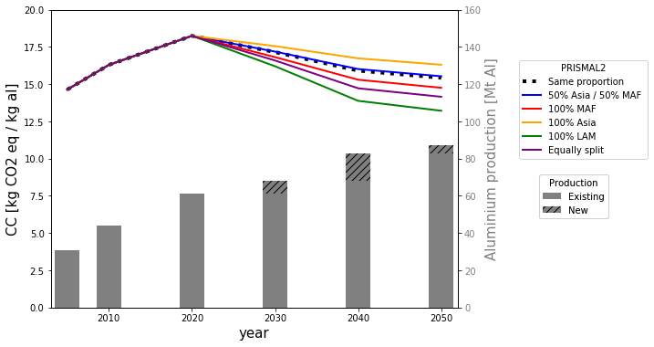
Figure SI-9: Sensitivity analysis of geographical aggregation until 2050 in PRISMAL2 baseline scenario. The hatched section represents the new production added in the previous decade. The black line representing a constant proportion is hardly visible because it is behind the blue line.

Table SI-19 : Numerical values of the sensitivity analysis according PRISMAL2 baseline scenario
PRISMAL2 - Baseline | CC [kg CO₂ eq/ kg Al]
 | 2005 | 2010 | 2020 | 2030 | 2040 | 2050
Constant proportion | 14.6 | 16.3 | 18.2 | 17.2 | 15.9 | 15.4
50% Asia / 50% MAF | 14.6 | 16.3 | 18.2 | 17.2 | 16.0 | 15.5
100% MAF | 14.6 | 16.3 | 18.2 | 16.8 | 15.3 | 14.8
100% Asia | 14.6 | 16.3 | 18.2 | 17.6 | 16.7 | 16.3
100% LAM | 14.6 | 16.3 | 18.2 | 16.2 | 13.9 | 13.2
Equally split | 14.6 | 16.3 | 18.2 | 16.6 | 14.7 | 14.2

The analysis shows that geographical aggregation rule does not have a major impact on the results. The extreme case where all new production after 2020 goes to LAM show the biggest difference from our initial assumption. The 50% Asia / 50% MAF case shows the same results as our assumption with constant regional market shares.

Total impacts

Table SI-20: Total impact values of primary aluminum production of climate change (CC) indicator for every PRISMAL scenario with their baseline mitigation scenario.
Impact |  | Climate change [Gt CO₂ eq]
Year |  | 2005 | 2010 | 2020 | 2030 | 2040 | 2050
Scenario | PRISMAL1-1.5°C | 451 | 711 | 1104 | 844 | 484 | 465
 | PRISMAL1-2.0°C | 451 | 711 | 1104 | 1035 | 938 | 699
 | PRISMAL1-bl | 451 | 711 | 1104 | 1165 | 1375 | 1312
 | PRISMAL2-1.5°C | 451 | 714 | 1117 | 545 | 502 | 485
 | PRISMAL2-2.0°C | 451 | 714 | 1117 | 816 | 669 | 549
 | PRISMAL2-bl | 451 | 714 | 1117 | 1171 | 1316 | 1344
 | PRISMAL3-bl | 451 | 717 | 1130 | 1262 | 1521 | 1589
 | PRISMAL4-2.0°C | 451 | 714 | 1117 | 670 | 552 | 514
 | PRISMAL4-bl | 451 | 714 | 1117 | 1160 | 1289 | 1258
 | PRISMAL5-1.5°C | 451 | 714 | 1117 | 838 | 552 | 452
 | PRISMAL5-2.0°C | 451 | 714 | 1117 | 930 | 762 | 581
 | PRISMAL5-bl | 451 | 714 | 1117 | 1256 | 1551 | 1640

Results comparison with LCA
Figure SI-10 compare SSP2 carbon intensity for different regions to McMillan and Keoleian (2009) results between 1990 and 2005. The different shade of blues on the McMillan side of the graph represents different sub region of the OECD.

Figure SI-10: Comparison of SSP results to (McMillan and Keoleian, 2009) results according different time periods. The comparison is made for three different regions: OECD, Asia and an world average
The world average, Asia and LAM results in 2005 are very similar for both models. The PRISMAL world average is 2 kg CO₂ eq/kg al higher in 2005. A little gap is also observed between Africa and MAF but both regions are not the same while MAF includes Gulf countries. For the North America, Europe and Oceania regions, they are merge into OECD in PRISMAL The PRISMAL2 OECD results in 2005 is in the range of the 3 sub regions.

Another comparison is made with Paraskevas et al. results (2016). Figure SI-11 shows the range between best and worst carbon intensity of aluminium production within different time and regions for each SSP and Paraskevas results.

Figure SI-11: Comparison of baseline results range from (Paraskevas et al., 2016) and our model
The range of results across geographies and SSPs of our model lies in the same interval than Paraskevas range, but maximum values are all lower according to PRISMAL model. This is explained by the use of aggregated regions in our model while Paraskevas look at 29 specific countries. The use of an average electricity mix in a full region explains why the upper limit of our range is lower than Paraskevas; our model cannot assess the possibility that an aluminum smelter can be 100% supplied by coal-based electricity. Our model calculates environmental impacts of an average production based on an average grid mix instead of a specific environmental profile for a specific smelter. For PRISMAL2, PRISMAL 3 and PRISMAL 5, the minimum value is higher than Paraskevas because once again, the aggregation of the region makes it not possible to have a 100% hydropower supply of the smelter as is the case for some countries studied by Paraskevas.

References
Alcoa (2019) Sustainability Report.
IAI (2020) Primary Aluminium Smelting Energy Intensity. Available at: http://www.world-aluminium.org/statistics/primary-aluminium-smelting-energy-intensity/ (Accessed: 25 February 2020).
McGeer, J. P. (1986) ‘Hall-Heroult: 100 Years of Processes Evolution’, JOM. Springer, 38(11), pp. 27–33. doi: 10.1007/BF03257618.
McMillan, C. A. and Keoleian, G. A. (2009) ‘Not All Primary Aluminum Is Created Equal: Life Cycle Greenhouse Gas Emissions from 1990 to 2005’, Environmental Science & Technology, 43(5), pp. 1571–1577. doi: 10.1021/es800815w.
Paraskevas, D. et al. (2016) ‘Environmental Impact Analysis of Primary Aluminium Production at Country Level’, Procedia CIRP. Elsevier, 40, pp. 209–213. doi: 10.1016/J.PROCIR.2016.01.104.
Ramkumar, S. (2014) Stock-Driven, Trade-Linked, Multi-Regional Model of the Global Aluminium Cycle. NTNU. Available at: https://core.ac.uk/download/pdf/52098686.pdf (Accessed: 2 August 2019).
Rio Tinto (2019) Our approach to climate change.
RUSAL (2018) Sustainability report.

