Chapter 8. Engineered Rivers in Spain: the case of the Jucar Basin
J. Albiac, M. T. Kahil and E. Esteban

1. Introduction

2. Water Resources in Spain and the Jucar River Basin
2.1 The mounting pressures on water resources in Spain
2.2 Water governance institutions
2.3 Conversion of the Jucar River into a closed basin
3. Management and Policies to Address Water Scarcity in the Jucar Basin
3.1 The institutional approach by the Jucar Basin Authority
3.2 Engineering solutions: investments in water technologies and public subsidies
3.3 Confronting droughts and the impending climate change with different policy instruments
4. Prospects for the Sustainable Management of the Jucar Basin
4.1 The Jucar basin in the coming decades
4.2 Potential sustainable outcomes and stakeholders’ perceptions of policy reforms
5. Conclusions and policy recommendations

8.1 Introduction

The pressures on water resources have been mounting worldwide with water scarcity becoming a widespread problem in arid and semiarid regions around the world. Global water extractions have climbed from 600 to 3,800 km³ per year in the last century, which is above the rate of population growth (WWC 2000). The degradation of water resources is a common threat to human water security and environmental biodiversity across the world. Large investments in developed countries ensure human security, but the threats to natural ecosystems are hardly accounted for (Vörösmarty et al. 2010). The water governance problem gravitates around the agricultural sector because the majority of water resources are used for irrigation.

Irrigation is a key component of agricultural production, covering 20 percent of cultivated land and generating 40 percent of the global food production (CAWMA 2007). Irrigation covers 310 million hectares of land with the large acreage located in Asia and America (Siebert et al. 2013). Irrigation demand for water is close to 2,750 km³ per year, of which 1,900 km³ are surface water diversions and 850 km³ are groundwater extractions. The construction of dams for irrigation has been reduced during recent decades, and most dams at present are being built for hydropower (Winemiller et al. 2016). The development of irrigation in recent decades has been based on the enormous expansion of groundwater extractions. Between 1960 and 2010, groundwater extractions from all sectors climbed from 300 to 1,000 km³ per year pushing depletion up to 150 km³ (Konikow 2011, Wada et al. 2010, IGRAC 2010).

Water reforms are needed because groundwater extractions and surface water diversions are causing severe water scarcity and water quality problems, with substantial damages to human activities and natural ecosystems. Also, water quality impairment results from urban, industrial and agricultural pollution loads of organic matter, heavy metals, nutrients, pesticides and salinity.

The massive ecosystem damages in basins such as Ganges, Indus, Nile, Yellow, Yangtze, Amu and Syr Darya, Tigris, Euphrates, Murray-Darling, Colorado and Rio Grande (WWAP 2006) call for a reconsideration of the current water management, institutions and policies, leading to far-reaching water reforms. The scale of the global growing water depletion indicates that water mismanagement is quite common, and that sustainable management of basins is a complex and difficult task. The upcoming water governance problem would be especially acute in arid and semiarid regions. In these regions the combined effects of human-induced permanent water scarcity and climate change-induced water scarcity and droughts, portend unprecedented levels of water resources degradation in the absence of remediating water reforms.

In the coming decades, climate change is going to be an important challenge for agricultural production. This challenge will be especially difficult to harness because global food demand will almost double by 2050 (Alexandratos and Bruisma 2012), driven by the growth of world population and income. Climate change will increase temperatures and modify the pattern of precipitations, reducing crop yields in both irrigated and rainfed cropland and also livestock productivity because of prolonged or extreme changes in temperature. The biological processes underlying the productivity of plants and animals will be negatively affected by increasing weeds, diseases and pests, along with changes in the development and pollination periods (OECD 2014, USDA 2012).

Table 1 around here/ Table 1. Water withdraws and utilization by sector in Spain (2010, Mm³).

Water resources projections using coupled global hydrological and crop models indicate that crop losses from climate change could be in the range of 20-30 percent by the end of the century (Elliot et al. 2014). Further losses may occur from water resources scarcity in some regions, which will force the reversion of irrigation to rainfed cropland. Changes in precipitation regimes and extreme precipitations will have negative effects on water availability. Precipitations will decrease in mid-latitude and subtropical dry regions, reducing renewable surface water and groundwater resources and escalating the competition for water among sectors (IPCC 2014a).

The sustainable management of water resources is quite challenging because of the different types of goods and services provided by water. These goods and services can be classified as private goods, common pool resources, or public goods depending on the degree of exclusion and rivalry in consumption. Treated drinkable water in urban networks is close to a private good (rivalry & exclusion), water in surface watercourses and aquifers is close to a common pool resource (rivalry & non-exclusion), while water sustaining ecosystems comes close to a public good (non-rivalry & non-exclusion) (Booker et al., 2012). The management of water resources is characterized by collective action processes since pure competitive markets cannot account for the common pool and public good characteristics of water. Collective action is needed to account for the externalities linked to the use of water resources, such as ecosystem damages or the depletion of groundwater systems. Finally collective action is also driven by the technologies employed in water utilization, which involve economies of scale and indivisibilities resulting in natural monopolies (Rausser et al. 2011).

8.2 Water Resources in Spain and the Jucar River Basin

Water management has always been an important issue in Spain. Irrigation projects were undertaken since Roman times, but it was during the twentieth century that the expansion of irrigation acreage accelerated, coupled with a strong process of economic development and industrialization. The consequence has been a growing pressure on water resources and the ensuing problems of water scarcity and quality degradation.

In Spain, the average annual rainfall is 680 mm or 340,000 Mm³, but with large variability across time and space. The average flow in rivers amounts to 110,000 Mm³ and the groundwater renewable resources are around 30,000 Mm³. The large time and space variability of water regimes in rivers has led to the construction of dams with a storage capacity close to 50,000 Mm³ (MIMAM 2000).

Figure 1 around here/ Figure 1. River Basins in Spain.

8.2.1 The mounting pressures on water resources in Spain

Water scarcity in Spain is mainly linked to the enormous development of irrigation, while quality degradation is mainly linked to pollution from urban, industrial and agricultural sources. Water withdraws for consumptive uses were 15,500 Mm³ per year in 1960, at the beginning of a period of strong economic growth (MOPT 1993). Five decades later, these water withdraws have doubled to 30,100 Mm³ per year, mainly driven by the expansion of irrigation acreage from 1.8 to 3.5 million hectares and the growth in urban and industrial demands. The distribution of water withdraws by sector in Spain is presented in table 1. Withdraws are close to 30,100 Mm³, covering the demand from irrigation, water supplying companies, and other industrial and service sectors. Household demand is 2,400 Mm³ with an average price of 1.90 €/m³, and industrial and service demand is 4,100 Mm³ with an average price of 2.50 €/m³ for network supplied water. Net irrigation demand is 18,100 Mm³ and prices are related to the type of agriculture; prices rank between 0.07 €/m³ in less profitable irrigation areas and 0.12-0.30 €/m³ in high profitable areas (INE 2014, 2016).

There are severe water scarcity and quality degradation problems in all basins, except in the northern Ebro and Duero basins which have lower pressures from human activities (Figure 1). The expanding water demands in Segura, Jucar, Guadiana, Guadalquivir and Tajo required building a substantial dam storage capacity, around twice the annual stream flows of basins. This has resulted in the conversion of these rivers in almost closed basins, as indicate the very small environmental flows being enforced (Table 2).

The main pressures come from agriculture under intensive production systems, urban sprawling, and from tourism along the Mediterranean coast. The surge in aquifer pumping by farmers, that occurred in recent decades in the southern and eastern basins, has reduced water flows considerably in the Segura, Jucar, Guadiana and Guadalquivir basins. Competition for water is keen among economic sectors and territories (Albiac et al., 2013). The large surface diversions and groundwater extractions are degrading water resources and creating significant environmental damages. The resulting threats to human water security have been compensated in Spain with important investments in water technologies.

Table 2 around here/ Table 2. Stream flows, storage capacity and environmental flows in basins.

8.2.2 Water governance institutions
The institutional organization of water management is based on the public administration bodies, the legal system, and the water policies. These institutional components are integrated through the interplay between the Spanish and European legislation, and the Spanish federal and state governments.
The Spanish legislation grants an important role to the public administrations at national, basin, regional, and sub-regional levels. Water management is based on water authorities in each basin, which elaborate and implement the river basin plans. The Ministry of Agriculture and Environment is the federal authority on water resources, and its main tasks are the design and enforcement of water policies and managing federal basin authorities. The state governments are in charge of urban supply and wastewater treatment, agriculture, land planning, environment protection, and state river basins (Varela & Hernández 2010).
The participation of water users is especially strong in agriculture. Agricultural users relying on water from a single common concession must create a water users’ association, with their own equity and legal status. Water users’ associations are responsible for the management of secondary infrastructures and allocation of water among members.
The approach to water management is institutional and relies on the river basin authorities, taking advantage of the strong tradition of cooperation among stakeholders in Spain dating back centuries. The common pool and public good characteristics of water are the reasons behind this institutional approach based on basin authorities enabling the collective action of stakeholders.
The responses and adaptation to water scarcity and water quality degradation in Spain have been shaped by the national water policies of the last twenty years, with large investment proposals costing billions of Euros. The main water policies have been the National Irrigation Plan of 2002, the AGUA Project of 2005 to build desalination plants, and the Sanitation Plans of 1995 and 2007 dealing with urban wastewater treatment. The National Irrigation Plan provided subsidies (50%) for investments of 6 billion € in irrigation technologies to upgrade primary and secondary irrigation networks and parcel irrigation systems. The AGUA project involved investments of 2.4 billion € to build desalination plants and to expand water supply by 600 Mm³, of which 300 Mm³ are for irrigation purposes in the coastal fringe (MIMAM 2004). The Sanitation Plans investments in tertiary and secondary wastewater treatment plants have been around 12 billion € since 1995.

Figure 2 around here/ Figure 2. The Jucar River Basin

8.2.3 Conversion of the Jucar River into a closed basin
The Jucar River Basin (JRB) is located in the regions of Valencia and Castilla La Mancha in Southeastern Spain. It extends over 22,300 km² and covers the area drained by the Jucar River and its tributaries. The basin has an irregular Mediterranean hydrology, characterized by recurrent drought spells and normal years with dry summers.
At present, renewable water resources in the JRB are nearly 1,700 Mm³/year of which 930 are surface water and 770 are groundwater. Water extractions are 1,680 Mm³, very close to renewable resources, making the JRB an almost closed water system. Extractions for irrigated agriculture are nearly 1,400 Mm³. Urban and industrial extractions total 270 Mm³, which supply households, industries, and services of more than one million inhabitants, located mostly in the cities of Valencia, Sagunto and Albacete.
The basin includes 13 reservoirs, the most important of which are the Alarcon, Contreras and Tous dams. There are two major water distribution canals in the lower Jucar: the Acequia Real canal, which conveys water from the Tous dam to the traditional irrigation districts, and the Jucar-Turia canal, which transfers water from the Tous dam to modern irrigation districts. The irrigated area extends over 190,000 ha, and the main crops grown are rice, wheat, barley, garlic, grapes, and citrus. There are three major irrigation areas, the irrigation area in the upper Jucar based on groundwater pumping from the Eastern La Mancha aquifer, the downstream traditional irrigation area fed by the Acequia Real canal, and the downstream modern irrigation area fed by the Canal Jucar-Turia and located North of traditional irrigators (Figure 2).
The expansion of water extractions and the severe drought spells in recent decades have triggered considerable negative environmental and economic impacts in the basin (CHJ, 2009). The growth of water extractions has been driven especially by groundwater irrigation from the Eastern La Mancha aquifer, the largest aquifer system in Spain (Esteban and Albiac 2012). Intensive groundwater pumping since the 1980s has caused a significant drop in the water table reaching 80 m depth in in some areas, resulting in large storage depletion, fluctuating around 2,500 Mm³. The Eastern La Mancha aquifer is linked to the Jucar River stream, and it used to feed the river with more than 250 Mm³/year prior to the 1980s. Due to the depletion, aquifer discharges to the river have declined considerably over the past 30 years, and they are below 50 Mm³/year at present (Figure 3). The consequence is that the lower Jucar is undergoing severe problems of low flows and water-quality degradation, with the riverbed in the middle Jucar being completely dry during recent droughts.

Figure 3 around here/ Figure 3. Annual stream flows in the Jucar River along La Mancha aquifer.

Environmental flows are dwindling in many parts of the basin, resulting in serious damages to water-dependent ecosystems but also in significant costs to economic sectors. The minimum environmental flow in the final tract of the Jucar River is 0.5 m³/s, which shows that the River is becoming a closed basin. Downstream water users are sustaining negative impacts, especially downstream irrigators. For instance the water available to the Acequia Real irrigation district has been reduced from 700 to 200 Mm³ in the last 40 years, with damages not only to irrigators but also to the environment because of the fall in irrigation return flows. The Albufera wetland, which is the main aquatic ecosystem in the Jucar River, is mostly fed by these return flows which are dwindling (Garcia-Molla et al. 2013).

8.3 Management and Policies to Address Water Scarcity in the Jucar Basin
To confront the progressive water scarcity and water quality degradation in the Jucar Basin and other Spanish basins, there has been a large set of management and policy initiatives in recent decades. The list entails massive investments in water technologies, such as modernization of irrigation technologies, urban wastewater treatment plants, seawater desalination plants, and inter-basin water transfers. There has been also national legislation to promote water markets together with the creation of public water banks in basins, and regulation to facilitate the use of recycled urban wastewater in irrigation and the environment.

Figure 4 around here/Figure 4. Organization of the Jucar Basin Authority

8.3.1 The institutional approach in the Jucar Basin Authority
The Jucar Basin Authority is the main administrative body responsible for water management not only over the Jucar Basin but also over the Turia Basin and other minor coastal basins (Figure 2). The Basin Authority is organized around the governing boards, the stakeholder boards, and the management services (Figure 4). The special characteristic of this institutional approach is the key role played by stakeholders in the Basin Authority. Stakeholders are inside the Basin Authority and include water users from each sector (irrigation, urban, industrial, hydropower), state and federal public administrations, farmers’ unions and environmental groups. The stakeholders’ representatives are present in all governing and participation bodies at basin scale, and run the watershed boards at local scale. Therefore, the stakeholders are involved in every level of decision making: planning, financing, water allocation and water public domain, waterworks, design and enforcement of measures, and water management at basin and watershed levels (MARM 2008). The management of water is decentralized, with the Basin Authority in charge of water allocation, and water user associations in charge of secondary infrastructure, water usage, operation and maintenance, investments, and cost recovery. The main advantage of this institutional setting is that stakeholders cooperate in decisions, rules and regulations, and therefore the implementation and enforcement processes are carried out smoothly.
During periods of water scarcity, the watershed boards reduce the level of surface diversions and groundwater extractions assigned to each water user association in the watershed. There is also a drought basin plan based on hydrological indicators to declare the state of alert or full drought, and the measures to be taken to minimize the environmental, economic and social impacts of drought spells.

8.3.2 Engineering solutions: investments in water technologies and public subsidies
The investments in water technologies during the last two decades in the district covered by the Jucar Basin Authority correspond mostly to the investments made in the Valencia region, where disaggregated data are available. The main components are the investments of 1300 M€ in urban wastewater treatment plants, the investments of 1000 M€ in irrigation modernization technologies covering 170,000 ha, the investments of 250 M€ in eight desalination plants for urban supply with a total capacity of 100 Mm³/year, and the investments of 400 M€ in the Jucar-Vinalopo inter-basin water transfer of 80 Mm³/year. Public subsidies have covered the bulk of financing in wastewater treatment plants, desalination plants, and the Jucar-Vinalopo water transfer. In irrigation modernization technologies, public subsidies have covered 65% of investments and the rest has been financed by farmers
The investments in wastewater treatment plants have reduced considerably the point pollution loads into water media from urban centers. Treated wastewater could be an important resource to confront water scarcity, however only less than one fourth (120 Mm³) of the treated water is reused in the environment or irrigation because farmers are reluctant to substitute freshwater for urban recycled water.
The large investments in advanced irrigation technologies have improved the efficiency of irrigation at parcel level, but total water consumption at basin level has not been reduced with investments in advanced irrigation technologies. Efficiency gains could increase water consumption because efficient technologies convert a larger share of applied water to consumed water lowering the cost of consumption, so farmers respond by increasing water consumption and irrigated acreage, and changing the crop mix to more water demanding crops (Scheierling and Treguer 2016). Even if irrigation withdraws are maintained, the falling irrigation returns reduce basin stream flows. This could be remediated by reducing the water allocation of modernizing districts in order to avoid the expansion of water consumption, but this type of measure will be opposed by farmers.
Seawater desalination has been an important addition to urban water supply in Alicante, Sagunto and other urban centers and tourist hubs. But these municipalities are not willing to pay the higher costs of desalination, and they prefer to continue overdrafting surface streams and groundwater which are obtained at lower costs. These costs are lower because the environmental and opportunity costs of water are disregarded. The desalination facilities are being used at very low capacity and these public investments are being wasted. The alternative being considered is to subsidize desalinated water with public funds until desalination prices become competitive with current water sources.
Another engineering solution has been the water inter-basin transfer between the Jucar and the Vinalopo rivers, completed recently in 2014. There was an important conflict over the water transfer point of diversion involving the Jucar downstream stakeholders. The initial point of diversion was the middle Jucar, but this would have reduced downstream flows. Finally the point of diversion was moved from the middle Jucar River to the Jucar mouth. This inter-basin water transfer adds further pressure to the almost closed Jucar basin.

8.3.3 Confronting droughts and the impending climate change with different policy instruments
Severe droughts could have large impacts on agriculture, domestic and industrial users, tourism and ecosystems. The average costs of drought damages have been estimated at 0.1% of the gross domestic product (GDP) in the USA and the European Union during normal years (NOAA 2008, EC 2007), although the costs of droughts could be exceptionally higher during years of severe drought, up to 1% of GDP (Kirby et al. 2014).
Climate change is a major challenge for sustainable agricultural production in the coming decades in arid and semiarid regions of Spain and other Southern European countries. In those regions, climate change will likely increase temperature and evapotranspiration, reduce precipitation and snowmelt, and modify precipitation patterns, impacting negatively on water resources, irrigated and dryland agriculture, and water-dependent ecosystems. This challenge will be difficult to manage in a context of rising world food demand and growing competition between consumptive and environmental water uses (IPCC 2014b).
The issue of irrigated agriculture adaptation to droughts and climate change has been addressed by many studies in the literature. A string of the literature calls for a reconsideration of water institutions and policies. These new approaches should implement incentive-based policies for an effective uptake of adaptation to more frequent and long drought events driven by climate change (Zilberman et al. 2002, Booker et al. 2005). Three popular incentive-based policies to address irrigation adaptation to climate change which are widely considered in the literature are water markets, water pricing, and public subsidies for investments in efficient irrigation systems.
Water markets are a good policy alternative to address the economic impacts of climate change (Calatrava and Garrido 2005, Montilla-Lopez et al. 2016, Gohar and Ward 2010). Water market benefits during the last drought in the Murray-Darling basin of Australia, the most active water market in the world, have been around 1 billion US dollars per year (Connor and Kaczan 2013). Also, the potential water market benefits in California during the recent drought are estimated at 1 billion US dollars per year, assuming that water markets would have been in full operation (Medellin et al. 2013). A challenge to water markets is the third party effects such as environmental impacts. The reasons are that water markets reduce streamflows because previously unused water allocations are traded, and also because gains in irrigation efficiency at parcel level from water trading reduce return flows (Qureshi et al. 2010), as indicated above.
Water pricing in irrigation, to achieve water conservation, has been the subject of debate since the 1990s. A string of the literature finds that irrigation water pricing has limited effects on water conservation (Moore 1991, Scheierling et al. 2004), and some authors indicate that water markets seem far more effective than water pricing for allocating irrigation water (Cornish et al. 2004). Some studies in Spain support those previous findings, but also find that water pricing involves disproportionate costs to farmers (Garrido and Calatrava 2009, Calatrava et al. 2011).
Subsidizing investments in efficient irrigation systems is another important policy for climate change adaptation. The reason is that modernization reduces land abandonment, facilitates the adoption of diversified and high-value cropping patterns, and improves crop yields, leading to an increase in the value of agricultural production. In addition, modernization supports rural development and improves water quality (Playan et al., 2013). However, contrary to widespread expectations, modernization increases water depletion through enhanced crop evapotranspiration and reduction of return flows (Perry et al., 2014).
Another policy option to be considered is the institutional cooperation approach, where affected stakeholders design the rules and enforcement mechanisms for the allocation of scarce water. This is the policy approach of basin authorities in Spain, although this approach has not received widespread attention in either research or policy circles.
The empirical analysis of these policy options is based on a modeling framework developed for the Jucar River Basin. The hydro-economic river basin model integrates hydrological, economic, institutional and environmental components, and includes the irrigation, urban and environmental sectors in the basin. Details of the modeling framework can be found in Kahil et al. (2015a, 2015b, 2016a, 2016b).

Table 3 around here/ Table 3. Policies under drought: institutional, water markets, and water pricing.

A direct comparison of water markets, water pricing and institutional policy instruments is made using the hydro-economic model of the Jucar. Table 3 shows the economic and environmental effects of drought under each policy instrument. The empirical results highlight that both water markets and institutional policies are economically-efficient instruments to limit the damage costs of droughts, achieving similar social benefits in terms of private and environmental benefits. This finding is important because it shows that the status quo institutional policy can attain almost the same private benefits as water markets.
Water markets minimize the losses of private benefits from drought but disregard the environmental benefits. Results show that water markets entail a larger reduction of water for the environment than the institutional policy, and the reason is the public good characteristic of environmental flows which are external to markets.
Water pricing is the policy advocated by the European Water Framework Directive. This policy involves important implementation challenges in arid and semiarid regions such as the Jucar Basin in Spain, where irrigation is the main water use. Water pricing is quite detrimental to farmers, because implementing water pricing instead of water markets or institutional policies triples farmers’ drought losses from 50 to almost 150 million Euros. Under the water pricing policy drought reduces farmers’ benefits by 72%, when the drought loss could be limited to 26% of benefits under water markets or institutional policies. These empirical results demonstrate that water markets and institutional policies are much more economically-efficient and equitable than water pricing, and water pricing results in disproportionate costs to farmers. Enforcing water pricing seems a quite unfeasible task facing tough political and technical hurdles.
The protection of environmental flows from the water markets and institutional policies could be enhanced with additional measures. In the case of water markets, public water buyback programs to increase streamflows is a measure that allows to reap the benefits of water markets while protecting ecosystems (Kahil et al. 2015a). In the case of the institutional policy, the measure is greening the institutional cooperation by including the environment as a full stakeholder in the process of water allocation among sectors and spatial locations (Kahil et al. 2016b).
The policy of subsidizing investments in efficient irrigation systems has been compared to the water markets policy in the lower Jucar Basin (Kahil et al. 2015b). The results show the advantage of water markets over irrigation subsidies in terms of private and social benefits. Both water markets and irrigation subsidies reduce environmental flows compared to a drought scenario without any policy intervention, but with larger flow reductions from irrigation subsidies than water markets. The empirical results indicate that the benefits of the irrigation subsidies policy are very small, especially when public subsidies and social costs of replacing lost environmental flows are accounted for. In contrast, the benefits of water markets are large, even though well-functioning water markets involve sizable monitoring and transaction costs that are not considered in the analysis but require evaluation.
Summing up, the water markets and institutional policies seem to be much more suitable than water pricing and irrigation subsidies policies to confront droughts and the forthcoming climate change. The main drawback of water pricing is the enormous burden placed on farmers’ private benefits, making water pricing politically unfeasible. The main drawback of irrigation subsidies is the large fall in streamflows, above any other instrument, and the subsequent damages to ecosystems. As indicated above, this fall in streamflows could be remediated by reducing water allocations in modernizing districts.

8.4 Prospects for the Sustainable Management of the Jucar Basin
The Jucar Basin is almost a closed basin, with groundwater extractions and surface diversions for human uses exhausting most basin resources. The consequence is a very strong pressure on environmental assets, with minimum environmental flows at the Jucar mouth being only 0.5 m³/s. Natural stream flows in the basin have fallen by 200 Mm³ in the 1980-2012 period, and the water scarcity problem is going to worsen with the upcoming climate change. The estimates are that water available in the basin will fall by 12% in 2040 and by 25% in 2100, with a much higher frequency of major drought events up to three times higher in 2040 and almost ten times in 2100 (Perez-Martin et al. 2015).

8.4.1 The Jucar basin in the coming decades
The change in the balance of water resources in the Jucar, estimated by the Jucar Basin Authority for 2040, is presented in table 4. The impact of climate change reduces available water resources in the basin. The water balance deteriorates in 2040, since the planned reduction in water demand for human activities does not cover the fall of available water resources in the basin. Between 2015 and 2040, the reductions are 200 Mm³ in water availability and 105 Mm³ in net water demand, and the balance difference shrinks from 390 to 295 Mm³ (last row in table 4).

Table 4 around here/ Table 4. Water resources balance in the Jucar Basin (Mm³/y).

However, this shortfall in the water balance could be underestimated. One reason is that the planned reduction in irrigation demand is based on investments in irrigation technologies after 2015. As indicated in the previous section, the modernization of irrigation will likely lead to higher evapotranspiration by crops, reduced irrigation
return flows, and falling basin streamflows. If irrigation modernization could not reduce irrigation demand, then the current net water demand will not decrease and the balance difference in 2040 will further deteriorate below 190 Mm³ (1500 availability – 1310 net demand). Another reason for the shortfall in the water balance is the additional 80 Mm³ of water diversions for the new Jucar-Vinalopo interbasin water transfer. Taken together, irrigation modernization and the Jucar-Vinalopo water transfer would cut down the current positive water balance and turn the Jucar basin into a fully closed hydrological basin.
Considering the entire territory covered by the Jucar Basin Authority, which includes the Jucar and Turia basins and other minor basins (Figure 2), the sustainability prospects are also dim. The current water demand of 3300 Mm³ is above the 3100 Mm³ of renewable water resources, and the projected trends for 2040 are water demand at 3000 Mm³ and water resources availability at 2900 Mm³ (CHJ 2015). However the projected reduction in demand is based on irrigation modernization, which could expand water consumption rather than reduce it. Water scarcity problems are likely to worsen in the coming decades, especially in the already vey stressed southern Alicante area. The engineering solutions provided in the last decade are the 500 Mm³ of recycled water from urban treated wastewater, of which only 120 Mm³ are used at preset, and the already built 100 Mm³ capacity of seawater desalination plants being used at 10 percent of capacity.
The improvement of sustainability in the Jucar Basin Authority district depends on solving the problem of water governance as the case of Alicante shows. The urban use in Alicante is 40 Mm³, supplied with water from the Tajo-Segura interbasin transfer and overdrafted aquifers located in the Vinalopo basin. The desalination plants built in Alicante could cover the full supply of urban water in Alicante, but the stakeholders don’t want to pay the costs of desalinated water. They keep using water from the interbasin transfer and groundwater from overdrafted aquifers, which are much cheaper. This demonstrates that the engineering solutions based on investments in water technologies could not deliver sustainable outcomes, and the key issue is to solve the social conflicts. The upcoming task is to promote the cooperation of stakeholders through suitable institutions, in order to advance the sustainable management of water resources and the protection of dependent ecosystems.

8.4.2 Potential sustainable outcomes and stakeholders’ perceptions of policy reforms
One option to improve the sustainability in the Jucar basin is the substitution of freshwater for recycled water in irrigation. There are available 200 Mm³ of recycled water from urban wastewater treatment plants in Valencia and other towns, but only 20 Mm³ are being used mostly to supplement environmental inflows to the Albufera wetland. Farmers are opposed to using recycled water at present.
A major contribution to sustainable management would be to curtail irrigation surface diversions and groundwater extractions, making sure that the water consumed by irrigation is reduced. The reduction of groundwater extractions in the upstream Eastern La Mancha irrigation district would recover the water table of the aquifer and the aquifer discharges feeding the Jucar River, which have almost disappeared during the 2000s (Figure 3). The reduction of diversions and extractions should also be substantial in downstream irrigation districts where irrigation demand concentrates. The reduction of irrigation allocations will not be possible without the cooperation of farmers. Farmers can be compensated by public subsidies for irrigation technologies in exchange for reduced allocations to modernizing districts. These allocation reductions must be large enough to guarantee the decrease in the water consumed by crops.
The current institutional approach to water management of the Basin Authority based on stakeholders’ cooperation should be maintained and improved. The water allocation decisions under scarcity are taken with the involvement and support of stakeholders. Economic instruments such as water markets and water pricing can be ancillary instruments to this institutional approach, rather than instruments to substitute the institutional approach. The reason is that sustainable water management can not be achieved without the collective action of stakeholders.
The improvement of water management requires detailed information of the water flowing thorough the basin. The Basin Authority has already access to measuring devices controlling the flows of water diversions and groundwater extractions in downstream irrigation districts. Remote sensing coupled with farmers’ crop plans are used by the Basin Authority to control groundwater extractions in the upper irrigation district, although control will be enhanced with measuring devices in all wells.
The progressive water scarcity in the Jucar Basin has intensified the conflicts between the interest groups with a keen competition over water allocation among sectors and spatial locations. The success of water policy reforms under such acute water scarcity is quite challenging and depends on accommodating the opposite interests of water users having different political power.
The perceptions of the different interest groups in Jucar regarding policy outcomes have been analyzed by Esteban et al. (2016). Basin upstream irrigators are a small group of large landholders that are very well organized, while downstream irrigators are large and heterogeneous groups of small landholders weakly organized. The upstream irrigators have more influence over water authorities and policy makers than downstream irrigators, because of their strong coordination and lobbying effort.
Both upstream and downstream irrigators consider irrigation modernization a good policy, but the policy of limiting extractions is mostly supported by downstream irrigators but not so much by upstream irrigators. Also, downstream irrigators consider that the policy of limiting extractions has been very unfair to them. The reason is that the upstream irrigators increased water extractions fivefold since 1980, while downstream irrigators have seen their water extractions fall strongly (e.g. Acequia Real canal from 700 down to 200 Mm³).
There are also different policy perceptions by sectors in the same location: urban water utilities upstream prefer limits of extractions, and utilities downstream prefer irrigation modernization, just the opposite of irrigators perceptions in each location.
The implication for achieving sustainable management in the basin is that irrigation modernization is supported by all stakeholders, and this is the policy choice of the Basin Authority for water planning in the coming decades (CHJ 2015). As indicated above, this policy will not result in the reduction of irrigation extractions. For sustainable outcomes addressing the acute water scarcity, the policy of limiting water extractions is also needed. This policy would have the strongest support from downstream irrigators and upstream urban utilities but less support from the other stakeholders.

8.5 Conclusions and Policy Recommendations
Water policy reforms are needed in many river basins around the world facing water scarcity from excessive water abstractions and deteriorating water quality from large pollution loads. Water scarcity is common in arid and semiarid regions with substantial irrigated agriculture, resulting in mounting competition among human uses and considerable environmental damages. Water quality degradation is driven by pollution coming from human activities and affects basins in all regions.
The scale of this global water depletion shows that correcting water mismanagement to achieve more sustainable outcomes is a quite challenging task. The challenges for successful water reforms are the sound design of reforms, and the support of the key groups of stakeholders. Water reforms should be based on rigorous analysis based on economic and biophysical information that could support the appropriate measures and instruments for reform. Water reforms change the power and benefits of the groups of stakeholders, so the active support of the groups gaining with the reform is needed, while the losing groups have to be compensated to avoid the failure of reforms.
Water resources in Spain are under mounting pressures, with water scarcity linked to the large development of irrigation, and water quality degradation linked to urban, industrial and agricultural pollution. There are severe water scarcity and quality problems in the Jucar River and the other Southern rivers in Spain. The expanding water demands have resulted in the conversion of these rivers in almost closed basins with dwindling streamflows at river mouths. The ensuing threats to human water security have been compensated with important investments in water technologies.
The water management approach in Spain is institutional and relies on the river basin authorities enabling the collective action of stakeholders. Stakeholders are involved at all levels of decision making such as planning, financing, water allocation, design and enforcement of measures, and water management at basin, watershed and district levels. The advantage of this institutional setting is the legitimacy gains in implementation and enforcement processes.
In the Jucar Basin, water demand is very close to renewable water resources and the basin is becoming a closed water system. The growth of water extractions in recent decades has been driven mostly by groundwater irrigation in the upper Jucar, which has reduced streamflows in the lower Jucar and caused the desiccation of the middle Jucar during recent droughts.
To confront the progressive water depletion in the Jucar Basin Authority district, there has been a large set of management initiatives mostly based on engineering solutions supported with public subsidies. The list includes massive investments in water technologies such as modernization of irrigation systems (1000 M€), urban wastewater treatment plants (1300 M€), seawater desalination plants (250 M€), and inter-basin water transfers (400 M€).
Three prevailing policies to address irrigation adaptation to water scarcity and climate change being considered in the literature are water markets, water pricing, and public subsidies for irrigation modernization. Another policy option receiving less attention is the institutional cooperation of stakeholders, which is the approach of basin authorities in Spain.
A direct comparison of water markets, water pricing and institutional cooperation policies has been made in the Jucar Basin. The results show that both water markets and institutional policies are economically-efficient instruments to deal with water scarcity achieving similar social benefits, although environmental benefits are higher under the institutional policy since water markets disregard environmental outcomes. Water pricing is the worst policy option in terms of social benefits, and it is also very inequitable because farmers sustain disproportionate benefit losses. The implication is that water pricing in irrigation will face tough political and technical hurdles.
Water markets have also been compared in the Jucar with the policy of subsidizing irrigation modernization. There is a clear advantage of water markets over irrigation subsidies, with water markets attaining higher social benefits and larger river streamflows. This empirical evidence in Jucar indicates that water markets and institutional policies seem to be more suitable than water pricing and irrigation subsidies policies to confront water scarcity.
The prospects for achieving a sustainable management of the Jucar Basin in the coming decades seem to be dim. Natural streamflows have been falling in the last three decades, and water scarcity is going to worsen with the impact of climate change. The predictions of falling natural streamflows are 12 percent in 2040 and 25 percent in 2100. The Jucar Basin Authority estimates that the water balance between available resources and net water demand is going to shrink by 25 percent in 2040. However this balance shortfall could double to 50 percent, because it is assumed that irrigation modernization would reduce the water consumed by irrigation and this reduction could not materialize.
For the whole territory covered by the Jucar Basin Authority that includes the Jucar, Turia and other minor basins, the outlook for sustainable management is also dubious. The improvement of sustainability involves solving the problem of water governance, rather than pure engineering solutions. Some pressing water governance hotspots are first to convince farmers of substituting freshwater for the available urban recycled water, and second to make the arrangements in order for seawater desalination plants to work at full capacity. More long-term governance endeavors are to curtail irrigation surface diversions and groundwater extractions, and reallocating water to urban, industrial and environmental uses. Therefore the viability of reforms requires getting the support and cooperation of farmers by compensating farmers for the reallocation of water from agriculture to other sectors.

References

Albiac, J., Esteban, E., Tapia, J., Rivas, E. (2013) Water Scarcity and Droughts in Spain: Impacts and Policy Measures, in Schwabe, K., Albiac, J., Connor, J., Hassan, R. & Meza, L. (Eds.) Drought in Arid and Semi-Arid Environments: A Multi-Disciplinary and Cross-Country Perspective. Dordrecht: Springer.

Alexandratos, N., Bruinsma, J. (2012), World agriculture towards 2030/2050: the 2012 revision, Global Perspective Studies Team, FAO Agricultural Development Economics Division, ESA Working Paper No. 12-03. Rome: FAO.

Booker J., Michelsen A., Ward F. (2005). Economic impacts of alternative policy responses to prolonged and severe drought in the Rio Grande Basin. Water Resour. Res. 41: 1–15.

Booker, J., Howitt, R., Michelsen, A., Young, R. (2012) Economics and the Modeling of Water Resources and Policies, Natural Resource Modeling 25(1): 168-218.

Calatrava, J., Garrido, A., (2005). Modelling water markets under uncertain water supply. Eur. Rev. Agric. Econ. 32(2): 119–142.

Calatrava, J.; Guillem, A.; Martinez-Granados, D. (2011). Análisis de alternativas para la eliminación de la sobreexplotación de acuíferos en el Valle del Guadalentín. Econ. Agrar. Recur. Nat. 11: 33–62.

Comprehensive Assessment of Water Management in Agriculture (CAWMA). (2007). Water for Food Water for Life: A Comprehensive Assessment of Water Management in Agriculture, Earthscan-International Water Management Institute, London.

Confederacion Hidrografica del Jucar (CHJ). (2015). Plan Hidrologico de la Demarcacion Hidrografica del Jucar. Memoria. Ciclo de planificación hidrológica 2015 – 2021. Valencia: CHJ.

Connor, J., Kaczan, D. (2013). Principles for economically efficient and environmentally sustainable water markets: the Australian experience. In: Schwabe, K., Albiac, J., Connor, J., Hassan, R., Meza, L. (Eds.), Drought in Arid and Semi-arid Environments: A Multidisciplinary and Cross-country Perspective. Dordrecht: Springer.

Cornish, G.; Bosworth, B.; Perry, C.; Burke, J. (2004). Water Charging in Irrigated Agriculture. An Analysis of international Experience; FAO Water Report No. 28. Rome: FAO.

Esteban E., A. Dinar, J. Albiac, A. Calera, M. Garcia-Molla, L. Avella. (2016). The political economy of water Policy design and implementation in the Jucar Basin, Spain. UCR SPP Working Paper Series WP#16-04. Riverside: University of California.

European Commission (EC). (2007). Communication from the Commission to the European Parliament and the Council, Addressing the Challenge of Water Scarcity and Droughts in the European Union, COM 414/2007. Brussels: European Commission.

Garrido, A.; Calatrava, J. (2009). Trends in water pricing and markets. In Water Policy in Spain; Garrido, A., Llamas, M., Eds. Leiden: CRC Press.

Gohar, A.,Ward, F. (2010). Gains from expanded irrigation water trading in Egypt: an integrated basin approach. Ecol. Econ. 69: 2535-2548.

Instituto Nacional de Estadística (INE). (2014). Cuentas satélite del agua en España. Madrid: INE.

Instituto Nacional de Estadística (INE). (2016). Encuesta sobre el suministro y saneamiento del agua. Madrid: INE.

International Groundwater Resources Assessment Center (IGRAC). (2010). Global Groundwater Information System, Delft: IGRAC.

Intergovernmental Panel on Climate Change (IPCC). (2014a), Summary for Policymakers, In Climate Change 2014. Synthesis Report, ed. R. Pachauri and core team. Geneva: IPCC.

Intergovernmental Panel on Climate Change (IPCC). (2014b). Summary for policy makers, In: Field, C., Barros, V., Dokken, D., et al. (Eds.), Climate change 2014: impacts, adaptation, and vulnerability. Part A: global and sectoral aspects. Contribution of Working Group II to the Fifth Assessment Report of the Intergovernmental Panel on Climate Change. Cambridge: Cambridge University Press.

Kahil M.T., Dinar, A., Albiac, J. (2015a) Modeling water scarcity and droughts for policy adaptation to climate change in arid and semiarid regions. Journal of Hydrology 522: 95-109.

Kahil M.T., Connor, J.D., Albiac, J. (2015b) Efficient water management policies for irrigation adaptation to climate change in Southern Europe. Ecological Economics 120: 226-233.

Kahil M.T., Dinar, A., Albiac, J. (2016a) Cooperative water management and ecosystem protection under scarcity and drought in arid and semiarid regions. Water Resources and Economics 13: 60-74.

Kahil M.T., Albiac, J., Dinar, A., Calvo, E., Esteban, E., Avella, L., Garcia-Molla, M. (2016c) Improving the performance of water policies: Evidence from drought in Spain. Water 8(2) 34.

Kirby, M., Bark, R., Connor, J., Qureshi, E., Keyworth, S. (2014). Sustainable irrigation: how did irrigated agriculture in Australia’s Murray-Darling Basin adapt in the Millennium Drought? Agric. Water Manage. 145: 154–162.

Konikow, L. (2011), Contribution of global groundwater depletion since 1900 to sea-level rise. Geophysical Research Letters 38, doi:10.1029/2011GL048604.

Medellin, J., Howitt, R., Lund, J. (2013). Modeling economic-engineering responses to drought: the California case. In: Schwabe, K., Albiac, J., Connor, J., Hassan, R., Meza, L. (Eds.), Drought in Arid and Semi-arid Environments: A Multi-disciplinary and Cross-country Perspective. Dordrecht: Springer.

Ministerio de Medio Ambiente (MIMAM). (2000). Libro blanco del agua en España, Dirección General de Obras Hidraúlicas y Calidad de las Aguas. Secretaría de Estado de Aguas y Costas. Madrid: MIMAM.

Ministerio de Medio Ambiente (MIMAM). (2004). Programa A.G.U.A.: Actuaciones para la Gestión y Utilización del Agua. Madrid: MIMAM.

Ministerio de Obras Públicas y Transportes (MOPT). (1993). Plan Hidrológico Nacional. Memoria y Anteproyecto de Ley. Madrid: MOPT.

Moore M. (1991). The bureau of reclamations new mandate for irrigation water conservation-purposes and policy alternatives. Water Resour. Res. 27: 145–155.

Montilla-López, N.M., Gutiérrez-Martín, C., Gómez-Limón, J.A. (2016). Water banks: What have we learnt from the international experience?. Water 8(10): 466

National Oceanic and Atmospheric Administration (NOAA). (2008). Summary of National Hazard Statistics for 2008 in the United States, National Weather Service, Washington DC: NOAA.

Organisation for Economic Co-operation and Development (OECD). (2014), Climate Change, Water and Agriculture: Towards Resilient Systems, OECD Studies on Water. Paris: OECD Publishing.

Perez-Martin M, Estrela, T., Andreu, J., Ferrer J. (2014). Modeling water resources and river-aquifer interaction in the Júcar River Basin, Spain. Water Resour Manag 28: 4337–4358.

Perez-Martin M., Batan, A., Del-Amo P., Moll, S. (2015). Climate change impact on water resources and droughts of AR5 scenarios in the Jucar River, Spain. In Andreu J., A. Solera, J. Paredes, D. Haro and H. Van Lanen (Eds), Drought: Research and Science-Policy Interfacing. Leiden: CRC Press/Bakelma.

Qureshi,M., Schwabe, K., Connor, J., Kirby, M. (2010). Environmental water incentive policy and return flows. Water Resour. Res. 46: 1–12.

Rausser, G., Swinnen, J., Zusman, P. (2011). Political Power and Economic Policy. Theory, Analysis and Empirical Applications. New York: Cambridge University Press.

Scheierling, S., Young, R., Cardon, G. (2004). Determining the price responsiveness of demands for irrigation water deliveries versus consumptive use. J. Agric. Resour. Econ. 29: 328–345.

Scheierling, S., Treguer, D. (2016). Investing in Adaptation: The Challenge of Responding to Water Scarcity in Irrigated Agriculture. Federal Reserve Bank of Kansas City Economic Review, Special Issue 2016.

Siebert, S., Henrich, V., Frenken, K., Burke, J. (2013). Update of the Digital Global Map of Irrigation Areas (GMIA) to Version 5, Institute of Crop Science and Resource Conservation, Bonn: University of Bonn.

United States Department of Agriculture (USDA). (2012). Climate change and agriculture in the United States: effects and adaptation, Agriculture Research Service, USDA Technical Bulletin 1935. Washington: USDA.

Varela, C., Hernández, N. (2010). Institutions and institutional reform in the Spanish water sector: A historical perspective, in Garrido, A., Llamas, R. (Eds.), Water Policy in Spain. Abingdon: CRC Press.

Vörösmarty, C. et al. (2010). Global threats to human water security and river biodiversity. Nature 467: 555-561.

Wada, Y. et al. (2010). Global depletion of groundwater resources. Geophysical Research Letters 37: 1-5.

Winemiller, K. et al. (2016). Balancing hydropower and biodiversity in the Amazon, Congo, and Mekong. Science 351(6269): 128-129.

World Water Assessment Programme (WWAP). (2006). Water: A Shared Responsibility, New York: UNESCO-Berghahn Books.

World Water Council (WWC). (2000). World Water Vision. London: Earthscan.

Zilberman, D., Dunarm, A., MacDougal, N., Khanna, M., Brown, C., Castillo, F., (2002). Individual and institutional responses to the drought: the case of California agriculture. J. Contemp. Water Res. Educ. 121: 17–23.

Table 1. Water withdraws and utilization by sector in Spain (2010, Mm³).
 | Total | Agriculture | Water supply companies | Other sectors
Withdraws  Surface  Groundwater | 30,100  23,900  6,200 | 22,100  17,900  4,200 | 5,400  3,800  1,600 | 2,600  2,200  400
Network losses | 5,500 | 4,000 | 1,000 | 500
Utilization  Agriculture  Households  Other sectors | 18,100  2,400  4,100 | 18,100 | 2,400  2,000 | 2,100

Source: INE (2014) and Martínez and Hernández (2003). Figures do not include energy production cooling, hydropower and aquaculture.

Figure 1. River Basins in Spain.
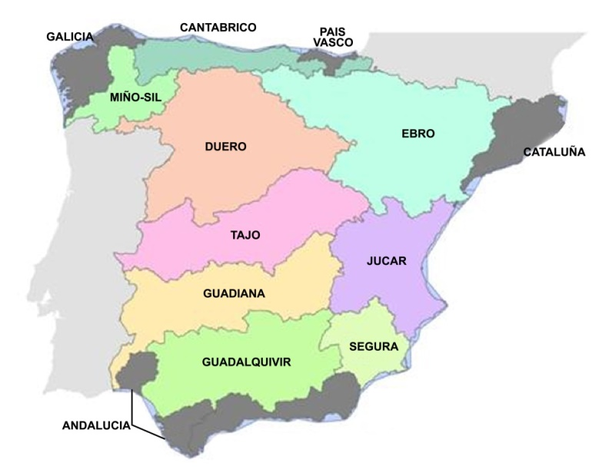

Table 2. Stream flows, storage capacity and environmental flows in basins.
Basin | Natural stream flows (Mm³/y) | Dam storage capacity  (Mm³) | Minimum environmental  flowsª (m³/s)
Segura | 740 | 1300 | 1
Jucar | 1700 | 3000 | 0,5
Guadiana | 4430 | 9600 | 3,5
Guadalquivir | 5750 | 8800 | 7
Tajo | 8200 | 11140 | 10
Duero | 12200 | 7550 | 116
Ebro | 14600 | 7600 | 107
ª Environmental flows at river mouth, or at border with Portugal for Tajo and Duero.

Figure 2. The Jucar River Basin
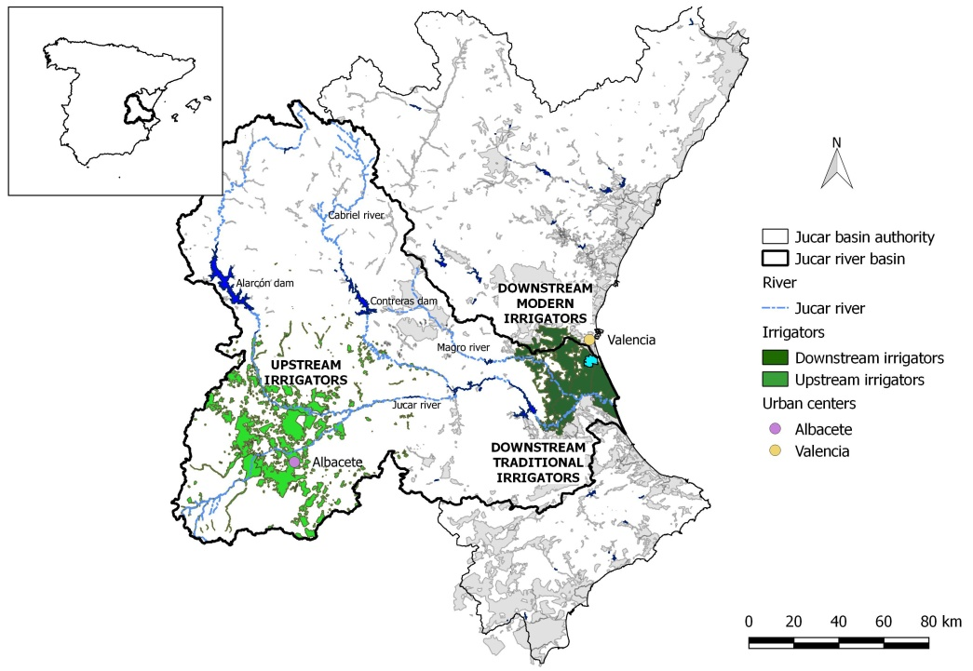

Figure 3. Annual stream flows in the Jucar River along La Mancha aquifer.
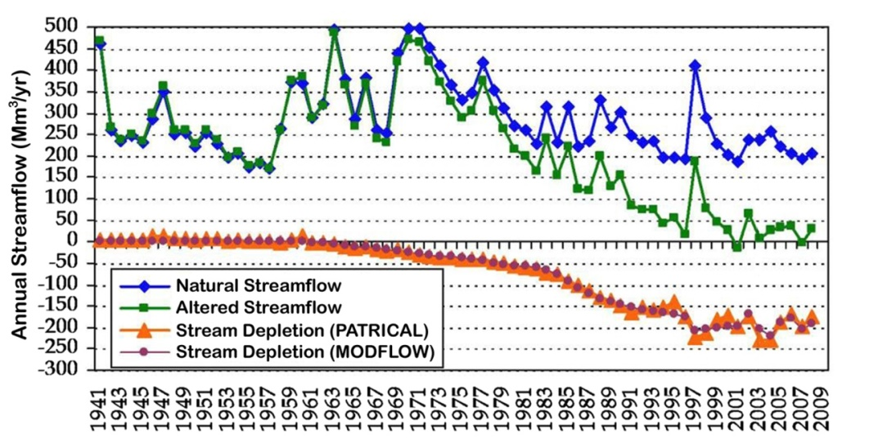

Source: Perez-Martin et al. (2014). The figure shows the natural and altered annual stream flows in the Jucar River stretch along La Mancha aquifer, and the pumping-induced stream depletion.

Figure 4. Organization of the Jucar Basin Authority.
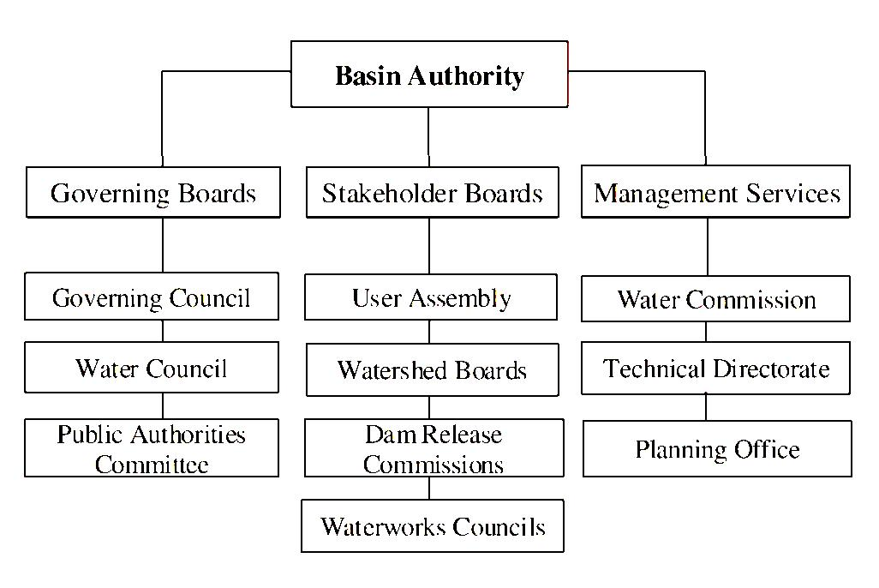

Table 3. Policies under drought: institutional, water markets, and water pricing.
Water Availability | Normal Year |  | Drought
Water Policy | Current policy  (Institutional cooperation) |  | Institutional cooperation | Water markets | Water  pricing
Water Use (Mm³)
Irrigation districts |  | 1030 | 683 | 683 | 683
EM |  | 399 | 304 | 316 | 316
CJT |  | 155 | 107 | 146 | 146
ARJ |  | 200 | 131 | 185 | 185
ESC |  | 33 | 18 | 31 | 31
RB |  | 243 | 123 | 4 | 4
Urban use |  | 119 | 74 | 74 | 74
Environmental flows to Albufera |  | 60 | 34 | 29 | 29
Private and Environmental Benefits (million Euros)
Private benefits
Irrigation districts | 190 |  | 136 | 148 | 54
EM | 80 |  | 61 | 62 | 31
CJT | 45 |  | 36 | 39 | 17
ARJ | 34 |  | 23 | 25 | 4
ESC | 7 |  | 4 | 5 | 2
RB | 24 |  | 12 | 17 | 0
Urban use | 283 |  | 241 | 241 | 241
Total | 473 |  | 377 | 389 | 295
Environmental benefits | 75 |  | 22 | 19 | 19
Social benefits | 548 |  | 399 | 408 | 314
(Top) Water allocations by sector in million cubic meters. (Bottom) Private and environmental benefits by sector in million Euros. EM: Eastern La Mancha, CJT: Canal Jucar-Turia, ARJ: Acequia Real del Jucar, ESC: Escalona, RB: Ribera Baja. Source: Kahil et al. (2016a).

Table 4. Water resources balance in the Jucar Basin (Mm³/y).
Period | Current (2015) | Future (2040)
Available resources | 1700 | 1500
Water demand | 1670 | 1530
Irrigation | 1400 | 1260
Industrial | 50 | 70
Urban | 220 | 200
Return flows | 360 | 325
Net water demand | 1310 | 1205
Difference | 390 | 295
Source: CHJ (2015).

