Could resource rents finance universal access to infrastructure?
A first exploration of needs and rents

SABINE FUSS, Corresponding Author
Mercator Research Institute on Global Commons and Climate Change, Torgauer Straße 12–15, 10829 Berlin, Germany. Email: fuss@mcc-berlin.net

CLAUDINE CHEN
Mercator Research Institute on Global Commons and Climate Change, Torgauer Straße 12–15, 10829 Berlin, Germany.

MICHAEL JAKOB
Mercator Research Institute on Global Commons and Climate Change, Torgauer Straße 12–15, 10829 Berlin, Germany; Potsdam Institute for Climate Change Impact Research, Telegrafenberg 31, 14473 Potsdam, Germany.

ANNIKA MARXEN
Mercator Research Institute on Global Commons and Climate Change, Torgauer Straße 12–15, 10829 Berlin, Germany; Technical University Berlin, Straße des 17. Juni 152, 10623 Berlin, Germany.

NARASIMHA D. RAO
International Institute for Applied Systems Analysis, Schlossplatz 1, A-2361 Laxenburg, Austria.

OTTMAR EDENHOFER
Mercator Research Institute on Global Commons and Climate Change, Torgauer Straße 12–15, 10829 Berlin, Germany; Technical University Berlin, Straße des 17. Juni 152, 10623 Berlin, Germany; Potsdam Institute for Climate Change Impact Research, Telegrafenberg 31, 14473 Potsdam, Germany.

Online Appendix

Figure 1. Share of population without access to (a) water, (b) sanitation, (c) electricity, (d) telecommunication. Panel (e) shows the share of unpaved roads in total roads. Countries with missing data are shaded in grey; white areas show countries with 100 per cent access.

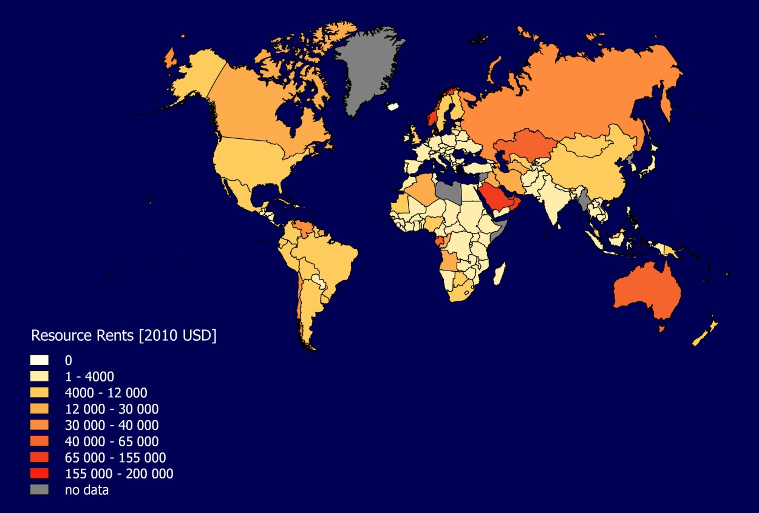
Figure 2. Natural resource rents from forests, oil, gas, coal, and minerals, extrapolated until 2030 based on WDI data. Rents were summed over the 15 year period from 2015 to 2030, and are represented per capita based on the estimated population in 2030. (White areas have no rents; grey areas have no data available).

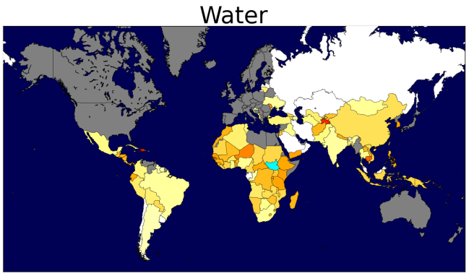 | 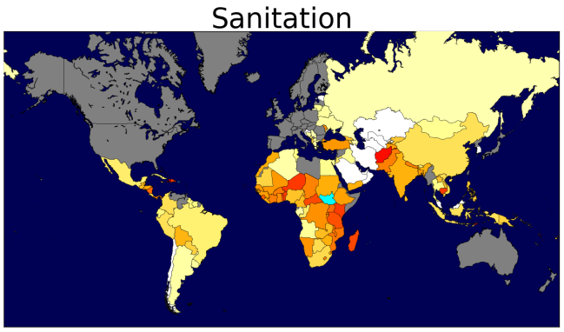 | 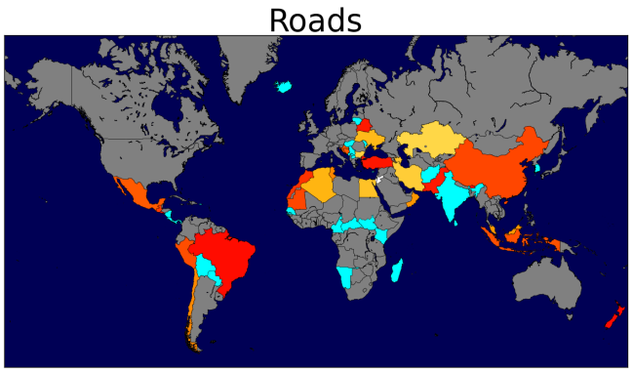
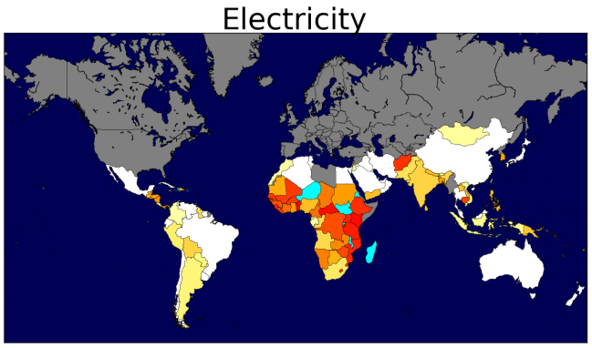 | 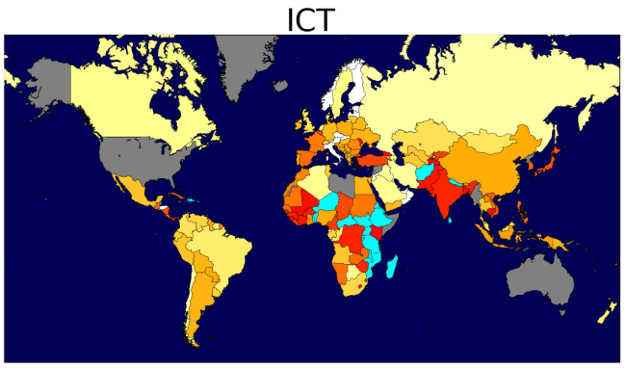

Figure 3. Share of total resource rents required to finance universal access to (a) water, (b) sanitation, (c) electricity, (d) telecommunication, and (e) transport. Scale is logarithmic.

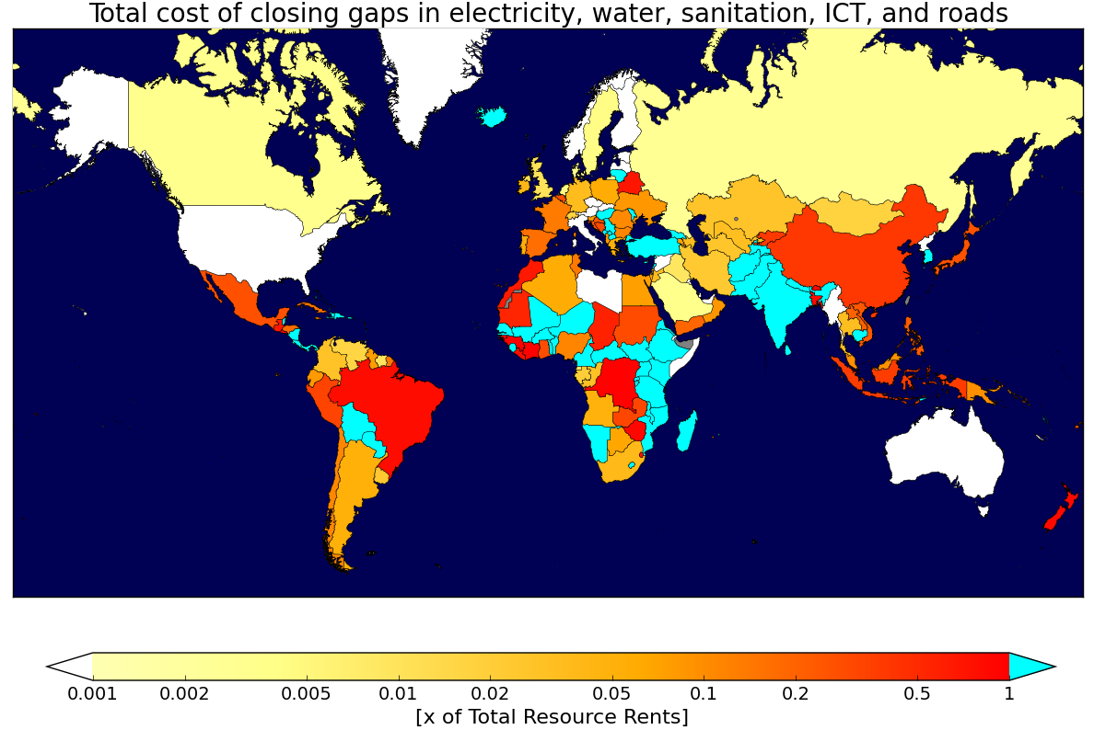
Figure 5. Total share of resource rents needed to simultaneously achieve universal access to electricity, water, sanitation and communications and to pave all unpaved roads. Scale is logarithmic.

