Supplementary Information for: ‘Land use futures in the Shared Socio-Economic Pathways’

1. Overview on integrated modeling frameworks
Here, we give an overview on the five integrated assessment frameworks and describe briefly how the respective land-use modules interact with the energy and economy modules. More detailed descriptions of the models and specifically of the land-use modules can be found in the model specific papers in this issue (Calvin et al., this Special Issue, Fricko et al, this Special Issue, Fujimori et al, this Special Issue, Kriegler et al , this Special Issue, van Vuuren et al., this Special Issue).

The ReMIND/MAgPIE integrated assessment framework (Popp et al., 2011) provides a consistent system for the evaluation of potentials and conflicts between demographic and economic development, food production and land based mitigation in different world regions. It consists of a global dynamic vegetation and water balance model, a global land and water use model, and a global energy–economy–climate model. The vegetation and hydrology model LPJmL (Bondeau et al., 2007) supplies spatially explicit agricultural yields, carbon contents and water fluxes. MagPIE (Lotze-Campen et al. 2008, Popp et al. 2014) takes the spatially explicit data from LPJmL, as well as regional economic conditions such as demand for agricultural commodities, trade, level of agricultural technology, and production costs into account and derives specific land use patterns, rates of future agricultural yield increases, GHG emissions from agricultural production and land use change and total costs of agricultural production for each grid cell. The energy–economy–climate model ReMIND (Luderer et al., 2013) generates demand for bioenergy, taking into account the direct competition with other energy technology options. ReMIND and MAgPIE are coupled by exchanging price and demand information on bioenergy, GHG prices and emissions from land use and land use change. Finally, all emissions from MAgPIE and ReMIND (land use, energy supply, industry, transport, residential and commercial) are fed into the MAGICC model in order to compute climate change outcomes.

The GCAM integrated assessment model links modules of the economy, the energy system, the agriculture and land-use system, and the climate. The agriculture and land-use component (Wise et al., 2014) determines supply, demand, and prices for 12 crop and forestry categories, 6 animal categories, and bioenergy based on expected profitability. Additionally, the model determines the land allocation of these categories, as well as pastureland, grassland, shrubland, and non-commercial forestland. GCAM includes both irrigated and rainfed options for all crop categories, and the use of irrigation depends on the price of the commodity and the cost of the irrigation water, among other factors. Supply and land-use is resolved for 283 world regions, while demand is resolved for 32 world regions. Within each of the 283 model regions, land is allocated economically based on profit maximization with an assumption of non-linear distributions of profits for each competing use. Demand for bioenergy is determined by the energy system component of GCAM, which is fully integrated with the agriculture and land use component. GCAM allows for global trade in crops, forestry, and bioenergy. In addition to computing land-use change CO2 emissions, emissions from land use (e.g., crop and bioenergy production, agriculture waste burning, meat production, savannah burning, forest fires) are tracked for 8 gases and species (CH4, N2O, NH3, VOCs, NOx, SO2, BC, OC). Mitigation of CH4 and N2O from crop, bioenergy, and meat production is considered under a carbon price, using marginal abatement cost curves.

The IMAGE framework (Stehfest et al. 2014) describes various global environmental change issues using a set of linked submodels describing the energy system, the agricultural economy and land use, natural vegetation and the climate system. The socio-economic models distinguish 26 world regions, while the natural ecosystems mostly work at a 5 x 5 minutes and 30 x 30 minutes grid. Agricultural demand, production and trade is modelled via the MAGNET model (Woltjer et al. 2014), which is integral part of the IMAGE framework in most scenario studies. The use of bio-energy plays a role at several components of the IMAGE system. First of all, the potential for bio-energy is determined using the land use model, taking into account several sustainability criteria, i.e. the exclusion of forests areas, agricultural areas and nature reserves (see van Vuuren et al., 2009). In the energy submodel, the demand for bio-energy is assessed by describing the cost-based competition of bio-energy versus other energy carriers (mostly in the transport, electricity production, industry and the residential sectors). The resulting demand for bio-energy crops is combined with the demand for other agricultural products within a region to determine future land use. For this, the LPJml model is used, determining yields as a function of land and climate conditions and assumed changes in technology. Based on these spatially explicit attainable yields, and other suitability considerations, land use is allocated on the grid level. Finally, the emissions associated with land use and land-use change and the energy system are used in the climate model (MAGICC-6) to determine climate change, which then affects all biophysical submodels.

The AIM/CGE builds on the work by Fujimori et al. (2012) and was recently used in several climate change studies (Hasegawa et al. (in press)) In the model, supply, demand, investment, and trade are described by individual behavioral functions that respond to changes in the prices of production factors and commodities, as well as changes in technology and preference parameters on the basis of assumed population, GDP, and consumer preferences. Production functions are formulated as multi-nested constant elasticity substitution (CES) functions. Household demand is formulated as a linear expenditure system function. For trade, substitution between domestic and imported commodities is based on the Armington assumption, and the CES function is used for the aggregation of domestic and imported commodities. Disaggregation between exports and domestic supply is described by a constant elasticity transformation function. A single international trade market is assumed for each traded commodity. The model incorporates the following five mechanisms for GHG emission reductions: (1) substitution of energy with capital, caused by increased energy costs due to carbon prices; (2) bioenergy production; (3) power production by wind, solar and geothermal energy; (4) use of carbon capture and storage technology; and (5) measures to abate GHG emissions from non-energy sources. Possible feedstocks for ligno-cellulosic bioenergy would include crop residues, but also purpose-grown grasses (e.g., miscanthus, switchgrass). Allocation of land by sector is formulated as a multi-nominal logit function (Fujimori et al. 2014) to reflect differences in substitutability across land categories with land rent. The model contains 17 regions and countries and 42 sectors, including 10 agricultural ones
MESSAGE-GLOBIOM. The Global Biosphere Optimization Model (GLOBIOM, Havlík et al. (2014)) is a partial-equilibrium model which represents various land-use based activities, including agriculture, forestry and bioenergy sectors. The model is built following a bottom-up setting based on detailed grid-cell information, providing the biophysical and technical cost information. This detailed structure allows taking into account a rich set of environmental parameters. Its spatial equilibrium modelling approach represents bilateral trade based on cost competitiveness. The model was initially developed mostly for integrated assessment of climate change mitigation policies in land based sectors, including biofuels, and is increasingly being implemented also for agricultural and timber markets foresight, and economic impacts analysis of climate change and adaptation. Three sources of lignucellulosic biomas for energy production are considered: short rotation tree plantations, managed forests and forest industry residues. For a comprehensive AFOLU assessment, GLOBIOM is coupled with the G4M model (Kindermann et al. 2006). The Global Forest Model (G4M) estimates the impact of forestry activities (afforestation, deforestation and forest management) on biomass and carbon stocks. The main forest management options considered by G4M are variation of thinning and choice of rotation length. As outputs, G4M produces estimates of forest area change, carbon sequestration and emissions in forests. In this study, direct emissions from agriculture and other land use are provided by GLOBIOM while emissions from afforestation, deforestation and forest management are provided by G4M. A reduced form of GLOBIOM/G4M is emulated through two dimensional scenarios along CO2 prices and biomass demand levels for each SSP. This reduced form of GLOBIOM/G4M is then integrated in MESSAGE to estimate the competitive mitigation efforts required from the AFOLU sector as well as the amount of biomass for energy production. Finally, the CO2 prices and biomass demand compatible with alertnative RCPs is fed back from MESSAGE to GLOBIOM which generates the final LU related projections.

References
Bondeau, A., Smith, P.C., Zaehle, S., Schaphoff, S., Lucht, W., Cramer, W., Gerten, D., Lotze-Campen, H., Müller, C., Reichstein, M., Smith, B., 2007. Modelling the role of agriculture for the 20th century global terrestrial carbon balance. Glob. Change Biol. 13, 679–706.
Calvin, K. et al., 2016. SSP4: A World of Inequality. Global Environ. Change, this Special Issue.
Fricko et al. 2016. SSP2: A middle of the road scenario for the 21st century. Global Environ. Change, this Special Issue.
Fujimori S, Masui T and Matsuoka Y. 2012. AIM/CGE [basic] manual Discussion paper series (Vol. 2012-01), Center for Social and Environmental Systems Research, National Institute Environemntal Studies. Retrieved from: http://www.nies.go.jp/social/dp/pdf/2012-01.pdf.
Fujimori S, Hasegawa T, Masui T and Takahashi K 2014 Land use representation in a global CGE model for long-term simulation: CET vs. logit functions Food Sec. 6, 5, 685-99.
Fujimori, S. et al. 2016 Global Environ. Change, SSP3: AIM Implementation of Shared Socioeconomic Pathways, this Special Issue.
Hasegawa T, Fujimori S, Shin Y, Tanaka A, Takahashi K and Masui T in press Consequence of Climate Mitigation on the Risk of Hunger Environmental Science & Technology.
Havlík, P., Valin, H., Herrero, M., Obersteiner, M., Schmid, E., Rufino, M.C., Mosnier, A., Thornton, P.K., Böttcher, H., Conant, R.T., Frank, S., Fritz, S., Fuss, S., Kraxner, F., Notenbaert, A., 2014. Climate change mitigation through livestock system transitions. Proc. Natl. Acad. Sci. 111, 3709–3714. doi:10.1073/pnas.1308044111
Kindermann, G.E., Obersteiner, M., Rametsteiner, E., McCallum, I., 2006. Predicting the deforestation-trend under different carbon-prices. Carbon Balance Manag. 1, 15. doi:10.1186/1750-0680-1-15
Kriegler, E. et al 2016. Fossil-fueled development (SSP5): an emission, energy and resource intensive reference scenario for the 21st century, Global Environ. Change, this Special Issue
Lotze-Campen, H., Müller, C., Bondeau, A., Rost, S., Popp, A., Lucht, W., 2008. Global food demand, productivity growth, and the scarcity of land and water resources: a spatially explicit mathematical programming approach. Agric. Econ. 39, 325–338.
Luderer, G., Leimbach, M., Bauer, N., Kriegler, E., Aboumahboub, T., Arroyo Curras, T., Baumstark, L., Bertram, C., Giannousakis, A., Hilaire, J., Klein, D., Mouratiadou, I., Pietzcker, R., Piontek, F., Roming, N., Schultes, A., Schwanitz, V.J., Strefler, J., 2013a. Description of the REMIND model (Version 1.5). Potsdam Institute for Climate Impact Research, Potsdam, Germany.
Popp, A., Humpenöder, F., Weindl, I., Bodirsky, B.L., Bonsch, M., Lotze-Campen, H., Müller, C., Biewald, A., Rolinski, S., Stevanovic, M., Dietrich, J.P., 2014. Land-use protection for climate change mitigation. Nat. Clim. Change 4, 1095–1098.
Stehfest, E., van Vuuren, D., Kram, T., Bouwman, L., Alkemade, R., Bakkenes, M., Biemans, H., Bouwman, A., den Elzen, M., Janse, J., Lucas, P., van Minnen, J., Müller, M., Prins, A. (2014), Integrated Assessment of Global Environmental Change with IMAGE 3.0. Model description and policy applications, The Hague: PBL Netherlands Environmental Assessment Agency.
van Vuuren, D.P. et al, (2016) Energy, land-use and greenhouse gas emissions trajectories under a green growth paradigm. Global Environ. Change, this Special Issue
van Vuuren, D.P., van Vliet, J., Stehfest, E., 2009. Future bio-energy potential under various natural constraints. Energy Policy 37, 4220–4230. doi:10.1016/j.enpol.2009.05.029
Wise, M., Calvin, K. V., Kyle, G. P., Luckow, P., and Edmonds, J. A. (2014) Economic and physical modeling of land use in GCAM 3.0 and an application to agricultural productivity, land, and terrestrial carbon, Climate Change Economics, 5, 1450003, doi:10.1142/S2010007814500031, 2014.
Woltjer GB, Kuiper M, Kavallari A, van Meijl H, Powell J, Rutten M, Shutes L and Tabeau A (2014). The Magnet Model – Module description. LEI, part of Wageningen University and Research Centre, The Hague.

2. Additional results
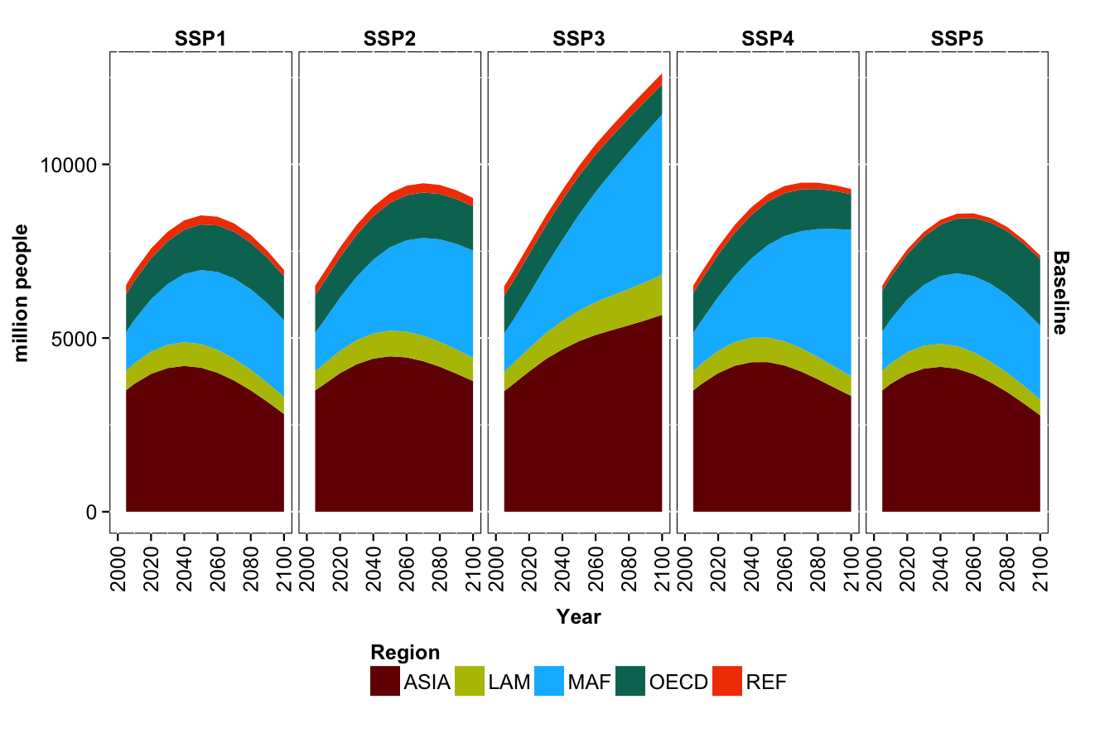
Fig SI1: Regional population dynamics of the five SSP marker scenarios (based on Lutz et al. 2014). Data is shown are for five aggregate regions: (1) OECD90 countries (OECD), (2) reforming economies of Eastern Europe and the Former Soviet Union (REF), (3) countries of the Middle East and Africa (MAF), (4) countries of Latin America and the Caribbean (LAM) and (5) Asian countries with the exception of the Middle East, Japan and Former Soviet Union states (ASIA).

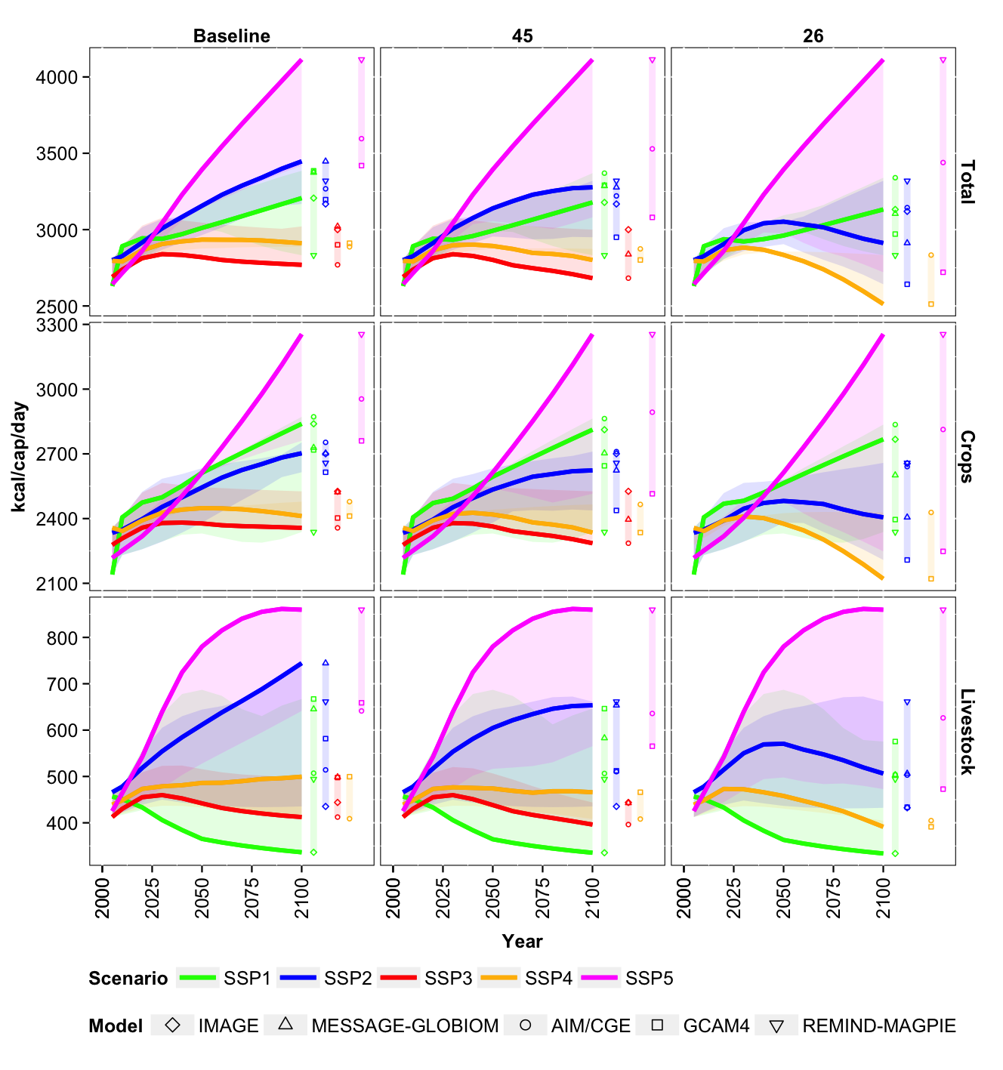
Fig SI2: Global per capita demand [kcal/cap/day] for crop (upper row) and livestock products (lower row) of the five SSP marker scenarios for the baseline (left column), RCP4.5 (middle column) and RCP2.6 (right column) cases. Colored lines indicate the marker model results for each SSP. Colored bars indicate the range of data in 2100 across all marker and non-marker projections for each SSP (models are depicted by icon).

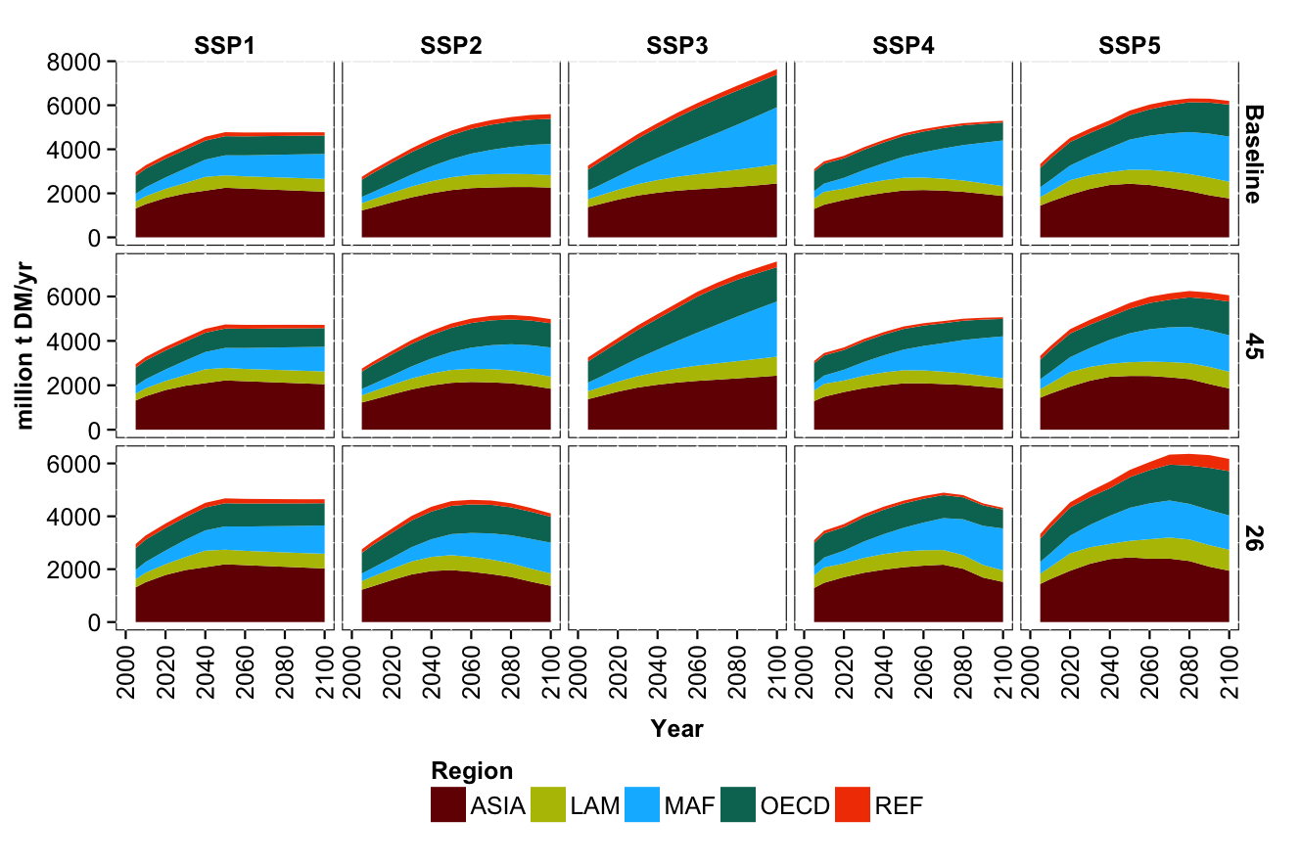
Fig SI3: Total regional demand for food and feed crops of the five SSP marker scenarios for the baseline (upper row), RCP4.5 (middle row) and RCP2.6 (lower row) cases. Data is shown are for five aggregate regions: (1) OECD90 countries (OECD), (2) reforming economies of Eastern Europe and the Former Soviet Union (REF), (3) countries of the Middle East and Africa (MAF), (4) countries of Latin America and the Caribbean (LAM) and (5) Asian countries with the exception of the Middle East, Japan and Former Soviet Union states (ASIA).

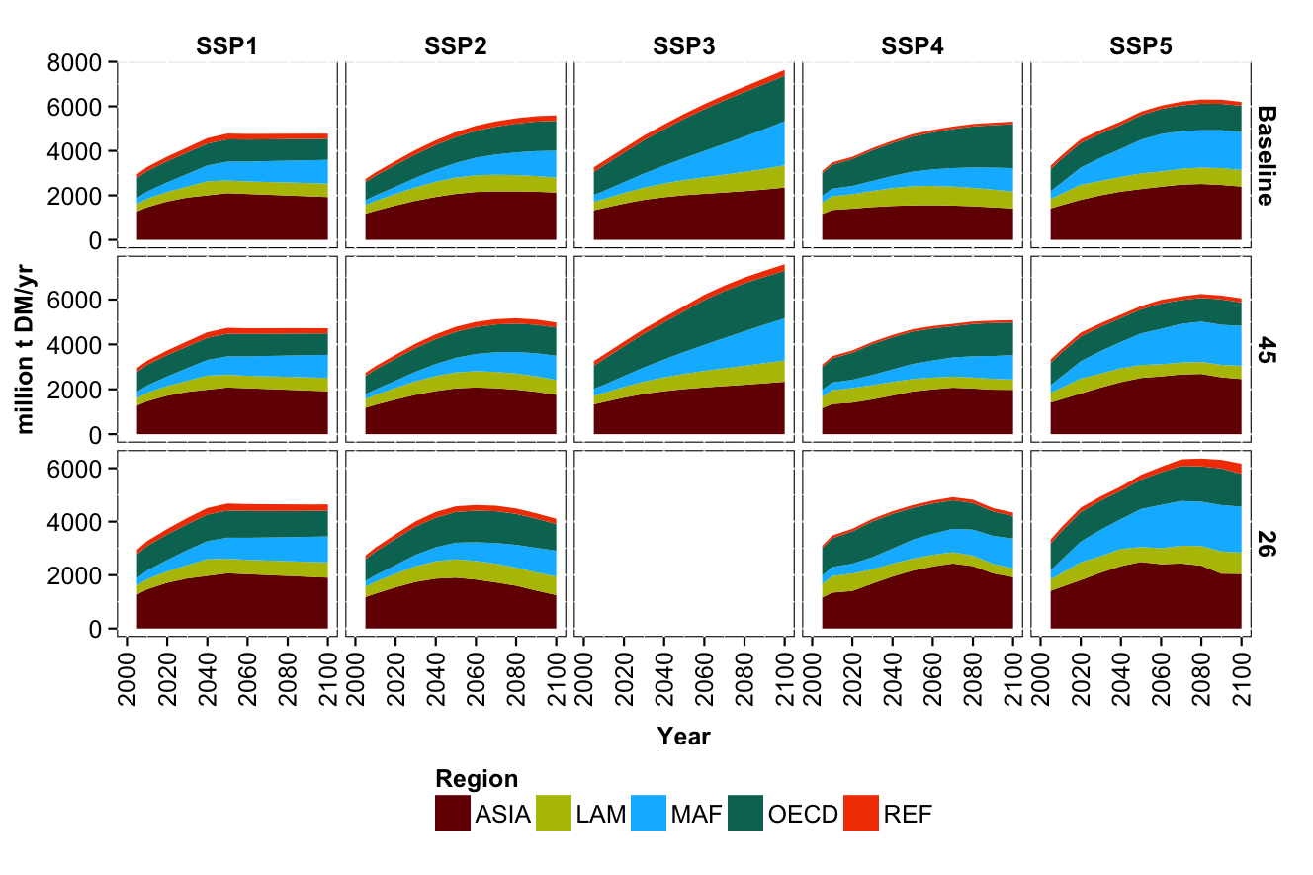
Fig SI4: Regional production for food and feed crops of the five SSP marker scenarios for the baseline (upper row), RCP4.5 (middle row) and RCP2.6 (lower row) cases. Data is shown are for five aggregate regions: (1) OECD90 countries (OECD), (2) reforming economies of Eastern Europe and the Former Soviet Union (REF), (3) countries of the Middle East and Africa (MAF), (4) countries of Latin America and the Caribbean (LAM) and (5) Asian countries with the exception of the Middle East, Japan and Former Soviet Union states (ASIA).

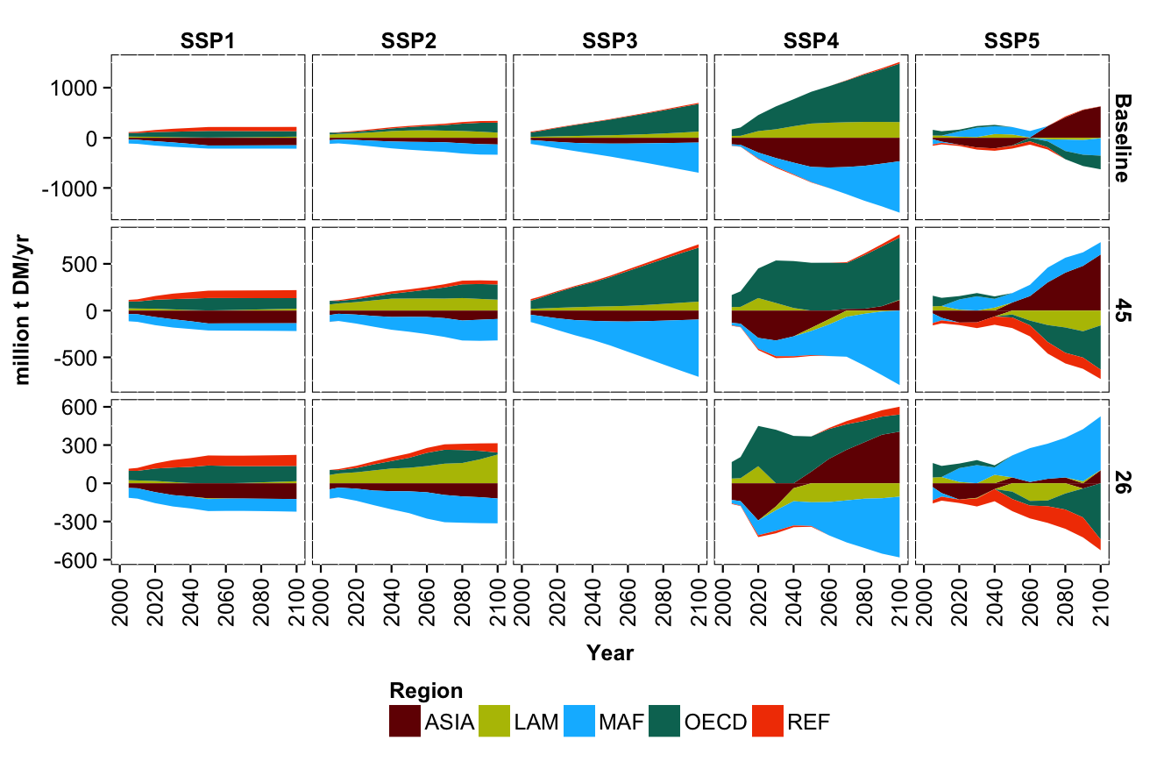
Fig SI5: Agricultural net trade of food and feed crops of the five SSP marker scenarios for the baseline (upper row), RCP4.5 (middle row) and RCP2.6 (lower row) cases. Data is shown are for five aggregate regions: (1) OECD90 countries (OECD), (2) reforming economies of Eastern Europe and the Former Soviet Union (REF), (3) countries of the Middle East and Africa (MAF), (4) countries of Latin America and the Caribbean (LAM) and (5) Asian countries with the exception of the Middle East, Japan and Former Soviet Union states (ASIA).

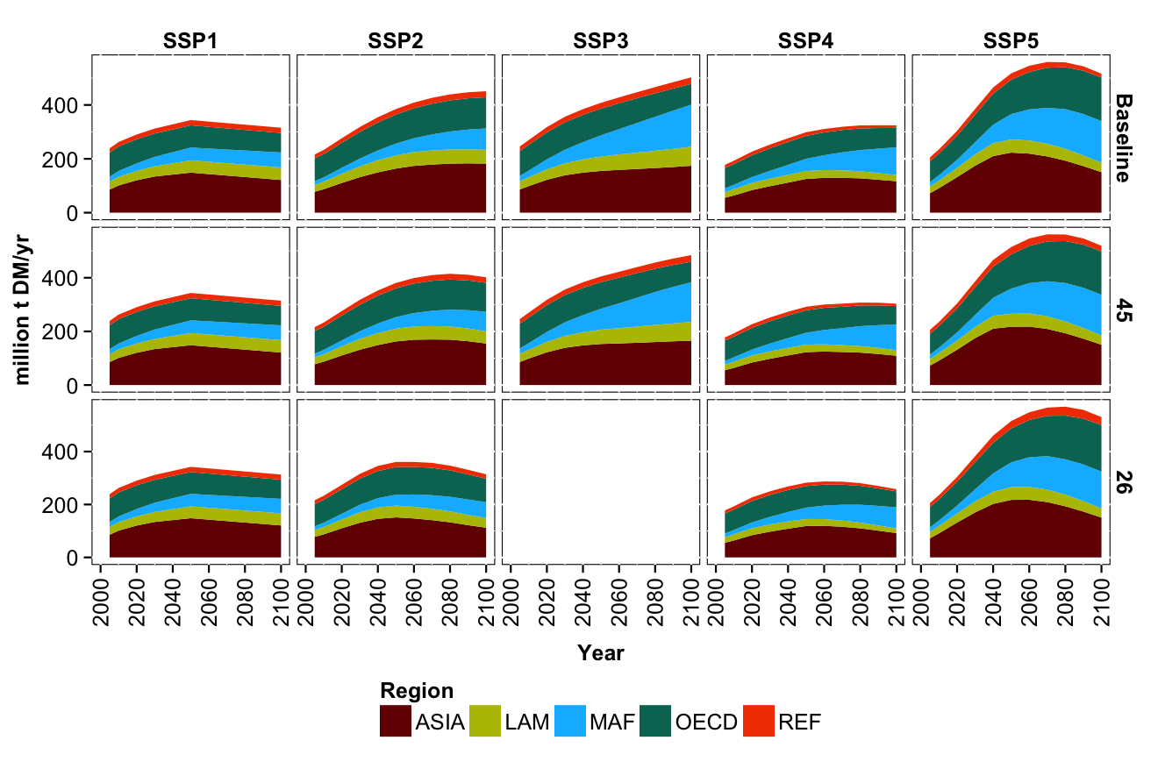
Fig SI6: Regional demand for livestock products of the five SSP marker scenarios for the baseline (upper row), RCP4.5 (middle row) and RCP2.6 (lower row) cases. Data is shown are for five aggregate regions: (1) OECD90 countries (OECD), (2) reforming economies of Eastern Europe and the Former Soviet Union (REF), (3) countries of the Middle East and Africa (MAF), (4) countries of Latin America and the Caribbean (LAM) and (5) Asian countries with the exception of the Middle East, Japan and Former Soviet Union states (ASIA).

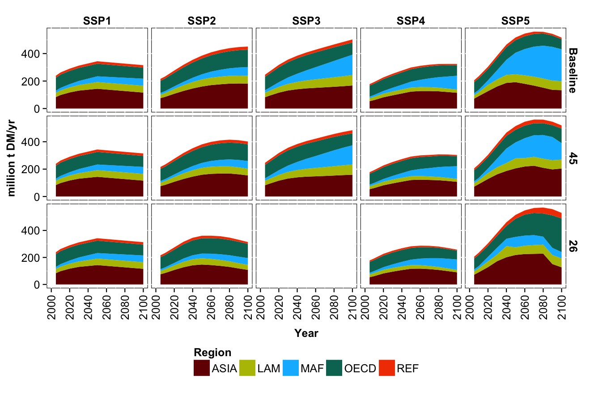
Fig SI7: Regional production of livestock products of the five SSP marker scenarios for the baseline (upper row), RCP4.5 (middle row) and RCP2.6 (lower row) cases. Data is shown are for five aggregate regions: (1) OECD90 countries (OECD), (2) reforming economies of Eastern Europe and the Former Soviet Union (REF), (3) countries of the Middle East and Africa (MAF), (4) countries of Latin America and the Caribbean (LAM) and (5) Asian countries with the exception of the Middle East, Japan and Former Soviet Union states (ASIA).

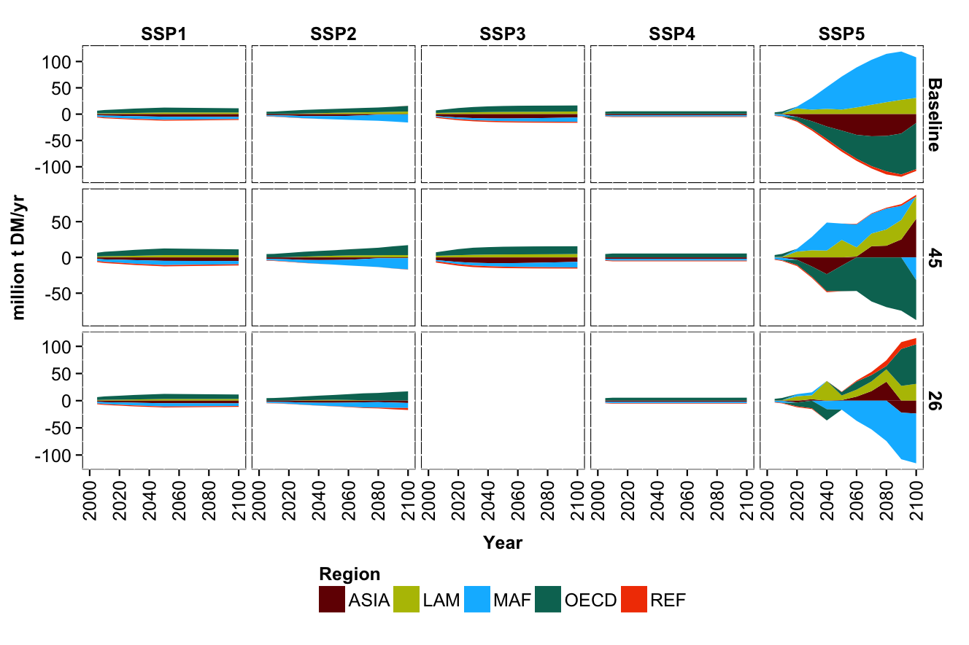
Fig SI8: Agricultural net trade of livestock products of the five SSP marker scenarios for the baseline (upper row), RCP4.5 (middle row) and RCP2.6 (lower row) cases. Data is shown are for five aggregate regions: (1) OECD90 countries (OECD), (2) reforming economies of Eastern Europe and the Former Soviet Union (REF), (3) countries of the Middle East and Africa (MAF), (4) countries of Latin America and the Caribbean (LAM) and (5) Asian countries with the exception of the Middle East, Japan and Former Soviet Union states (ASIA).

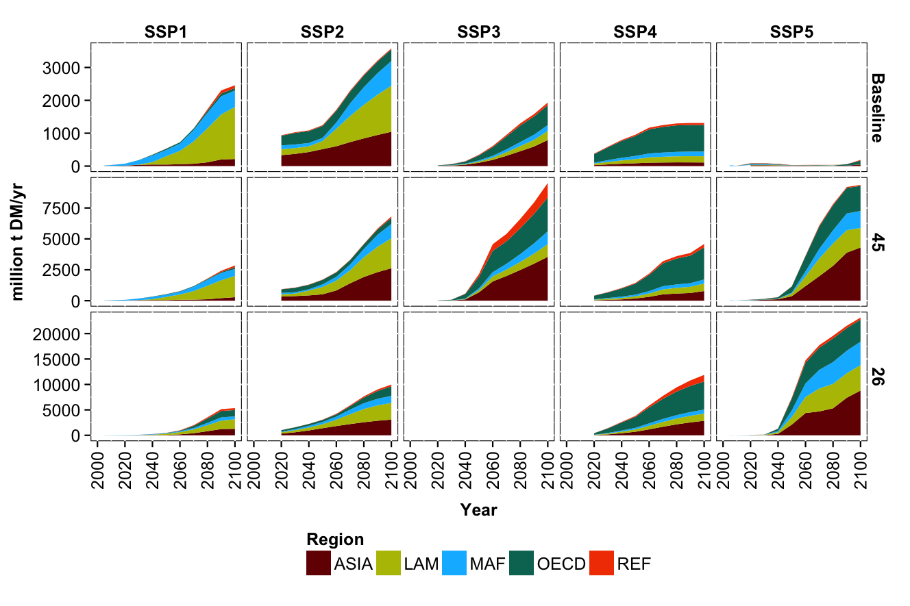
Fig SI9: Regional production of dedicated 2nd generation bioenergy crops of the five SSP marker scenarios for the baseline (upper row), RCP4.5 (middle row) and RCP2.6 (lower row) cases. Data is shown are for five aggregate regions: (1) OECD90 countries (OECD), (2) reforming economies of Eastern Europe and the Former Soviet Union (REF), (3) countries of the Middle East and Africa (MAF), (4) countries of Latin America and the Caribbean (LAM) and (5) Asian countries with the exception of the Middle East, Japan and Former Soviet Union states (ASIA).

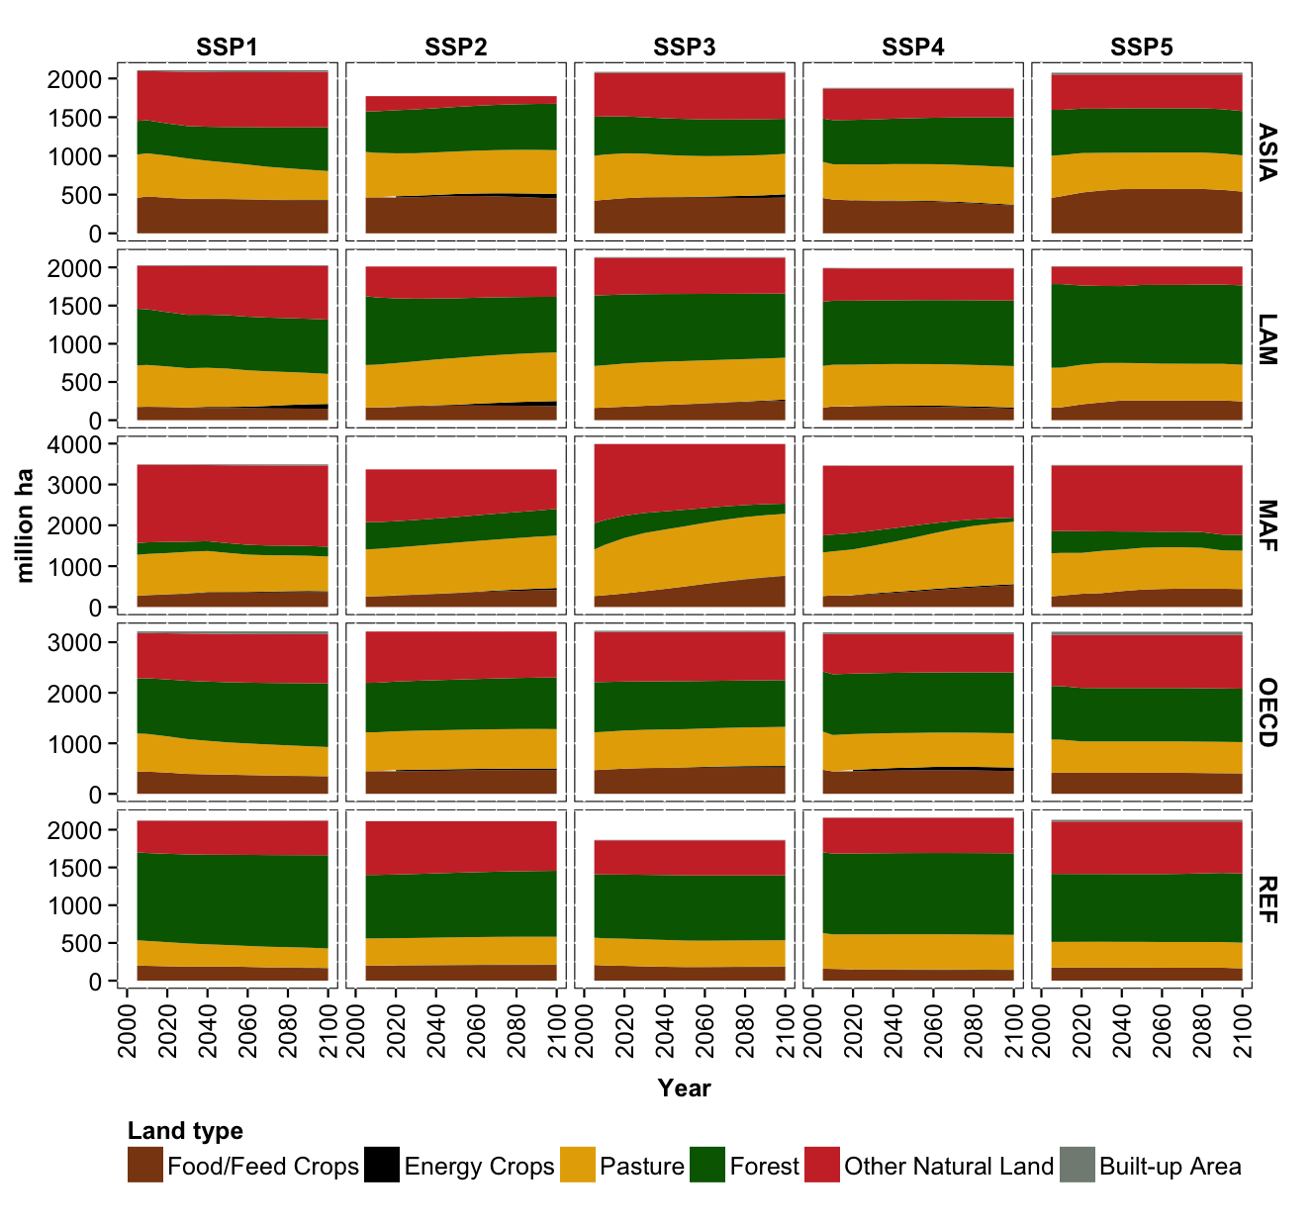
Fig SI10: Regional land use dynamics of the five SSP marker scenarios for the baseline case. Results are shown are for five aggregate regions: (1) OECD90 countries (OECD), (2) reforming economies of Eastern Europe and the Former Soviet Union (REF), (3) countries of the Middle East and Africa (MAF), (4) countries of Latin America and the Caribbean (LAM) and (5) Asian countries with the exception of the Middle East, Japan and Former Soviet Union states (ASIA).

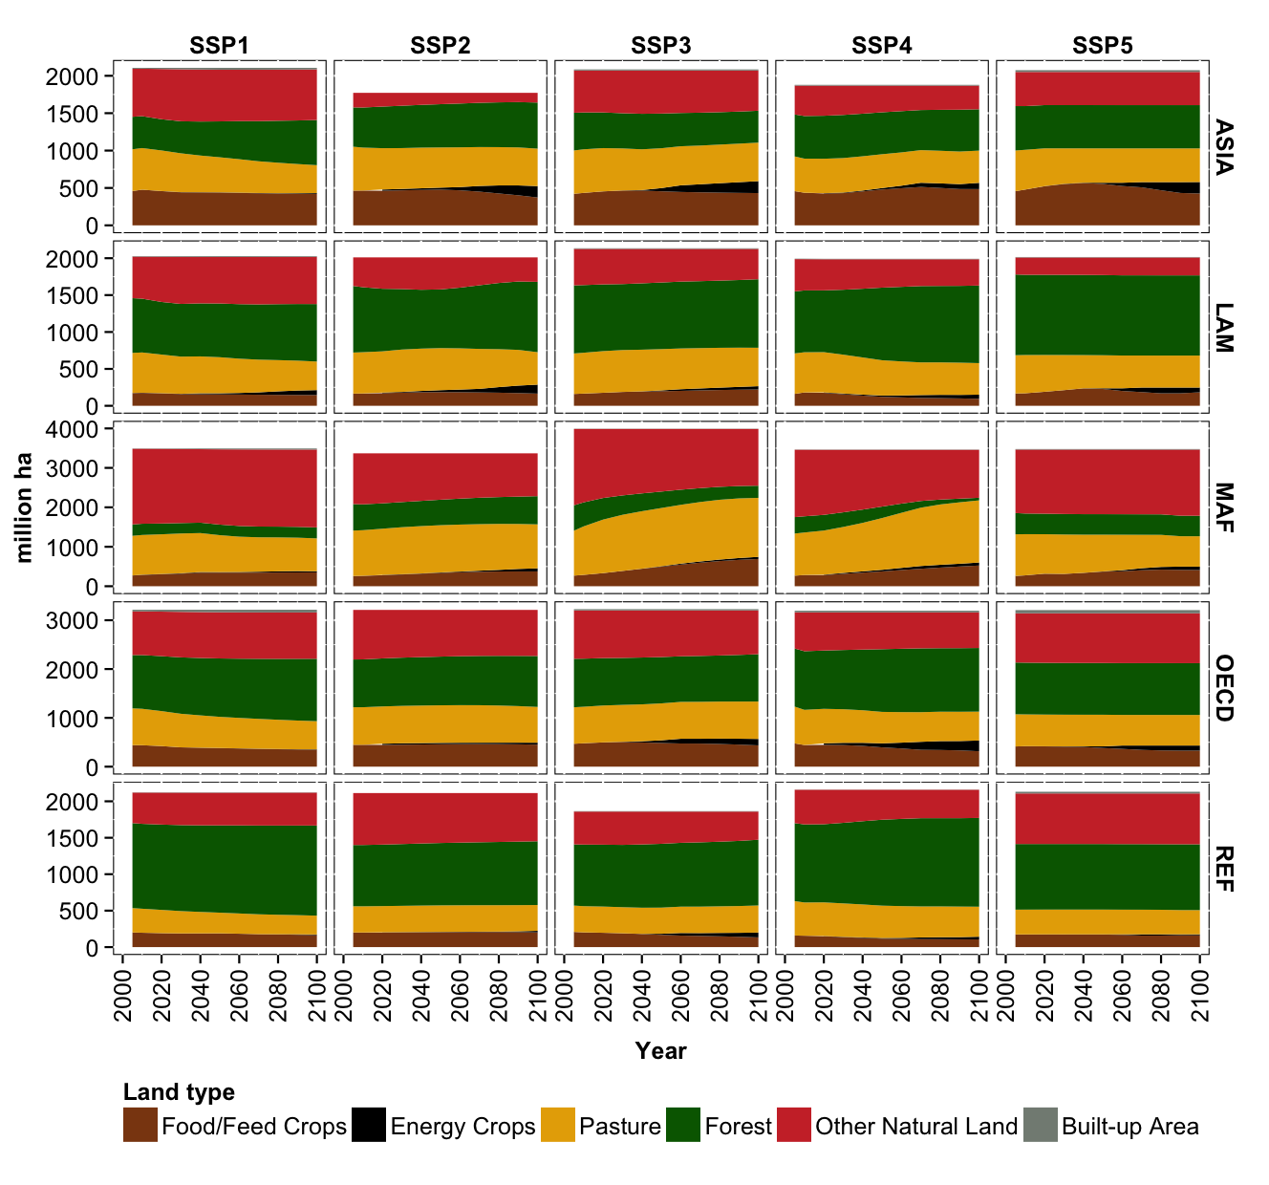
Fig SI11: Regional land use dynamics of the five SSP marker scenarios for the RCP4.5 case. Results are shown are for five aggregate regions: (1) OECD90 countries (OECD), (2) reforming economies of Eastern Europe and the Former Soviet Union (REF), (3) countries of the Middle East and Africa (MAF), (4) countries of Latin America and the Caribbean (LAM) and (5) Asian countries with the exception of the Middle East, Japan and Former Soviet Union states (ASIA).

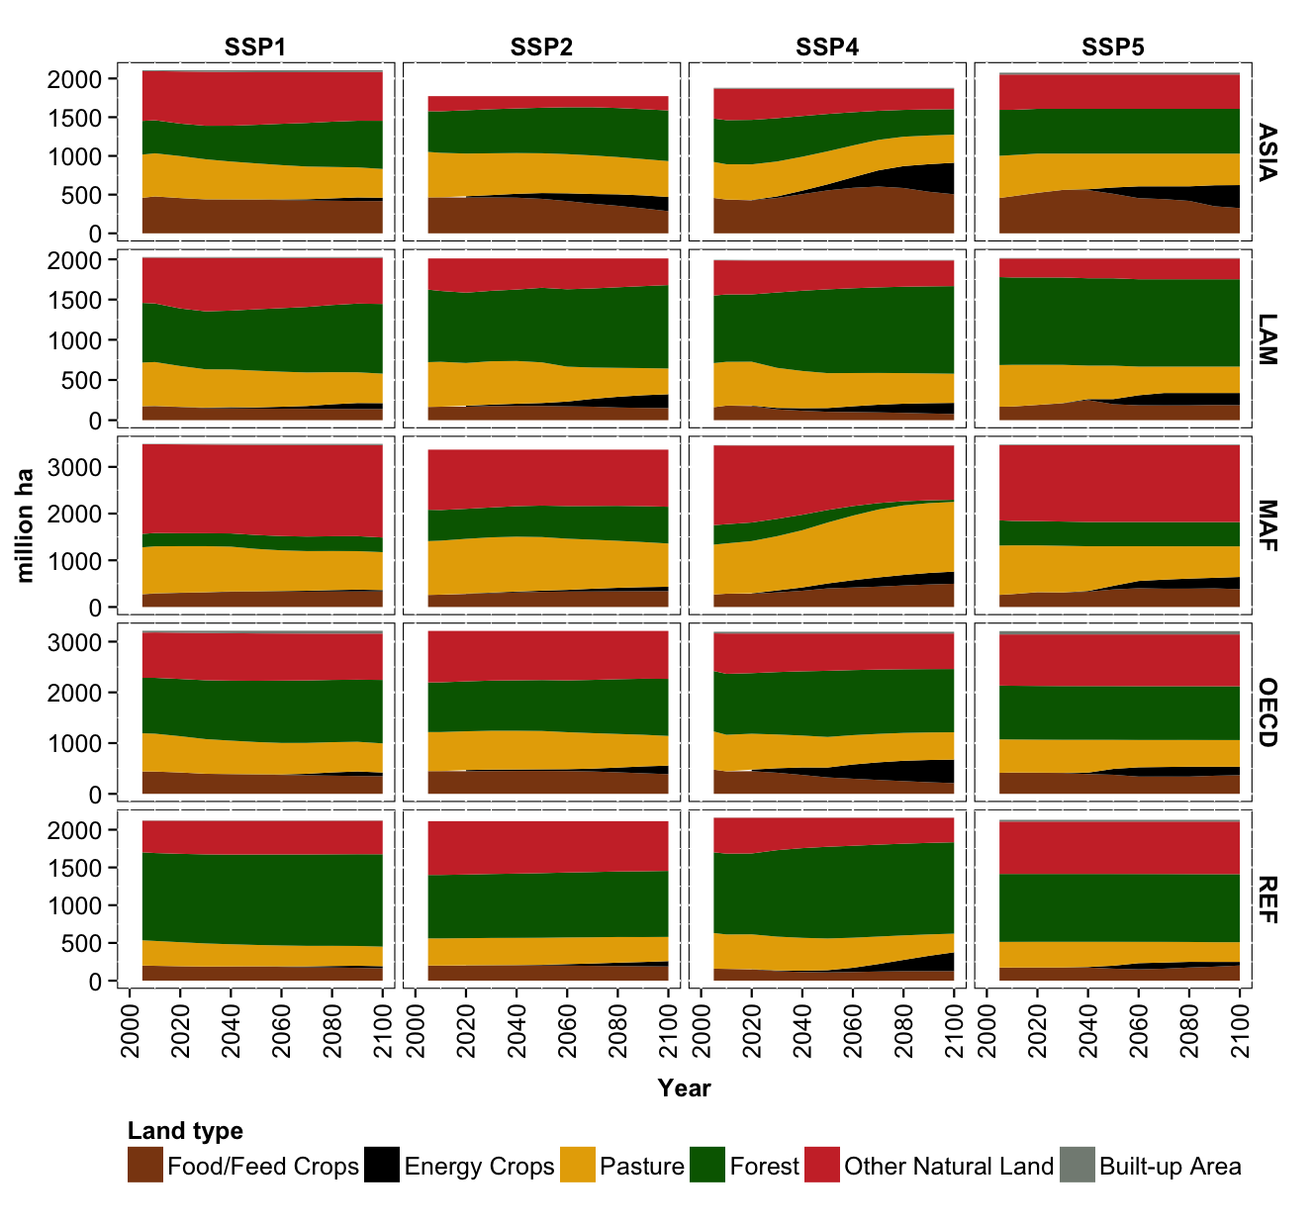
Fig SI12: Regional land use dynamics of the five SSP marker scenarios for the RCP2.6 case. Results are shown are for five aggregate regions: (1) OECD90 countries (OECD), (2) reforming economies of Eastern Europe and the Former Soviet Union (REF), (3) countries of the Middle East and Africa (MAF), (4) countries of Latin America and the Caribbean (LAM) and (5) Asian countries with the exception of the Middle East, Japan and Former Soviet Union states (ASIA).

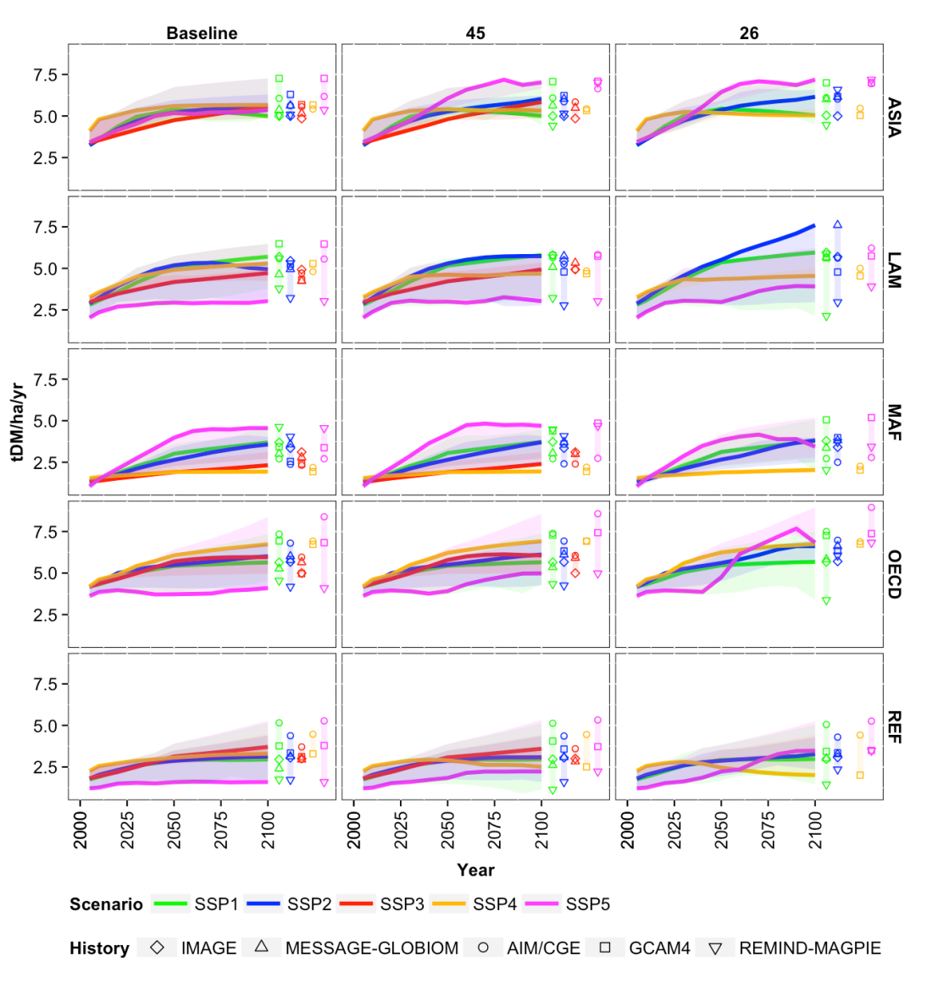
Fig SI13: Regional cereal crop yields of the five SSP marker scenarios for the baseline (left column), RCP4.5 (middle column) and RCP2.6 (right column) cases. Results are shown for five aggregate regions: (1) OECD90 countries (OECD), (2) reforming economies of Eastern Europe and the Former Soviet Union (REF), (3) countries of the Middle East and Africa (MAF), (4) countries of Latin America and the Caribbean (LAM) and (5) Asian countries with the exception of the Middle East, Japan and Former Soviet Union states (ASIA). Colored lines indicate the marker model results for each SSP. Colored bars indicate the range of data in 2100 across all marker and non-marker projections for each SSP (models are depicted by icon).
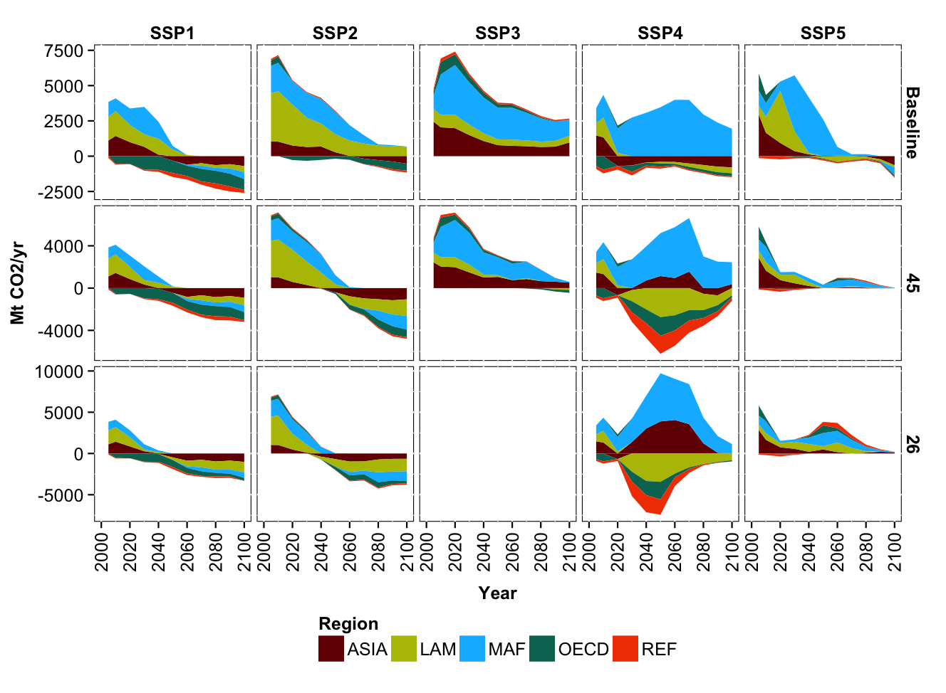
Fig SI14: Regional carbon dynamics from land use change of the five SSP marker scenarios for the baseline (upper row), RCP4.5 (middle row) and RCP2.6 (lower row) cases. Data is shown for five aggregate regions: (1) OECD90 countries (OECD), (2) reforming economies of Eastern Europe and the Former Soviet Union (REF), (3) countries of the Middle East and Africa (MAF), (4) countries of Latin America and the Caribbean (LAM) and (5) Asian countries with the exception of the Middle East, Japan and Former Soviet Union states (ASIA).
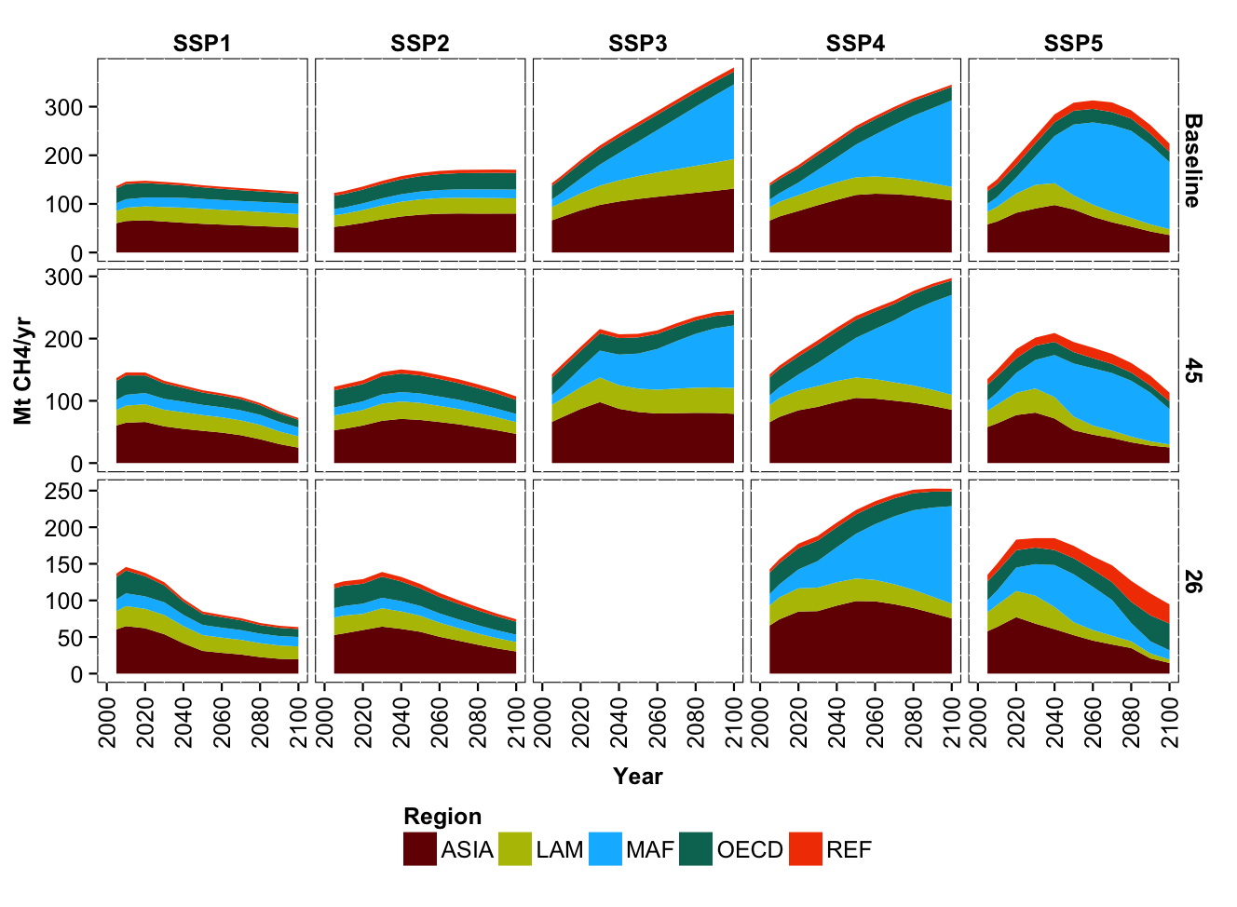
Fig SI15: Regional methane emissions from agricultural production of the five SSP marker scenarios for the baseline (upper row), RCP4.5 (middle row) and RCP2.6 (lower row) cases. Data is shown for five aggregate regions: (1) OECD90 countries (OECD), (2) reforming economies of Eastern Europe and the Former Soviet Union (REF), (3) countries of the Middle East and Africa (MAF), (4) countries of Latin America and the Caribbean (LAM) and (5) Asian countries with the exception of the Middle East, Japan and Former Soviet Union states (ASIA).

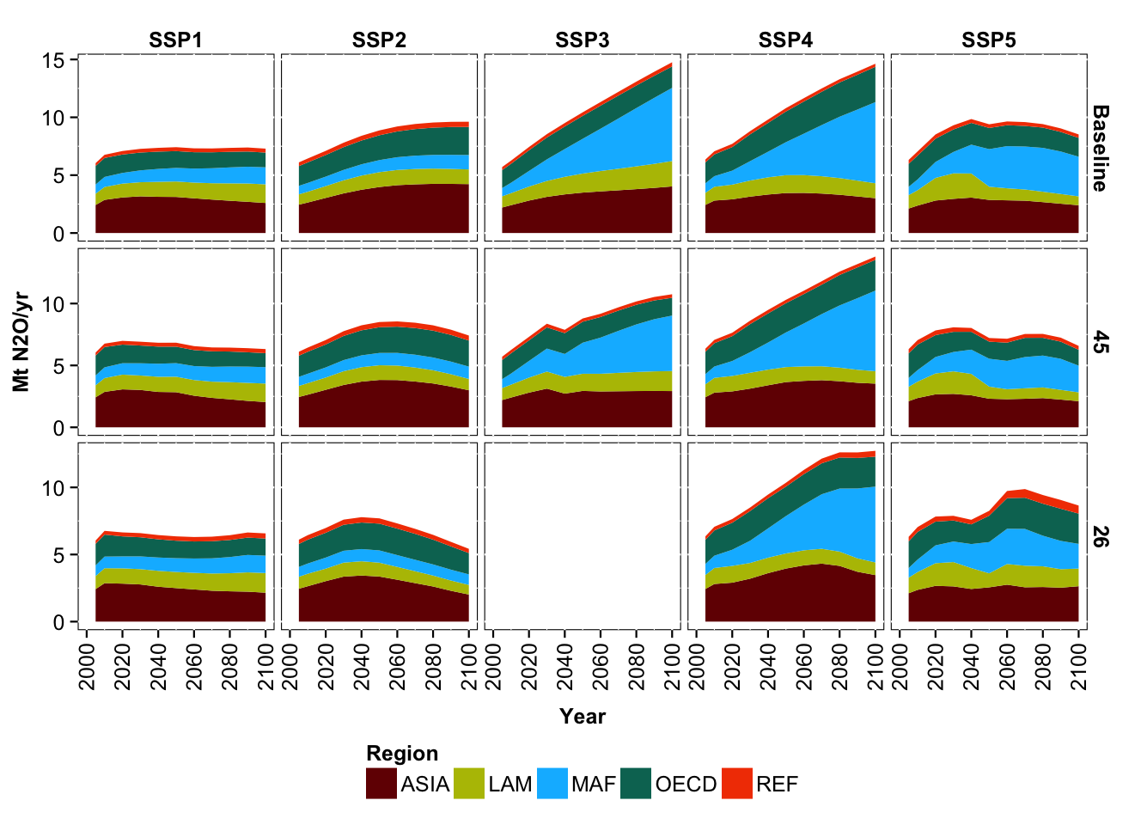
Fig SI16: Regional nitrous oxide emissions from agricultural production of the five SSP marker scenarios for the baseline (upper row), RCP4.5 (middle row) and RCP2.6 (lower row) cases. Data is shown for five aggregate regions: (1) OECD90 countries (OECD), (2) reforming economies of Eastern Europe and the Former Soviet Union (REF), (3) countries of the Middle East and Africa (MAF), (4) countries of Latin America and the Caribbean (LAM) and (5) Asian countries with the exception of the Middle East, Japan and Former Soviet Union states (ASIA).

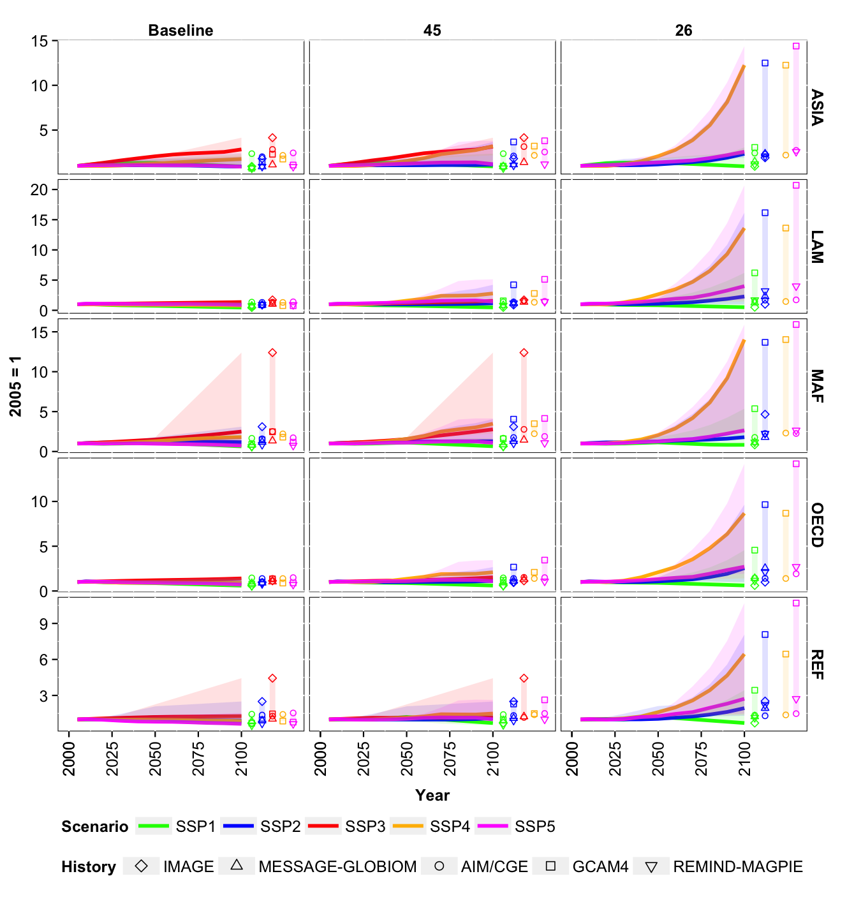
Fig SI15: Changes in regional market prices [2005=1] aggregated across all crop and livestock commodities of the five SSP marker scenarios for the baseline (left column), RCP4.5 (middle column) and RCP2.6 (right column) cases. Colored lines indicate the marker model results for each SSP. Colored bars indicate the range of data in 2100 across all marker and non-marker projections for each SSP (models are depicted by icon).
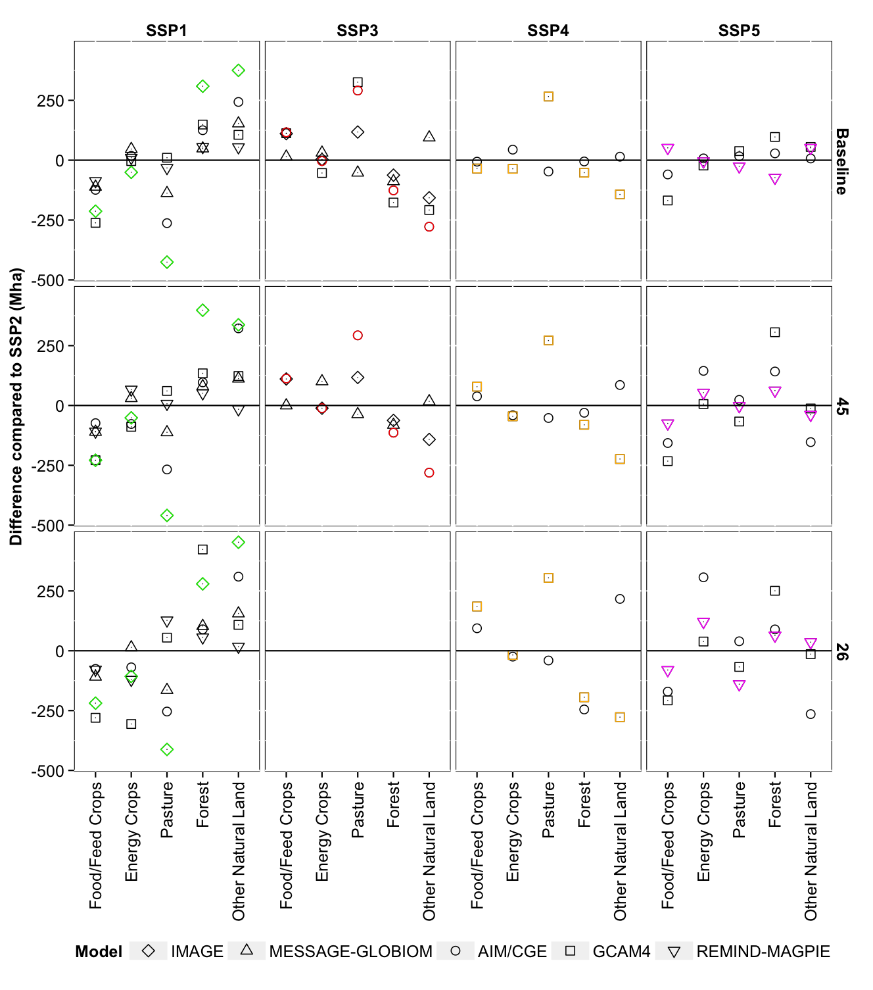
Fig SI16: Differences in land-use compared to SSP2 in 2050 for each SSP (horizontal) and RCP (vertical). Models are depicted by icon. Marker scenarios are indicated by color: SSP1 (green), SSP3(red), SSP4 (orange), SSP5 (pink).
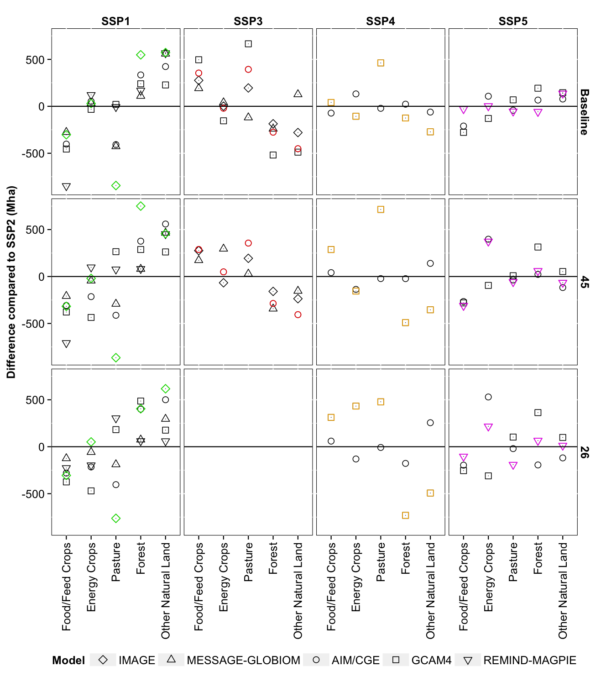
Fig SI17: Differences in land-use compared to SSP2 in 2100 for each SSP (horizontal) and RCP (vertical). Models are depicted by icon. Marker scenarios are indicated by color: SSP1 (green), SSP3(red), SSP4 (orange), SSP5 (pink).
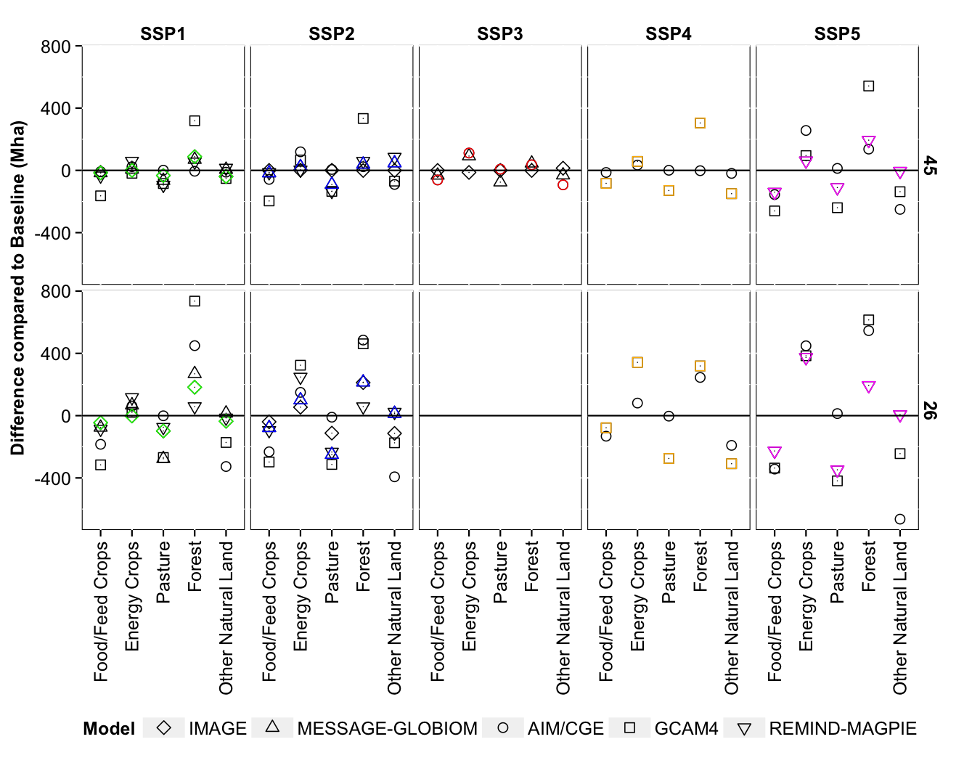
Fig SI18: Differences in land-use compared to Baseline in 2050 for each SSP (horizontal) and RCP (vertical). Models are depicted by icon. Marker scenarios are indicated by color: SSP1 (green), SSP2 (blue), SSP3(red), SSP4 (orange), SSP5 (pink).
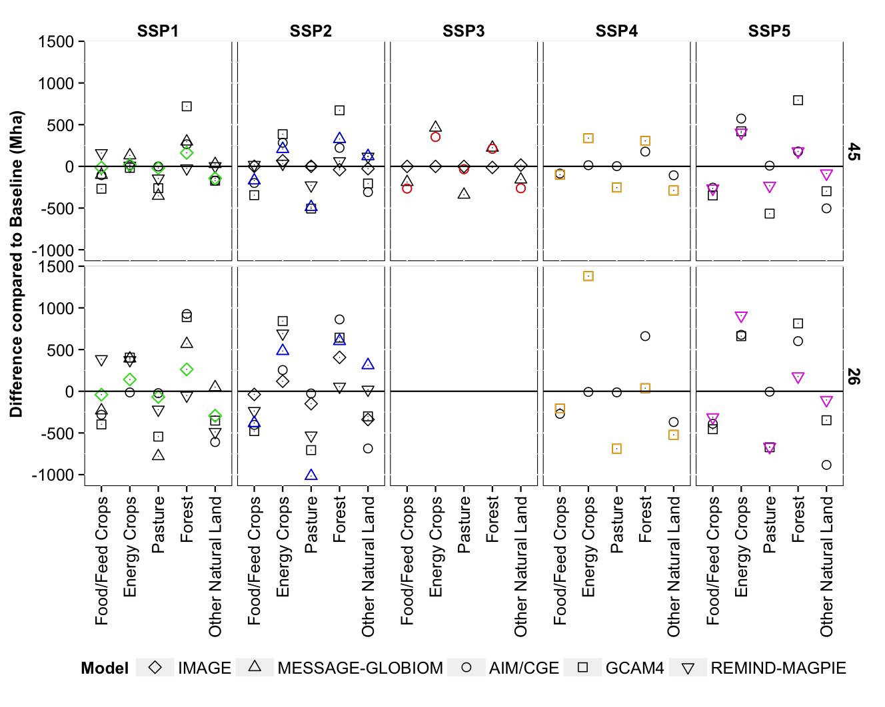
Fig SI19: Differences in land-use compared to Baseline in 2100 for each SSP (horizontal) and RCP (vertical). Models are depicted by icon. Marker scenarios are indicated by color: SSP1 (green), SSP2 (blue), SSP3(red), SSP4 (orange), SSP5 (pink).

Table SI1: Summary of qualitative results in 2100 across IAMs for the Baseline scenario. All results are compared to SSP2. Dark green indicates consistency across models. Light green indicates consistency in most models.
 |  | SSP1 | SSP3 | SSP4 | SSP5
Demand | Crops | Lower than SSP2 in all models | Higher than SSP2 in all models | Similar to SSP2 in 1 model; Lower than SSP2 in 1 model | Lower than SSP2 in 2 of 3 models
 | Livestock | Lower than SSP2 in all models | Higher than SSP2 in 3 of 4 models | Lower than SSP2 in both models | Higher than SSP2 in 2 o3 3 models
 | 2nd Generation Bioenergy | Higher than SSP2 in 4 of 5 models | Higher than SSP2 in 2 models; Lower in 2 models | Higher than SSP2 in 1 model; Lower in 1 model | Similar to SSP2 in 1 model; Higher in 1 model; Lower in 1 model
Land Use/Land Cover Change | Food/Feed Crops | Lower than SSP2 in all models | Higher than SSP2 in all models | Similar to SSP2 in both models | Similar to or lower than SSP2 in all models
 | Energy Crops | Similar to SSP2 in all models | Similar to SSP2 in all models | Higher than SSP2 in 1 model; Lower in 1 model | Similar to SSP2 in 1 model; Lower in 1 model; Higher in 1 model
 | Forest | Higher than SSP2 in all models | Lower than SSP2 in 3 of 4 models | Similar to SSP2 in 1 model; Lower in 1 model | Higher than SSP2 in 2 of 3 models
 | Pasture | Similar to SSP2 in 2 models; Lower in 3 models | Higher than SSP2 in 3 of 4 models | Similar to SSP2 in 1 model; Higher in 1 model | Slightly lower than SSP2 in 2 of 3 models
Yield | Cereal Crops | Higher than SSP2 in 3; Lower in 2 models | Lower than SSP2 in all models | Lower than SSP2 in both models | Higher than SSP2 in all models
Emissions | Land Use Change CO₂ | Lower than SSP2 in all models | Higher than SSP2 in all models | Higher than SSP2 in both models | Similar to or lower than SSP2 in all models
 | CH₄ | Lower than SSP2 in all models | Higher than SSP2 in all models | Lower than SSP2 in both models | Lower than SSP2 in all models
 | N₂O | Lower than SSP2 in all models | Higher than SSP2 in all models | Similar to SSP2 in GCAM; Lower in AIM | Lower than SSP2 in all models
Price | Crops and Livestock | Lower than SSP2 in 4 of 5 models | Higher than SSP2 in all models | Lower than SSP2 in 1 model; Higher in 1 model | Lower than SSP2 in 2 of 3 models

Table SI2: Summary of qualitative results in 2100 across IAMs for the 2.6 scenario. All results are compared to the Baseline; SSP3 is omitted as no model could produce an SSP3 RCP2.6. Dark green indicates consistency across models. Light green indicates consistency in most models.
 |  | SSP1 | SSP2 | SSP4 | SSP5
Land Use/Land Cover Change | Food/  Feed Crops | Lower than Baseline in all models | Lower than Baseline in all models | Lower than Baseline in all models | Lower than Baseline in all models
 | Energy Crops | Higher than Baseline in all models | Higher than Baseline in all models | Higher than Baseline in all models | Higher than Baseline in all models
 | Forest | Higher than Baseline in all models | Higher than Baseline in all models | Higher than Baseline in all models | Higher than Baseline in all models
 | Pasture | Similar to or lower than Baseline in all models | Similar to or lower than Baseline in all models | Similar to or lower than Baseline in all models | Similar to or lower than Baseline in all models

