## Supplementary information

### S1 Participating models in the NDC analysis

**Table S1.1**: Models participating in the EMF30 NDC scenarios

|  |  |  |  |  |  |
| --- | --- | --- | --- | --- | --- |
| Model | Institute | Economy representation | Solution dynamics | Time horizon | Scenarios \* |
| AIM/CGE | NIES, Japan | General equilibrium | Recursive dynamic | 2100 | All \*\*\* |
| DNE21+ | RITE, Japan | General equilibrium | Intertemporal optimization | 2100 | All |
| ENV-Linkages | OECD, France | General equilibrium | Recursive dynamic | 2050 | 1,2,3,4 |
| IMAGE | PBL/UU, The Netherlands | Partial equilibrium | Recursive dynamic | 2100 | All |
| MESSAGE-GLOBIOM | IIASA, Austria | General equilibrium | Intertemporal optimization | 2100 | All \*\* |
| POLES | JRC, Spain | Partial equilibrium | Recursive dynamic | 2100 | All |
| REMIND | PIK, Germany | General equilibrium | Intertemporal optimization | 2100 | All \*\*\* |
| WITCH-GLOBIOM | FEEM-CMCC, Italy | General equilibrium | Intertemporal optimization | 2150 | All |

\* See numbering from scenario table

\*\* In MESSAGE, the HFC reduction potential in scenario 5 is limited. MESSAGE takes into account mitigation options such as refrigerant recovery, but does not include substitution by non-GHG gases.

\*\*\* REMIND and AIM have no endogenous representation of strong HFC reduction policies, and have therefore made use of IMAGE projections for HFCs in the 2-degree case.

#### S1.1 Model Descriptions

Descriptions below are copied from the EMF30 overview paper, (Klimont & Smith et al. 2018, forthcoming).

|  |  |
| --- | --- |
| Model Name | Description |
| AIM/CGE | Dynamic-recursive, general-equilibrium, integrated energy and land-use, explicit transportation services, MAGICC6 climate model (Fujimori et al. 2017) |
| DNE21+ | Inter-temporal optimization, partial-equilibrium, integrated energy and land-use, explicit industry, transportation and building services, MAGICC6 climate model (Akimoto et al. 2010, Sano et al. 2015, Hayashi et al. 2015) |
| ENV-Linkages | Global dynamic computable general equilibrium (CGE), multi-sectoral, multi-regional model that links economic activities to energy and environmental issues (Chateau et al. 2014) |
| IMAGE | Dynamic-recursive, partial-equilibrium, soft linked energy and land-use, high coverage of low carbon energy technologies, endogenous land use dynamics, MAGICC6.3 climate model ([Stehfest et al., 2014](#_ENREF_38)) |
| MESSAGE-GLOBIOM | Intertemporal optimization, systems engineering partial equilibrium models linked to aggregated GE, integrated energy and land-use, MAGICC6 (Krey et al. 2016, Fricko et al. 2017). |
| POLES | Global energy-economy partial equilibrium simulation model, upstream production to final user demand and greenhouse gas emissions (Criqui et al, 2015, Keramidas et al. 2017) |
| REMIND | Integrated energy-economy-climate model with perfect foresight, detailed energy system representation including buildings, industry, transport sectors, land-use based on MAgPIE model, MAGICC6 climate model. |
| WITCH | Optimal growth model, perfect-foresight, endogenous technical change, detailed energy system and coupled land-use (Bosetti et al. 2007, Emmerling et al. 2016) |

##### AIM/CGE

**AIM/CGE(**[**Fujimori et al., 2017**](#_ENREF_14)**)** is a one-year-step recursive-type dynamic general equilibrium model that covers all regions of the world. The AIM/CGE model includes 17 regions and 42 industrial classifications. For appropriate assessment of bioenergy and land use competition, agricultural sectors are also highly disaggregated ([Fujimori et al., 2014a](#_ENREF_12)). Details of the model structure and mathematical formulae are described by [Fujimori et al. (2012)](#_ENREF_15). The production sectors are assumed to maximize profits under multi-nested constant elasticity substitution (CES) functions and each input price. Energy transformation sectors input energy and value-added are fixed coefficients of output. They are treated in this manner to deal with energy conversion efficiency appropriately in the energy transformation sectors. Power generation values from several energy sources are combined with a Logit function. This functional form was used to ensure energy balance because the CES function does not guarantee an energy balance. Household expenditures on each commodity are described by a linear expenditure system function. The parameters adopted in the linear expenditure system function are recursively updated by income elasticity assumptions([Hasegawa et al., 2015](#_ENREF_18)). Land use is determined by Logit selection([Fujimori et al., 2014b](#_ENREF_13)). In addition to energy-related CO2, CO2 from other sources, CH4, N2O, and fluorinated gases (F-gases) are treated as GHGs in the model. Energy-related emissions are associated with fossil fuel feedstock use. The non-energy-related CO2 emissions consist of land use change and industrial processes. Land use change emissions are derived from the forest area change relative to the previous year multiplied by the carbon stock density, which is differentiated by AEZs (Global Agro-Ecological Zones). Non-energy-related emissions other than land use change emissions are assumed to be in proportion to the level of each activity (such as output). CH4 has a range of sources, mainly the rice production, livestock, fossil fuel mining, and waste management sectors. N2O is emitted as a result of fertilizer application and livestock manure management and by the chemical industry. F-gases are emitted mainly from refrigerants used in air conditioners and cooling devices in the industry. Air pollutant gases (BC, CO, NH3, NMVOC, NOX, OC, SO2) are also associated with fuel combustion and activity levels. Emissions factors change over time with the implementation of air pollutant removal technologies and relevant legislation.

References

1. Fujimori, S.; Hasegawa, T.; Masui, T.; Takahashi, K.; Herran, D. S.; Dai, H.; Hijioka, Y.; Kainuma, M., SSP3: AIM implementation of Shared Socioeconomic Pathways. *Global Environmental Change* **2017,** *42*, 268-283.

2. Fujimori, S.; Hasegawa, T.; Masui, T.; Takahashi, K., Land use representation in a global CGE model for long-term simulation: CET vs. logit functions. *Food Security* **2014,** *6*, (5), 685-699.

3. Fujimori, S.; Masui, T.; Matsuoka, Y. *AIM/CGE [basic] manual*; 2012-01; Center for Social and Environmental Systems Research, National Institute Environmental Studies: 2012; pp 1-87.

4. Hasegawa, T.; Fujimori, S.; Takahashi, K.; Masui, T., Scenarios for the risk of hunger in the twenty-first century using Shared Socioeconomic Pathways. *Environmental Research Letters* **2015,** *10*, (1), 014010.

5. Fujimori, S.; Hasegawa, T.; Masui, T.; Takahashi, K., Land use representation in a global CGE model for long-term simulation: CET vs. logit functions. *Food Secur* **2014,** *6*.

##### DNE21+

Dynamic New Earth 21 Plus (DNE21+) is an integrated assessment model. The model’s assessment framework consists of 4 modules; 1) Key assessment model for energy-related CO2, 2) assessment model for land use (land area for food production, energy crops, and afforestation) and LULUCF CO2 emission, 3) Non-energy CO2 emission scenario, which assumes specific non-energy CO2 emissions separately from mitigation levels of energy-related CO2, 4) assessment model for Non-CO2 GHG, for mitigation of the five non-CO2 greenhouse gases emissions of the Kyoto Protocol, based on the United States Environmental Protection Agency assessments.

The model for energy-related CO2 is an intertemporal linear programming model for assessment of global energy systems and global warming mitigation in which the worldwide costs are to be minimized. The model represents regional differences, and assesses detailed energy-related CO2 emission reduction technologies up to 2100. When any emission restriction (for example, emission reduction targets, targets of energy or emission intensity improvements, or carbon taxes) is applied, the model specifies the energy systems whose costs are minimized, meeting all the assumed requirements, including assumed production for industries such as iron and steel, cement, and paper and pulp, transportation by automobile, bus, and truck, and other energy demands. Non-GHG SLCF emissions (e.g., black carbon) are hard-linked with this model.

References

Akimoto, K., Sano, F., Homma, T., Oda, J., Nagashima, M., Kii, M., Estimates of GHG emission reduction potential by country, sector, and cost, Energy Policy, Vol. 38 pp. 3384-3393, 2010.

Sano, F., Wada, K., Akimoto, T., Oda, J., Assessments of GHG emission reduction scenarios of different levels and different short-term pledges through macro- and sectoral decomposition analyses, Technological Forecasting & Social Change, Vol. 90, Part A, pp. 153-165, 2015

Hayashi, A., Akimoto, K., Sano, F., Tomoda, T., Evaluation of global energy crop production potential up to 2100 under socioeconomic development and climate change scenarios, Journal of Japan Institute of Energy, Vol. 94, No. 6, pp. 548-554, 2015

##### ENV-Linkages

The OECD’s in-house global dynamic computable general equilibrium (CGE) model – ENV-Linkages – is a multi-sectoral, multi-regional model that links economic activities to energy and environmental issues. It is used as the basis for the assessment of the economic consequences of climate impacts as well as outdoor air pollution damages until 2060. The advantage of using a CGE framework to model those impacts is that the sectoral details of the model can be exploited. Contrary to aggregated Integrated Assessment Models, where monetized impacts are directly subtracted from GDP, in a CGE model the various types of impacts can be modeled as directly linked to the relevant sectors and economic activities.

ENV-Linkages is the successor to the OECD GREEN model for environmental studies (Burniaux et al., 1992). A more comprehensive model description is given in Chateau et al. (2014); whereas a description of the baseline construction is given in Chateau et al. (2011).

ENV-Linkages (with a disaggregation in 25 regions and 35 sectors) describes how economic activities are linked to each other between sectors and across regions. The model contains bilateral trade flows and has a sophisticated description of capital accumulation using capital vintages, in which technological advances only trickle down slowly over time to affect existing capital stocks. In ENV-Linkages, sectoral and regional economic activities are projected for the medium- and long-term future, up to 2060, based on socio-economic drivers such as demographic developments, economic growth and development in economic sectors. ENV-Linkages also links economic activity to environmental pressure, specifically to GHG and air pollutant emissions.

*References*

Burniaux, J.-M., G. Nicoletti and J. Oliveira Martins (1992), “GREEN: A Global Model for Quantifying the Costs of Policies to Curb CO 2 Emissions”, OECD Economic Studies, 19 (Winter).

Chateau, J., R. Dellink and E. Lanzi (2014), “An Overview of the OECD ENV-Linkages Model: Version 3”, OECD Environment Working Papers, No. 65, OECD Publishing, Paris, http://dx.doi.org/10.1787/5jz2qck2b2vd-en.

Chateau, J., C. Rebolledo and R. Dellink (2011), “An Economic Projection to 2050: The OECD ‘ENV-Linkages’ Model Baseline”, OECD Environment Working Papers, No. 41, OECD Publishing, Paris, http://dx.doi.org/10.1787/5kg0ndkjvfhf-en.

##### IMAGE

The description of the IMAGE 3.0 model below relies heavily on and uses text from the online IMAGE 3.0 model documentation, which in turn is fully based on the IMAGE 3.0 book ([Stehfest et al., 2014](#_ENREF_38)). The online documentation can be found here:

<http://themasites.pbl.nl/models/image/index.php/Welcome_to_IMAGE_3.0_Documentation>

A stepwise introduction to the modeling framework can be found at the following link:

<http://themasites.pbl.nl/models/image/index.php/IMAGE_framework>

IMAGE 3.0 is an integrated assessment modeling framework that simulates global and regional environmental consequences of changes in human activities ([Stehfest et al., 2014](#_ENREF_38)). The model is a simulation model, i.e. changes in model parameters are calculated on the basis of the information from the previous time-step. The model includes a detailed description of the energy and land-use system and simulates most of the socio-economic parameters for 26 regions and most of the environmental parameters on the basis of a geographical grid of 30 by 30 minutes or 5 by 5 minutes (depending on the variable). The IMAGE framework is comprises two main systems: 1) the human or socio-economic system that describes the long-term development of human activities relevant for sustainable development; and 2) the earth system that describes changes in natural systems, such as the carbon and hydrological cycle and climate.

Exogenous assumptions on population, economic development, lifestyle, policies and technology change form a key input into the energy system model TIMER ([De Vries et al., 2001](#_ENREF_6); [Van Vuuren et al., 2007](#_ENREF_49)) and the food and agriculture system model MAGNET ([Woltjer et al., 2014](#_ENREF_55)).

TIMER simulates long-term trends in energy use, issues related to depletion, energy-related greenhouse gas and other air polluting emissions, together with land-use demand for energy crops. The focus is on dynamic relationships in the energy system, such as inertia and learning-by-doing in capital stocks, depletion of the resource base and trade between regions. As a simulation model, TIMER differs from most macroeconomic models, which let the system evolve on the basis of minimizing cost or maximizing utility under boundary conditions. As such, TIMER can be compared to energy simulation models, such as POLES and GCAM.

MAGNET describes, in interaction with the main IMAGE framework, changes in food production and trade for a broad set of crops and animal products. The model is is a multi-regional, static, applied CGE model based on neoclassical microeconomic theory.

A key component of the earth system is the LPJmL model that is included in IMAGE 3.0, and that covers the terrestrial carbon cycle and vegetation dynamics. This model is used to determine productivity at grid cell level for natural and cultivated ecosystems. Climatic change is calculated as global mean temperature change using a slightly adapted version of the MAGICC 6.3 climate model.

**IMAGE version for EMF-30**

The IMAGE version used in EMF30 is based on the version used in the development of the shared socio-economic pathways (SSPs) ([Riahi et al., 2017](#_ENREF_29); [Van Vuuren et al., 2017](#_ENREF_50)). The EMF30 scenarios follow assumptions as defined for the middle-of-the-road trajectory of SSP2.

References

De Vries HJM, et al. (2001) The targets image energy model regional (TIMER) -Technical documentation. PBL Netherlands Environmental Assessment Agency (formerly MNP), Bilthoven/The Hague [www.pbl.nl/en](file:///\\Client\Y$\ontwapps\Timer\Users\Mathijs\Projects\EMF30\EMF30%20-%20info\INDC%20paper\Submissions\Submission%202%20_%20August%202018\Additional%20Analysis\www.pbl.nl\en).

Riahi K, et al. (2017) The Shared Socioeconomic Pathways and their energy, land use, and greenhouse gas emissions implications: An overview. Global Environmental Change.

Stehfest E, et al. (2014) *Integrated Assessment of Global Environmental Change with IMAGE 3.0. Model description and policy applications*. The Hague: PBL Netherlands Environmental Assessment Agency.

Van Vuuren DP, et al. (2007) Stabilizing greenhouse gas concentrations at low levels: an assessment of reduction strategies and costs. Climatic Change 81.

Van Vuuren DP, et al. (2017) Energy, land-use and greenhouse gas emissions trajectories under a green growth paradigm. Global Environmental Change 42:237-250.

Woltjer GB, et al. (2014) The Magnet Model - Module description. LEI - part of Wageningen University and Research Centre, The Hague.

##### MESSAGE-GLOBIOM

MESSAGE-GLOBIOM 1.0 integrates the energy engineering model MESSAGE with the land-use model GLOBIOM via soft-linkage into a global integrated assessment modeling framework (Krey et al., 2016; Fricko et al., 2017). On-line model documentation is available at: <http://data.ene.iiasa.ac.at/message-globiom> (Krey et al., 2016).

MESSAGE (Model for Energy Supply Strategy Alternatives and their General Environmental Impact) is a linear programming (LP) energy engineering model with global coverage (Riahi et al., 2007; Riahi et al., 2012; Messner and Strubegger, 1995). As a systems engineering optimization model, MESSAGE is primarily used for medium- to long-term energy system planning, energy policy analysis, and scenario development. The model provides a framework for representing an energy system with all its interdependencies from resource extraction, imports and exports, conversion, transport, and distribution, to the provision of energy end-use services such as light, space conditioning, industrial production processes, and transportation. To assess economic implications and to capture economic feedbacks of climate and energy policies, MESSAGE is linked to the aggregated macro-economic model MACRO (Messner and Schrattenholzer, 2000).

Land-use dynamics are modeled with the GLOBIOM (GLobal BIOsphere Management) model, which is a partial-equilibrium model (Havlik et al., 2011; Havlik et al., 2014). GLOBIOM represents the competition between different land-use based activities. It includes a detailed representation of the agricultural, forestry and bio-energy sector, which allows for the inclusion of detailed grid-cell information on biophysical constraints and technological costs, as well as a rich set of environmental parameters, incl. comprehensive AFOLU (agriculture, forestry and other land use) GHG emission accounts and irrigation water use. For spatially explicit projections of the change in afforestation, deforestation, forest management, and their related CO2 emissions, GLOBIOM is coupled with the G4M (Global FORest Model) model (Kindermann et al., 2006; Gusti, 2010). As outputs, G4M provides estimates of forest area change, carbon uptake and release by forests, and supply of biomass for bioenergy and timber.

MESSAGE-GLOBIOM covers all greenhouse gas (GHG)-emitting sectors, including energy, industrial processes as well as agriculture and forestry. The emissions of the full basket of greenhouse gases including CO2, CH4, N2O and F-gases (CF4, C2F6, HFC125, HFC134a, HFC143a, HFC227ea, HFC245ca and SF6) as well as other radiatively active substances, such as NOx, volatile organic compounds (VOCs), CO, SO2, and BC/OC is represented in the model. Air pollution implications of the energy system are accounted for in MESSAGE by applying technology-specific air pollution coefficients from GAINS (Amann et al., 2011; Rao et al., 2013). MESSAGE-GLOBIOM is used in conjunction with MAGICC (Model for Greenhouse gas Induced Climate Change) version 6.8 (Meinshausen et al., 2011) for calculating atmospheric concentrations, radiative forcing, and annual-mean global surface air temperature increase.

**MESSAGE implementation for EMF-30**

Due to the way in which the landuse model (GLOBIOM) is coupled to MESSAGE, reductions in CH4 will automatically result in decreased CO2 and N2O emissions from landuse. This is because the underlying landuse scenarios used for this exercise are based on the SSPs, for which landuse emission mitigation scenarios were derived by applying a carbon price on all landuse GHGs as opposed to just CH4. A set of landuse scenarios based solely on the application of prices on CH4 only was not available for use in this study. Because of this the EMF-30 CH4-only and SLCF scenarios likely do not reflect the full near-term reduction in land-use related CH4 emissions, which includes the agricultural. Also, this set-up results in net reductions in land-use related CO2 emissions in these same scenarios that might not occur if only a CH4 price were applied to the land-use sector.

References

Amann, M., Bertok, I., Borken-Kleefeld, J., Cofala, J., Heyes, C., Hoglund-Isaksson, L., Klimont, Z., Nguyen, B., Posch, M., Rafaj, P., Sandler, R., Schopp, W., Wagner, F. & Winiwarter, W. 2011. Cost-effective control of air quality and greenhouse gases in Europe: Modeling and policy applications. *Environmental Modelling & Software,* 26**,** 1489-1501.

Fricko, O., Havlik, P., Rogelj, J., Klimont, Z., Gusti, M., Johnson, N., Kolp, P., Strubegger, M., Valin, H., Amann, M., Ermolieva, T., Forsell, N., Herrero, M., Heyes, C., Kindermann, G., Krey, V., Mccollum, D. L., Obersteiner, M., Pachauri, S., Rao, S., Schmid, E., Schoepp, W. & Riahi, K. 2017. The marker quantification of the Shared Socioeconomic Pathway 2: A middle-of-the-road scenario for the 21st century. *Global Environmental Change,* 42**,** 251-267.

Gusti, M. I. 2010. An algorithm for simulation of forest management decisions in the global forest model. *Штучний інтелект*.

Havlik, P., Schneider, U. A., Schmid, E., Bottcher, H., Fritz, S., Skalsky, R., Aoki, K., De Cara, S., Kindermann, G. & Kraxner, F. 2011. Global land-use implications of first and second generation biofuel targets. *Energy Policy,* 39**,** 5690-5702.

Havlik, P., Valin, H., Herrero, M., Obersteiner, M., Schmid, E., Rufino, M. C., Mosnier, A., Thornton, P. K., Bottcher, H. & Conant, R. T. 2014. Climate change mitigation through livestock system transitions. *Proceedings of the National Academy of Sciences,* 111**,** 3709-3714.

Kindermann, G. E., Obersteiner, M., Rametsteiner, E. & Mccallum, I. 2006. Predicting the deforestation-trend under different carbon-prices. *Carbon Balance and management,* 1**,** 15.

Krey, V., Havlik, P., Fricko, O., Zilliacus, J., Gidden, M., Strubegger, M., Kartasasmita, G., Ermolieva, T., Forsell, N., Gusti, M., Johnson, N., Kindermann, G., Kolp, P., Mccollum, D. L., Pachauri, S., Rao, S., Rogelj, J., Valin, H., Obersteiner, M. & Riahi, K. 2016. MESSAGE-GLOBIOM 1.0 Documentation. International Institute for Applied Systems Analysis (IIASA).

Meinshausen, M., Raper, S. C. B. & Wigley, T. M. L. 2011. Emulating coupled atmosphere-ocean and carbon cycle models with a simpler model, MAGICC6–Part 1: Model description and calibration. *Atmospheric Chemistry and Physics,* 11**,** 1417-1456.

Messner, S. & Schrattenholzer, L. 2000. MESSAGE–MACRO: linking an energy supply model with a macroeconomic module and solving it iteratively. *Energy,* 25**,** 267-282.

Messner, S. & Strubegger, M. 1995. *User's Guide for MESSAGE III*, International Institute for Applied Systems Analysis (IIASA).

Rao, S., Pachauri, S., Dentener, F., Kinney, P., Klimont, Z., Riahi, K. & Schoepp, W. 2013. Better air for better health: Forging synergies in policies for energy access, climate change and air pollution. *Global environmental change,* 23**,** 1122-1130.

Riahi, K., Dentener, F., Gielen, D., Grubler, A., Jewell, J., Klimont, Z., Krey, V., Mccollum, D., Pachauri, S., Rao, S., Van Ruijven, B., Van Vuuren, D. P. & Wilson, C. 2012. Chapter 17 - Energy Pathways for Sustainable Development. *Global Energy Assessment - Toward a Sustainable Future.* Cambridge University Press, Cambridge, UK and New York, NY, USA and the International Institute for Applied Systems Analysis, Laxenburg, Austria.

Riahi, K., Grubler, A. & Nakicenovic, N. 2007. Scenarios of long-term socio-economic and environmental development under climate stabilization. *Technological Forecasting and Social Change,* 74**,** 887-935.

##### POLES

The Prospective Outlook for Long-term Energy Systems - POLES model, is a global sectoral simulation model for the development of long‐term (2050‐2100) energy demand and supply pathways with worldwide coverage. Projections are made on the basis of exogenous economic growth, demographic projections and energy resources for each region. It is market-oriented, which means that market equilibrium prices drive the balance of supply and demand for each type of energy. Separate modules represent the national energy balances and the international markets for the world energy system in 57 countries and regions. The model identifies 22 energy demand sectors and more than 40 energy technologies with endogenous technical progress combining “learning by doing” and “learning by searching” on the performance improvement dynamics. Model represents relatively detailed fossil-fuel and bioenergy supply.

Primary biomass resources have been divided into three categories: forest residues (cellulosic biomass), short rotation crops (cellulosic biomass) and other energy crops such as sugar or biooil crops (non-cellulosic biomass). Non-cellulosic biomass is exclusively used as input for the production of 1st generation biofuels. Cellulosic biomass can be used as a transformed product in every consuming sector (including as input for 2nd generation biofuels).

The biomass potential is calculated as the product of the available area for bioenergy collection by the productivity of the biomass resource on this surface. Normalized supply cost curves are calculated taking into account the percentage of the total potential already used.

Biomass demand is modeled in transformation (power sector), inputs for biofuels production and final demand (4 industrial sectors, 2 sectors for buildings, road and air for transport). Two biofuel types are distinguished in POLES: first and second-generation biofuels (cellulosic ethanol). Demand in biofuels stems from road and air transport. Biofuel production technologies are explicitly modeled: domestic production costs are determined from fixed costs and variable costs; the variable costs include O&M costs, amoving average of the biomass price weighted by the biofuel process efficiency, and the subsidies to biofuel production. First generation biofuels are progressively excluded over time and replaced by 2nd generation biofuels.

An international biofuels market supplies importing countries. Imports start as soon as national production is unable to meet domestic demand and an exporting country ceases importing.

POLES allows the production of a relatively robust estimate of the impacts of energy and environmental policies (promotion of variable renewables, biomass, energy efficiency, energy security issues, GHG emissions limitations, effort sharing between countries…).

The model was originally developed at the Centre National de la Recherche (CNRS) – Universite Grenoble Alpes (UGA) in France and is now collaboratively maintained and further developed by the European Commission’s JRC, GAEL-CNRS and ENERDATA.

References

Criqui, P., Mima, S., Menanteau, P. & Kitous, A. (2015). Mitigation strategies and energy technology learning : an assessment with the POLES model. *Technological Forecasting and Social Change*, vol. 90 Part A.

Keramidas, K, Kitous, A., Després, J., Schmitz, A., *POLES-JRC model documentation*. EUR 28728 EN, Publications Office of the European Union, Luxembourg, 2017, ISBN 978-92-79-71801-4, doi:10.2760/225347, JRC107387[,](\\\\Client\\Y$\\ontwapps\\Timer\\Users\\Mathijs\\Projects\\EMF30\\EMF30 - info\\INDC paper\\Submissions\\Submission 2 _ August 2018\\Additional Analysis\\,https:\\ec.europa.eu\\jrc\\en\\publication\\poles-jrc-model-documentation)

[https://ec.europa.eu/jrc/en/publication/poles-jrc-model-documentation](\\\\Client\\Y$\\ontwapps\\Timer\\Users\\Mathijs\\Projects\\EMF30\\EMF30 - info\\INDC paper\\Submissions\\Submission 2 _ August 2018\\Additional Analysis\\,https:\\ec.europa.eu\\jrc\\en\\publication\\poles-jrc-model-documentation).

##### REMIND

REMIND models the global energy-economy-climate system for 11 world regions and for the time horizon until 2100. For the present study, REMIND in its version 1.7 was used. REMIND represents five individual countries (China, India, Japan, United States of America, and Russia) and six aggregated regions formed by the remaining countries (European Union, Latin America, sub-Saharan Africa without South Africa, Middle East / North Africa / Central Asia, other Asia, Rest of the World). For each region, intertemporal welfare is optimized based on a Ramsey-type macro-economic growth model.

By coupling a macroeconomic equilibrium model with a technology-detailed energy model, REMIND combines the major strengths of bottom-up and top-down models. The macro-economic core and the energy system module are hard-linked via the final energy demand and costs incurred by the energy system. A production function with constant elasticity of substitution (nested CES production function) determines the final energy demand. For the baseline scenario, final energy demands pathways are calibrated to regressions of historic demand patterns. More than 50 technologies are available for the conversion of primary energy into secondary energy carriers as well as for the distribution of secondary energy carriers into final energy.

REMIND uses reduced-form emulators derived from the detailed land-use and agricultural model MAgPIE (Lotze-Campen et al. 2008; Popp et al. 2014) to represent land-use and agricultural emissions as well as bioenergy supply and other land-based mitigation options. Beyond CO2, REMIND also represents emissions and mitigation options of major non-CO2 greenhouse gases (EPA 2013; Strefler et al. 2014a) and air pollutants (Strefler et al. 2014b), recently updated using emissions factors from the GAINS model (Rao et al. 2016). REMIND uses the MAGICC model (Meinshausen et al. 2011) in its version 6.4 to analyze climate change implications of emission scenarios.

References

EPA (2013) Global Mitigation of Non-CO2 Greenhouse Gases: 2010-2030. EPA-430-R-13-011

Lotze-Campen H, Müller C, Bondeau A, et al (2008) Global food demand, productivity growth, and the scarcity of land and water resources: a spatially explicit mathematical programming approach. Agricultural Economics 39:325–338. doi: 10.1111/j.1574-0862.2008.00336.x

Meinshausen M, Raper SCB, Wigley TML (2011) Emulating coupled atmosphere-ocean and carbon cycle models with a simpler model, MAGICC6 – Part 1: Model description and calibration. Atmos Chem Phys 11:1417–1456. doi: 10.5194/acp-11-1417-2011

Popp A, Humpenöder F, Weindl I, et al (2014) Land-use protection for climate change mitigation. Nature Clim Change 4:1095–1098. doi: 10.1038/nclimate2444

Rao S, Klimont Z, Leitao J, et al (2016) A multi-model assessment of the co-benefits of climate mitigation for global air quality. Environmental Research Letters 11:124013. doi: 10.1088/1748-9326/11/12/124013

Strefler J, Luderer G, Aboumahboub T, Kriegler E (2014a) Economic impacts of alternative greenhouse gas emission metrics: a model-based assessment. Climatic Change. doi: 10.1007/s10584-014-1188-y

Strefler J, Luderer G, Kriegler E, Meinshausen M (2014b) Can air pollutant controls change global warming? Environmental Science & Policy 41:33–43. doi: 10.1016/j.envsci.2014.04.009

##### WITCH

WITCH (World Induced Technical Change Hybrid) is an integrated assessment model designed to assess climate change mitigation and adaptation policies (Emmerling et al., 2016; Bosetti et al., 2007). It is developed and maintained at the Fondazione Eni Enrico Mattei and the Centro Euro-Mediterraneo sui Cambiamenti Climatici. WITCH is a global dynamic model that integrates into a unified framework the most important drivers of climate change. An inter-temporal optimal growth model captures the long- term economic growth dynamics. A compact representation of the energy sector is fully integrated (hard linked) with the rest of the economy so that energy investments and resources are chosen optimally, together with the other macroeconomic variables. Land use mitigation options are available through a linkage with a land use and forestry model (Havlik, 2014). WITCH represents the world in a set of fourteen representative native regions; for each, it generates the optimal mitigation strategy for the long-term (from 2005 to 2100) as a response to external constraints on emissions. A modelling mechanism aggregates the national policies on emission reduction or the energy mix into the WITCH regions. Finally, a distinguishing feature of WITCH is the endogenous representation of R&D diffusion and innovation processes that allows a description of how R&D investments in energy efficiency and carbon-free technologies integrate the mitigation options currently available.

Further documentation is available at http://doc.witchmodel.org.

References

Havlik, P., H. Valin, M. Herrero, M. Obersteiner, E. Schmid, M. C. Rufino, A. Mosnier, et al. 2014. “Climate Change Mitigation Through Livestock System Transitions.” *Proceedings of the National Academy of Sciences* 111 (10). Proceedings of the National Academy of Sciences: 3709–14.

Bosetti, Valentina, Emanuele Massetti, and Massimo Tavoni. 2007. “The Witch Model: Structure, Baseline, Solutions.” 2007.010. FEEM Working Paper.

Emmerling, J., L. Drouet, L. A. Reis, et al., (2016). “The WITCH 2016 Model – Documentation and Implementation of the Shared Socioeconomic Pathways”, FEEM Note di Lavoro 42.2016.

**Table S1.2**: Included SLCF sources of models taking part in the EMF30 INDC analysis (all major CH4 and pollutant emissions included, the latter partly exogenous).

|  |  |  |  |  |  |  |
| --- | --- | --- | --- | --- | --- | --- |
| Model | Included species | Included CH4 sources \* | Included pollutant sources | Calibration year | Calibration reference | GWP used (value for CH4) |
| AIM/CGE | GHGs, BC, OC, NOx, SO2, CO, VOC, NH3 | All, except Def | All, except flaring | 2005 | EDGAR V4.2 | AR4 100 year GWP (25) |
| DNE21+ | GHGs, BC, OC, NOx, SO2, CO, VOC, NH3 | All, except Def, IS and IA | All, but exogenous for NOx, SO2, CO, VOC, NH3 and BC, OC from land-use | 2010 | UNFCCC (2014), IEA (2014) | SAR 100 year GWP (21) |
| ENV-Linkages | GHGs, BC, OC, NOx, SO2, CO, VOC, NH3 | All | All | 2010 | EDGAR V4.2, GTAP, US-EPA | SAR 100 year GWP (21) |
| IMAGE | GHGs, BC, OC, NOx, SO2, CO, VOC, NH3 | All | All | 2010 | EDGAR V4.2, RCP | AR4 100 year GWP (25) |
| MESSAGE-GLOBIOM | GHGs, BC, OC, NOx, SO2, CO, VOC, NH3 | All, except IP | All, except industrial processes / non-energy processes | 2010 | US-EPA, FAOSTAT | AR4 100 year GWP (25) |
| POLES | GHGs, BC, OC, NOx, SO2, CO, VOC, NH3 | All, except IP, IS, IA and parts of ED | All | 1990-2015 | UNFCCC, EDGAR V4.2, GLOBIOM look-up | AR5 100 year GWP (34) |
| REMIND | GHGs, BC, OC, NOx, SO2, CO, VOC | All, except IP, Def and ED | All, but industry exogenous | 2010 | EDGAR V4.2 | AR4 100 year GWP (25) |
| WITCH-GLOBIOM | GHGs, BC, OC, NOx, SO2, CO, VOC, NH3 | All, except IP | All, except non-energy emissions exogenous | 2005-2010 | EDGAR V4.2, RCP | AR4 100 year GWP (25) |

\* ES = Energy Supply, Agr = Agriculture, W = Waste, IP = Industrial Processes, ED = Energy Demand, Def = Deforestation, IS = International shipping, IA = International Aviation, All = All anthropogenic sources

**Table S1.3**: Included sectors of models taking part in the EMF30 INDC analysis (light green shaded is partly included, orange shaded is not included or exogenous emissions).

|  |  |  |  |  |  |  |  |  |  |
| --- | --- | --- | --- | --- | --- | --- | --- | --- | --- |
|  |  | **AIM/CGE** | **DNE21+** | **ENV-Linkages** | **IMAGE** | **MESSAGE** | **POLES** | **REMIND** | **WITCH** |
| **Buildings** | Commercial /Services | Yes | Yes | Yes/No | Yes | Aggregated residential/commercial | Yes | Aggregated residential/commercial | Aggregated residential/commercial |
| Residential heating | Yes | Yes | Yes | Yes | Yes | Yes | Yes, by proxy | Yes, by proxy |
| Residential cooking | Yes | Yes | Yes | Yes | Yes | Yes | Yes, by proxy | Yes, by proxy |
|  | Traditional biomass included? | Yes | No, exogenous emissions | No, exogenous emissions | Yes | Yes | Yes, but semi-exogenous scenarios | No, exogenous emissions | Yes |
| **Industry** | Iron and Steel | Yes | Yes | Yes | Yes | Aggregated industry non-energy | Yes | Aggregated industry | No |
| Cement Manufacturing | Yes | Yes | Aggregated to Non-Metallic Minerals | Yes | Aggregated industry non-energy | Yes, non-metallic minerals | Aggregated industry | No |
| Chemical Manufacturing | Yes | Yes | Yes | Feedstock/plastics | Aggregated industry non-energy | Yes | Aggregated industry | No |
| Pulp & Paper Manufacturing | Yes | Yes | Yes | No | Aggregated industry non-energy | No | Aggregated industry | No |
| Other industry | Food processing, other manufacturing | Aluminum manufacturing | Other mining, Coal extraction, Crude Oil extraction, Gas extraction and distribution, Metals n.e.s., Fabricated metal products, Food Products, Other manufacturing, Motor vehicles, Electronic Equipment, Textiles | By proxy for emissions | Aggregated industry non-energy, Coal extraction, Crude Oil extraction, Gas extraction | Other manufacturing, mining, construction | Aggregated industry | No |
| Refining | Yes | Yes | Yes | By proxy for emissions | Yes | Yes | Aggregated industry | No |
| **Transport** | Passenger road | Yes | Yes | Aggregated transport, excluding private car use | Yes | Aggregated transport | Yes | Yes | Only light duty vehicles |
| Freight road | Yes | Yes | Aggregated transport | Yes | Aggregated transport | Yes | Yes | Yes |
| Passenger rail | Yes | Aggregated rail transport | Aggregated transport | Yes | Aggregated transport | Yes | Aggregated to rail (no differentiation passenger vs. Freight) | no |
| Freight rail | Yes | Aggregated rail transport | Aggregated transport | Yes | Aggregated transport | Yes | Aggregated to rail (no differentiation passenger vs. Freight) | no |
| Aviation | Yes | Yes | Yes | Yes | Yes, but only at the global level | Yes | No (exogenous emissions) | Yes |
| Navigation | Yes | Yes | Yes | Yes | Yes, but only at the global level | Yes | No (exogenous emissions) | Yes |
|  | Distinction petrol (LLF) and diesel (HLF)? | No | Yes | No | Yes, exogenous | No | Yes | Yes | No |

### S2 Potential HFC reductions resulting from the Kigali Amendment of the Montreal Protocol

An assessment of the potential impact of including HFCs in the Montreal protocol has been done with the IMAGE model at the PBL Netherlands Environmental Assessment Agency ([PBL, 2015](#_ENREF_24)). According to this study, the successful execution of the Kigali amendment would lead to a reduction of roughly 54% of the global HFC emissions in 2030 compared to a no policy case.[[1]](#footnote-1)

*Text from that study (with some text edits):*

The Kigali Amendment contains a reduction scheme up until 2043 with a delayed phasing-out for Article 5 (mainly developing countries). Figure S2.1. shows the emission reduction pathway if the reduction scheme is precisely followed.

All countries are expected to observe the HFC amendment as they are all signatories to the Montreal Protocol. The emission reductions resulting from implementation of the proposed reduction scheme are projected to amount to 0.7 GtCO2e by 2030, relative to a baseline of 1.3 GtCO2e. These reductions account for the substitution of hydrochlorofluorocarbons (HCFCs) by HFCs, as prescribed by the proposal. This inclusion of HCFCs also explains the decrease and subsequent increase in HFC emissions. The volume of HCFCs is based on EPA (2013a). Baseline emissions for HFCs are projected to increase from the present day level of 0.5 GtCO2e to 1.3 GtCO2e by 2030. More reductions are expected after 2030, as the proposal runs until 2043.

**Figure S2.1:** Projected HFC Emission reductions from the amended Montreal protocol. Left panel: emission reductions and resulting emission level (in Mt CO2eq). Right panel: Emission levels in the no policy baseline case as well as the policy case (in Gt CO2eq). The red horizontal line indicates the baseline emission level in the protocol. This is higher than the current emission level because it accounts for HCFC substitution by HFCs.



EPA (2013b). Summary: North American 2013 HFC Submission to the Montreal Protocol U.S. Environmental Protection Agency.

### S3 Region definitions in regional emission analysis

From: EMF30 Scenario Database, 2014

Available at: <https://tntcat.iiasa.ac.at/EMF30DB>

Five global macro regions have been used in this study’s scenario analysis. These regions are defined as follows:

**OECD90 = Includes the OECD 90 countries.**

Australia, Austria, Belgium, Canada, Denmark, Fiji, Finland, France, French Polynesia, Germany, Greece, Guam, Iceland, Ireland, Italy, Japan, Luxembourg, Netherlands, New Caledonia, New Zealand, Norway, Portugal, Samoa, Solomon Islands, Spain, Sweden, Switzerland, Turkey, United Kingdom, United States of America, Vanuatu

**REF = Countries from the Reforming Economies of Eastern Europe and the Former Soviet Union.**

Albania, Armenia, Azerbaijan, Belarus, Bosnia and Herzegovina, Bulgaria, Croatia, Cyprus, Czech Republic, Estonia, Georgia, Hungary, Kazakhstan, Kyrgyzstan, Latvia, Lithuania, Malta, Poland, Republic of Moldova, Romania, Russian Federation, Slovakia, Slovenia, Tajikistan, TFYR Macedonia, Turkmenistan, Ukraine, Uzbekistan, Yugoslavia

**ASIA = The region includes most Asian countries with the exception of the Middle East, Japan and Former Soviet Union states.**

Afghanistan, Bangladesh, Bhutan, Brunei Darussalam, Cambodia, China, China Hong Kong SAR, China Macao SAR, Democratic People's Republic of Korea, East Timor, India, Indonesia, Lao People's Democratic Republic, Malaysia, Maldives, Mongolia, Myanmar, Nepal, Pakistan, Papua New Guinea, Philippines, Republic of Korea, Singapore, Sri Lanka, Taiwan, Thailand, Viet Nam

**MAF = This region includes the countries of the Middle East and Africa.**

Algeria, Angola, Bahrain, Benin, Botswana, Burkina Faso, Burundi, Cameroon, Cape Verde, Central African Republic, Chad, Comoros, Congo, Cote d'Ivoire, Democratic Republic of the Congo, Djibouti, Egypt, Equatorial Guinea, Eritrea, Ethiopia, Gabon, Gambia, Ghana, Guinea, Guinea-Bissau, Iran (Islamic Republic of), Iraq, Israel, Jordan, Kenya, Kuwait, Lebanon, Lesotho, Liberia, Libyan Arab Jamahiriya, Madagascar, Malawi, Mali, Mauritania, Mauritius, Morocco, Mozambique, Namibia, Niger, Nigeria, Oman, Qatar, Reunion, Rwanda, Saudi Arabia, Senegal, Sierra Leone, Somalia, South Africa, Sudan, Swaziland, Syrian Arab Republic, Togo, Tunisia, Uganda, United Arab Emirates, United Republic of Tanzania, Western Sahara, Yemen, Zambia, Zimbabwe

**LAM = This region includes the countries of Latin America and the Caribbean.**

Argentina, Bahamas, Barbados, Belize, Bolivia, Brazil, Chile, Colombia, Costa Rica, Cuba, Dominican Republic, Ecuador, El Salvador, Guadeloupe, Guatemala, Guyana, Haiti, Honduras, Jamaica, Martinique, Mexico, Netherlands Antilles, Nicaragua, Panama, Paraguay, Peru, Puerto Rico, Suriname, Trinidad and Tobago, Uruguay, Venezuela

### S4 Model specific CH4 and BC emission projections

**Figure S4.1:** CH4 emission pathways

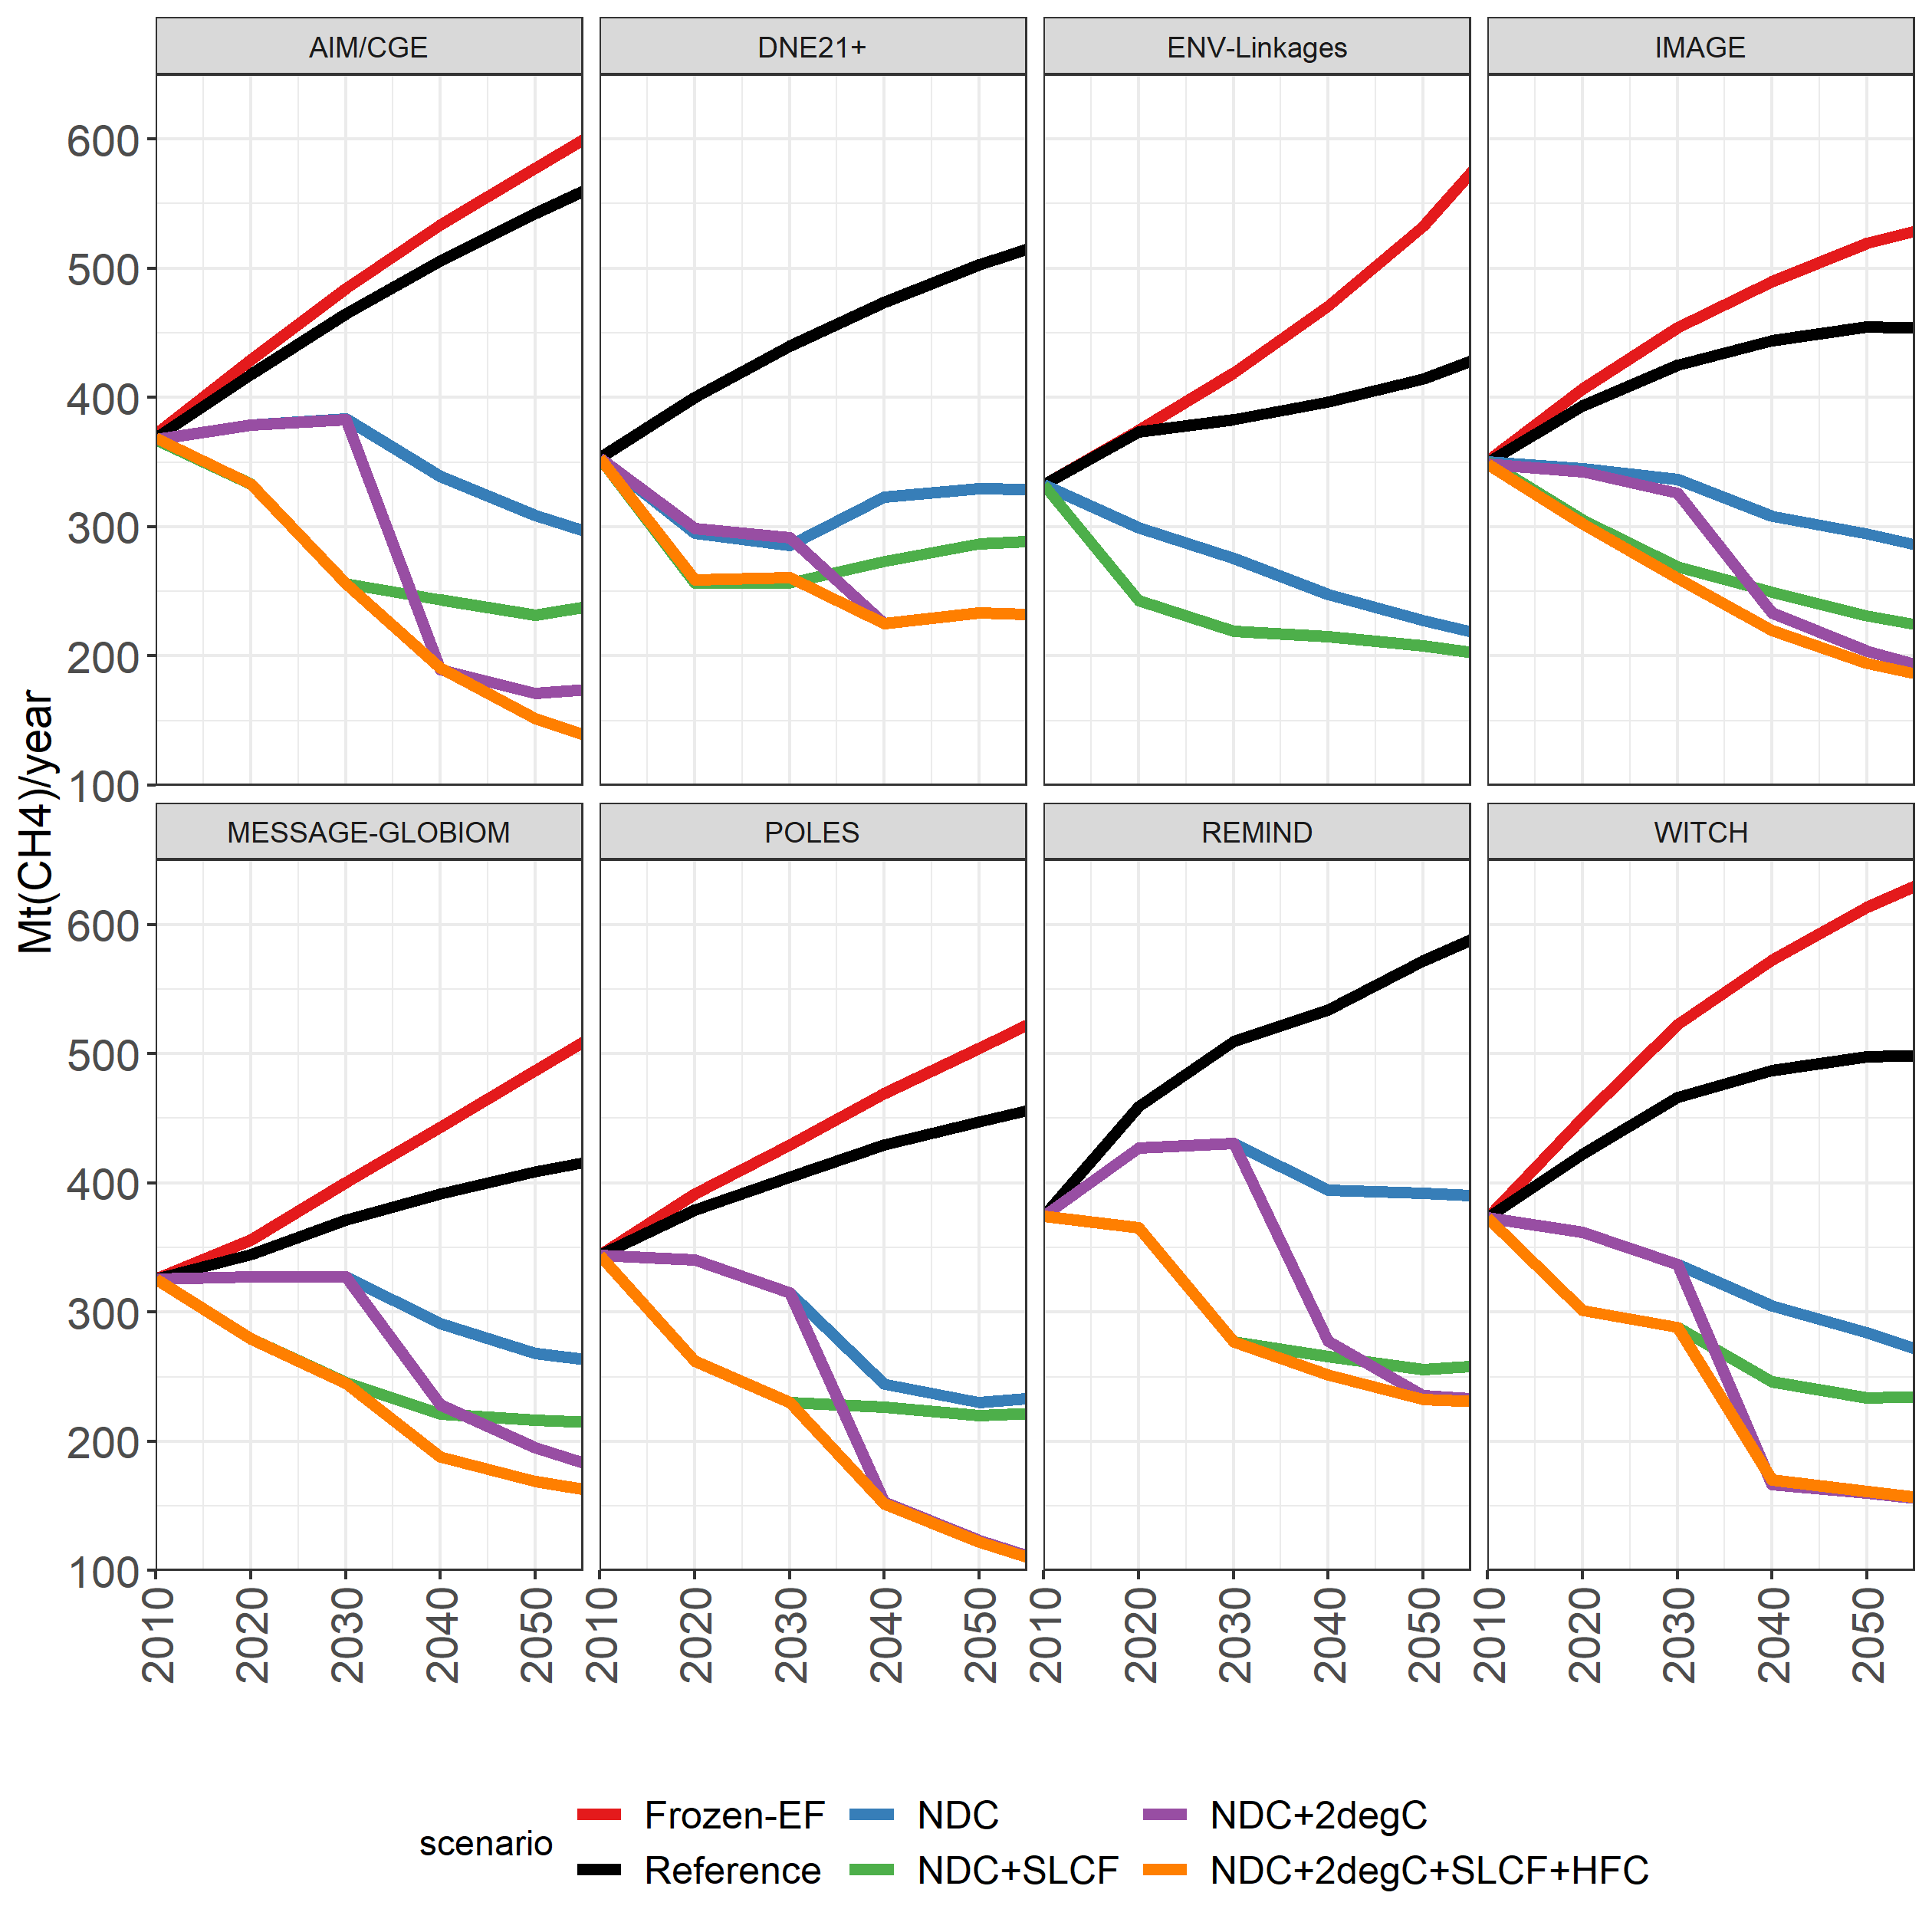

**Figure S4.2:** 2030 sectoral emissions CH4

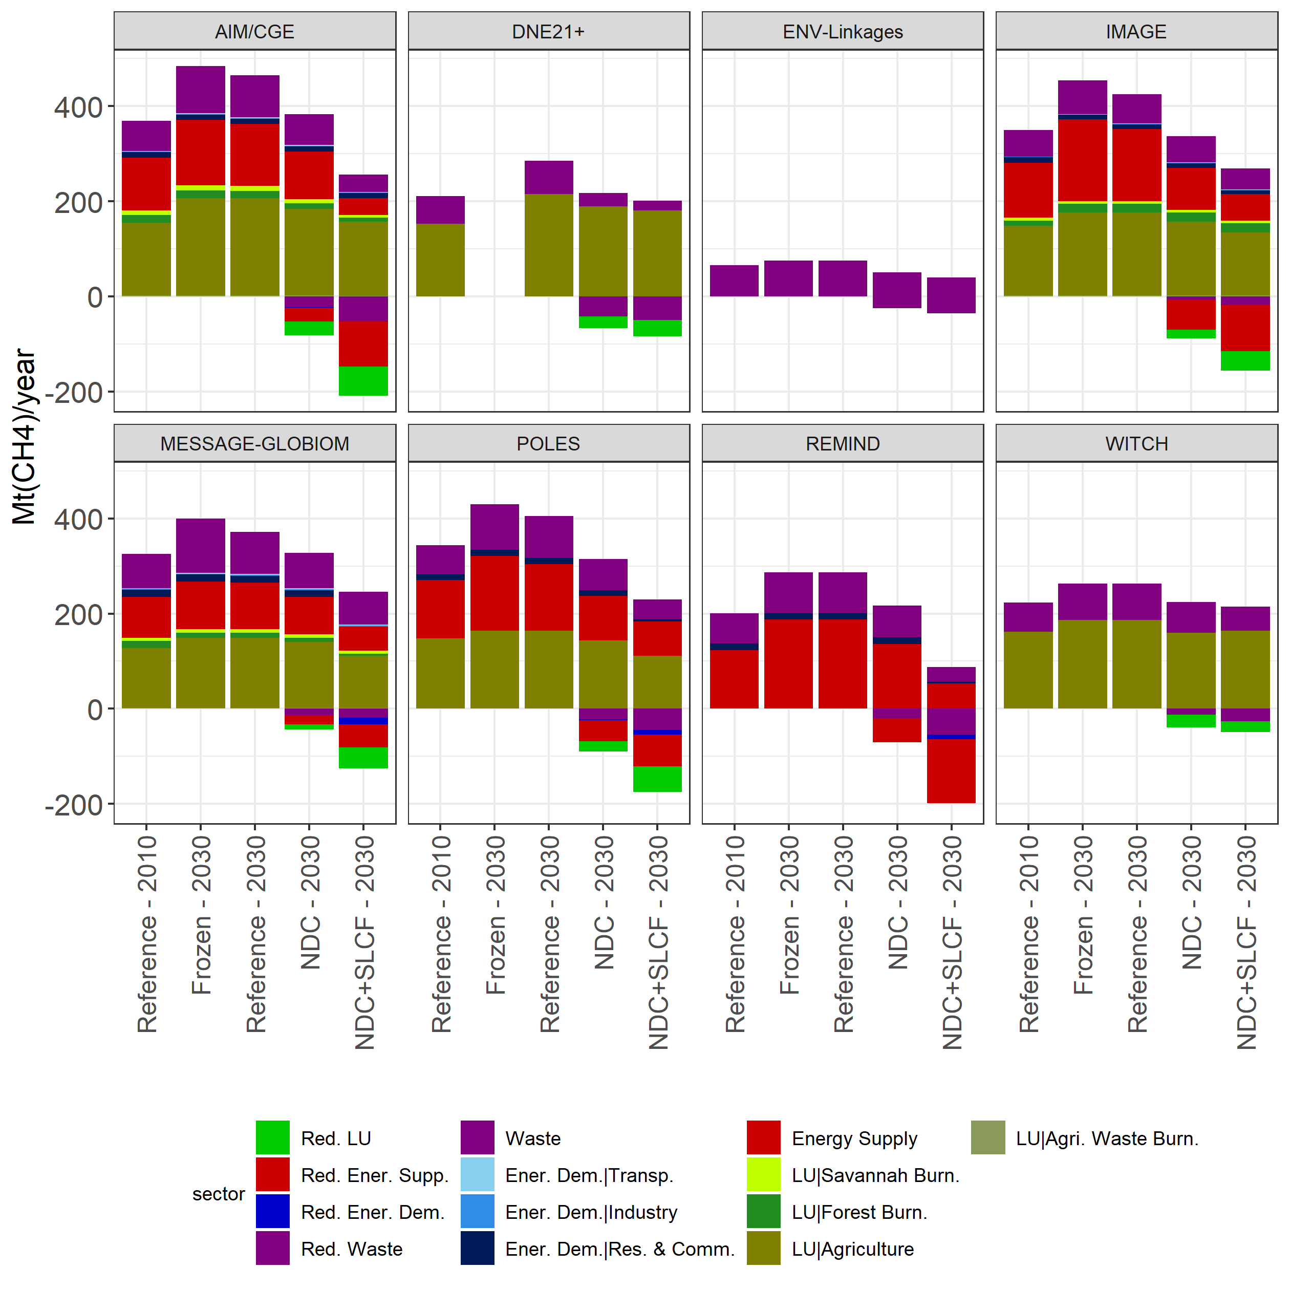

**Figure S4.3:** 2030 sectoral emissions CH4

**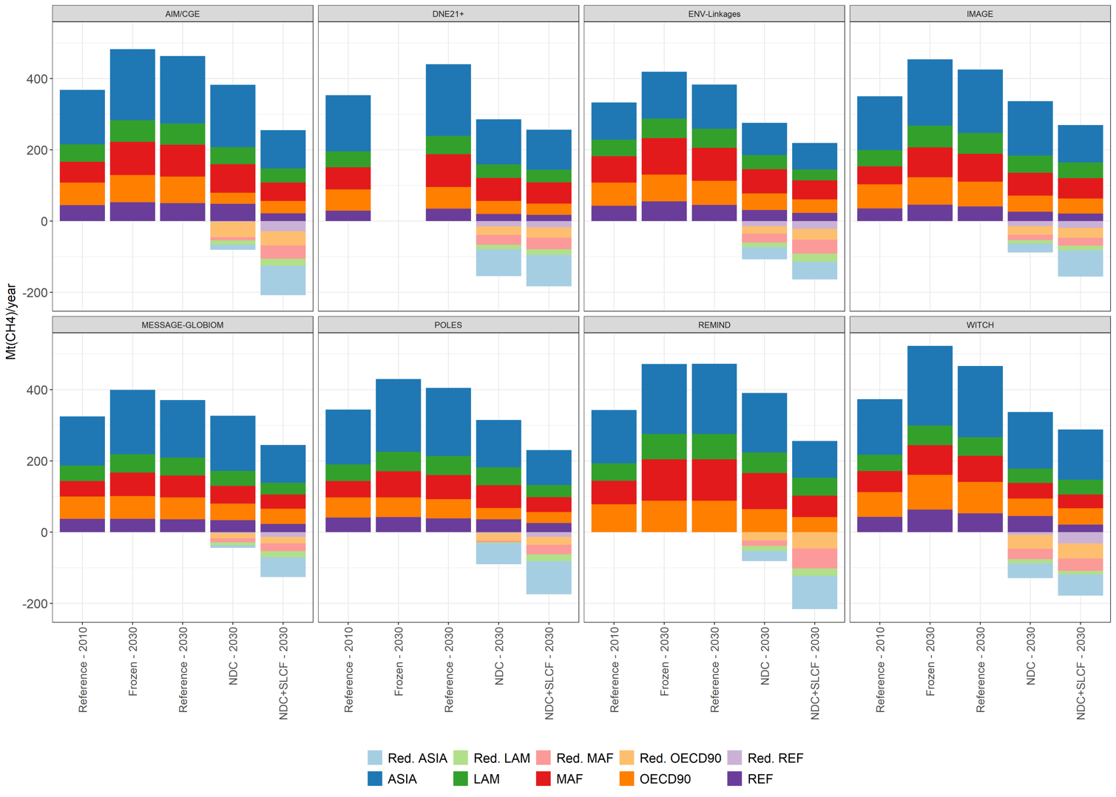**

**Figure S4.4:** BC Emission pathways

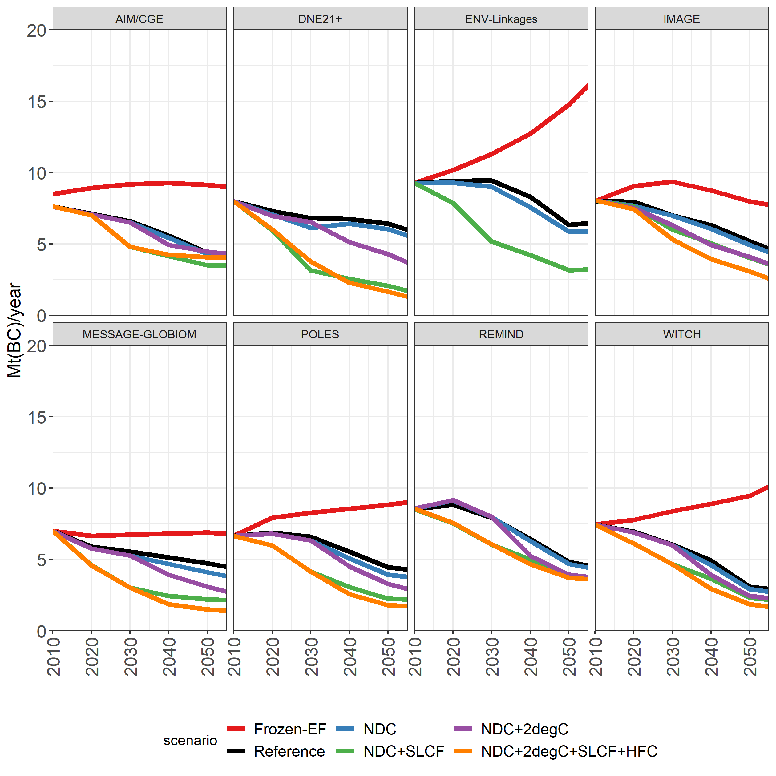

**Figure S4.5:** 2030 sectoral emissions BC

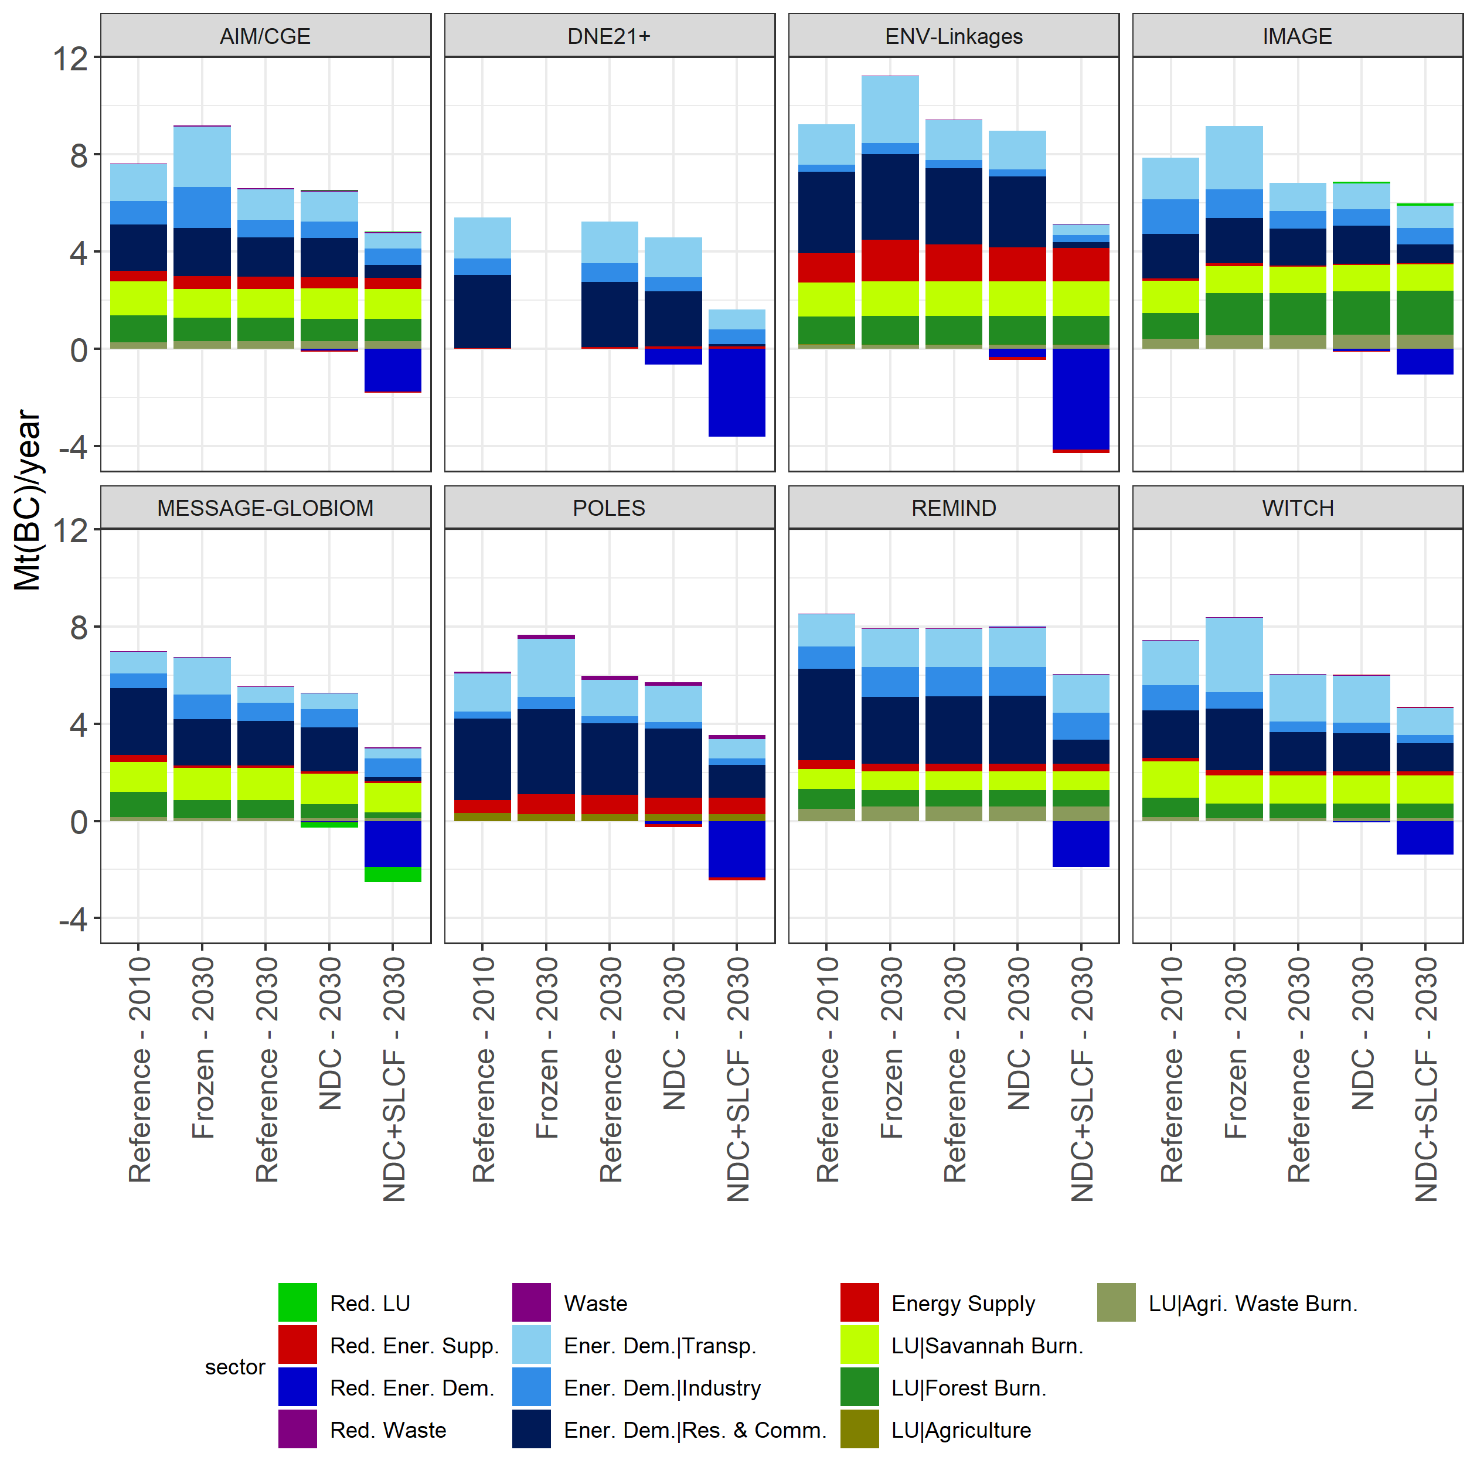

**Figure S4.6:** 2030 regional emissions BC 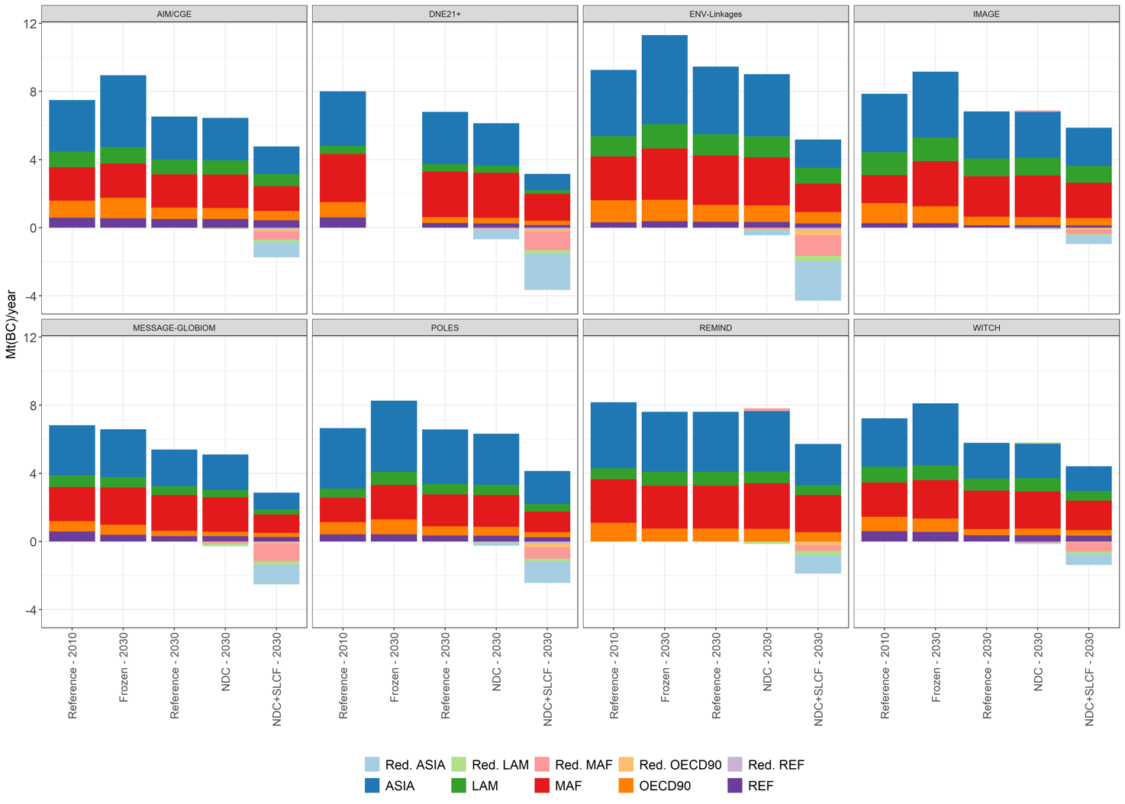

### S5 Sectoral CH4 emission reduction potential and the role of agriculture

Figure S5.1 (from: [Harmsen et al. (2018)](#_ENREF_17)) shows how mitigation of CH4 emissions from agriculture is projected to be a large bottleneck in the mitigation of global CH4 emissions. A comparison is made between the no climate policy baseline (Reference) and the 2 degree mitigation case (ClimPolicy, which for the agriculture sector, is very comparable to the SLCF scenarios in this study, and which effectively represents the maximum reduction potential projected by the models). From Harmsen et al. 2018: “*In 2010, agriculture emissions (from livestock, rice and other crops) are found to be the largest anthropogenic source (43%-49% of total emissions), followed by energy supply and demand (32%-39%) and waste (16%-22%). Without climate policy, emissions from all three main aggregated sectors will continue to increase, with similar growth rates (i.e. their relative contribution to total emissions are not expected to change much in time, see Supplement). In ClimPolicy scenario, energy emissions are expected to decrease dramatically, due to a combination of direct mitigation and a reduction of fossil fuel. Waste emissions in 2100 are expected to decrease by half compared to 2010, while agriculture emissions are projected to only slightly decrease or even remain stable. This difference in sectoral mitigation potential makes agriculture CH4 emissions by far the largest source of remaining emissions under the climate policy scenario: 60% to 80% in of total emissions 2050 and 55% to 88% in 2100.”*

In this study, maximum relative emission reductions of CH4 from agriculture are 22% in 2030 (=model mean difference between NDC+2degC+SLCF and Reference, range = 12% - 32%), 44% in 2050 (range 21% - 54%) and 57% in 2100 (range 38% - 79%). This indicates how the models consistently expect limitations in the mitigation of agriculture CH4 emissions, but also indicates a large uncertainty.

Note that the projected reductions result from “end-of-pipe” solutions and that food demand / lifestyle related solutions play a much smaller role (e.g. reducing enteric fermentation emissions through genetic selection and food supplements for ruminant animals, rather than eating less meat (products)). Partly, this is a consequence of using SSP2 as a baseline scenario, in which a steady growth of global meat product demand is projected (unlike in SSP1, where this demand is much smaller). Note, however, that most models do include price feedbacks, where ruminant meat and dairy demand is lowered somewhat as a result of higher CH4 prices.

Due to physiological limitations in ruminants, it seems unlikely that CH4 emission reductions in agriculture can be much higher than projected (with enteric fermentation emission reductions of higher than 60%), through technological advances alone (e.g. better genetic selection and improved food supplements). However, higher reductions would in principle be feasible, either by lifestyle changes (i.e. lower demand of meat and dairy) or for instance by cultivated meat production.

If it would be possible to further bring down emissions from agriculture, emissions are expected to be much lower in both the NDC+2degC and NDC+2degC+SLCF cases, particularly by the end of the century when climate action is ambitious in both cases. The short-term impact of SLCF policy could then be considerably higher. However, the difference in GMT in 2100 between the two cases would likely be low, as the level of SLCF emissions would be comparable in the two scenarios by the end of the century.

**Figure S5.1:** Global CH4 emissions in the no policy Reference and 2oC ClimPolicy cases for 2050 and 2100. Based on: [Harmsen et al. (2018)](#_ENREF_17). Subdivision into 1) Energy supply and demand 2) Agriculture 3) Waste (Boxplot and whiskers based on quartiles, line shows median, cross shows mean.

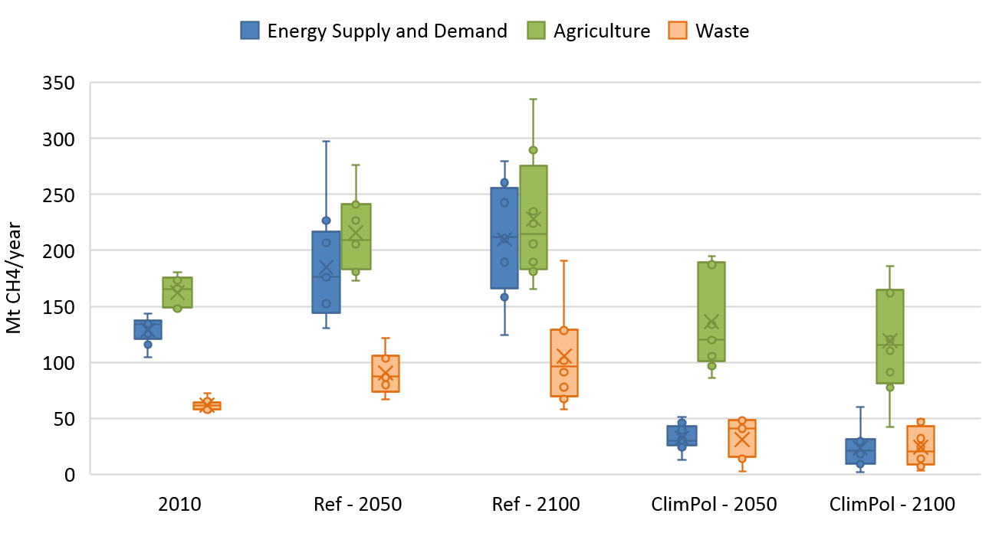

### S6 HFC emissions in the NDC scenario analysis

Figure S6.1 shows the HFC emission pathways for the models that ran the additional HFC reduction scenario (NDC+2DC+SLCF+HFC). REMIND and AIM have no endogenous representation of strong HFC reduction policies, and have therefore made use of IMAGE projections for HFCs in the 2 degree case.

Not all scenarios are shown, because of the inherent overlap in emission profiles between scenarios:

* For all models, Reference and Frozen\_EF have the same emissions, because only CH4 and BC emission factors have been frozen in the latter scenario. HFC is not affected.
* HFC emissions in NDC+2DC and NDC+2DC+SLCF are the same in all cases. Only CH4 and BC policies form the difference)
* HFC emissions in NDC and NDC+SLCF are the same in all cases. Only CH4 and BC policies form the difference)

**Figure S6.1:** HFC emission pathways (Only shown for the models that submitted NDC+2DC+SLCF+HFC)



### S7 Model specific radiative forcing decrease from SLCF policy in NDC + 2 dC

Figure S7.1 shows the forcer specific radiative forcing reduction resulting from SLCF policy in the NDC+2degC scenario for all the models that included HFC measures. Model differences in CH4 and HFC result from different assumptions on mitigation potentials and included measurers as explained in the main text. For BC, this is a bit more complicated. From the figures, the effect of BC reduction seems smaller than perhaps could be expected. Partly, this can result from suboptimal BC/OC reduction ratios (reducing BC leads to a decrease in forcing, whereas reducing OC leads to an increase). Secondly, aerosol emission reductions (from sulphur, BC, OC and nitrate) decrease the cloud indirect forcing effect. The forcing reduction shown in the graphs is the sum of the BC/OC direct forcing difference and the BC/OC cloud indirect forcing difference. The latter has a negative sign and counteracts the former. While BC reducing measures can lead to a considerable direct forcing decrease, they also lead to a net increase in forcing from clouds.

For example, in MESSAGE, the effect of BC/OC is relatively small. Whilst BC reduction in the SLCF case is considerable, OC reduction is very large as well. Due to large aerosol emission reductions the cloud indirect aerosol forcing is considerably increased, adding up to a small net forcing decrease.

In DNE21+ the opposite is happening. Here, there is also a very large and sustained difference in BC emissions between NDC+ 2DC and NDC+DC+SLCF. However, OC and other aerosols are mitigated much less, leading to a much smaller change in OC direct and aerosol indirect effect.

**Figure S7.1:** Model specific radiative forcing decrease from SLCF policy in NDC+2degC. Radiative forcing is disaggregated for the different SLCF species.



### S8 Assessment of NDCs and national climate plans

In order to assess the benefit of strong SLCF reduction in addition to the NDCs, it is crucial to know how much SLCF reduction is already expected to be realized as a result of NDC policies. This is however not straightforward. Table S8.1 gives an overview of national Non-CO2 GHG policies in the G20 (specifically of the SLCFs: CH4, BC and HFCs). Under their NDCs, most G20 countries include non-CO2 GHGs in their economy-wide GHG reduction targets, with the notable exception of China. Most countries, also outside the G20 (not shown), defined their NDC targets in terms of total GHG reduced compared to a baseline or base year value[[2]](#footnote-2). However, this does not mean that countries have defined national policies aimed explicitly at reducing non-CO2 gases. In fact, of the G20 countries, only the EU has defined a strong reduction target aimed at mitigating all non-CO2 GHGs. The USA also has relatively stringent targets with respect to CH4 and HFCs (both SLCFs), but has not formulated country wide policies to reduce longer-lived non-CO2 GHGs such as N2O, PFCs and SF6. Australia and to a much lesser extent China and Japan have policies specifically aimed at reducing HFCs, while Mexico has pledged to significantly reduce BC emissions. Mexico forms an exception in this respect, since BC is not an official offset under the Kyoto protocol, and countries cannot use BC reduction to reach aggregated GHG targets as part of the NDCs.

While only in some cases HFC reduction has been explicitly anchored in national policies, all countries in the United Nations have agreed to ambitious HFC abatement when this has been incorporated in the Montreal protocol in October 2016 as part of the Kigali Amendment ([UNEP, 2016b](#_ENREF_44)). The successful execution of this amendment would lead to a reduction of 54-58% of the global HFC emissions in 2030 compared to a no policy case ([Höglund-Isaksson et al., 2017](#_ENREF_19); [PBL, 2015](#_ENREF_24); [Purohit and Höglund-Isaksson, 2017](#_ENREF_26))(see supplement S2). This implies that even in the context of the current NDCs, there could potentially be a large reduction of HFCs. As the model assessment will show, there is however still a potential for further HFC emission reduction.

In this study’s scenario analysis, the models follow a least-cost approach in implementing the NDC targets. In this interpretation, there is a significant role for non-CO2 emission reduction as a result of the relatively low costs for the first abatement measures for non-CO2 gases ([van Vuuren et al., 2006](#_ENREF_51)). If countries would limit non-CO2 mitigation to implementing their currently formulated national policies, non-CO2 (particularly CH4) emission reduction would play a much smaller role in reaching their NDC target. The NDC scenarios in this scenario could in such case be considered ambitious with respect to CH4 mitigation, and the additional benefit of SLCF policy could potentially be higher if countries focus more on CO2. The implications of this uncertainty in CH4 emission reduction are assessed in a sensitivity analysis that is described in the discussion.

**Table S8.1**: Non-CO2 GHG policies in the G20 country national plans. The first column specifies which GHGs are included in the NDC targets (“All” means that there is explicit mention of all relevant GHG groups under the Kyoto protocol), the second column shows which non-CO2 reducing policies are explicitly mentioned in the countries’ national plans. Based on datasets from: ([Den Elzen et al., 2016](#_ENREF_7))

|  |  |  |
| --- | --- | --- |
|  | NDCs | National plans |
|  |  |  |
|  | ***Included GHGs?*** | ***Explicit direct non-CO2 policies?*** |
|  |  |  |
| Argentina | All | None |
| Australia | All | HFC (85% reduction in 2036, compared to a no policy baseline) |
| Brazil | All | None |
| Canada | All | None |
| China | CO2-only | HFCs (partly) (Reduction of HCFC22: 68% in 2025, compared to a no policy baseline, leading to reduced HFC23 emissions) |
| European Union | All | All (Reduction compared to 1990, 72%-73% (in 2030) and 70% -78% (in 2050)) |
| India | All \* | None |
| Indonesia | All | None |
| Japan | All | HFCs (partly) (Reduction of fluorinated gases: 9.7-15.6 MtCO2e in 2020 compared to compared to a no policy baseline, is +/- 10% ) |
| Mexico | All | Black Carbon (51% - 70% reduction in 2030, compared to a no policy baseline) |
| Republic of Korea | All | None |
| Russian Federation | All | None |
| Saudi Arabia | All | None |
| South Africa | All | None |
| Turkey | All | None |
| United States of America | All | CH4 (40-45% reduction in oil & gas production by 2025, compared to 2012), HFCs (85% reduction by 2033, compared to 2010) |

\* India excludes land-use related policies, so also land-use related non-CO2 measures.

### S9 Sensitivity analysis: SLCF policy potential in case of CO2 focused NDCs

This section describes the sensitivity analysis performed to assess if the potential of additional SLCF policy could be higher than projected. This would be the case if the models assume that the NDCs are more non-CO2 focused than in reality.

In order to determine how much larger this potential could be, we used the IMAGE integrated assessment model in combination with MAGICC6.3 to assess the global mean temperature (GMT) effects.

Figure S9.1and S9.2 show the temperature change in the NDC extrapolated and NDC+2dC cases (as was shown for all the models in Figure 3 and 4 in the main text).

Description:

* *NDC, NDC+SLCF, NDC\_2DC, NDC\_2DC+SLCF* are the same scenarios as provided in the original model runs.
* *NDC\_LessCH4,* *NDC\_LessCH4+SLCF, NDC\_2DC\_LessCH4* and *NDC\_2DC\_LessCH4+SLCF* are alternative counterpart scenarios that represent an extreme case where countries that have not explicitly defined non-CO2 mitigation policies in their national plans are assumed to only implement CO2 mitigation policies to reach their aggregated NDC target (in terms of CO2 equivalent emissions). This is an exaggerated assumption but useful to explore the solution space. In this scenario, there is more room for additional CH4 mitigation and to a lesser extent HFC mitigation (BC does not play a role here, because the models do not assume BC reduction in the absence of explicit SLCF policy, since BC is not an offset under the Kyoto protocol).
* For most regions in the “LessCH4” scenarios, non-CO2 mitigation is excluded, with the exception of the USA and the EU (which have explicitly integrated comprehensive SLCF policy in their national plans).
* For the 2degC scenarios (*NDC\_2DC\_LessCH4* and *NDC\_2DC\_LessCH4+SLCF*), it is assumed that after 2030, SLCF mitigation will take place again in all regions, since this would be expected when aiming for a stringent 2degC target. These scenarios are arguably the most interesting, because here, SLCF policy has the potential to lower peak GMT before the 2degC target is met.

Result:

* The GMT reducing potential of SLCF policy could be larger if countries stick to a more CO2 focused mitigation strategy (in theory: up to twice as large in the 2degC case):
* The difference between the green and the blue line indicates the GMT reducing potential in case of comprehensive, multi-gas climate policy (as assumed in this study). The difference between the purple and the red line indicates the GMT reducing potential in case of extremely CO2 focused climate policy. In the NDC scenarios this is assumed until the end of the century, in the NDC\_2degC scenarios until 2030. See figure S9.3 for a graphical representation of the GMT reducing effects in the latter case (where it is most relevant because of the potential peak temperature reducing effect).
* In the NDC+2degC case, SLCF policy combined with an extremely CO2 focused NDC mitigation strategy (NDC\_2DC\_LessCH4+SLCF) can potentially lead to substantially higher emission reductions than SLCF policy combined with a multi-GHG focused NDC mitigation strategy (NDC\_2DC+SLCF). In theory, this difference could be up to 100% higher (in 2050), however, note that this could only occur if no non-CO2 policy whatsoever would be implemented, which is highly unlikely.
* There are two causes for the higher potential: 1) GMT in the mitigation case is lower: In NDC\_2DC\_LessCH4+SLCF, the net GHG reduction is higher than in NDC\_2DC+SLCF, as CO2 mitigation is stronger and non-CO2 mitigation is the same. 2) GMT in the reference case is higher (largest effect): In NDC\_2DC\_LessCH4, without SLCF policy, GMT is higher mainly due to less CH4 mitigation. This higher GMT has a positive feedback on the CO2 concentration through less vegetation growth. Despite lower CO2 emissions, the CO2 concentration is therefore slightly higher than in NDC\_2DC.
* For the same reason, the peak GMT lowering potential could also be significantly higher (up to 108%) in case of a very strong CO2 focused reference case (NDC\_2DC\_LessCH4): 0.034 degC as opposed to 0.016 degC with the conventional reference (NDC\_2DC).
* The potential model error in underestimating the minimum GMT in the scenarios with additional SLCF policy is small, implying that the GMT results in the SLCF scenarios in this study are robust, and would not change much in case of a more CO2 focused NDC reference case.
* In the continued NDC case, the temperature difference between the two cases increases in time (0.01 degrees C in 2040, 0.03 degrees C in 2060). In the NDC + 2dC case (most relevant due to the peak GMT reduction potential) the difference between CO2 focused and multi-GHG focused (NDC\_2DC\_LessCH4+SLCF and NDC\_2DC\_+SLCF) is never more than 0.008 degrees. Largely this is due to the CO2 indirect effect, which reduces about half of the CH4 emissions that can be abated.
* The maximum temperature rate of change hardly differs between the two scenarios. In fact, it is projected to be virtually equal in both scenarios: 0.026 oC/year. This is estimated to occur in 2020 when the emission reductions are still limited in both scenarios.
* The continued NDC case also shows that due to the higher assumed CO2 reduction in NDC\_LessCH4+SLCF, long-term cumulative CO2 emissions are lower, leading to lower temperatures in the long term.

**Figure S9.1:** Temperature change in NDC scenarios (difference with pre-industrial levels) 

**Figure S9.2:** Temperature change in NDC + 2degC scenarios (difference with pre-industrial levels)



**Figure S9.3**: GMT reducing effect of SLCF policy in the NDC\_2degC case. The "LessCH4" scenario represents more CO2 oriented climate policy until 2030



### S10 Uncertainly analysis probabilistic MAGICC

This section describes the results of the uncertainty analysis of GMT change in the two 2 degree scenarios (NDC+2degC and NDC+2degC+SLCF), as these are most interesting, considering the potential for lowering peak GMT. The GMT projections presented in the results section of this paper are based on central assumptions for climate parameters (climate sensitivity, ocean heat diffusion rate and radiative forcing strength of aerosol and GHG species). The potential impact of uncertainty in these parameters has been tested by applying a Monte Carlo analysis using a probabilistic version of MAGICC6, the simple climate model applied in this study ([Meinshausen et al., 2011](#_ENREF_21)). All IAM model versions of the two 2 degree scenarios have been run with the probabilistic MAGICC model, with 600 cases per scenario that represent alternate configurations of 82 climate model parameters, resulting in a range of possible GMT changes (see Figure S10.1).

Although the uncertainty in GMT change is very large (with a range in 2040 that is larger than 0.6 oC for the two scenarios), the GMT difference between the two 2 degree scenarios will likely not exceed 0.13 oC (the maximum value found in 2040), when implementing the mitigation measures considered in this study. At the lower end of the range, the GMT difference between the two scenarios is almost neglectable (0.002 oC). Uncertainly in the GMT peak lowering potential of the SLCF measures is smaller and ranges between 0-0.055 oC (largely around the year 2060).

**Figure S10.1**: Result probabilistic MAGICC6 runs for the NDC+2DC and NDC+2DC+SLCF scenarios. Upper panel: GMT change range (line represents median scenario). Lower panel: range in GMT difference between the two scenarios (line represents difference in median case). 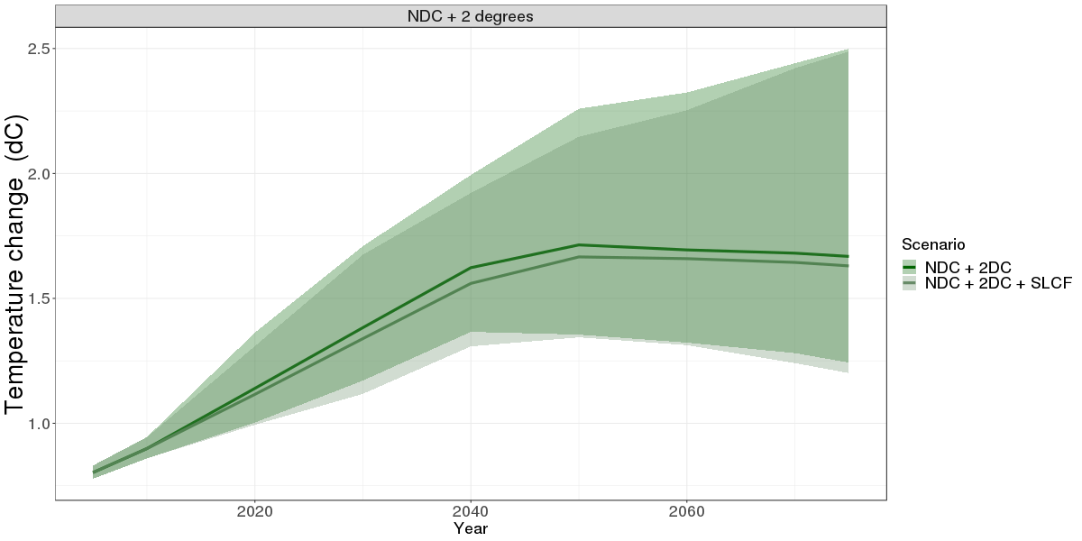

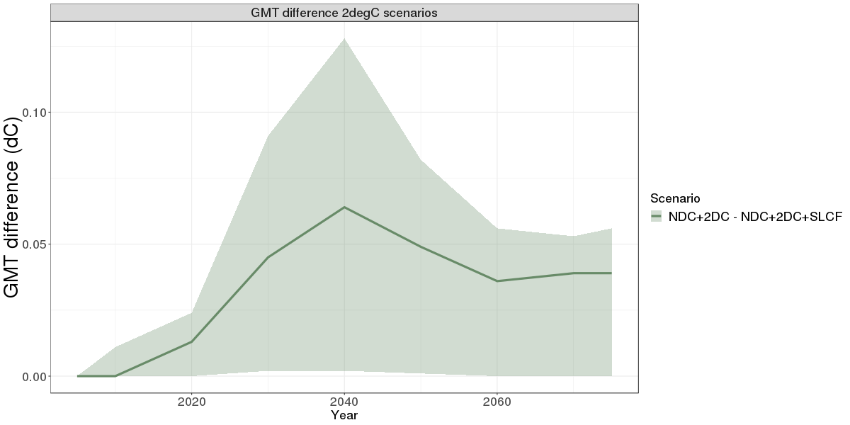

1. Höglund-Isaksson et al (2017) project a reduction of 58% in 2030 (Höglund-Isaksson L, et al. (2017) Cost estimates of the Kigali Amendment to phase-down hydrofluorocarbons Environmental Science & Policy 75: 138-147.) [↑](#footnote-ref-1)
2. Outside the G2O there are only a small number of countries that do not include non-CO2 emissions in their economy-wide NDC target; Albania, Macedonia, Venezuela [↑](#footnote-ref-2)