Managing future air quality in megacities: Emission inventory and scenario analysis for the Kolkata Metropolitan City, India*

Dipanjali Majumdar,ª Pallav Purohit,^{b} Anil D. Bhanarkar,ª Padma S. Rao,ª Peter Rafaj,^{b} Markus Amann,^{b} Robert Sander,^{b} Ankita Pakrashi, ªAnjali Srivastavaª
ªCSIR-National Environmental Engineering Research Institute (NEERI),Nehru Marg, Nagpur, 440020, India
^{b}International Institute for Applied Systems Analysis (IIASA), Schlossplatz 1, A-2361, Laxenburg, Austria

Abstract
Air pollution in Indian cities is a serious problem and a threat to human health. Kolkata Metropolitan City (KMC) is one of the Indian metro cities urgently requiring policy interventions to ensure breathable air in the near future. We developed a detailed emissions inventory of key air pollutants for 2015 in KMC, considering both particulate matter (PM₁₀, PM_{2.5}, BC, OC) and gaseous pollutants (SO₂, NO_{x}, CO, VOC and NH₃). We estimated the emissions in a business-as-usual (BAU) scenario for the year 2030, while accounting for the impacts of current and planned policies. Our results reveal that current policies/measures are not sufficient to reduce PM_{2.5} emissions substantially in KMC by 2030. We thus explored three alternative policy scenarios considering various emission control strategies and non-technical city-specific control measures, along with associated cost implications. Our results indicate that significant emission reductions can be achieved (35% for PM_{2.5} and 45% for NOx) by spending €1.15 billion for advanced control measures across various sectors, compared with the business-as-usual scenario, are expected to cost €0.78 billion by 2030. Advanced control measures, coupled with the control of non-technical emission sources, may prove to be the most effective solution, yielding a significant reduction of key air pollutants (51% for PM_{2.5} and 54% for NOx) with a cost implication of €1.18 billion by 2030. Low carbon policies may also be able to substantially reduce key air pollutants with the additional co-benefit of reduced emissions of greenhouse gas, CO₂ by 24% in 2030, with a running cost of €0.70 billion.
Keywords: Air pollutants, emissions inventory, GAINS model, Kolkata, greenhouse gas (GHG), co-benefits

Introduction
Air pollution is an important environmental health issue in urban areas, especially in developing countries. Such areas are often affected by severe air pollution due primarily to increased anthropogenic activities (for example, fossil fuel combustion in the power sector, industry, and vehicles). Moreover, solid fuel combustion in households and the burning of municipal waste release multiple products of incomplete combustion, including particulate matter (PM_{2.5}, PM₁₀) and other gaseous air pollutants. The emissions generate by pursuit of economic progress through industrial development, together with poverty-related emissions, combine with difficulties in imposing regulations and cause continuous deterioration in the ambient air (Gordon et al 2018, Balakrishnan 2013). According to the Global Burden of Disease (GBD) database, 4.9 million premature deaths can be attributed to air pollution globally (Stanaway et al., 2018), whereas in India over one million premature deaths can be associated with ambient and household air pollution (Balakrishnan et al., 2019). It is estimated that in 2015 more than half the Indian population were exposed to ambient PM_{2.5} concentrations (Purohit et al., 2019) that are non-compliant with India’s National Ambient Air Quality Standard (NAAQS). Further, less than one percent enjoyed air quality that met the global World Health Organization (WHO) benchmark limit of 10 μg/m³ annual average concentration of PM_{2.5} in the atmosphere (IEA, 2016).
Globally, Indian cities rank poorly in terms of air pollution. Thirteen Indian cities are listed among the world's 20 most polluted cities (WHO, 2018). Numerous monitoring sites across India report high concentrations of PM_{2.5} that exceed the benchmark limit (of 40 μg/m³) suggested by the NAAQS. Kolkata city has a severe level of air pollution, and its status has been alarming for the past two decades (Shannigrahi et al., 2003; Ghose et al., 2005; Das et al., 2006; Chatterjee et al., 2013; Lelieveld et al., 2015). The annual average pollution level, especially with respect to NO_{x} and Respirable Suspended Particulate Matter (RSPM; (~PM₁₀), was non-compliant with the national standard during the 1999–2011 period (CPCB 2015). In recent years, the annual average PM₁₀ and NO_{x} levels have been consistently beyond the NAAQS, while PM_{2.5} has been found to far exceed the standard during the winter months. A detailed account of the air quality of Kolkata city is given in Section 3, supplementary information (SI). According to Garaga et al. (2018) lack of an adequate emissions inventory and uncertainty regarding the mix of pollutants in ambient air have been a major hurdle in establishing strategies to mitigate air pollution.
Several studies have demonstrated that an integrated approach to mitigating air pollution and greenhouse gases (GHGs) is more cost-effective than treating these as separate issues (Aaheim et al., 1999; Reis et al., 2005; Amann et al., 2011; Wagner et al., 2012; Rafaj et al., 2018). Air pollution control strategies often prove to provide co-benefits in terms of reduced greenhouse gases (GHGs) and improvement of human health. GHG emission reduction strategies often result in reducing harmful air pollutants, including particulate matter and their precursors, namely, oxides of nitrogen (NO_{x}), sulfur dioxide (SO₂), and volatile organic compounds (VOCs), leading to health benefits (Purohit at al., 2010; Liu et al 2013). In this study we analyze and estimate the current and future anthropogenic emissions of air pollutants from key sectors in Kolkata using the GAINS-City tool.
This paper is set out as follows: Section 2 briefly presents the GAINS methodology to assess emissions of air pollutants from different sources along with an overview of alternative policy scenarios analyzed in this study. The results based on multi-pollutant emission inventory for Kolkata city are presented in Section 3. Section 4 presents alternative strategies to control air pollution and GHG emissions in Kolkata city. Uncertainties in emission estimates are highlighted in Section 5. Section 6 discusses the key findings of this study and Section 7 concludes.

Methodology

The GAINS-City model
The Greenhouse Gas and Air Pollution Interactions and Synergies (GAINS) model, developed by IIASA, deals with the synergistic relationship of multiple air pollutants and major greenhouse gases. The GAINS model has been applied widely for policy analyses in Europe (Amann et al., 2011), South Asia (Purohit et al., 2010; Purohit et al., 2013; Dholakia et al., 2013; Mir et al., 2016; Klimont et al., 2017; Karambelas et al., 2018; Purohit et al., 2019), and East Asia (Amann et al., 2008; Klimont et al., 2009; Liu et al., 2019). A more detailed account of the GAINS model is given in Section 4, SI.
The GAINS model has been modified to develop the more localized GAINS-City model as a policy framework for air pollution and GHG mitigation at a city scale. The GAINS-City model has the same model structure and functions as the regional GAINS model but deals with air quality management in urban areas at a more local scale (Amann at al., 2017). Two major changes have been made to the GAINS regional model to obtain a more suitable city-scale emission estimation and co-benefit assessment in the GAINS-City model: a) the source categories have been adjusted to city-specific activities: for example, the use of the 3-wheeler “auto-rickshaw” in Indian cities has been incorporated into the vehicular sector and crematoria into the domestic sector; b) The emission factor database has also been updated based on Indian and city-based measurements (Bhannarkar et al., 2018).

Study area
Kolkata city, the state capital of West Bengal, India, is situated between 22°33.76′ N latitude and 88°21.78′ E longitude in the Indian subcontinent. The city is a major hub of economic and cultural activities of a national and international scale. The city, earlier known as Calcutta, is under the authority of Kolkata Municipal Corporation. The urban agglomeration around the old city, reffered to as the Kolkata Metropolitan City (KMC), is the largest in eastern India (Figure 1). KMC consists of the old city itself and parts of five surrounding districts, namely, North 24 Pargana, South 24 Pargana, Howrah, Hugli, and Nadia. It extends over 1886.67 sq. km. and consists of 3 municipal corporations, 39 municipalities, and 24 Panchayat Samitis (blocks). According to 2011 census data, the total population of KMC is 14.0 million, as against the total urban population of West Bengal of 22.5 million (GoI, 2011).
For the purposes of this study we considered the KMC as our study area. Although the old Kolkata city is the capital of West Bengal, but the major financial and commercial activities are not confined to within the city boundaries; rather, they have outgrown the city and spilled into the urban agglomeration, that is, the KMC area (KMDA, 2011). None of the thermal power plants that cater to the city’s power requirements are situated inside the old city boundary, but are adjacent to it within the KMC area. Agricultural activity is almost non-existent within the old city but has considerable presence outside the old city boundary. Air pollutants emitted from industrial, waste, domestic, and transport activities are therefore not confined by the old city boundaries. Thus, to account for all major activities located in this highly populated area, it is necessary to study the entire KMC area and not just old Kolkata city separately.

Emissions inventory
In this study, we developed an emissions inventory with base years 2010 and 2015 for primary emissions of key air pollutants, types of particulate matter (e.g., PM₁₀, PM_{2.5}, BC, OC) and other pollutants (e.g., SO₂, NOx, CO, NH₃, and VOCs): we considered detailed activities from major contributing sectors such as transport, power, industry, domestic (both residential and commercial activity), waste, agriculture, and construction. Such an approach has been widely used to successfully develop emissions inventories at the national, regional, and city scale (Ramachandra and Shwetmala, 2009; Guttikunda and Calori, 2013; Sahu et al., 2015, Sindhwani et al., 2015; Amann et al., 2017; Bhanarkar et al., 2018).
In the power sector, we considered all four operational coal based thermal power plants within the study area as of 2015. The majority of the operating industrial units considered for emission estimation fall into medium-, small-, and micro-scale and belong to the Orange category (moderately polluting) (EMIS, 2015). In the residential sector we considered different fuel used for cooking and lighting in households in residential areas (GoI 2011). Under commercial sector we considered the type and amount of fuel used in both registered hotels, resturants as well as unregistered hotels and roadside eateris (EMIS 2015, in-house survey). In waste sector, we considered the emissions during municipal waste handling along with emissions from open burning considering 1% of total municipal solid waste (MSW) to be subjected to open burning (GoI 2011, Das et al., 2011). Emissions from crematoria were also considered (KMDA, 2005). We considered both residential and infrastructural constructions for emissions from this sector (DoEA 2015). Emission from non-road mobile sector includes aviation, maritime and locomotive (AERAI 2012, IOCL 2015). The fleet distribution and average traffic movement of on road active fleet is used to estimate the emissions from onroad mobile sector (WBPCB 2015, ADB 2008, KTP 2010). Section 6, SI, describes the emission inventory in detail including the data sources for activity data in sectors in KMC.

Emission factors
Emission factors used in this study reflect Indian conditions and are estimated based on various international sources and the published literature. Local and international measurements were also used to estimate emissions from various sectors such as power, transport, domestic (residential/commercial), agriculture, and waste. These are based on published reports and experiments conducted by government certification agencies and also by government-authorized non-governmental, and autonomous agencies under various projects (UNEP, 1999; US EPA, 2000, 2006; Reddy and Venkataraman, 2002a, 2002b; NEERI, 2008; CPCB, 2011). We used the GAINS emission factors in cases where emission factors were not available. To calculate PM and SO₂ emissions, the most relevant ash and sulfur contents for fuels used in India were used (CPCB, 2011), as these emission factors are based on ash and sulfur content in fuel (Shah and Nagpal, 1997; IPCC, 2006; UNEP, 2006; NEERI, 2008; CEA, 2014) The emission factors used in the study are discussed with further details in Section 7, SI.

Scenario overview
The GAINS-City model, which built upon integrated methodologies developed for mitigation of air pollution together with GHGs, has recently been successfully applied to the National Capital Territory (NCT) of Delhi, India (Amann et al., 2017; Bhanarkar et., 2018). Now, for the first time, a comprehensive emissions inventory has been developed of Kolkata’s anthropogenic emissions. The inventory considers activity data and emission factors for all air-polluting sectors. It accounts for emissions of key air pollutants, both primary particulate matter (e.g., PM₁₀, PM_{2.5}, BC and OC) and gaseous precursors of secondary particulate matter (e.g., SO₂, NO_{x}, CO, NH₃, and VOCs). This has allowed the first emission projections to be developed for KMC and the co-benefits of different air pollution control policy measures to be assessed in terms of reduction in GHG emissions such as CO₂, CH₄, and N₂O.
We drew up detailed emission inventories for key air pollutants and GHGs for 2010 and 2015. We next projected emissions for near future, namely, for 2020, 2025, and 2030 under the business-as-usual (BAU) scenario, as well as three alternative policy and technological scenarios. The BAU scenario considers all current and declared regulations, legislation, and policies affecting air pollutant emissions applicable to Kolkata. Projected emissions under the BAU scenario indicate the extent of primary emissions of pollutants in the near future if no additional measures are implemented. Under the advanced control technology (ACT) scenario, we assessed the application of the best available technologies and advanced air pollution control policies, as applied in cities of industrialized countries. In the low carbon intensity (LCI) scenario, we considered switching to cleaner and more energy-efficient fuels in key economic sectors without any advanced control technology. In the most ambitious scenario (i.e., the clean air scenario [CAS]) we considered advanced control technologies for industrial and other major polluting activities along with policies to control the unregulated emissions typical of the urban agglomeration; these included a ban on polluting vehicles, restriction of vehicle fleet volume, and a ban on open-air combustion of waste and biomass.
The emission levels for key air pollutants and GHGs obtained for 2015 are considered as the baseline for Kolkata. The projected emission load for air pollutants and GHGs up to 2030, obtained under the alternate scenarios, are compared with the baseline to understand their possible impact on emissions and eventually on city air quality.
Future emissions were estimated under the alternate scenarios following the same general methods used for the baseline year. The different legislation, regulations, and policies considered in the BAU scenario are listed in section 5, SI. Various assumptions used to project future activity (during 2020–2030) are described in detail in Section 8, SI. Various city-specific policy interventions considered under alternative scenarios, along with control policies, are detailed in Table S3 of Section 9, SI. This study involves comprehensive analysis of the effectiveness of each measure implemented in the targeted sectors, along with their emission-reduction efficiencies with respect to the corresponding emission factors, coupled with associated costs.
Figure 1. Map of study domain: Kolkata Metropolitan Area

Results

Baseline emission estimates and sectoral contributions
Our study gives a detailed account of sectoral contributions to key air pollution emissions for 2015 with a view to analyzing the impact of these sectoral activities on future emissions. Figure 2(a-i) presents the detailed sectoral contribution to air pollutants for 2015. The GAINS model estimates the future emission-based information regarding energy statistics, fuel quality, combustion characteristics related to a specific sector, and also implementation of control measures. Our inventory suggests that in 2015 KMC emitted into the atmosphere 58.6 kt of PM₁₀, 29.4 kt of PM_{2.5}, 7.7 kt of BC, 7.2 kt of OC, 76.5 kt of SO₂, 77.9 kt of NO_{x}, 78.7 kt of CO, 35.9 kt of VOCs and 24.8 kt of NH₃.
The residential sector, including both domestic and commercial combustion, is the largest contributor to air pollutant emissions, adding almost one-third (32%) of total PM₁₀ emissions. This is closely followed by road dust related to vehicular movement, namely, the non-exhaust vehicular emissions contribution (25%). Coal-based thermal power plants, construction, and industrial emission contribute significantly, 15%, 11%, and 5% respectively, of total PM₁₀ emissions. Waste and open burning and agriculture also contribute 5% and 2% respectively. Vehicular exhaust contributes only 4% of total PM₁₀ emissions, contradicting the widespread belief that most air pollution in cities comes from vehicles. For PM_{2.5} emissions, the residential sector is the single largest contributor, responsible for half (50%) of the total PM_{2.5} emissions of KMC. Other major sources include power, waste and open burning, road transport (exhaust) and road transport (non-exhaust), contributing 16%, 10%, 8%, and 8%, respectively. Industrial emissions, construction and agriculture sector has minor contribution (4%, 2% and 1% respectively). The majority of black carbon (BC) emissions are from the domestic sector (72%), with road-transport exhaust and non-exhaust contributing 18% and 4%, respectively. Other sources of BC include waste and open burning and non-road machinery, contributing 3% and 2% respectively. The domestic sector contributes the most to organic carbon (OC) emissions (48%). Other prominent sources are road-transport non-exhaust emissions, waste and open burning, road-transport exhaust emissions and non-road machinery contributing 21%, 17%, 12% and 1% respectively. For sulfur dioxide (SO₂) emissions, power plants are the single major source (92%) within the study domain, with minor contributions from industrial emissions, the domestic sector, and road-transport exhaust contributing 4%, 2% and 2%, respectively, to total SO₂ emissions. Power plants and vehicle exhaust are major contributors of NO_{x}, with 57% and 34%, respectively, while the domestic sector contributes 3%. The major contributing source of carbon monoxide (CO) is the domestic sector (49%) followed by road-transport exhaust and waste and open burning, contributing 36% and 10%, respectively. Other sources of CO includes power plants and non-road machinery contributing 3% and 2% respectively. Exhaust emissions from road transport contribute 36% volatile organic compounds (VOCs) emissions. Other major VOC sources include solvent use, fuel distribution, and the domestic sector contributing 25%, 18%, and 14%, respectively. Minor sources of VOCs include power plant, non-road machinery and waste and open burning contributing 5%, 2% and 1% respectively. The agriculture sector is the single most important source of ammonia (NH₃) emissions, contributing 99% of total emissions.

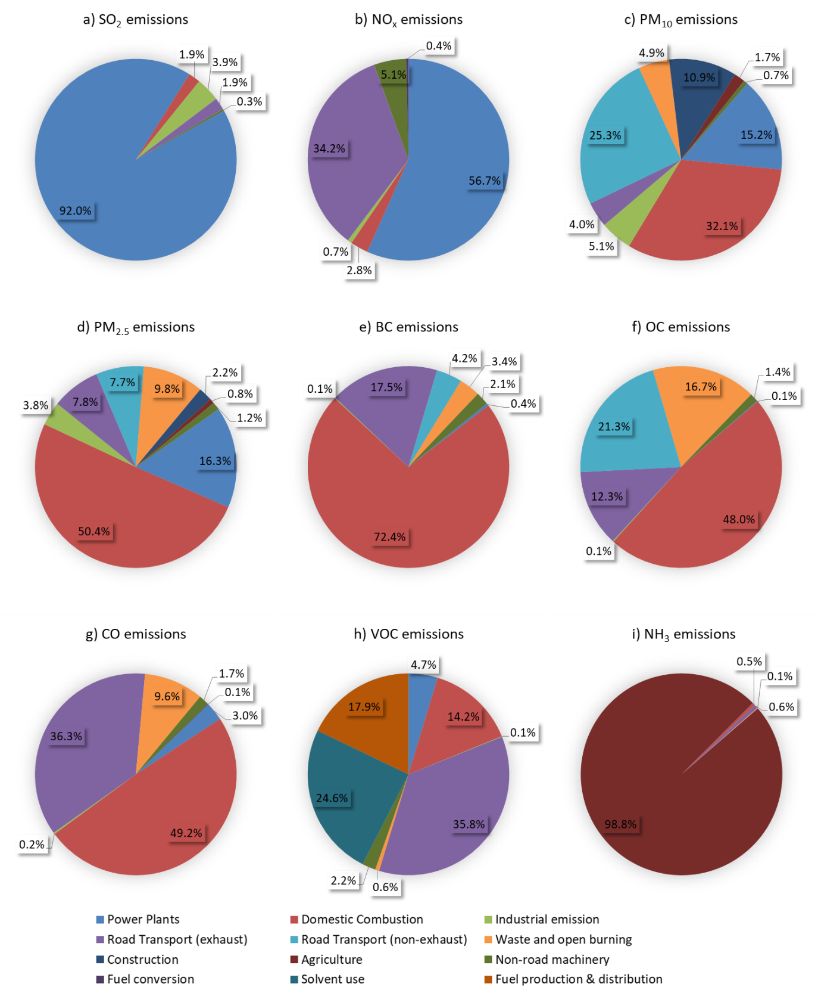

Figure 2. Sectoral contribution of air pollutant emissions in Kolkata in 2015.

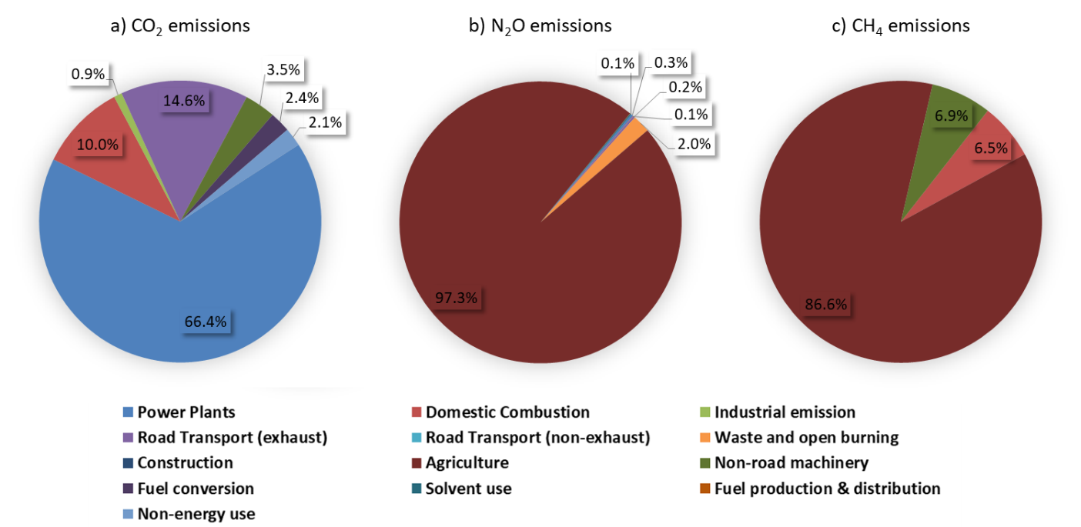

Figure 3. Sectoral distribution of GHG emissions in Kolkata in 2015.

Figure 3 (a-c) presents the sectoral distribution of GHG emissions for 2015 in Kolkata. In 2015, KMC emitted 20.3 Mt of CO₂, 74.8 kt of N₂O, and 25.2 kt of CH₄. The power plant sector contributed the large share (66%) of CO₂ emissions in the KMC domain, followed by light- and heavy-duty vehicle exhaust (15%), and residential combustion (10%) The agriculture sector contributed the majority of N₂O and methane emissions, 97% and 87%, respectively, as shown in Figure 3.
Reportedly, some studies on air quality have been conducted in Kolkata city during the past two decades. However, very few of them deal with making an emissions inventory of air pollutants for KMC. It is difficult to match our results with previous data, as some reported estimates are for a base year prior to 2005, over a decade ago, and have variable study domains (Sharma et al. 2002; Guttikunda et al., 2003; ADB 2005). Some studies considered only the vehicular sector for emissions estimates (Sharma et al. 2002; Gurjar et al., 2010; CPCB 2015) as well as power plant and industrial emissions (ADB 2005) as major contributors of a single selected air pollutant. These studies also did not account for certain emission sources such as emissions from the residential, construction, and waste sectors which emerge as significant contributors as of 2015. Moreover, several regulations and policies have been adopted for the city since 2005 (see: Section 5, SI) and this is expected to significantly affect the present emissions estimate in comparison with previous estimates. The present study is the first to estimate the emissions of multiple pollutants as well as GHGs for Kolkata, based on multiple air-polluting sectors. A comparison of the emissions inventory result in the present study, along with published results is discussed in more detail in Section 10, SI.

Emissions projections up to 2030 in the baseline (BAU)

Key assumptions/drivers
The gross domestic product (GDP) of Kolkata city is obtained from GoWB (2015) at a 2004–2005 constant price. An estimate of city-specific per capita GDP is then used to derive the GDP of KMC. The GDP of KMC for 2010–2011 is estimated to be €14.9 billion. The average annual GDP growth rate from 2005–2006 to 2012–2013 is reported to be 6.59%. The same rate is used to project GDP until 2030 (Figure 4a). The share of various economic sectors in the city’s GDP are obtained from GoWB (2015).
(a) | (b)

Figure 4. Assumptions on the baseline projection: a) Macro-economic indicators, relative to the year 2015; b) Primary energy consumption (in PJ/year) in Kolkata.
To project future GDP in different sectors of the economy, the annual average growth rates (for 2005 to 2013) of the state GDP of West Bengal by Industry of Origin at Constant (2004-05) Prices were used (GoWB, 2015). For sectoral growth projection, it is also assumed that the construction and transport sectors within the KMC area will have 25% more growth than the rest of West Bengal. In the industrial sector (manufacturing) because of the decision of the city authority not to permit any more industry to open within the KMC area, a nominal 1% annual growth is assumed, compared to a 5.59% projected growth for the rest of the West Bengal.
Coal remains the principal source of primary energy within the study area because of its use in thermal power plants and fuel in the residential and commercial sector (Figure 4b). The net primary energy consumption within KMC is expected to increase (+3.5% per year). However, consumption of biomass is expected to decrease (-5.2% per year). As no new thermal power plant will be installed in KMC, increase in coal consumption is restricted by the capacity of the existing plant (up to +2.4% per year). The additional requirement of electricity will need to be met by importing from outside the KMC boundary. Oil and gas (both LPG and CNG) consumption is expected to increase (+5.8% and +2.8% per year, respectively). As of 2015, the contribution of renewable energy (excluding biomass) is negligible in total primary energy consumption, and there are concerns that it will remain insignificant in 2030 without a major policy thrust.
Future projections of air pollutants (PM₁₀, PM_{2.5}, BC, OC, NOx, SO₂, CO, VOCs and NH₃) and GHGs (CO₂, CH₄ and N₂O) emissions in the KMC are briefly discussed in the following subsections.

SO₂ emissions
SO₂ emissions in the KMC area decreased from 85.8 kt in 2010 to 76.5 kt in 2015 due to the reduction in actual coal consumption at thermal power plants and to the use of low sulfur fuel in diesel vehicles (Figure 5a). SO₂ emissions are expected to further decrease to 13.9 kt (-82% of the 2015 total) by 2030 mainly because of stricter emission norms to control SO₂ emissions from power plants, which are currently being retrofitted with flue gas desulfurization (FGD) units. The process is expected to be implemented fully during 2018–2025. Industrial SO₂ is expected to increase (13%) due to diesel emissions, on which no controls have been imposed to date. From April 2020 onwards, the use of Bharat stage-VI- (i.e., BS-VI-, equivalent to Euro-VI-) compliant low sulfur fuel use (both gasoline and diesel) is to be implemented, and this is expected to considerably reduce sulfur emissions from the transport sector.

NO_{X} emissions
NO_{x} emissions decreased slightly from 78.5 kt in 2010 to 77.9 kt in 2015 (Figure 5b) due to the reduction in coal consumption in the power sector over this period. From 2015 NOx emissions are expected to increase gradually to 106.7 kt by 2030 (an overall 37% increment). The power plant contribution is expected to increase upto 60.7 kt in 2030 in case of lack of stringent NO_{x} controls; however, the contribution of vehicles is expected to decrease after 2025 due to an increase in the number of BS-VI-compliant vehicles in active fleet.

PM₁₀ and PM_{2.5} emissions
Emissions of particulate fractions PM₁₀ and PM_{2.5} in the KMC area were 58.5 kt and 32.0 kt, respectively, and almost the same as in 2015 (58.6 kt and 29.4 kt). One of the power plants (Cossipore plant) has been closed since 2014, and issues with coal supply have resulted in less coal consumption for power generation in 2015 than in 2010. The practice of biomass burning was reduced in 2015 in comparison with 2010, as evident from the primary survey conducted as a part of this study. Although the total number both of registered vehicles and the estimated active fleet increased from 2010 to 2015, the contribution of transport exhaust was estimated to have reduced marginally in this period (2.5 kt to 2.3 kt of PM_{2.5} and 2.6 kt to 2.4 kt of PM₁₀ in 2010 and 2015, respectively) because of the implementation of BS-IV emission standards and the banning of old vehicles. The decision to ban vehicles older than 15 years was taken in 2009; it is thought, however, that full implementation took place after 2010 and was reflected in the results by 2015.
The reduction in particulate emissions from the power sector and from vehicular exhausts has been offset mainly by increased emissions from non-exhaust road transport due to an increase in the total number of vehicles on the road (Figure 5). PM₁₀ emissions are projected to increase 43% from 2015 to 2030 (Figure 5c). The increase is expected to be due mainly to an increase in road transport emissions from non-exhaust sources (173%) due to an increased fleet volume followed by increased emissions from power plants (37%, assuming the exploitation of full potential of existing plants). Significant increases are also projected from the open burning of waste and residuals (34%). Although open burning of household waste is banned by the West Bengal State Pollution Control Board, the ban is not being completely implemented. As a result, open burning of municipal waste is a common sight in the city, especially in the winter months. PM₁₀ emissions from vehicle exhausts are projected to increase by only 2% from 2015 to 2030, despite the increase in fleet volume, because of the expected BS-VI implementation from 2020. All these sources are expected to offset the significant emissions reduction projected in the residential sector (-37%). On the other hand, overall PM_{2.5} emissions are projected to decrease (-3%) from 2015 to 2030 (Figure 5d). PM_{2.5} emissions will increase substantially in the road transport non-exhaust, power plant and waste and open burning sectors by 174%, 37%, and 34%, respectively during 2015 to 2030. However, a substantial emissions reduction (-53%) is expected from the domestic sector due to the expected shift from solid fuel to cleaner fuel.

BC and OC emissions
BC is also expected to reduce significantly (-53%) from 2015 to 2030 (Figure 5e) mainly due to a reduction in the use of solid fuel in the residential sector (-78%) and from road transport exhaust (-31%). An increase in BC emissions is projected from non-exhaust emissions from the road transport sector, waste and open burning activities, and the power sector (172%, 35%, and 33%, respectively). OC emissions are expected to remain almost the same from 2015 to 2030 (Figure 5f), with a minor increase (1.7%). There will be a significant reduction in OC emissions from the domestic sector from 2015 to 2030 (-93%); however, this is expected to be more than offset by the growth in both exhaust and non-exhaust emissions in the transport sector along with emissions from waste and open burning (24%, 173%, and 36%, respectively).

CO, VOC, and NH₃ emissions
CO emissions showed an altogether opposite trend from VOC and NH₃ emissions (Figure 5). The annual VOC emissions remained almost the same in 2010 (35.4 kt) and 2015 (35.9 kt). Reduced emissions from power plants (1.9 kt to 1.7 kt in 2010 to 2015) were due to lower coal consumption and reduced emissions from the domestic sector (6.6 kt in 2010 to 5.1 kt in 2015) were a result of the shift toward cleaner fuel use. This was offset by increased emissions from vehicular exhaust (11.4 kt to 12.8 kt in 2010 and 2015, respectively) and other sources linked to increased population during this period (Figure 5h). The overall VOC emissions are projected to increase by 52% from 2015 to 2030. While emissions from the domestic sector are expected to reduce significantly (-87%), increased emissions are expected from all other sources, especially from the highest contributing sector, namely, vehicular exhaust (132%), followed by waste and open burning activity (48%) as well as power plants (39%) and solvent use (28%).
NH₃ emissions remain almost the same in 2010 and 2015 (23.6 and 24.8, respectively). Emissions from the agriculture sector, the single biggest contributing sector to NH₃, are expected to increase by 48% from 2015 to 2030, resulting in an overall increase of up to 36.5 kt in 2030 (Figure 5i).
On the other hand, CO emission were found to decrease from 90.6 kt in 2010 to 78.7 kt in 2015 (Figure 5g), mainly due to a reduction in emissions from the domestic sector owing to the fuel shift from solid (coal, cow dung, wood etc.) toward energy-efficient and cleaner fuel (LPG/electricity). A reduction in CO emissions from this sector is projected to be significant (-86%) from 2015 to 2030. Overall CO emissions are projected to gradually reduce until 2030 (-19%) compared with 2015. An increase in CO emissions is expected from vehicular exhaust (51%) power plants (39%), and waste and open burning activities (31%).

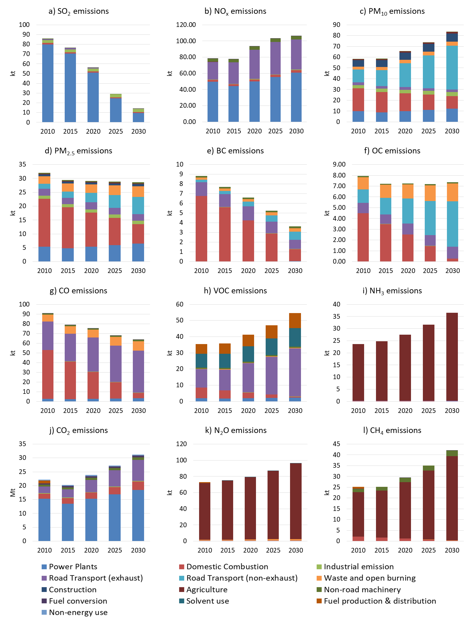

Figure 5. Air pollutant and GHG emission projections in the baseline for Kolkata city.

Greenhouse gas emissions
Among the GHGs, total CO₂ emissions reduce marginally from 2010 (21.2 Mt) to 2015 (20.3 Mt) (Figure 5j). CO₂ emissions are mainly driven by the quantity and type of fuel used. In the KMC area, the projected energy requirement increases with increasing population, vehicular fleet volume, as well as activities in other sectors. Even if the fuel composition shifts toward cleaner and more efficient fuel in both the residential and transport sectors, the overall CO₂ emissions are projected to be 31.2 Mt in 2030, that is, 1.5 times as high as in 2015.
CH₄ emissions show a gradual increase from 2010 to 2015 (24.2 kt and 25.2 kt, respectively) mainly due to emissions from the agricultural sector (87% of total emissions in 2015). The domestic sector also contributes marginally (7% in 2015). However, in 2030 the decrease in CH₄ emission in the domestic sector compared to 2015 emissions (-91%) will be far exceeded by the increased emissions from the agricultural sector (78%) as shown in Figure 5l. An overall increase of 67% is expected in 2030 compared to the 2015 level. The agriculture sector is also the single largest source of N₂O emissions in 2015 (Figure 5k), contributing 97% of the total emissions of 74.8 kt. N₂O from the agriculture sector; total emissions are also expected to increase by 2030 compared with the 2015 emissions (28% and 29%, respectively) representing a total emissions load of 96.3 kt in 2030.

Comparison of primary emissions: Kolkata vs Delhi
As an Indian metropolitan city, Kolkata has very similar emission characteristics to the national capital territory (NCT) of Delhi (Bhannarkar et al., 2018) given that fuel characteristics, socioeconomic situation, and the demographic structure of both Delhi NCT and Kolkata are comparable. However, there is a wide variation in primary source contributions. The vehicular sector is reported to be the prime contributing factor to key pollutants in Delhi in 2010, contributing more than half of PM₁₀ (46% from non-exhaust, 9% from exhaust emission) and NOx (52%) as well as 39% of PM_{2.5} (17% from non-exhaust and 22% from exhaust emissions). In Kolkata, on the other hand, as of 2015 the residential sector was the leading contributor of PM₁₀ (32%) and PM_{2.5} (50%), while the power sector was the leading contributor of NOx (57%). The vehicular sector in Kolkata contributes much less PM₁₀ than it does in Delhi for (25% from non-exhaust and 4% from exhaust) and NOx emissions (34%) even less for PM_{2.5} (16% equally from non-exhaust and exhaust emissions).

Figure 6: Comparison of air pollutant and GHG emissions for 2015 in Delhi and Kolkata

We compared primary emission of air pollutant in Kolkata for 2015 (present study) with the same in Delhi for 2015 (Bhanarkar et. al., 2018). The total estimated emissions for Kolkata were found to be greater than those of Delhi NCT for all air pollutants except CO and VOCs. Total emission of CO₂ were also higher for Delhi NCT among GHGs. It is relevant to mention here that Delhi NCT imports electricity from outside city boundary whereas Kolkata city exports electricity outside city boundary.
Primary emissions for 2030 projected in our study for Kolkata and in Bhannarkar et. al. (2018) for Delhi are compared to the BAU scenario for both. In 2030 emissions of most of the pollutants and GHGs in Delhi are expected to be less than in Kolkata (14% for PM₁₀, 20% for PM_{2.5}, 15% for BC, 24% for NOx, 11% for VOCs, 46% for CH₄, and 92% for N₂O). A few of the emissions are projected to be higher for Delhi than Kolkata (22% for OC, 279% for SO₂, 29% for CO, and 25% for CO₂).

Scenario analysis of strategies to control air pollution in Kolkata
The projected emissions of key pollutants in the BAU scenario to 2030 do not indicate enough progress toward the achievement of desirable air quality standards. It is essential to explore the technology and policy options of additional measures needed to push the attainment of better air quality in the near future. In this process, we use the GAINS-City tool to project the effectiveness of various emission control measures for primary emissions of air pollutants. The effect of different policies and assumptions considered under different scenarios (Table S3, Section S9 in SI) are discussed in the following subsections. The emission under different policy scenario is also tabulated in Table S5, Section 11 in SI.

Advanced control technology (ACT) scenario
In many countries, advanced emission control measures are applied to secure acceptable air quality in the midst of expanding economic activity. These measures effectively decouple economic growth from primary emissions of air pollutants (Rafaj and Amann, 2018). In this scenario, we assume implementation of advanced end-of-pipe technologies with abated emission factors (see: Table S3 in the SI). However, the scenario does not consider introduction of any non-technical measures that would improve resource efficiency and lead to a significant change in the energy balance. The measures are assumed to be applied immediately from 2020 without any transition state. Moreover, factors beyond the scope of this study such as socioeconomic or political constraints were not considered. The model projects 26%, 35%, 2%, 4%, 19%, 45%, 3%, 5%, and 9% reduction in primary emissions for 2030 as compared to the BAU scenario for PM₁₀, PM_{2.5}, BC, OC, SO₂, NOx, CO, VOC and NH₃ respectively (Figure 7). Emissions of CO₂ and N₂O remain almost unchanged, with a 3% reduction and increment, respectively. CH₄ emission also remains same as expected in BAU scenario. As advanced control measures in the transport sector have already been implemented in the BAU scenario, no emission reduction in the transport (exhaust) sector is projected under the ACT scenario.

Low carbon intensity (LCI) scenario
In the LCI scenario we assume phasing out coal and biomass use in the power and domestic sectors and the introduction of cleaner and more energy-efficient fuel, such as gas for power generation or LPG/electricity in the domestic sector (see: Table S3 in the SI). The GAINS-City model projects 27%, 43%, 30%, 3%, 89%, 53%, 7%, 4% and -1% reduction in primary emission for 2030 as compared to emissions in the BAU scenario for PM₁₀, PM_{2.5}, BC, OC, SO₂, NOx, CO, VOC, and NH₃ , respectively (Figure 7). Of the GHGs, emissions of CO₂ reduce significantly (24%) in this scenario with a marginal reduction (0.3% and 0.2 %) in N₂O and CH₄ emissions respectively.

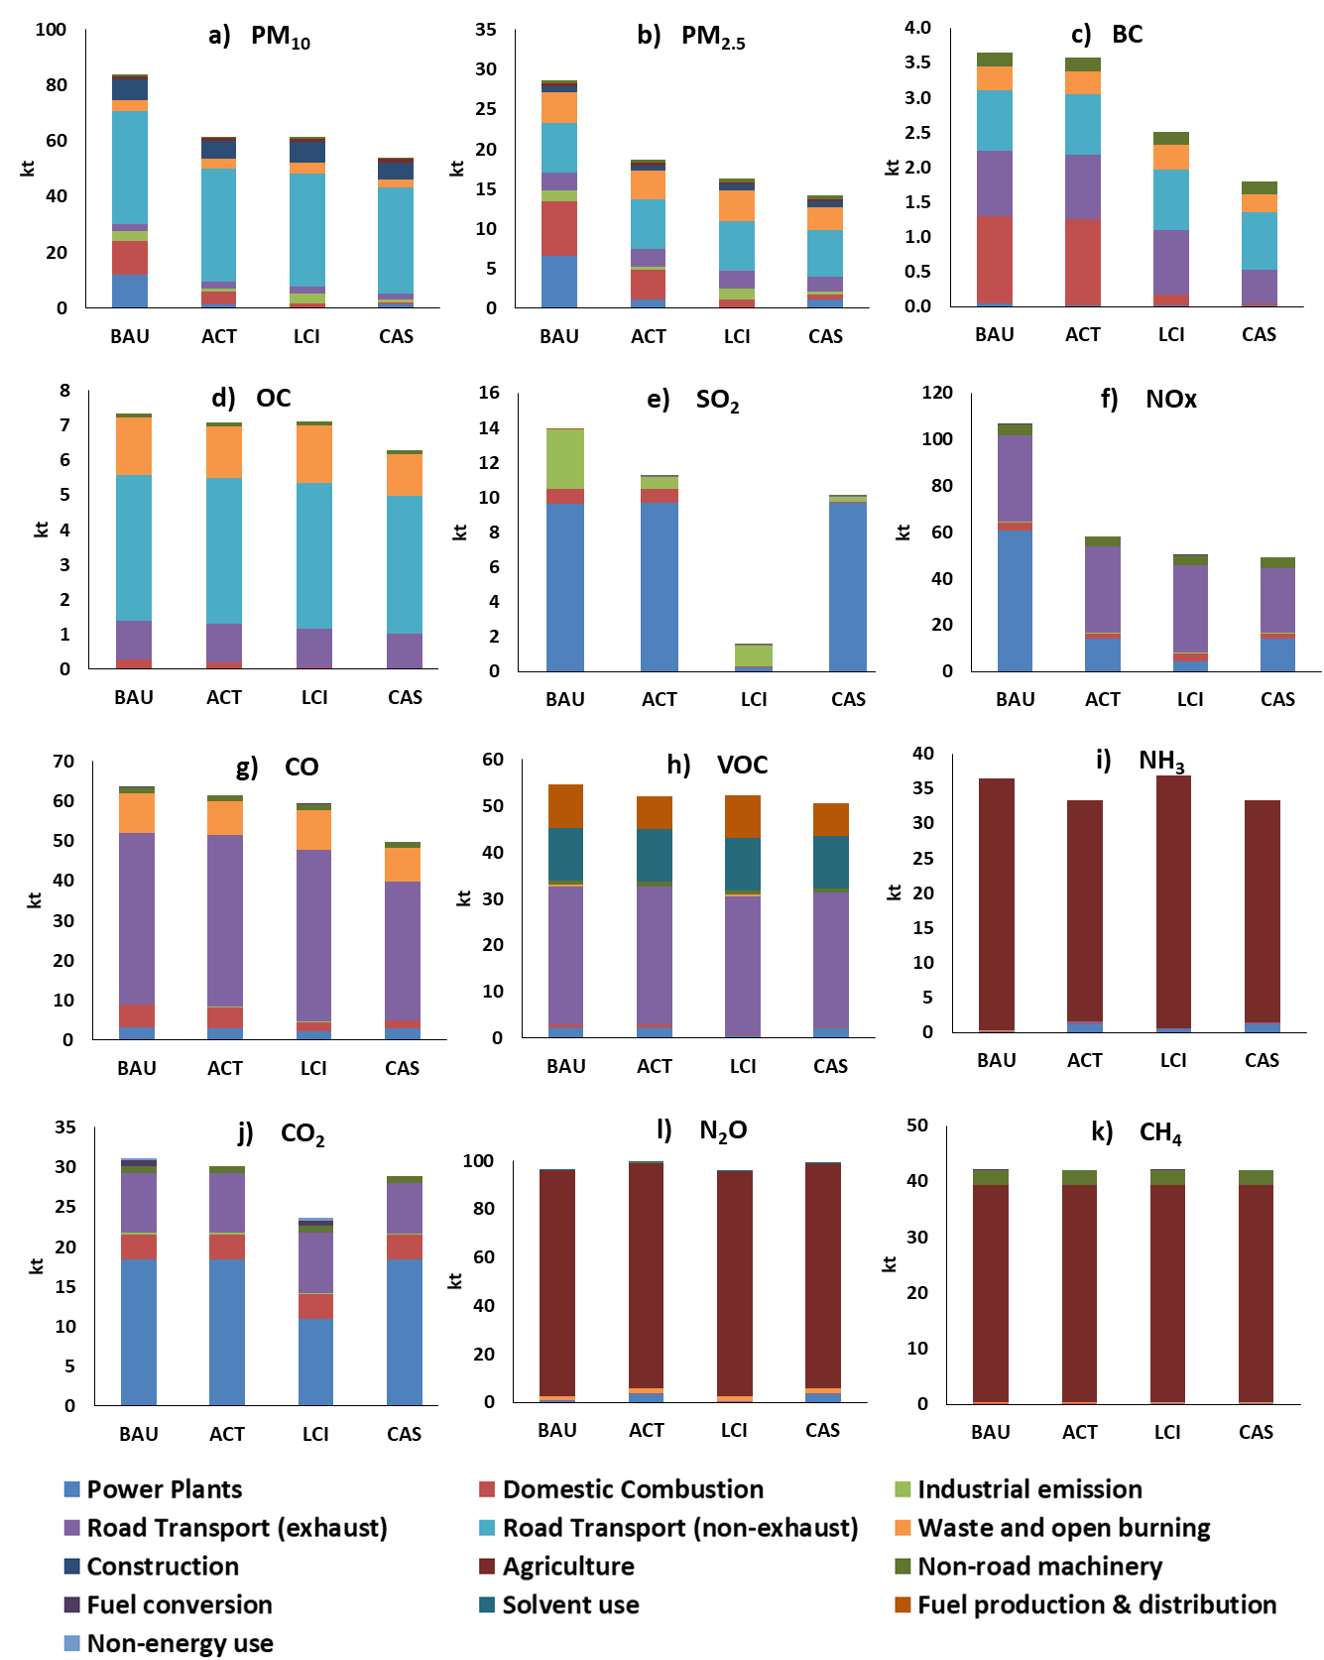
Figure 7: Estimated emissions aggregated by sector for Kolkata under policy scenarios in 2030.

Clean air scenario (CAS)
To find plausible solutions to cities’ air quality crisis, we explore the possibility of regulating non-industrial and to date unregulated activities, as well as the use of end-of-pipe control technologies as considered in the ACT scenario. However, fuel switching is not considered for the power sector, as it is expected to be a less plausible solution for the CAS scenario. Here, we assume there will be a complete ban from 2020 on vehicles below the BS-IV standard and a restriction of 2-wheelers and 4-wheel cars in active fleets by up to 50% by 2030. This will require a shift toward public transport. We also assume a fast switch from solid fuels /kerosene to clean fuels (LPG, NG, or electricity) by 2030 and a ban on firewood use from 2020. However, 10% coal combustion is assumed to continue for traditional tandoor ovens, with advanced cookstoves being used in the residential and commercial sector. Under this scenario, cremation is carried out using only electricity. We also assume control of particulate matter in the construction sector and combating road dust by paving, water sprinkling, etc. (see: Table S3 in the SI). These additional controls in the CAS scenario will be able to reduce primary emissions of PM₁₀, PM_{2.5}, BC, OC, SO₂, NOx, CO, VOC, and NH₃ by 35%, 51%, 51%, 14%, 27%, 54%, 22%, 8%, and 9% respectively, compared to the BAU scenario by 2030 (Figure 7). CO₂ is projected to decrease by 7% as additional co-benefits in the CAS scenario by 2030 compared with the BAU scenario while CH₄ decrease marginally (0.3%). Emissions of N₂O may increase marginally (3%) in this scenario.

Individual policy implications
To effectively combat air pollution, the implementation of specific policy measures and the length of time taken to enforce them are of utmost importance. However stringent and efficient the policy is, it will have no effect on air pollutant emissions if it is not implemented completely and in a timely fashion (Liu et al., 2013).

Domestic sector
As of 2015, the domectic combustion from both residential and commercial sectors emerge as the largest contributors to air pollution. Each policy considered in this study (see: Table S3 in the SI) will have a significant effect on the reduction of key air pollutants. The reduction of pollutants in the domestic sector in different scenarios is presented in Figure 8. All emissions from the domestic sector (e.g., PM₁₀, PM_{2.5}, BC, OC, SO₂, CO, and VOCs) are projected to decrease in the BAU scenario (-37%, -53%, -78%, -93%, -41%, -86%, and -87%, respectively) by 2030 except NO_{x} which is projected to increase by +45% due to the increasing use of LPG. Of the GHGs, CO₂ emissions are projected to increase by 51% due to increasing energy demand.
It is possible to reduce the emission of pollutant considerably (emissions -76% PM₁₀, -75% PM_{2.5}, -78% BC, -94% OC, -41% SO_{2,} -89% VOCs, -87% CO) by 2030 with proper control in domestic cookstoves and other applicable sources, as considered in ACT scenario. NO_{x} emission may increase nominally (+3%).
A gradual, but complete, fuel switch is considered for the domestic sector, with firewood, dung-cake, coal, kerosene, etc., giving way to LPG and electricity (80:20 ratios, respectively) in the LCI scenario. If implemented, the switch may be able to reduce emissions (-91% PM₁₀, -92% PM_{2.5}, -97% BC, -99% OC, -94% SO_{2,} -96% VOCs, -94% CO) more from this sector, compared with the 2015 level, even with 10% coal use with proper control system to preserve the culinary culture. By 2030 even greater reductions are possible (-96% PM₁₀, -95% PM_{2.5}, -95% BC, -100% OC, -95% SO_{2,} -97% VOCs, -95% CO) compared with the 2015 level, if complete ban on biomass burning is implemented, as considered in the CAS scenario (Figure 8). An increase in NOx emissions (by +45% compared with the 2015 level) is anticipated in the LCI scenario, resulting from increased use of LPG; however, with the use of appropriate control measures, as considered in the CAS scenario, the increase in NOx emissions can be restricted to +2.3% of the 2015 level. Of the GHGs, CO₂ emissions are expected to increase in both the LCI and CAS scenarios (+49% in both cases).
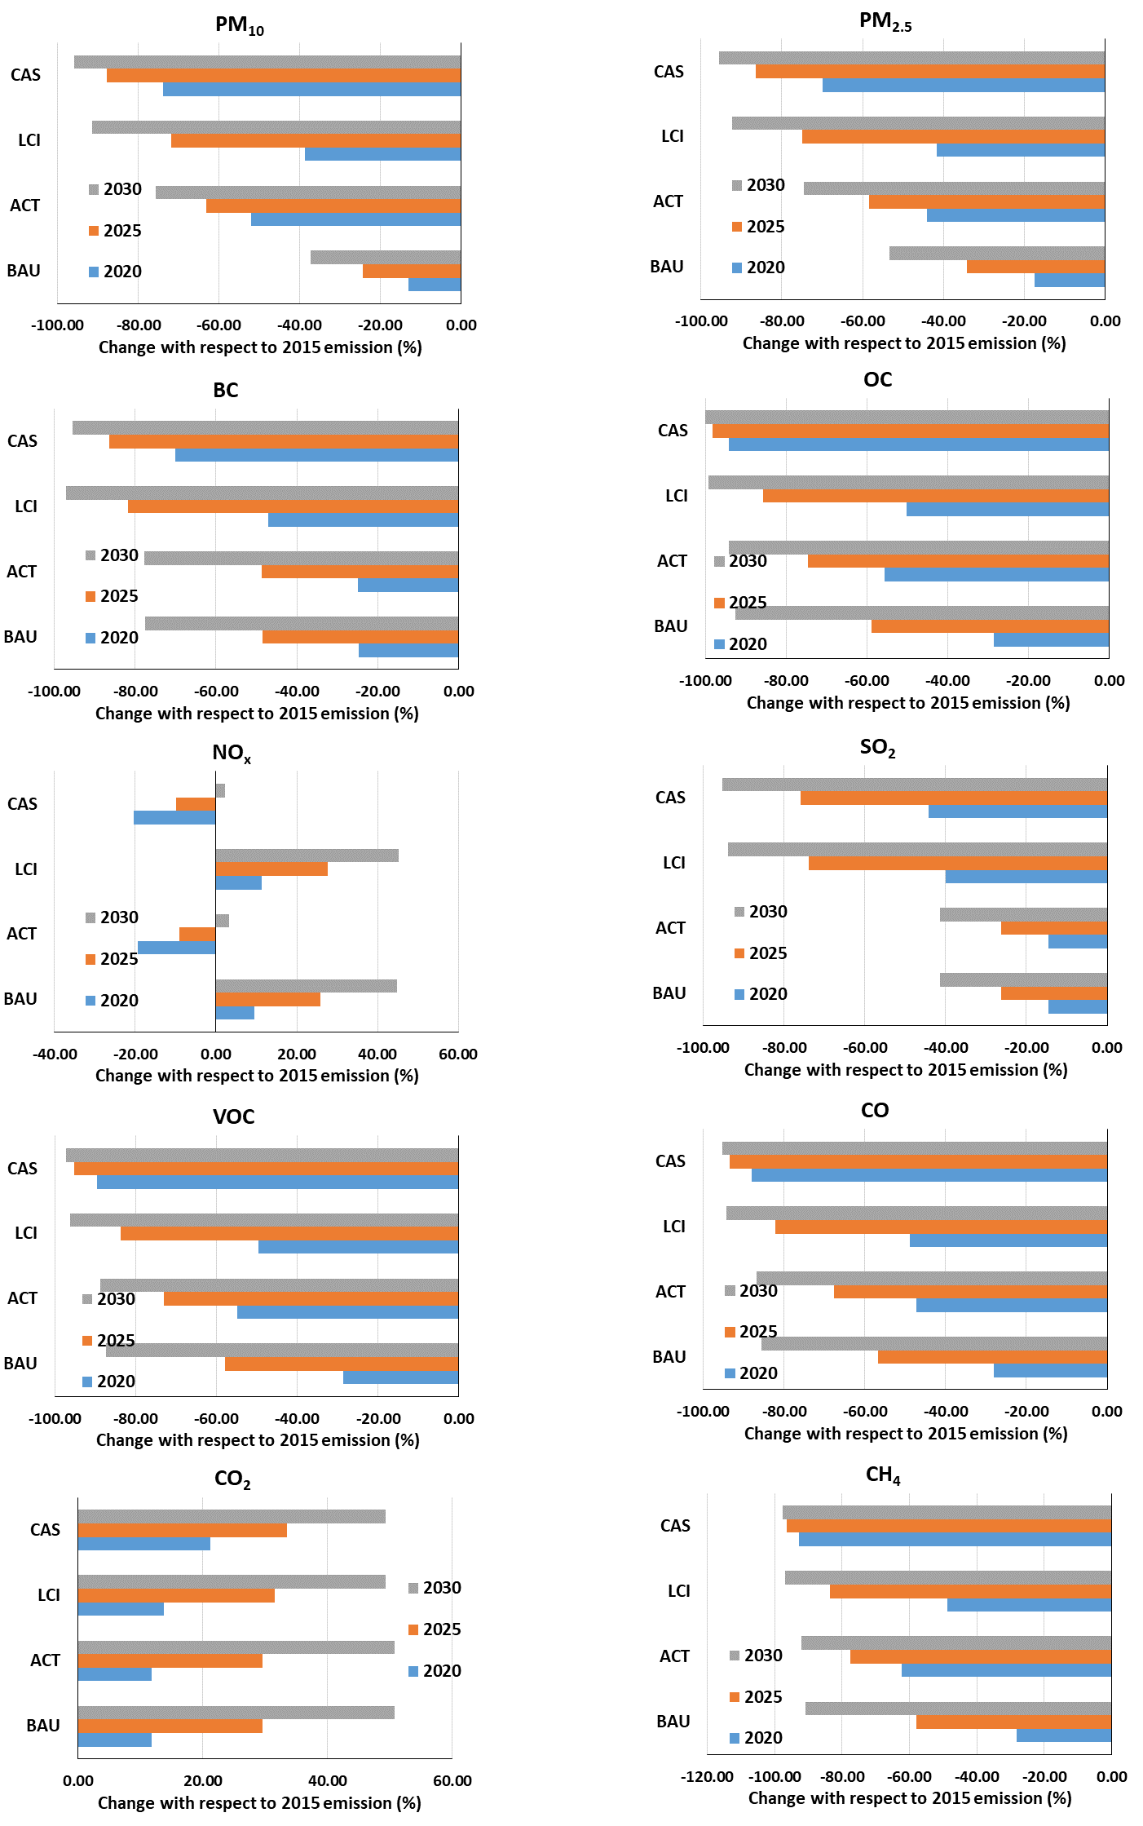
Figure 8. Reduction of key pollutants from domestic sector in different scenarios

Power generation sector
The power sector is estimated to be one of the major contributors to many of the air pollutants in 2015. All the power plants within the KMC area are coal-based thermal power plants and, according to official communications with individual power plants, are fitted with electrostatic precipitators (ESPs) with reported removal efficiency ranging from 99.4% to 99.9%. The effects of various policy measures under alternative scenarios are analyzed to understand the effect of specific policies for this sector (see Figure 9). Only existing thermal power plants have been considered here, reaching their maximum capacity in 2030. In the BAU scenario, all relevant air pollutants in this sector are projected to increase by 2030 except SO₂ (37% for PM₁₀, PM_{2.5} , and NOx). Reduction in SO₂ emission (-86%) are due to the proposed implementation of the FGD system in existing plants in lieu of stringent emission-norm by the Government of India (MoEFCC 2015).
In the ACT scenario, it is projected that significant emission reduction is possible for remaining key pollutants over the 2015 emission level (-84% PM₁₀, -77% PM_{2.5}, -68% NOx by 2030) by implementing the appropriate control technology, such as the high efficiency de-duster for particulate control, combustion modification and selective catalytic reduction for NOx control. Alternatively, even more emission reductions compared with 2015 emissions are possible (-99.7% PM₁₀, -99%PM_{2.5}, -99.7% SO₂, 90% NO_{x} by 2030) if the fuel is switched and power plants become gas-based instead of coal-based, as projected in the LCI scenario. For CAS, no additional measures have been considered for the power plant sector; hence, the projected emissions will be the same as in the ACT scenario.
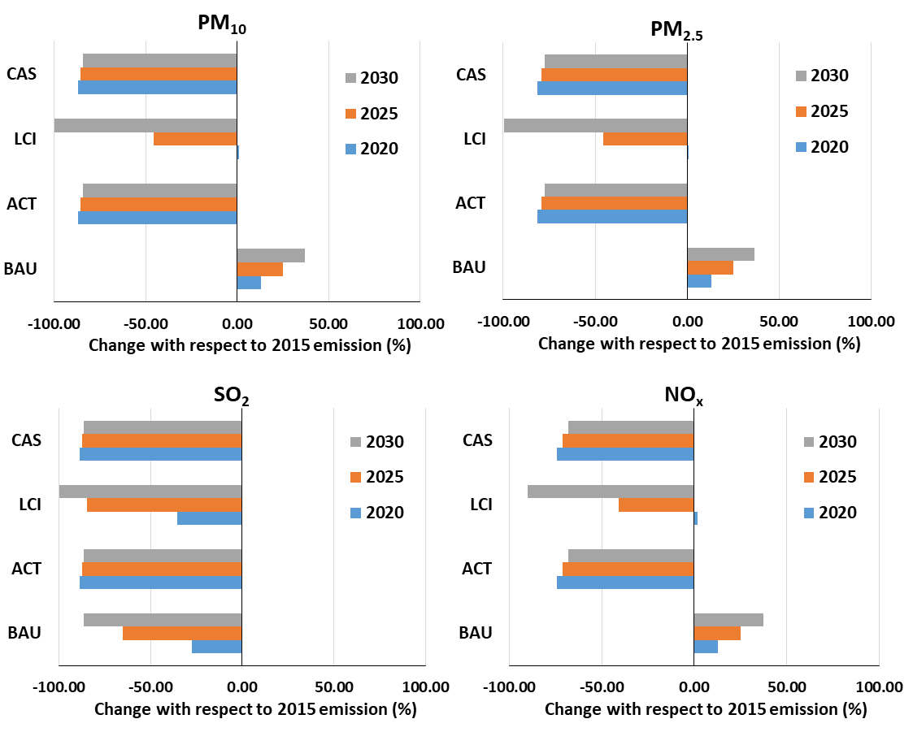

Figure 9. Mitigation potential of air pollutants in different policy scenarios from the power sector

Transportation sector
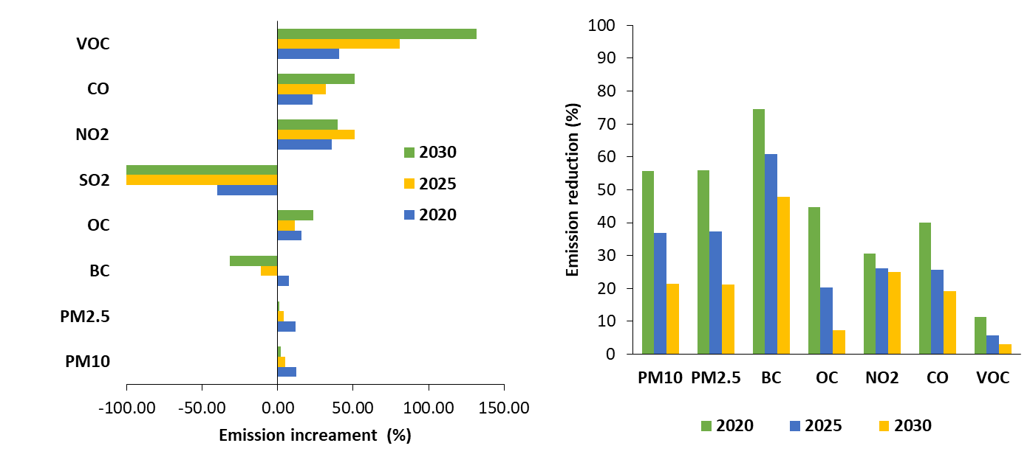
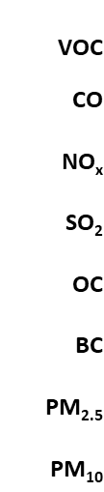
It was observed that, in 2015, vehicular exhaust emissions, except for NOx, contributed less significantly to key pollutants (4% of PM₁₀, 8% of PM_{2.5,} 2% of SO₂, and 34% of NO_{x} emissions). However, vehicle-related non-exhaust emissions contributed considerably to particulate emissions (25% of PM₁₀ and 8% of PM_{2.5}). At present, in the transport sector Bharat stage-IV (BS-IV; equivalent to Euro-IV) norms have prevailed for on-road vehicular emissions in Kolkata since 2010. As per the draft notification issued by the Government of India under the Motor Vehicle Amendment Rule, BS-VI (equivalent to Euro-VI) will apply to all new registered on-road vehicles from April 2020. Vehicles older than 15 years are banned within the city of Kolkata. However, older active fleet vehicles registered between 2000 and 2010 will not meet BS-IV norms as of 2015. Similarly, in the year 2020 a fraction of the fleet registered between 2005 and 2010 is expected to stay on the road despite not meeting BS-IV standard as part of the phasing-out procedure. The effect of implementation of the BS-VI standard in pollutant emissions will take a fair amount of time to be seen, as only vehicles newly introduced to the active fleet will be subject to advanced control. The older fraction of the vehicle fleet is projected to still be running in 2020 and 2025 and to continue emitting key pollutants, but with a decreasing trend. By 2030, PM₁₀ and PM_{2.5} from vehicle exhausts are expected to come down to the 2015 level, but emissions are not expected to reduce further due to the increase in fleet volume (Figure 10a). On the other hand, non-exhaust emissions are expected to contribute more toward particulate emissions (48% PM₁₀ and 22% of PM_{2.5}). In the CAS scenario, we have considered a ban on all vehicles not meeting BS-IV emission norms. We have also considered a gradual restriction for 2- and 4-wheelers reducing by 50% by 2030. The demand for transportation is expected to be met by public transport like buses. Such a restriction should be effective in terms of reducing the actual vehicular fleet and consequently reducing both non-exhaust and exhaust emissions. A similar approach was also recently enforced in the NCT of Delhi through its daily odd-and-even-number car scheme. As a result of these two proposed measures, a considerable reduction in vehicular exhaust emissions is projected, especially for 2020 and 2025 compared with the 2015 level (Figure 10b). However, only a marginal reduction is expected in non-exhaust emission (6% for both PM₁₀ and PM_{2.5}). To reduce these, it is essential to reduce the share of heavy vehicles in the active fleet.
a) | b)
Figure 10. Emission reductions of pollutants through vehicle-related policies in Kolkata city: a) increase in pollutant emissions from road transport exhaust in the BAU scenario compared to 2015 emissions; b) reduction in emission of air pollutants in the CAS scenario as compared to the BAU scenario

Emission control costs for air pollutants in different policy scenarios
The GAINS model estimates life-cycle costs for emission reductions from a social planner's perspective focusing on the diversion of societal resources. This approach excludes transfer payments such as taxes, subsidies and profits, and balances up-front investments with subsequent cost savings, for example from lower energy consumption. Moreover, the GAINS model estimates the scope for further environmental improvements that is offered by commercially available emission control technologies (excluding the potential from structural changes), their costs, and the composition of cost-effective portfolios of measures that achieve higher environmental protection at least cost (Purohit et al., 2019). In GAINS, costs for controlling air pollution are calculated as the sum of investment costs, labour costs and non-labour operation and maintenance costs (Amann et al., 2011; Höglund-Isaksson et al., 2012). Further details of cost calculation are incorporated in the section 12, SI.
Figure 11 represents the costs incurred by the control of air pollutant emissions in different alternative scenarios. As of 2015 the total cost of air pollution control is estimated to be €0.2 billion which is only about 1% of the GDP of KMC. The majority of the costs incurred in 2015 for air pollution control were in the mobile sector (89.5%) followed by the power (8.8%) and non-road machinery sectors (1.5%). Air pollution control costs were negligible for industries as well as for the domestic sector. In BAU the cost of air pollution control is expected to increase by up to €0.8 billion (2% of GDP) by 2030. In the LCT scenario, the cost of control measures is expected to be reduced to €0.7 billion with a switch to cleaner fuel. However, this does not take into account the conversion costs that the power sector would have to bear for thermal power plants to generate power from compressed natural gas (CNG). It also does not consider the additional cost of establishing the supply network for natural gas or other cleaner fuel. In the ACT scenario, the estimated cost is €1.15 billion, that is, 1.48 times costlier than the BAU scenario for 2030. The control cost in the ACT scenario is more expensive than in the BAU scenario, mainly in the industry sector, followed by the transport and power sectors. In the CAS scenario, the additional non-technical measures over and above the controls considered in the ACT scenario are estimated to make the cost 1.52 times higher than in the BAU scenario by 2030. However, the marginal increase in cost (€1.18 billion in the CAS scenario) compared with the ACT scenario is expected to significantly decrease emissions of air pollution in 2030 (see Figure 7).

Figure 11. Costs of emission control for all air pollutants with respect to the GDP of KMC.

Validation of emission inventory and uncertainty
We note that the bottom-up approach adopted in this study was difficult to validate due to lack of reports published on fuel sales data for the KMC region. Fuel sales by all oil companies were obtained from IOCL, 2015 and compared where applicable. For the transport sector, we estimated LPG use by 3-wheelers to be slightly more (~10%) than the sales data, whereas gasoline sales data and our estimate corroborate each other closely. However, our estimated diesel use is about 15% more than the diesel sold within the KMC area. It is possible that some of the diesel vehicle fleet, especially heavy vehicles, such as trucks, entering the KMC from adjoining areas may be refueling outside the city. Ease of parking outside the city and time restrictions for entering the city area may be the reason for this refueling pattern. We identify this as a source of uncertainty in estimation of emissions from on road diesel vehicles. There was major uncertainty in the data obtained from the West Bengal Pollution Control Board (WBPCB) on fuel use by industries, therefore, fuel sales to the industrial sector were used for emission estimation. Uncertainty is also identified in industrial process emission. No official record for coal sales to the residential sector has been reported whereas, our primary survey indicates widespread use of coal in the domestic residential sector and even more in the domestic commercial sector, especially outside the original city area. However, as the extent of survey was limited, we considere that the estimate of coal usage in domestic sector has some degree of uncertainty. Data on coal consumption at thermal power plants were obtained from individual plants and compared with electricity distribution data. The power plants inside the KMC were estimated to generate about 15–20% more electricity than is used inside KMC, and this power can thus be considered to be exported to outside the KMC boundaries. Agricultural activities have been downscaled from state and district level statistics and hence there is scope of certain uncertainty.
The future emission projections in BAU scenario were based on macroeconomic drivers and sectorial growth considerations. The growth of population in KMC is projected till 2030 based on population data 1950 to 2010 (GoI 2011; Banerjee 2018). The GDP of Kolkata city is obtained from the GoWB Report (2015) at 2004–2005 constant prices. The estimate of city-specific per capita GDP is then used to derive the GDP of Kolkata Metropolitan Area. There has been appreciable population growth in the KMC area in the past few decades: this has increased i) infrastructure and urban development; ii) demand in the service sector; and, in turn, iii) energy demand. In making future projections, various country and state-level planning and projection documents, as well as sector-specific policy documents, were considered. There are a number of assumptions made towards the sectoral activity projection (see Section 8, SI for more details) which imparts certain inherent uncertainties in the emission projections under BAU scenario.
A number of policies have been considered in emission projections in alternative scenarios (see section 9, SI). Future emission projections are primarily dependent on the rate as well as extent of implementation of existing and planned policies. One of the major barrier in India’s air quality management is the stringent enforcement of air pollution control measures/regulations. For example, Greenstone et al. (2017) noted based upon a rich set of empirical evidence to show that widespread non-compliance has undercut the impact of existing regulation on air pollution in India. Moreover, the socio-political factors, that are out of scope of this study, may implay considerable uncertainty over the projected emissions.

Discussions
The city of Kolkata, the largest metropolis in eastern India, is suffering critical concentrations of air pollution, according to measurements of the ambient level of key pollutants in the past few years (Figure S3). Emissions from an ever increasing number of vehicles on the road is often perceived as one of the main sources of air pollution in urban areas, perhaps due to their visibility, and possible human exposure to such emissions. After careful consideration of key potential air pollution sources and activities in different sectors, and total emissions at the city scale, it emerges that other significant sources contribute to the polluted air of KMC besides vehicular traffic. The government has taken major policy decisions with respect to some of the sectors responsible for emission of key air pollutants. National policies have been set, such as: stringent norms for coal-based thermal power plants; supply and use of diesel as well as gasoline with low sulfur content (less than 10 ppm) at the national level; and fuel switching to LPG from firewood and kerosene. Some of the national policies have been declared but are yet to be implemented such as BS-VI norms on road vehicles which will be implemented from April 2020. Some of the policies are in place, but yet to be entirely enforced, such as a ban on the burning of open trash. There are also some city-specific policies in place such as a ban on vehicles older than 15 years or not allowing new air polluting industry within the city precincts. This study projected emissions of air pollutants for the near future considering all the applicable national and city-specific policies expected to affect air pollution emissions in KMC. The trend in emissions of key pollutants in the BAU scenario indicates that the policies and efforts undertaken by the government to date to decrease emissions will be superseded by increased energy demand in various sectors due to economic and population growth. This growth is also expected to increase emissions from non-combusting sources of pollutants. In Kolkata under the BAU scenario even after complete implementation of proposed policies, it is estimated that total emissions of PM₁₀, NOx, VOC, and NH₃ will still be increasing substantially from 2020 to 2030 (43%, 37%, 52%, 47%, respectively, with more emissions in 2030 than in 2015). Organic carbon associated with particulate matter is expected to increase marginally (2%), while emissions of PM_{2.5} are estimated to decrease marginally (3%) by 2030. However, SO₂, BC, and CO emissions are estimated to decrease considerably by 2030 (82%, 53%, and 19%, respectively, compared with 2015). The current air quality of Kolkata is at a critical level, especially in winter months, with regard to ambient levels of PM₁₀, PM_{2.5}, and NOx. Under the BAU scenario, no significant improvement in air quality is envisaged in the near future unless additional strategies and policy measures considering both combustion and non-combustion sources are implemented. In fact, air quality status may degrade further unless immediate and complete implementation is not carried out of the policies already in place.
Emissions from the domestic sector are one of the major concerns for Kolkata city. In KMC, road site eateries are very common across the city especially near busy crossings. Due to easy availability and low cost of solid fuels, they are still being used widely in this sector as primary fuel along with kerosene and LPG. National fuel switching policies have started to penetrate the domestic residential sector; however, no such penetration was observed in the commercial sector during our primary survey. City-specific policy to encourage urgent fuel switching and the use of advanced cookstoves is urgently required to curb pollutant emissions from the commercial sector. City-specific policies to switch to cleaner fuel in the residential sector, along with a ban on firewood use, should also be considered among immediate action plans.
Transport exhaust is a dominant source of NOx, but contributes comparatively less than other sectors towards primary PM emission. The emissions are crucial from the health-impact viewpoint due to the proximity of sources to humans. Two- and 3-wheelers may be encouraged to shift to battery-operated engines, wherever possible. Restrictions may be imposed on vehicles not meeting the BS-IV standard for immediate relief from emissions from line sources. The contribution of resuspended road dust to the total PM₁₀ level is significant. The contribution is proportional to the fleet volume, especially of heavy vehicles. To control the emissions from road dust, control options need to be adopted, for example, road paving, and road washing and cleaning, etc. However, the fleet volume passing through the city roads, especially the heavy vehicular fleet, needs to be restricted to minimize emissions from this source. The low average speed of vehicles leads to increased emissions of pollutants due to poor fuel efficiency. The sidewalks of major city roads are full of temporary roadside stalls and vegetable markets (often in the morning and evening) and slum settlements, forcing pedestrians to walk along the road itself, which results in congestion and low vehicular speed. All these temporary structures must be relocated at least 30–50 m away from roads and sidewalks and properly fenced off so that the footpath/road is not encroached upon. Cycling paths should be made only in places where road widths are sufficiently wide and vehicle speed and load on the main roads are less. Walkable and/or cyclable roads should also be fenced to prevent encroachment. Roads should be fenced off so that pedestrians are not able to walk on the road surface to ensure maximum average speed for vehicular fleet.
Municipal solid-waste handling and burning has become one of the most notable sources of emissions of key pollutants. The regulation on banning uncontrolled open burning must be completely implemented to reduce emission from waste sector. Stricter compliance is also required to regulations on construction operations. Industrial activity within the city area is limited, but there is a wide scope for implementation of advanced emission control options to control both industrial combustion and process emissions.
Strategies should include technical measures such as advanced control for the thermal power and industrial sectors, management of fugitive emissions, improvement of the public transport system, switch to electric hybrid vehicles and non-motorized modes of transportation, compliance with enforced vehicular norms, switching to cleaner fuel for domestic purposes, etc. (NEERI, 2008; Amann et al., 2017). These technical measures should be enhanced by application of non-technical measures. These would include the removal of encroachments on the road, increasing the average vehicular speed by increasing the available roadway, improved parking facilities, proper maintenance and inspection of old and in-use vehicles, and control of firecracker use. Public awareness and participation in combating local air pollution may also prove pivotal. Economic measures such as heavy penalties for non-compliance in the industrial, commercial, or transport sectors, incentives for car-pooling, incentives for fuel switching in the residential and commercial sectors, congestion taxes etc., may also be considered (NEERI, 2008; Goel and Guttikunda, 2015).
The baseline emissions of air pollutants for Kolkata are estimated to be higher than those of the NCT of Delhi, as reported in earlier studies (Bhannerkar et. al., 2018) especially in terms of per capita emissions. Emissions for most of the pollutants and GHGs are projected to be higher for Kolkata than Delhi in 2030 in the BAU scenario. SO₂ projections are much higher for Delhi, as the use of FGD was not considered in the BAU scenario for Delhi, unlike in Kolkata. Most of the current policies and measures in various sectors for both metropolitan areas are similar, except for the power sector, where Delhi has already started to shift toward cleaner fuel. On the other hand, in Kolkata, emissions from transport exhaust are better managed due to a ban on older vehicles. The common and regularly practiced approaches of air pollution control options such as advanced end-of-pipe pollution-control technologies or switching to cleaner fuel are, if implemented, projected to provide certain relief to both cities in terms of primary emissions by 2030. However, the scenario where city-specific non-technical control measures have been considered is expected to be the most beneficial for both the cities, indicating that when formulating an air pollution mitigation policy framework for megacities, city-specific analysis is essential.

Under the scope of this study only primary sources of air pollutant emissions within the city boundary have been considered for projection of the total emissions to 2030. Different strategies and policy measures are also considered under three alternative policy scenarios to reduce the total emissions of individual pollutants and thereby prevent further air quality deterioration. This study did not consider primary emissions outside the city boundary. The present study thus gives a rather conservative account of air pollutant emissions for the city. A thorough and more detail study is required that considers secondary particulate formation as well as local sources outside the city boundary, to understand the actual scenario regarding air quality of KMC.
To understand the actual possible effect of the reduction of pollutant emissions on air quality compared with the BAU scenario, however, further modeling studies are required to show the dispersion of the emitted air pollutants and estimate these to predict air quality and consider secondary formation of particulate matter from available precursors. Local sources, primary as well as secondary, are most likely affecting the city air quality (Amann et. al., 2017). Such an effect also needs to be studied using effective dispersion models to understand why the air quality of NCT of Delhi is worse than that of Kolkata, even though Delhi has fewer primary emissions.

Conclusions
Air pollution has become a major concern for the KMC city population and authority alike. The GAINS-City model is applied in this study to analyze and estimate anthropogenic emissions of air pollutants and greenhouse gases from various sectors in KMC at present and to project them into the near future. The model has been successfully applied to the NCT of Delhi, India (Amann et al., 2017, Bhanarkar et. al., 2018). An emissions inventory has been developed for the historic anthropogenic emissions of Kolkata for 2010 and 2015 based on activity data and emission factors for different air-polluting sectors to estimate the emissions for key air pollutants (e.g., PM₁₀, PM_{2.5}, BC, OC, SO₂, NO_{x}, CO, NH₃ and VOCs). Projections of air pollutant emissions were performed for 2020, 2025, and 2030 under the BAU scenario considering current policies and legislation affecting key pollutant emissions under projected population and economic growth. Under the BAU scenario, PM₁₀ and NO_{x} emissions are projected to increase considerably along with VOC and NH₃ emissions. OC is expected to increase slightly, while PM_{2.5} is projected to decrease marginally by 2030 as compared to 2015 emissions. SO₂, BC, and CO emissions are estimated to decrease substantially by 2030. Among GHGs, CO₂ emissions are projected to increase because of increasing energy demand. CH₄ and N₂O emissions are also projected to increase substantially by 2030 compared with 2015 emissions. Hence, even if there were timely and complete implementation of all current policy measures, significant improvement of air quality cannot be expected in the near future.
Three alternative scenarios (ACT, LCI and CAS) were considered with the aim of better air quality for the city of Kolkata in the near future. The scenarios explore the likely reduction potential of complete implementation of existing policies and also implementation of more advanced and effective pollution-control strategies and measures on emissions of key air pollutants. Scenarios considering advanced control technology (ACT) and low carbon intensity with cleaner fuel use (LCI) if implemented in Kolkata metro city are expected to reduce primary emissions to some extent. However, a scenario that considers city-specific measures such as a ban on solid fuel burning or restrictions to the vehicular fleet volume along with advanced control technologies is expected to be most effective in terms of primary emission reductions.
A number of sources contribute to the total air pollutant load in the Kolkata city air shed. Dedicated and effective source-specific strategies and measures are essential to reduce the emissions of key air pollutants in addition to the policy measures already implemented and declared. To achieve cleaner air for Kolkata city, a stepwise systematic action plan must be identified. The plan should consider both the cost and reduction potential of that strategy or policy along with its rate of implementation to assess its effectiveness in the process of air pollution abatement. The policy or strategy measure that is expected to make the maximum impact at a reasonable cost should be implemented as a priority. This study provides an essential building block to assess the future air pollution prevention policies of KMC and impending human health impacts for the city population under various scenarios. Quantification of health impacts – not carried out in this study - might allow for a comprehensive cost-benefit analysis and will help the city authorities to take efficient policy decisions to control the emissions of air pollution in the quest for cleaner city air in the near future.

Acknowledgments
The support provided by the Technology Information Forecasting and Assessment Council (TIFAC), Department of Science and Technology, Government of India, which acts as the Indian National Member Organization of IIASA, and the International Institute for Applied Systems Analysis is gratefully acknowledged. The guidance and support of Director, CSIR-NEERI is gratefully appreciated. The KRC (Knowledge Resource Center of CSIR-National Environmental Engineering Research Institute) number for the manuscript is CSIR-NEERI/KRC/2019/JUNE/KZC-APC/1.

Appendix A. Supplementary Information
Supplementary material

References
Aaheim, H. A., Kristin A., Seip, H.M. 1999. Climate Change and Local Pollution Effects – An Integrated Approach. Mitigation and Adaptation Strategies for Global Change, 4 (1), pp 61–81.
ADB. 2005, Strengthening Environmental Management at the state level (cluster) Component E- strengthening Environmental management at West Bengal Pollution Control Board. Final Report; Volume V: Air Quality Management, 2005. Asian Development Bank
ADB. 2008, Comprehensive Mobility Plan; Back to Basics; Kolkata Metropolitan Area, 2008. Asian Development Bank
AERAI. 2012, Airports Economic Regulatory Authority of India Multi Year Tariff Proposal and Annual Tariff Proposals in respect of Netaji Subhash Chandra Bose International Airport, Kolkata for the First Control Period (2011-2016) Consultation Paper No. 17/2012-13
Amann, M., Bertok, I., Borken-Kleefeld, J., Cofala, J., Heyes, C., Höglund-Isaksson, L., Klimont, Z., Nguyen, B., Posch, M., Rafaj, P., Sandler, R., Schöpp, W., Wagner, F., Winiwarter, W., 2011. Cost-effective control of air quality and greenhouse gases in Europe: Modeling and policy applications. Environmental Modelling & Software, 26, pp. 1489–1501.
Amann, M., Kejun, J., Hao, J., Wang, S., Wei, W., Xing, J., Zhang, C., Bertok, I., Borken, J., Cofala, J., Heyes, C., Hoglund, L., Klimont, Z., Purohit, P., Rafaj, P., Schöpp, W., Toth, G., Wagner, F., Winiwarter, W., 2008. GAINS-Asia: Scenarios for cost-effective control of air pollution and greenhouse gases in China. International Institute for Applied Systems Analysis (IIASA), Laxenburg, Austria.
Amann, M., Purohit, P., Bhanarkar, A.D., Bertok, I., Borken-Kleefeld, J., Cofala, J., Heyes, C., Kiesewetter, G., Klimont, Z., Liu, J., Majumdar, D., Nguyen, B., Rafaj, P., Rao, P.S., Sander, R., Schöpp, W., Srivastava, A., Vardhan, B.H., 2017. Managing future air quality in megacities: A case study for Delhi. Atmospheric Environment, 161, pp. 99–111.
Balakrishnan, K. et al. 2019. The impact of air pollution on deaths, disease burden, and life expectancy across the states of India: The Global Burden of Disease Study 2017. The Lancet Planetary Health, 3, pp. e26-e39.
Balakrishnan, K., Ghosh, S., Ganguli, B., Sambandam, S., Bruce, N., Barnes, D.F., Smith, K.R. 2013. State and national household concentrations of PM2.5 from solid cookfuel use: results from measurements and modeling in India for estimation of the global burden of disease. Environmental Health, 12, pp. 1-14.
Banerjee S. 2018. Urban Expansion of the City Kolkata since last 25 years using Remote Sensing. International Journal of Research and Analytical Reviews, 5 (2), pp. 422-429.
Bhanarkar, A.D., Purohit, P., Rafaj, P., Amann, M., Bertok, I., Cofala, J., Rao, P.S., Vardhan, B.H., Kiesewetter, G., Sander, R., Schöpp, W., Majumdar, D., Srivastava, A., Deshmukh, S., Kawarti, A., Kumar, R., 2018. Managing future air quality in megacities: Co-benefit assessment for Delhi. Atmospheric Environment, 186, pp. 158–177.
CEA, 2014. Report on fly ash generation at coal/lignite based thermal power stations and its utilization in the country for the year 2013-14. Central Electricity Authority (CEA), Ministry of Power, Government of India, New Delhi, India.
Chatterjee, A; Sarkar, C; Adak, A; Mukherjee, U; Ghosh, SK; Raha, S. 2013. Ambient Air Quality during Diwali Festival over Kolkata - A Mega-City in India. Aerosol and Air Quality Research, 13 (13), pp. 1133–1144.
CPCB. 2011. Air quality monitoring, emission inventory and source apportionment study for Indian cities: National Summary Report. Central Pollution Control Board (CPCB), Ministry of Environment, Forest and Climate Change (MoEF&CC), New Delhi.
CPCB. 2015. Status of Pollution Generated from Road Transport in Six Mega Cities. Central Pollution Control Board (CPCB), Ministry of Environment, Forest and Climate Change (MoEF&CC), New Delhi.
Das A., Sanyal M., Roy P. K., Majumder A., Biswas A. K., Mazumdar A. 2011. Municipal solid waste management in Kolkata metropolitan areas-A case study. Environmental Science. 6(5), 247-256
Das, M., Maiti, S.K. & Mukhopadhyay, U. 2006. Distribution of PM2.5 and PM10-2.5 in PM10 Fraction in Ambient Air Due to Vehicular Pollution in Kolkata Megacity. Environmental Monitoring and Assessment, 122 (1-3), pp. 111-123.
Dholakia, H.H., Purohit, P., Rao, S., Garg, A. 2013. Impact of current policies on future air quality and health outcomes in Delhi, India. Atmospheric Environment, 75, pp. 241-248.
DoEA 2015. Department of Economic Affairs, Ministry of Finance; Planning Commission, Government of India Last accessed on 13th May 2019 from url : https://www.pppinindia.gov.in/infrastructureindia.
EMIS, 2015. Environmental Management Information System database, West Bengal pollution control board, url:: http://emis.wbpcb.gov.in. Collected in 2015 via official communication.
Garaga, R., Sahu, S.K., Kota, S.H. 2018. A review of air quality modeling studies in India: local and regional scale. Current Pollution Reports, 4 (2), pp. 59–73.
Ghose, M.K., Paul, R. & Banerjee, R.K. 2005. Assessment of the Status of Urban Air pollution And Its Impact on Human Health in the City of Kolkata. Environmental Monitoring and Assessment, 108 (1-3), pp. 151-137.
Goel, R., Guttikunda, S.K. 2015. Evolution of on-road vehicle exhaust emissions in Delhi. Atmospheric Environment, 105, pp. 78-90.
GoI. 2011. Office of Registrar General and Census Commissioner, Government of India (GoI), New Delhi (Available at: http://www.censusindia.gov.in/2011census last accessed on 27th April 2018)
Gordon, T., Balakrishnan, K., Dey, S., Rajagopalan, S., Thornburg, J., Thurston, G., Agrawal, A., Collman, G., Guleria, R., Limaye, S., Salvi, S., Kilaru, V., Nadadur, S. 2018. Air pollution health research priorities for India: Perspectives of the Indo-U.S. Communities of Researchers, Environment International, 119, pp. 100-108.
GoWB. 2015. State Domestic Product and District Domestic Product of West Bengal 2013-14. Bureau of Applied Economics and Statistics, Department of Statistics and Programme Implementation, Government of West Bengal, Kolkata.
Greenstone, M., Harish, S., Pande, R., Sudarshan, A. 2017. The Solvable Challenge of Air Pollution in India. India Policy Forum, National Council of Applied Economic Research (NCAER), New Delhi (Available at: https://scholar.harvard.edu/files/rpande/files/-ipf_2017_greenstone_harish_pande_sudarshan_submittedmanuscript.pdf . last accessed on 11/10/2017).
Gurjar, B.R., Jain, A., Sharma, A., Agarwal, A., Gupta, P., Nagpure, A.S., Lelieveld, J. 2010. Human health risks in megacities due to air pollution. Atmospheric Environment, 44 (36), pp. 4606-4613.
Guttikunda S.K., Carmichael G.R., Calori G., Eck C., Wood J.H. 2003. The contribution of megacities to regional sulfur pollution in Asia. Atmospheric Environment, 37, pp. 11–22.
Guttikunda, S.K., Calori, G. 2013. A GIS based emissions inventory at 1km x 1km spatial resolution for air pollution analysis in Delhi, India. Atmospheric Environment, 67, pp. 101-111.
Höglund-Isaksson, L., Winiwarter, W., Purohit, P., Rafaj, P., Schöpp, W., Klimont, Z. 2012. EU low carbon roadmap 2050: Potentials and costs for mitigation of non-CO₂ greenhouse gas emissions. Energy Strategy Reviews, 1 (2), pp. 97-108.
IEA. 2016. Energy and Air Pollution: World Energy Outlook Special Report. International Energy Agency (IEA), Paris.
IOCL, 2015. Fuel sale statistics for 2010 and 2015 in KMC. Indian Oil Corporation Limited, Coordinator of oil marketing companies in eastern India. Official communications.
IPCC, 2006. 2006 IPCC Guidelines for National Greenhouse Gas Inventories. Intergovernmental Panel on Climate Change, IGES, Japan.
Karambelas, A., Holloway, T., Kinney, P.L., Fiore, A.M., DeFries, R., Gregor Kiesewetter, Heyes, C. 2018. Urban versus rural health impacts attributable to PM2.5 and O3 in northern India. Environmental Research Letters, 13, pp. 064010.
Klimont, Z., Cofala, J., Xing, J., Wei, W., Zhang, C., Wang, S., Kejun, J., Bhandari, P., Mathur, R., Purohit, P., Rafaj, P., Chambers, A., Amann, M., Hao, J., 2009. Projections of SO2, NOx, and carbonaceous aerosols emissions in Asia. Tellus B, 61 (4), pp. 602–617.
Klimont, Z., Kupiainen, K., Heyes, C., Purohit, P., Cofala, J., Rafaj, P., Borken-Kleefeld, J., Schöpp, W., 2017. Global anthropogenic emissions of particulate matter including black carbon. Atmospheric Chemistry and Physics, 17, pp. 8681–8723.
KMDA. 2005. An overview of Ganga Action Plan Works in West Bengal (Series II) Performance evaluation of Electric Crematoria. Kolkata Metropolitan Development Authority.
KMDA. 2011. Annual Report 2010-11. Kolkata Metropolitan Development Authority, Urban Development Department of the Government of West Bengal, Kolkata (Available at: https://www.kmdaonline.org/-home/aar_2011).
KTP. 2010. Video footage of major traffic crossing of Kolkata of 2010, obtained from Kolkata Traffic Police. Official communication.
Lelieveld, J., Evans, J.S., Fnais, M., Giannadaki, D., Pozzer, A. 2015. The contribution of outdoor air pollution sources to premature mortality on a global scale. Nature, 525 (7569), pp. 367-371.
Liu, F., Klimont, Z., Zhang, Q., Cofala, J., Zhao, L., Huo, H., Nguyen, B., Schöpp, W., Sander, R., Zheng, B., Hong, C., He, K., Amann, M., Heyes, C. 2013. Integrating Mitigation of Air Pollutants and Greenhouse Gases in Chinese Cities: Development of GAINS-City Model for Beijing. Journal of Cleaner Production, 58, pp. 25-33.
Liu, J., Kiesewetter, G., Klimont, Z., Cofala, J., Heyes, C., Schöpp, W., Zhu, T., Cao, G., Gomez-Sanabria, A., Sander, R., Guo, F., Zhang, Q. Nguyen, B., Bertok, I., Rafaj, P., Amann, M. 2019. Mitigation pathways of air pollution from residential emissions in the Beijing-Tianjin-Hebei region in China. Environment International, 125, pp. 236-244
Mir, K.A., Purohit, P., Goldstein, G.A., Balasubramanian, R. 2016. Analysis of baseline and alternative air quality scenarios for Pakistan: an integrated approach. Environmental Science and Pollution Research, 23(21), pp. 21780-21793.
MoEFCC. 2015. Environment (Protection) Amendment Rules, 2015. Ministry of Environment, Forest and Climate Change (MoEFCC), Government of India, New Delhi.
NEERI, 2008. Air Quality Monitoring, Emission Inventory & Source Apportionment Studies for Delhi. National Environmental Engineering Research Institute (NEERI), Nagpur, India.
Purohit P, Amann M, Kiesewetter G, Chaturvedi V, Rafaj P, Dholakia HH, Nagar Koti P, Klimont Z, et al. 2019. Mitigation pathways towards national ambient air quality standards in India. Environment International, 133 (A), https://doi.org/10.1016/j.envint.2019.105147
Purohit P, Amann M, Mathur R, Gupta I, Marwah S, Verma V, Bertok I, Borken-Kleefeld J, et al. 2010. GAINS ASIA: Scenarios for cost-effective control of air pollution and greenhouse gases in India. International Institute for Applied Systems Analysis (IIASA), Laxenburg, Austria.
Purohit, P., Munir, T., Rafaj, P. 2013. Scenario analysis of strategies to control air pollution in Pakistan. Journal of Integrative Environmental Sciences, 10 (2), pp. 77-91.
Rafaj, P., Amann, M. 2018. Decomposing Air Pollutant Emissions in Asia: Determinants and Projections. Energies, 11(5), pp. 1299 (1-14).
Rafaj, P., Kiesewetter, G., Gül, T., Schöpp, W., Cofala, J., Klimont, Z., Purohit, P., Heyes, C., Amann, M., Borken-Kleefeld, J., Cozzi, L. 2018. Outlook for clean air in the context of sustainable development goals. Global Environmental Change, 53, pp. 1-11.
Ramachandra, T.V., Shwetmala. 2009. Emissions from India's transport sector: state-wise synthesis. Atmospheric Environment, 43, pp. 5510-5517.
Reddy, M.S., Venkataraman, C., 2002a. Inventory of aerosol and sulphur dioxide emissions from India: I e Fossil fuel combustion. Atmospheric Environment 36, 677–697. doi:http://dx.doi.org/10.1016/S1352-2310(01)00463-0
Reddy, M.S., Venkataraman, C., 2002b. Inventory of aerosol and sulphur dioxide emissions from India. Part II - biomass combustion. Atmospheric Environment 36, 699–712. doi:http://dx.doi.org/10.1016/S1352-2310(01)00464-2
Reis, S. Nitter, S., Friedrich, R. 2005. Innovative approaches in integrated assessment modelling of European air pollution control strategies – Implications of dealing with multi-pollutant multi-effect problems. Environmental Modelling & Software, 20 (12), pp. 1524-1531.
RTO. 2015. Regional Transport Offices of KMC. 2015. Official Communication.
Sahu, S.K., Beig, G., Parkhi, N.S. 2011. Emissions inventory of anthropogenic PM2.5 and PM10 in Delhi during commonwealth games 2010. Atmospheric Environment, 45, pp. 6180-6190.
Shah, J.J., Nagpal, T., 1997. Urban Air Quality Management Strategy in Asia: Greater Mumbai Report (World Bank Technical Paper No. 381). The International Bank for Reconstruction and Development (IBRD) and The World Bank, Washington D.C., U.S.A.
Shannigrahi, A.S., Sharma, R., Fukushima, T. 2003. Air pollution control by optimal green belt development around the Victoria memorial monument, Kolkata (India). International Journal of Environmental Studies, 60 (3), pp. 241-249.
Sharma, C., Dasgupta, A., Mitra, A.P. 2002. Inventory of GHGs and other urban pollutants from transport sector in Delhi and Calcutta. Proceedings of IGES/APN Mega-City Project, Institute for Global Environmental Strategies.
Sindhwani, R., Goyal, P., Kumar, S., Kumar, A. 2015. Anthropogenic emission inventory of criteria air pollutants of an urban agglomeration - national capital region (NCR), Delhi. Aerosol and Air Quality Research, 15, pp. 1681-1697.
Stanaway, J.D. et al. 2018. Global, regional, and national comparative risk assessment of 84 behavioural, environmental and occupational, and metabolic risks or clusters of risks for 195 countries and territories, 1990–2017: a systematic analysis for the Global Burden of Disease Study 2017. The Lancet, 392, pp. 1923-1994.
UNEP, 1999. Environmental Impacts of Trade Liberalization and Policies for Sustainable Management of Natural Resources: A Case Study on India’s Automobile Sector. United Nations Environment Programme (UNEP), New York, USA.
UNEP, 2006. Thermal Equipment: Fuels and Combustion. United Nations Environment Programme (UNEP), Nairobi, Kenya.
US EPA, 2000. Greenhouse Gases from Small-scale Combustion Devices in Developing Countries: Phase II A: Household Stoves in India. (No. USEPA/600/r-00/052). U.S. Environmental Protection Agency (US EPA), Washington D.C., USA.
US EPA, 2006. Emission factor documentation for AP-42, Section 13.2.1. Office of Air Quality Planning and Standards, United States Environmental Protection Agency (US EPA), Washington D.C., U.S.A.
Wagner, F., Amann, M., Borken-Kleefeld, J., Cofala, J., Höglund-Isaksson, L., Purohit, P., Rafaj, P., Schöpp, W., Winiwarter, W. 2012. Sectoral marginal abatement cost curves: Implications for mitigation pledges and air pollution co-benefits for Annex I countries. Sustainability Science, 7 (2), pp. 169-184.
WBPCB 2015. West Bengal Pollution Control Board. Final report of the expert committee constituted by the Hon’ble National Green Tribunal, Eastern Zone Branch. Official communication.
WHO. 2018. WHO Global Ambient Air Quality Database (update 2018). World Health Organization (WHO), Geneva, Switzerland.

* This is a companion paper of https://doi.org/10.1016/j.atmosenv.2018.05.026. Corresponding author: Dipanjali Majumdar <ds_majumdar@neeri.res.in>; Pallav Purohit <purohit@iiasa.ac.at>
Metro cities are referred to as urban agglomerations having population one million and above as per Indian population Census 2011.
As per average INR (Indian rupee) to Euro exchange rate of 2010 (i.e., 60.59 and at 2004–2005 constant prices)

