Water Resources Research
Supporting Information for
Hydropower production benefits more from 1.5°C than 2°C climate scenario
Ying Meng^{1,2}, Junguo Liu², Sylvain Leduc³, Sennai Mesfun^{3,4}, Florian Kraxner³, Ganquan Mao^{2,5}, Wei Qi² and Zifeng Wang^{2,6}
¹School of Environment, Harbin Institute of Technology, Harbin 150090, China, ²School of Environmental Science and Engineering, Southern University of Science and Technology, Shenzhen, 518055, China, ³International Institute for Applied Systems Analysis (IIASA), A-2361 Laxenburg, Austria, ⁴RISE Research Institute of Sweden (RISE), P.O Box 5604, 114 86, Stockholm, ⁵School of Water Resources and Hydropower Engineering, Wuhan University, Wuhan, 430072, China, ⁶Department of Geography, The University of Hong Kong, Hong Kong SAR, China

Contents of this file

Text S1 to S5
Figures S1 to S5
Tables S1to S3

Introduction
The supporting information provides additional description of the method and evaluation for the performances of the hydrological and power system model. The Text S1 presents Influence of RCP scenario selections on the results and evaluations of hydrological results. We add additional description of BeWhere model in the Text S2. The Text S3 presents evaluations of the BeWhere model results. The sensitivity of fossil fuel and transmission cost on potential hydropower production is shown in the Text S4. The Figure S1 presents the location of two hydrological stations (Lipat Kain and Kunyir) in Sumatra mainland. The Figure S2 and S3 show the hydrological model performance over the Sumatra. The Figure S4 shows the location of the existing dams in Sumatra, which was used to evaluate the performance or the power system model. The Figure S5 presents the sensitivity of fossil fuel on hydropower production. The Table S1 shows the comparison results of capacities between existing hydropower plants and simulated results.

Text S1
We used different representative concentration pathways (RCPs) and climate change scenarios to force the physically based hydrological modeling framework PCR-GLOBWB to quantify how global warming will affect hydropower potential in Sumatra. The uncertainties of PCR-GLOBWB, which are related to the parameters and meteorological forcing data, are discussed in detail by Weiland et al.(2015). The study showed that the parameter uncertainty comprises a relatively minor part of the hydrograph. Instead, the resolution of meteorological forcing data must be improved. To reduce uncertainties from meteorological forcing data, outputs of four GCMs (HadGEM2-ES, MIROC5, IPSL-CM5A-LR and GFDL-ESM2M) for both RCP2.6 and RCP6.0 were used because a large number of GCM outputs better represent the uncertainties in climate models(Tebaldi & Knutti, 2007).
We closely examined the hydrographs based on simulation results from PCR-GLOBWB and observation data from the Global Runoff Data Center (GRDC), which are representative of the dispersion between hydrological model performances and observation data. This procedure was performed for two different hydrological stations (Lipat Kain and Kunyir) in Sumatra (Figure S1), which featured discharge in different locations of Sumatra. Figure S2 displays the multiyear observed and simulated monthly discharges at the Lipat Kain and Kunyir stations. The trend of observed and simulated discharges is consistent, but the observed discharges are higher than the simulated discharges for peak times in several periods, with the exception of periods when observed data are missing. The correlation coefficients at Lipat Kain and Kunyir are 0.92 and 0.94, respectively (more validated metrics are provided in Table S1). Figure S3 presents the streamflow variability during the dry and wet seasons in Sumatra. The PCR-GLOBWB performs well for low flows in the dry and rainy seasons but it will underestimate the high flow significantly in the wet season at the Lipat Kain station. The simulated results could capture the trend of the discharge change.
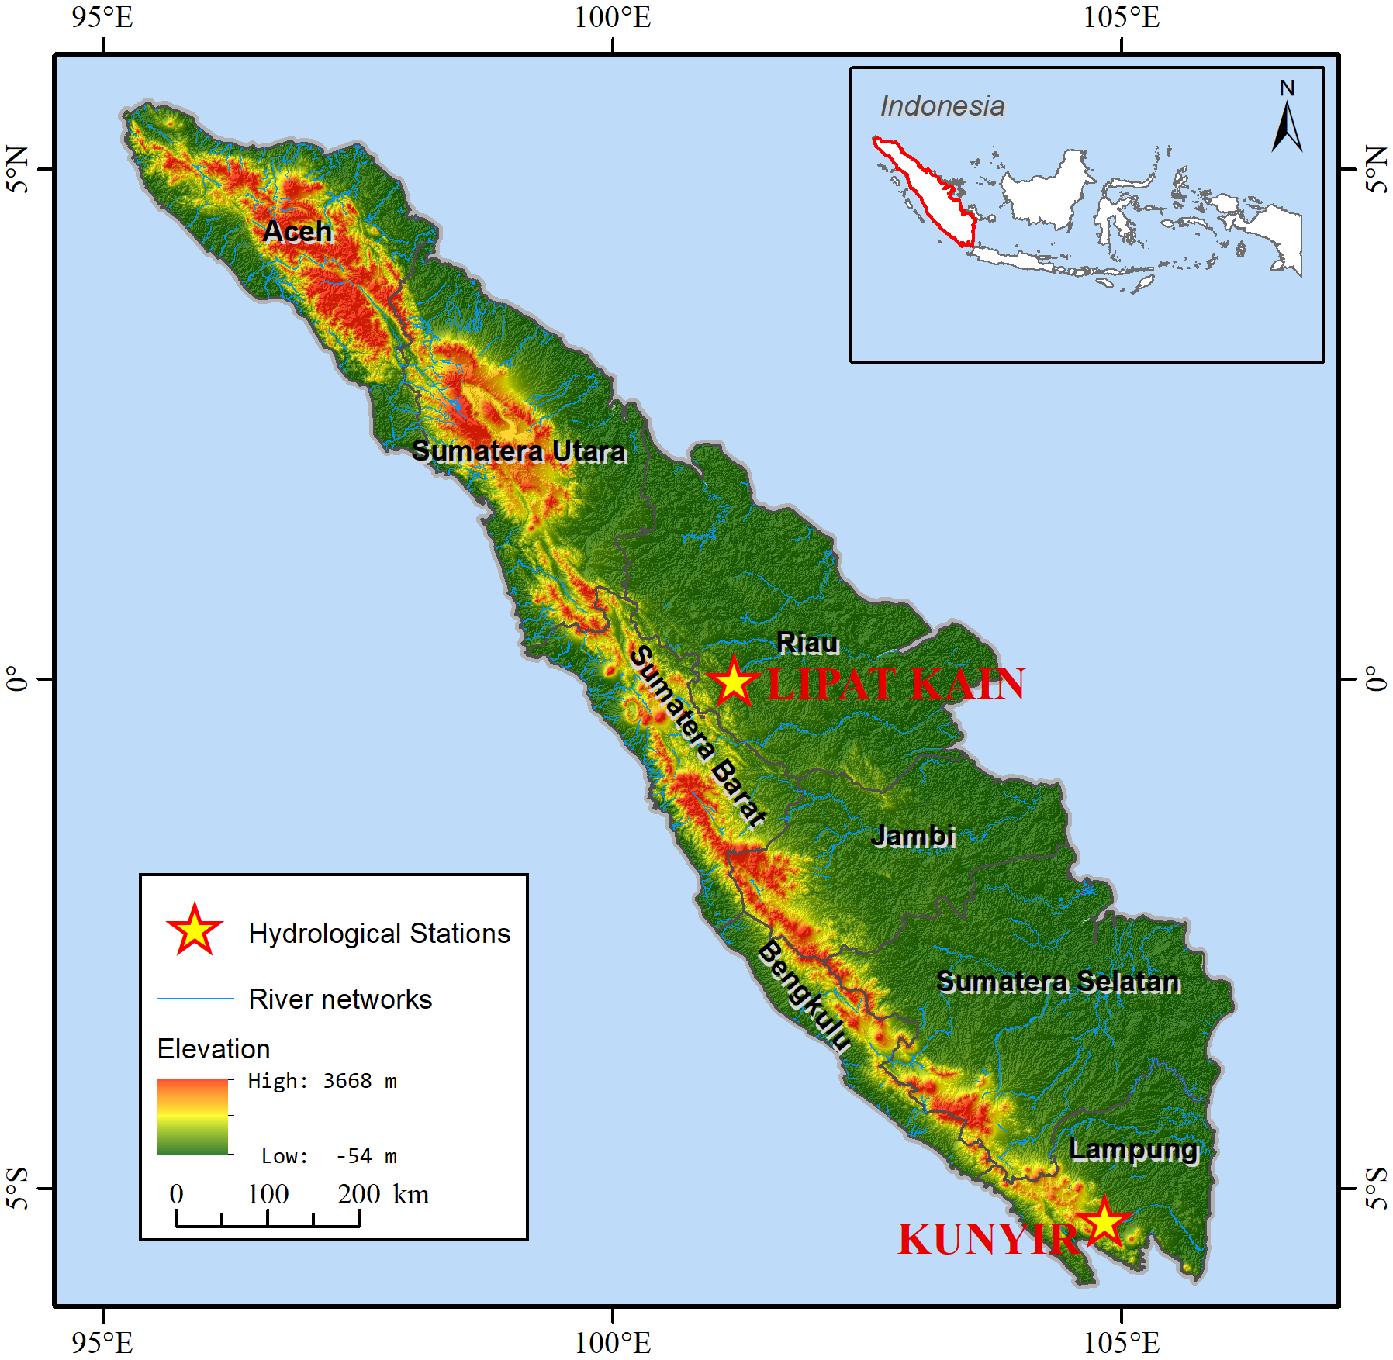

Figure S1. Locations of two hydrological stations (Lipat Kain and Kunyir) in Sumatra mainland.

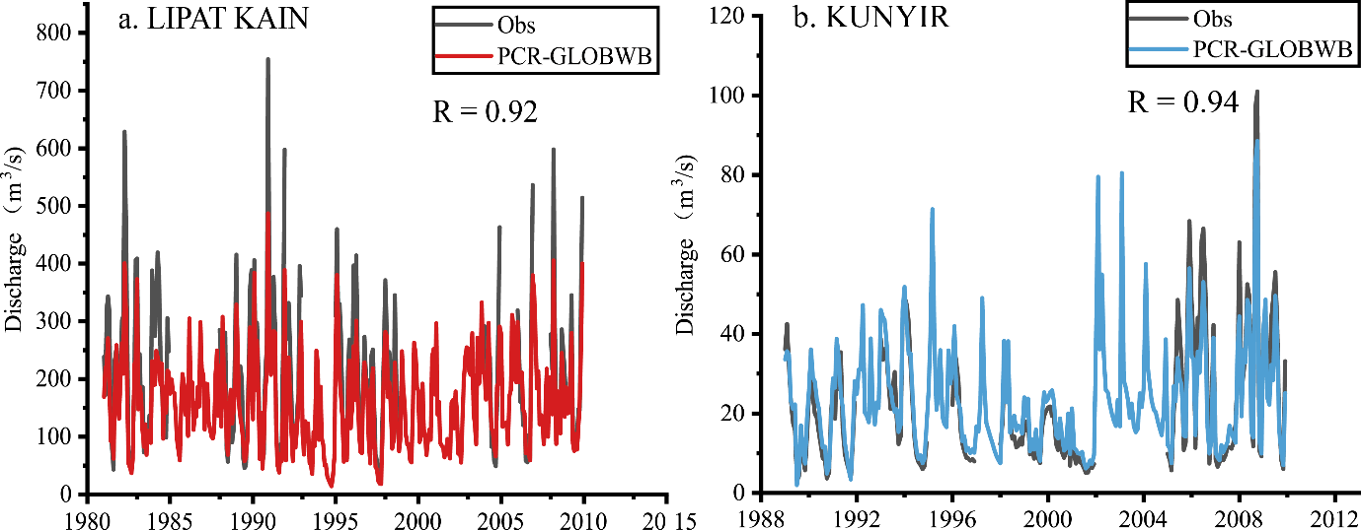
Figure S2. Multiyear observation and simulation by PCR-GLOBWB discharges, for a. the Lipat Kain station and b. the Kunyir station
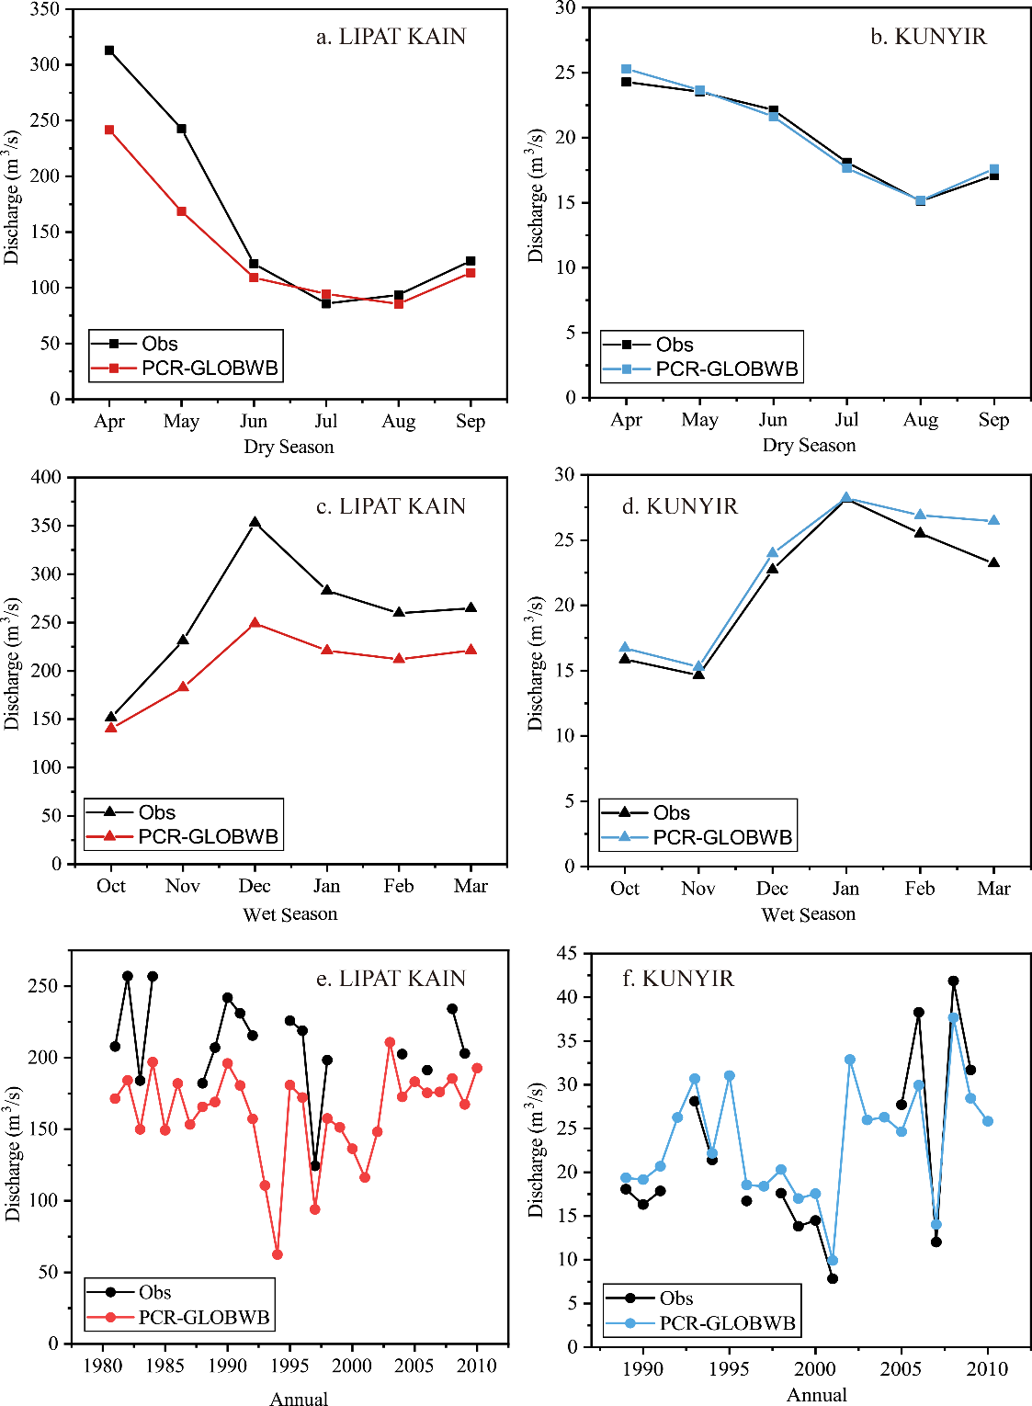

Figure S3. Streamflow variability during the dry season, wet season and annual bias, for the Lipat Kain station (a., c. and e.) and the Kunyir station (b., d., and f.)

Table S1. Evaluation of the hydrological model during the historical period using observed discharge.
Performance metrics | Lipat Kain |  |  | Kunyir
 | Dry Season | Wet Season | Annual | Dry Season | Wet Season | Annual
Mean Absolute Error (MAE) | 52.837 | 30.939 | 41.484 | 1.238 | 0.439 | 2.930
Mean Bias Error (MBE) | -52.837 | -28.046 | -41.484 | 1.238 | 0.125 | 0.420
Root Mean Square Error (RMSE) | 59.595 | 42.854 | 43.869 | 1.586 | 0.544 | 3.365
Coefficient of determination (R²) | 0.950 | 0.970 | 0.816 | 0.962 | 0.980 | 0.933
Index of agreement (D) | 0.728 | 0.944 | 0.651 | 0.975 | 0.994 | 0.957

Text S2
We assessed the sensitivity of discharge on the hydropower production under the historical period, RCP6.0-1.5°C and RCP6.0-2°C scenarios by varying the original discharge by ±50%, ±30% and ±10% to run the BeWhere model. Because we focus on the different effects under different global warming scenarios, we compared the difference in hydropower production under the historical period, RCP6.0-1.5°C and RCP6.0-2°C scenarios when the discharge varied (shown in Table 5). The change in hydropower production versus power demand ranged from -7.45% to 5.39, and the change in hydropower production versus power demand changed more when driven by power consumption (ranging from -7.45% to 5.39%) than power production sites (ranging from -0.05% to 2.70%). In addition, the maximum of the changes occurs when discharge decreases by 50% driven by power consumption from the historical period to RCP6.0-1.5°C. For global warming from 1.5°C to 2°C, the change in hydropower production versus power demand is less than 1% when driven by power production sites. Thus, although the hydropower potential has the highest sensitivity to discharge (Zhou et al., 2015), the hydropower production in our study has a low sensitivity to discharge alerting.

Table S2. The difference of hydropower production under the historical period and under the RCP2.6-1.5°C, RCP6.0-1.5°C and RCP6.0-2°C scenarios. (units: %).
Discharge variation | ªRCP6.0-1.5°C - Historical period |  | ^{b}RCP 6.0-2°C - Historical period |  | ^{c}RCP 6.0-2°C - RCP 6.0-1.5°C
 | Power Production Sites | Power Consumption | Power Production Sites | Power Consumption | Power Production Sites | Power Consumption
-50% | 2.74 | -3.54 | 2.64 | 0.12 | -0.10 | 3.66
-30% | 0.05 | -1.21 | 0.07 | -0.92 | 0.03 | 0.28
-10% | 0.05 | 0.61 | 0.02 | -1.06 | -0.03 | -1.67
Original discharge | 0.03 | 3.91 | -0.05 | 2.19 | -0.08 | -1.72
+10% | -0.08 | 1.06 | -0.02 | -0.28 | 0.05 | -1.34
+ 30% | -0.85 | 0.60 | 0.05 | -0.61 | 0.90 | -1.21
+50% | -0.02 | -0.84 | 0.03 | -0.29 | 0.05 | 0.55
^{d}-50% - original discharge | 2.70 | -7.45 | 2.69 | -2.07 | -0.02 | 5.39
^{d}-30% - original discharge | 0.01 | -5.12 | 0.12 | -3.12 | 0.11 | 2.00
^{d}-10% - original discharge | 0.02 | -3.30 | 0.07 | -3.26 | 0.06 | 0.05
^{d}+10% - original discharge | -0.11 | -2.85 | 0.03 | -2.47 | 0.14 | 0.38
^{d}+30% - original discharge | -0.88 | -3.31 | 0.10 | -2.80 | 0.99 | 0.51
^{d} +50% - original discharge | -0.05 | -4.76 | 0.08 | -2.48 | 0.13 | 2.27
ªthe difference between RCP6.0-1.5°C and Historical period; ^{b}the difference between RCP6.0-1.5°C and Historical period;^{c}the difference between RCP6.0-2°C and RCP6.0-1.5°C; ^{d}the difference between discharge variation and original discharge.

Text S3
The BeWhere model is a techno-economic engineering model used to identify the optimal locations for hydropower plants under different levels of global warming (Leduc et al., 2010; Sylvain Leduc, 2009; Mesfun et al., 2017).
The overall objective of the model is to minimize the entire cost (C_{tot}) of the energy supply chain according to the following:
$C_{tot}=C_{supply chain}+E_{supply chain}C_{{CO}_{2}}$ (1)
where C_{supply chain} is the supply chain cost (variable), E_{supply chain} is the supply emissions (variable), and C_{CO2} is the cost of emitting CO₂ (parameter). The supply chain cost C_{supply chain} in turn accounts for:
$C_{supply chain}=C_{set up}+C_{O\&M}+C_{T}+C_{fossil fuel}$ (2)
where C_{supply chain} is the supply chain cost, C_{set up} is the cost of setting up new hydropower plants, and C_{O&M} is the cost for operation and maintenance. C_{T} is the cost of transmission and C_{fossil fuel} is cost for competing against fossil fuel.
The transmission cost (C_{T}) is defined as follows:
$C_{T}=P_{new plants}×D×α$ (3)
where P_{new plants} is the amount of power produced from the hydro station (variable), D is the transmission distance from hydropower plants to power consumption points (variable) and α is a parameter related to the cost of connecting transmission lines.
The transmission cost represents the total cost of constructing transmission lines connecting new hydropower plants to an existing power transmission hub. A connecting transmission line cost of 1 $/km-kW is used assuming an economic lifetime of 40 years (Mesfun et al., 2018). The distance between the potential hydropower plant sites and the nearest hub is calculated by a network map of hub routes, which is parameterized in the model for cost estimation. This method has been described in detail by Leduc (2009).
The total cost of fossil fuel is the price of fossil fuel (parameter), which is 0.113 $/kWh in Indonesia, multiplied by the amount of fossil fuel-based electricity, which is a variable.
The supply chain emissions E_{supply chain} includes the emissions of fossil CO₂ from fossil-based power. E_{supply chain} is the emission factor (parameter) multiplied by the amount of fossil fuel (variable) used. The cost of emitting CO₂ (C_{CO2}) varies greatly among countries (Mesfun et al., 2017), and our simulation used 10 $/t CO₂ (Timilsina et al., 2011).

Text S4
We ran the historical period hydropower plant distribution and summarized the hydropower potential at the current existing hydropower plant sites in Sumatra. We found that the simulated plant capacities provided by the BeWhere model were higher than the installed capacities of the exiting hydropower plants. Our simulated results are the potential hydropower capacities, not the actual installed capacities. The development of micro- and mini- hydropower plants is popular in Indonesia because large-scale power plants are not safe to build due to environmental issues, such as the safety of fish (Hasan et al., 2012). As for simulation result is very close to the installed capacity at the site of Koto Panjang Kampar, it’s because the power demand at Koto Panjang Kampar site is relatively higher than the surrounding area (shown in Figure S4), which cause it is necessary to develop adequately the hydropower resource. On the other hand, the BeWhere model simulated results followed the results from the PCR-GLOWBW. While as we mentioned in Text S1, the PCR-GLOWBW model underestimated the discharge (shown in Figure S2), which would cause the underestimation of the hydropower potential capacity in chain.

Table S3. Comparison of capacities between existing hydropower plants and simulated results.
Existing hydropower plants |  |  |  | Simulated potential capacity (MW)
Name | Latitude | Longitude | Installed capacity (MW)
Asahan I | 2.51 | 99.26 | 180.00 | 1542.66
Sigura gura (asahan II) | 2.52 | 99.28 | 286.00 | 1542.66
Tangga (asahan II) | 2.55 | 99.30 | 317.00 | 1542.66
Koto Panjang Kampar | 0.29 | 100.88 | 114.00 | 114.38
Lau Renun | 3.08 | 98.07 | 82.00 | 239.85
Maninjau III | -0.29 | 100.15 | 123.00 | 560.50
Musi | -3.77 | 102.44 | 215.48 | 1176.71
Singkarak | -0.69 | 100.60 | 175.00 | 356.08
Sipansihaporas | 1.74 | 98.78 | 50.00 | 146.38

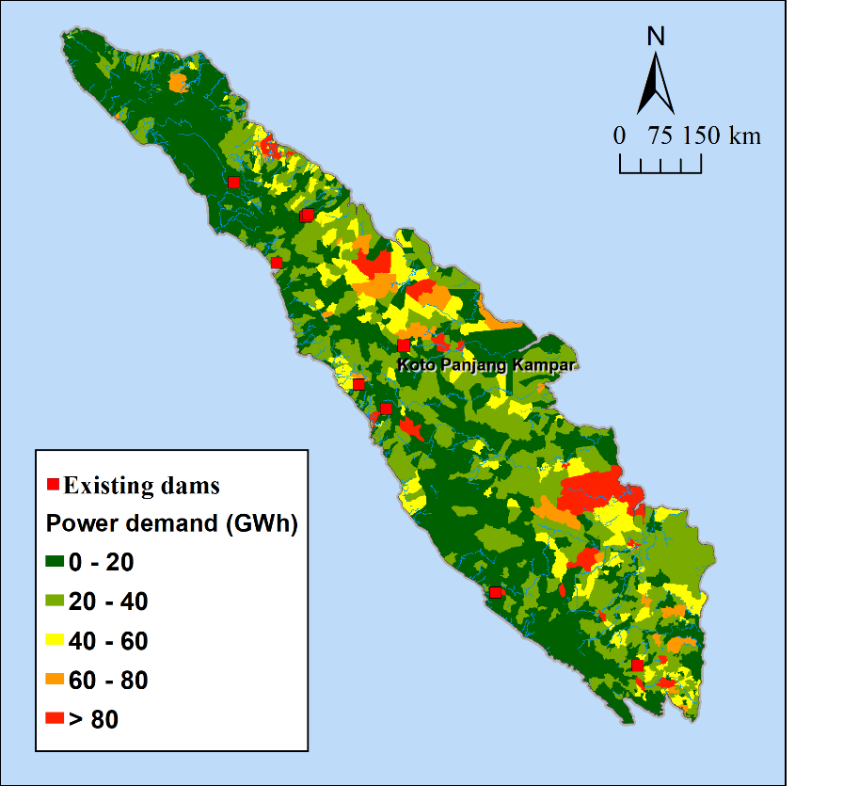

Figure S4. The Location of the existing dams in Sumatra

Text S5
We evaluated the sensitivity of fossil fuel cost on our results to determine the sensitivity of our results to fuel volatility (shown in Figure S4). We adjusted the fossil fuel cost from 0 to 0.25$/kWh, and the fossil fuel cost range is generally approximately 0.05-0.175$/kWh(IRENA, 2019). The sensitivity results presented that the effects of fossil fuel cost on our results are moderate among the fossil fuel cost range. This result is because the actual hydropower generation could be influenced notably by fossil fuel volatility (Mesfun et al., 2017). However, in our study, we mainly assessed the potential hydropower production, rather than the actual hydropower production. Therefore, our results are not sensitive to fossil fuel volatility.

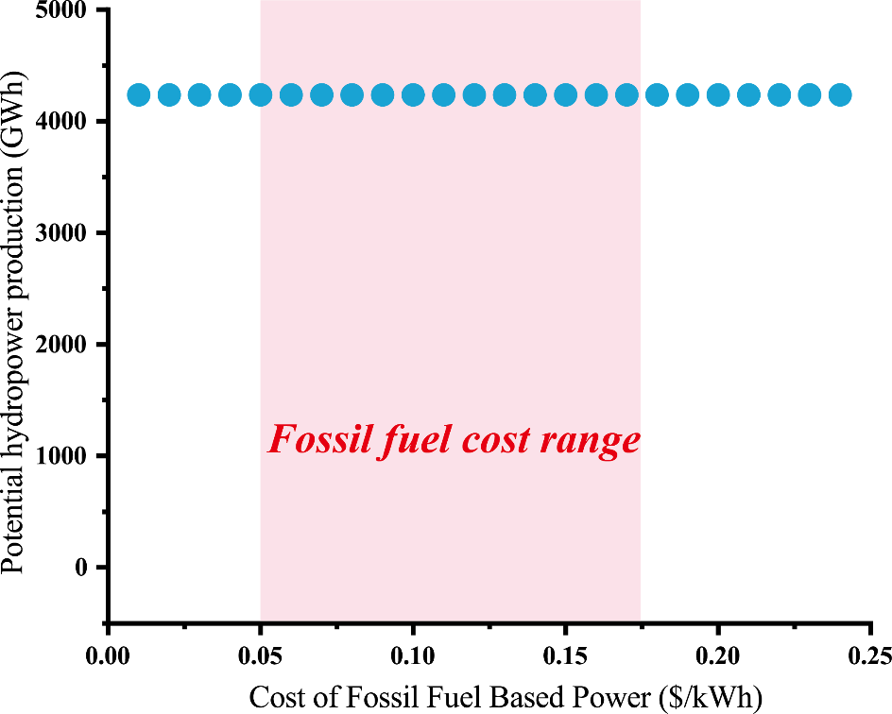

Figure S5. Sensitivity of fossil fuel on hydropower production

Reference
Hasan, M. H., Mahlia, T. M. I., & Nur, H. (2012). A review on energy scenario and sustainable energy in Indonesia. Renewable and Sustainable Energy Reviews, 16(4), 2316–2328. https://doi.org/10.1016/j.rser.2011.12.007
IRENA. (2019). Renewable Power Generation Costs in 2018. International Rewable Energy Agency. Abu Dhabi. Retrieved from https://irena.org/publications/2019/May/Renewable-power-generation-costs-in-2018
Leduc, S., Lundgren, J., Franklin, O., & Dotzauer, E. (2010). Location of a biomass based methanol production plant: A dynamic problem in northern Sweden. Applied Energy. https://doi.org/10.1016/j.apenergy.2009.02.009
Leduc, Sylvain. (2009). Development of an optimization model for the location of biofuel production plants, PhD Thesis. Doctoral thesis. https://doi.org/ISBN 978-91-86233-48-8, ISSN 1402-1544
Mesfun, S., Sanchez, D. L., Leduc, S., Wetterlund, E., Lundgren, J., Biberacher, M., & Kraxner, F. (2017). Power-to-gas and power-to-liquid for managing renewable electricity intermittency in the Alpine Region. Renewable Energy, 107, 361–372. https://doi.org/10.1016/j.renene.2017.02.020
Mesfun, S., Leduc, S., Patrizio, P., Wetterlund, E., Mendoza-Ponce, A., Lammens, T., et al. (2018). Spatio-temporal assessment of integrating intermittent electricity in the EU and Western Balkans power sector under ambitious CO2emission policies. Energy, 164, 676–693. https://doi.org/10.1016/j.energy.2018.09.034
Sperna Weiland, F. C., Vrugt, J. A., van Beek, R. L. P. H., Weerts, A. H., & Bierkens, M. F. P. (2015). Significant uncertainty in global scale hydrological modeling from precipitation data errors. Journal of Hydrology, 529, 1095–1115. https://doi.org/10.1016/j.jhydrol.2015.08.061
Tebaldi, C., & Knutti, R. (2007). The use of the multi-model ensemble in probabilistic climate projections. Philosophical Transactions of the Royal Society A: Mathematical, Physical and Engineering Sciences, 365(1857), 2053–2075. https://doi.org/10.1098/rsta.2007.2076
Timilsina, G. R., Csordás, S., & Mevel, S. (2011). When does a carbon tax on fossil fuels stimulate biofuels? Ecological Economics, 70(12), 2400–2415. https://doi.org/10.1016/j.ecolecon.2011.07.022

