Appendix

Text A.1. Short description of long-term field experiment and study regions in the Czech Republic
Ruzyně, the oldest experimental site in the Czech Republic, comprises 480 experimental plots treated by different combinations of mineral and organic fertilizers (Kunzová, 2013; Šimon and Czakó, 2014). A sugar beet-spring wheat rotation system with the longest history in SOC monitoring was used in this study. The Trutnov experiment was originally established to explore the possibility of replacing farmyard manure with straw applications in farms without livestock (Lipavský et al., 2008), while the experiments in Hněvčeves and Uherský Ostroh were installed to optimize the main nutrient inputs (Madaras et al., 2014; Madaras and Lipavský, 2009).

All treatments used in this study were replicated 4 to 6-times in all experiments except for Hněvčeves, where only the NP+FYM treatments were replicated. Soils have been cultivated by conventional tillage and sampled from the 0–25 cm ploughing layer shortly after crop harvest. A more detailed description of LTEs can be found in the respective publications cited above.
Hradec Králové is a diverse region with cropland spreading from fertile lowlands with an average annual temperature of 9°C and annual precipitation of 550 mm in the south to a cooler climate (~7°C and 730 mm) with less productive agricultural soils in uplands and mountains in the north. Although a substantial part of the Zlín region is also occupied by uplands and mountains (~8°C and 680 mm), the most productive cropland occurs in western and southwestern lowlands with an average temperature of 9.5°C and about 550 mm of annual precipitation. Prague is a small region with the most uniform climatic and soil conditions, with an average annual temperature of 9°C and annual precipitation ~500 mm. The total cropland areas of the study regions are summarised in Table 2 in the main text.

Text A.2. The biogeochemical model EPIC, version 0810 description
EPIC (Environmental Policy Integrated Climate) is a field-scale process-based model (Izaurralde et al., 2006; Williams, 1995; Williams et al., 1984) which calculates, with a daily time step, crop growth and yield, hydrological, nutrient and carbon cycling, soil temperature and moisture, soil erosion, tillage, and plant environment control. Potential crop biomass is calculated from photo-synthetically active radiation using the radiation-use efficiency concept modified for vapor pressure deficit and atmospheric CO₂ concentration effect. Potential biomass is adjusted to actual biomass through daily stress caused by extreme temperatures, water and nutrient deficiency or inadequate aeration. Plant phenological development, including leaf growth, plant nutrients concentration, partitioning of biomass among roots and shoots as well as yield formation are defined by heat units (in °C) accumulated over the growing season.
The coupled organic C and nitrogen (N) module in EPIC (Izaurralde et al., 2006) distributes organic C and N between three pools of soil organic matter (active, slow, and passive) and two litter compartments (metabolic and structural) as introduced in the Century model (Parton et al., 1994). EPIC calculates potential transformations of the five compartments as regulated by soil moisture, temperature, oxygen, tillage mixing and lignin content. Daily potential transformations are adjusted to actual transformations when the combined N demand in all receiving compartments exceeds the N supply from the soil. The transformed components are partitioned into CO₂ (respiration term) and the receiving C pools. EPIC also calculates the movement of C due to leaching. More detailed explanation of the EPIC model can be found in Izaurralde et al. (2006) and Sharpley and Williams (1990).

Table A.1. List of EPIC model features included in tiers T1 to T3 in sensitivity analysis, example for the Hradec Králové region (CZ052); SDF: sampling distribution function; T: triangular distribution, U: uniform distribution, D: discrete distribution
Feature | Description | SDF | Mode (min-max) | T1 | T2 | T3
P2 | Root growth vs. soil strength coefficient | T | 1.15 (1–2) | × | × | ×
P3 | Water stress vs. harvest index coefficient | T | 0.5 (0–1) | × | × | ×
P4 | Denitrification rate coefficient | T | 1 (0.1–5) | × | × | ×
P5 | Soil water lower limit | T | 0.5 (0–1) | × | × | ×
P7 | N-fixation coefficient | T | 0.5 (0–1) | × | × | ×
P11 | Moisture required for germination coefficient | U | 0.3–0.9 | × | × | ×
P12 | Soil evaporation coefficient | U | 1.5–2.5 | × | × | ×
P13 | Hargreaves PET equation exponent | U | 0.5–0.5 | × | × | ×
P14 | Nitrate leaching ratio | T | 0.5 (0.1–1) | × | × | ×
P20 | Microbial decay rate coefficient | T | 0.5 (0.1–1.5) | × | × | ×
P24 | Maximum depth for biological mixing | T | 0.3 (0.1–0.5) | × | × | ×
P25 | Biological mixing efficiency | T | 0.4 (0.1–0.5) | × | × | ×
P27 | Lower limit nitrate concentration | T | 2 (0–10) | × | × | ×
P30 | Denitrification soil-water threshold | T | 1 (0.9–1.1) | × | × | ×
P34 | Soluble P runoff exponent | T | 1.2 (1–1.5) | × | × | ×
P35 | Water stress weighting coefficient | U | 0–1 | × | × | ×
P38 | Hargreaves PET equation coefficient | U | 0.002–0.0032 | × | × | ×
P41 | Soil evaporation-cover coefficient | T | 0.1 (0.01–0.2) | × | × | ×
P42 | NRCS curve number index coefficient | T | 1.2 (0.5–1.5) | × | × | ×
P45 | Allocating slow to passive humus coefficient | T | 0.003 (0.001–0.06) | × | × | ×
P47 | Slow humus transformation rate | T | 5.48E-4 (3E-4–6.8E-4) | × | × | ×
P48 | Passive humus transformation rate | T | 1.2E-5 (7.2E-6–1.5E-5) | × | × | ×
P51 | Coefficient adjusts microbial activity in topsoil | T | 0.5 (0.1–1) | × | × | ×
P52 | Tillage effect on residue decay rate coefficient | T | 10 (4–16) | × | × | ×
P53 | Microbial activity with soil depth coefficient | T | 0.95 (0.8–1) | × | × | ×
P54 | Potential water use root growth distribution coef. | T | 5 (2.5–7.5) | × | × | ×
P55 | Allocating root growth coefficient | U | 0–1 | × | × | ×
P56 | Root growth distribution by depth function coef. | T | 8 (5–10) | × | × | ×
P57 | N volatilization coefficient | T | 0.4 (0.05–0.7) | × | × | ×
P61 | Soil evaporation weighting factor | U | 0–1 | × | × | ×
P62 | Upward N movement by evaporation coefficient | T | 2 (0.2–5) | × | × | ×
P63 | Upper N limit in percolating water | U | 100–10000 | × | × | ×
P64 | Upper limit of nitrification-volatilization | U | 0–1 | × | × | ×
P68 | N fixation upper limit | T | 20 (1–30) | × | × | ×
P69 | Heat unit adjustment at harvest | T | 0 (0–1) | × | × | ×
P70 | Day length component coefficient | T | 3 (1–10) | × | × | ×
P73 | Upper limit of CN retention parameter | T | 1.5 (1–2) | × | × | ×
P75 | Runoff CN residue adjustment parameter | T | 0.1 (0–0.3) | × | × | ×
P77 | P flux between labile and active pool coefficient | T | 0.001 (0.0001–0.6) | × | × | ×
P78 | P flux between active and stable pool coefficient | T | 0.0005 (0.0001–0.1) | × | × | ×
S2 | Governs soil evaporation as a function of soil depth | T | 95 (75–99) | × | × | ×
S5 | Estimates soil cover factor in soil temperature eq. | T | 95 (75–99) | × | × | ×
S6 | Bulk density reset after tillage | T | 95 (75–99) | × | × | ×
S8 | Plant stress caused by N or P deficiency | T | 95 (75–99) | × | × | ×
S10 | Effect of water stress on harvest index | T | 90 (75–99) | × | × | ×
S11 | Plant water stress as a function of available water | T | 95 (75–99) | × | × | ×
S20 | Oxygen content of soil as a function of depth | T | 90 (75–99) | × | × | ×
S24 | Oxygen content of soil as a function of C and clay | T | 95 (75–99) | × | × | ×
S25 | Denitrification as a function of soil water content | T | 99 (75–99) | × | × | ×

Table A.1. (continued)
Feature | Description | SDF | Mode (min-max) | T1 | T2 | T3
RTN0 | Years of cultivation at start of simulation | U | 10–100 |  | × | ×
UPS | Slope (%) | T | 0.01 (0–0.1) |  | × | ×
RFNX | Average concentration of N in rainfall (ppm) | T | 3 (1–10) |  | × | ×
FHP | SOC in passive pool (fraction) | T | 0.7 (0.3–0.9) |  | × | ×
WOC | Topsoil organic C (%) | T | 0.5 (1–3) |  | × | ×
FBM | SOC in biomass pool (fraction) | T | 0.04 (0.03–0.05) |  | × | ×
CEC | Cation exchange capacity (cmol₊ kg^{–1}) | T | 17 (10–25) |  | × | ×
BSAT | Base saturation (%) | T | 90 (70–100) |  | × | ×
TEXTUR | Soil texture  (sand-silt-clay % in topsoil/sand-silt-clay % in subsoil) | D | 1: 9-77-14 / 9-77-14  2: 35-29-36/ 29-31-40  3: 37-27-36/ 34-28-38  4: 41-36-23/40-36-24  5: 40-36-24/17-55-28  6: 43-35-22/21-54-25  7: 64-17-19/43-33-24  8: 67-17-16/63-19-18 |  | × | ×
ROK | Rock volume (vol. %) | T | 0 (0–20) |  | × | ×
Z | Soil depth (m) | T | 1.2 (0.5–2) |  | × | ×
ST | Initial soil water storage (fraction) | T | 0.5 (0.1–0.9) |  | × | ×
CROT | Crop rotation | D | 1: cs-bl-af-af-ww  2: bl-rp-af-af-ww  3: ot-af-af-ww-sg  4: af-af-ww-po-ww-rp  5: af-af-ww-rp-ww  6: bl-ww-sg  7: ot-ww-rp-ww  8: ot-wr-rp  9: cs-bl-mz-bl  10: bl-ww-rp-ww  11: af-af  12: ww-ww  13: bl-bl  14: rp-rp  15: cs-cs  16: ot-ot  17: sg-sg  18: po-po  19: wr-wr  20: mz-mz |  |  | ×
OAMEN | Organic amendments (Mg ha^{–1}) | U | 0 – 40000 |  |  | ×
TDPTH | Tillage depth (mm) | D | 100, 150, 200, 250, 300 |  |  | ×
MXEFF | Mixing efficiency (fraction) | D | 0.5, 0.6, 0.7, 0.8, 0.99 |  |  | ×
ORHI | Crop aboveground residue harvest (fraction) | D | 0.2, 0.4, 0.6, 0.8, 1 |  |  | ×
TILLNT | Number of tillage operations | D | 1: till, disking, harrows, row cultivation  2: till only |  |  | ×
FERT | N and P fertilization (kg N,P ha^{–1}) | D | 1: 1 kg N ha^{–1}, 1 kg P ha^{–1}  2: 10 kg N ha^{–1}, 5 kg P ha^{–1}  3: 20 kg N ha^{–1}, 5 kg P ha^{–1}  4: 50 kg N ha^{–1}, 10 kg P ha^{–1}  5: 100 kg N ha^{–1}, 20 kg P ha^{–1}  6: 200 kg N ha^{–1}, 20 kg P ha^{–1} |  |  | ×

Table A.2. Simulation layout (T1: tier 1, T2: tier 2, T3: tier 3, LTERot: experimental crop rotation from long-term experiment, CRot: top-down crop rotation, CMon: top-down crop monoculture, Cntr: control treatment, NP: N,P-mineral fertilization treatment, crop residues harvested, NP+FYM: N,P-mineral fertilization plus farmyard manure treatment, crop residue harvested, FYM: farmyard manure treatment, crop residues harvested, NP+resid: N,P-mineral fertilization treatment, crop residues retained, e: experimental treatment, r: regionalized treatment scenario)

Tier | Scale | Rotation | Treatment | Soil
T1 | plot | LTERot | Cntr^{e} | AF soil
 |  |  | NP^{e}
 |  |  | NP+FYMe
 |  |  | FYMe
 |  |  | NP+resid^{e}
T2 | Region | LTERot | Cntr^{e} | all soil grids
 | (plot) |  | NP^{e} | (AF, LF, TSD)
 |  |  | NP+FYMe
 |  |  | FYMe
 |  |  | NP+resid^{e}
T3 | Region | CRot | Cntr^{r} | all soil grids
 | (plot) | CMon | NP^{r} | (AF, LF, TSD)
 |  |  | NP+FYM^{r}
 |  |  | FYM^{r}
 |  |  | NP+resid^{r}

Table A.3. Relative differences in the 0–25 cm topsoil organic C stock (in %) between individual treatments evaluated after 20-year simulation. All statistically significant at P<0.01.

LTE Hněvčeves
 | Cntr | NP | NP+FYM | NP+resid | FYM
Cntr | 0.0
NP | 9.0 | 0.0
NP+FYM | 20.6 | 11.0 | 0.0
NP+resid | 16.8 | 7.0 | -3.1 | 0.0
FYM | 13.6 | 4.0 | -5.8 | -2.7 | 0.0
LTE Ruzyně
 | Cntr | NP | NP+FYM | NP+resid | FYM
Cntr | 0.0
NP | 12.2 | 0.0
NP+FYM | 25.6 | 12.0 | 0.0
NP+resid | 25.9 | 12.2 | 0.2 | 0.0
FYM | 16.0 | 3.4 | -7.7 | -7.9 | 0.0
LTE Trutnov
 | Cntr | NP | NP+FYM | NP+resid | FYM
Cntr | 0.0
NP | 10.9 | 0.0
NP+FYM | 27.1 | 14.6 | 0.0
NP+resid | 24.7 | 12.4 | -1.9 | 0.0
FYM | 19.2 | 7.5 | -6.2 | -4.4 | 0.0
LTE Uherský Ostroh
 | Cntr | NP | NP+FYM | NP+resid | FYM
Cntr | 0.0
NP | 4.5 | 0.0
NP+FYM | 13.0 | 8.1 | 0.0
NP+resid | 14.4 | 9.5 | 1.3 | 0.0
FYM | 10.3 | 5.6 | -2.4 | -3.6 | 0.0

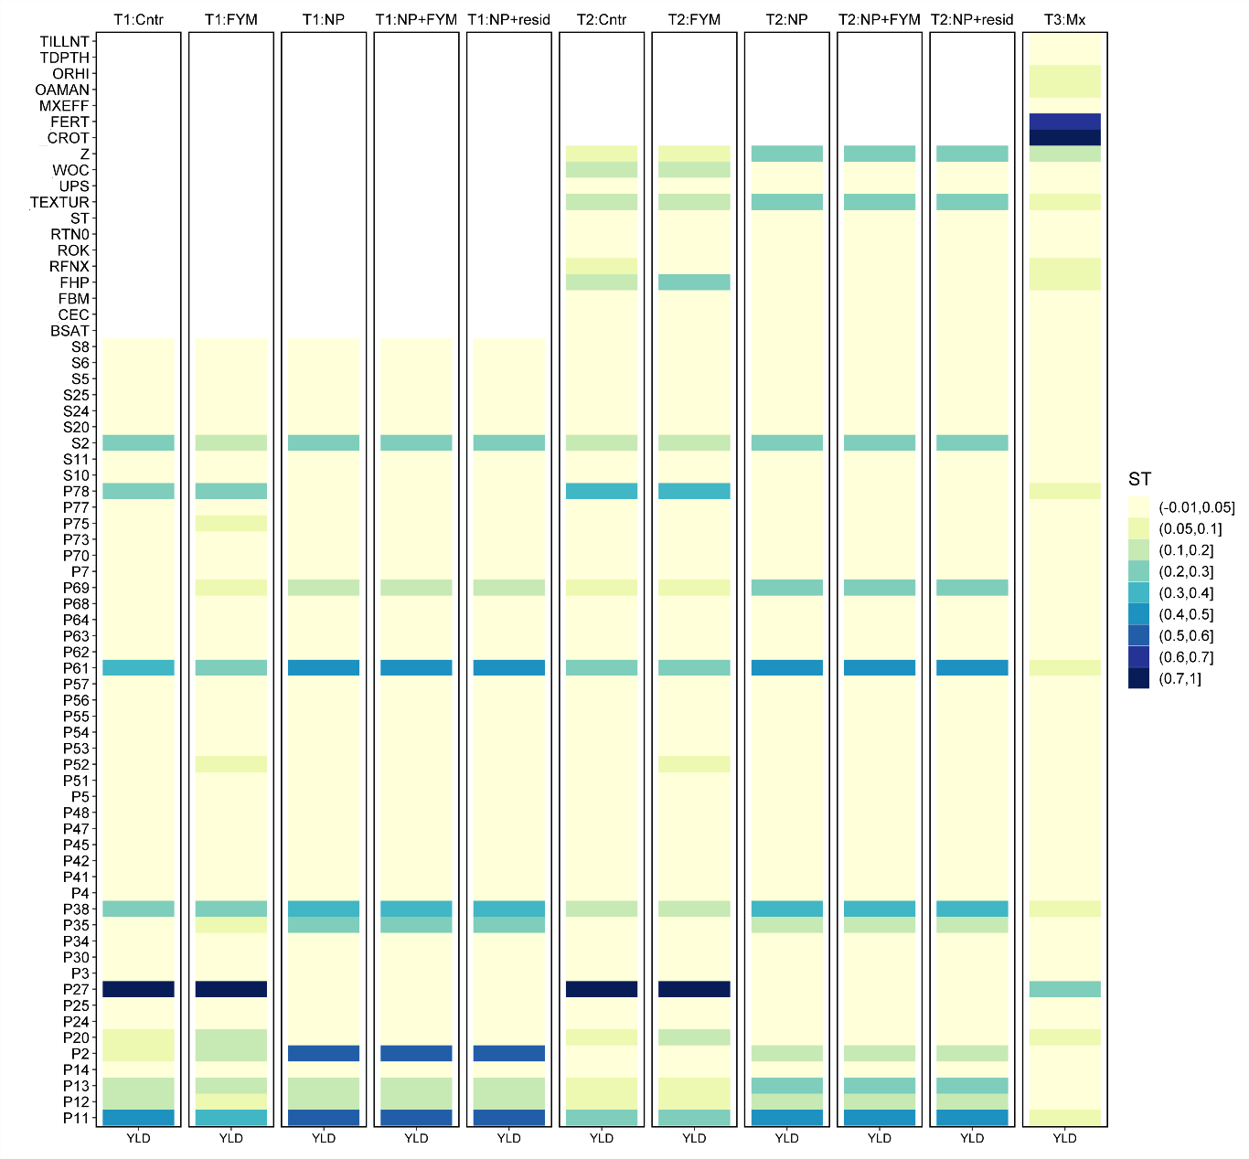
Fig. A.1. Crop yield (YLD) sensitivity (Sobol’s ST index) to the EPIC-IIASA model features (Y-axis) calculated for individual crop managements in tier T1 to T3 (X-axis). Example of LTE Trutnov; Cntr: control no-input crop treatment, FYM: farmyard manure treatment, NP: mineral N and P fertilization treatment, NP+FYM: mineral N,P fertilization plus manure treatment, NP+resid: mineral N,P fertilization with crop residue retention treatment. See Table S1 for feature abbreviations.

Fig. A.2. Regional 0–25 cm topsoil organic carbon stock change (ΔOCPD, in t ha^{–1} y^{–1}) simulated for a) Hradec Králové Region, b) Zlín Region, and c) Capital Prague Region; bars: median and percentiles shaded by 10%, circle: experimental soil (AF), triangle: soil grid overlaying LTE site.
Fig. A.3. Model verification calculated at locations of LTEs with underlaying soil grid (LF) and observational weather. Measured SOC stock time-series (OCPD, in Mg C ha^{–1}) plotted against the OCPD values simulated in tier 2 and 3 with experimental (LTERot) and regionalized (CRot, CMon) crop managements as well as the estimates calculated using the IPCC tier 1 land-management and input factors.

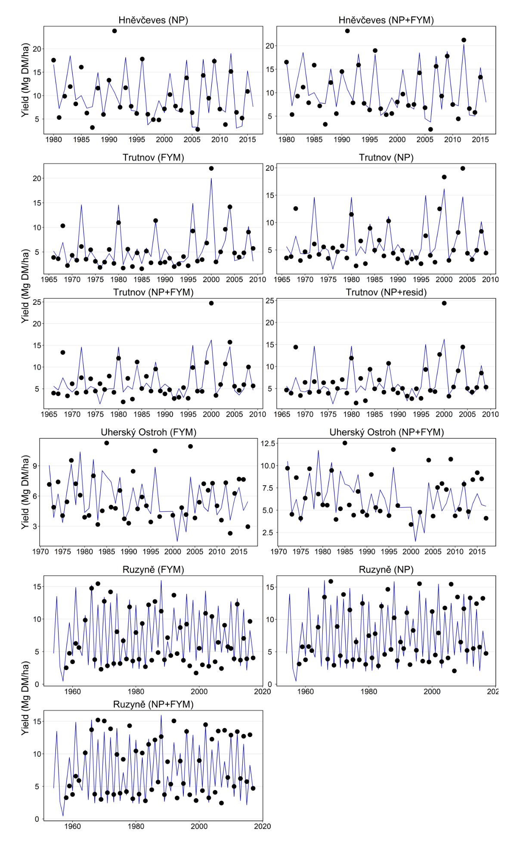
Fig. A.4. Time series of simulated (lines) and measured (dots) dry-matter crop yield (in Mg of dry matter ha^{–1}) calculated at locations of LTE with experimental crop management, experimental soils, and observational weather.
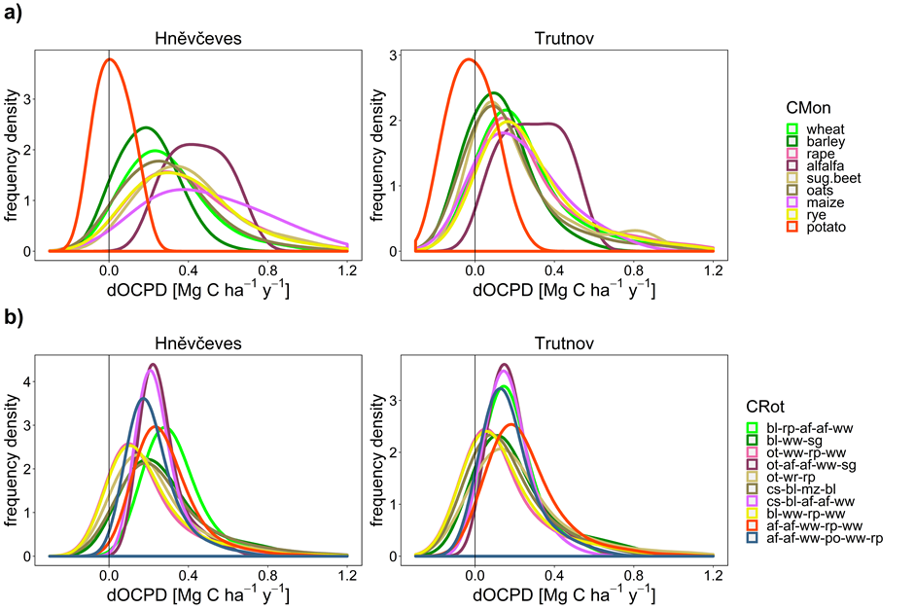

Fig. A.5. Distribution of ΔOCPD (in Mg ha^{–1} y^{–1}) simulated for the entire crop treatment gradient (Mx), experimental soil, and observational weather as resulted from the uncertainty analysis runs with the top-down a) CMon and b) CRot regionalization approaches. Example of the Hradec Králové region.

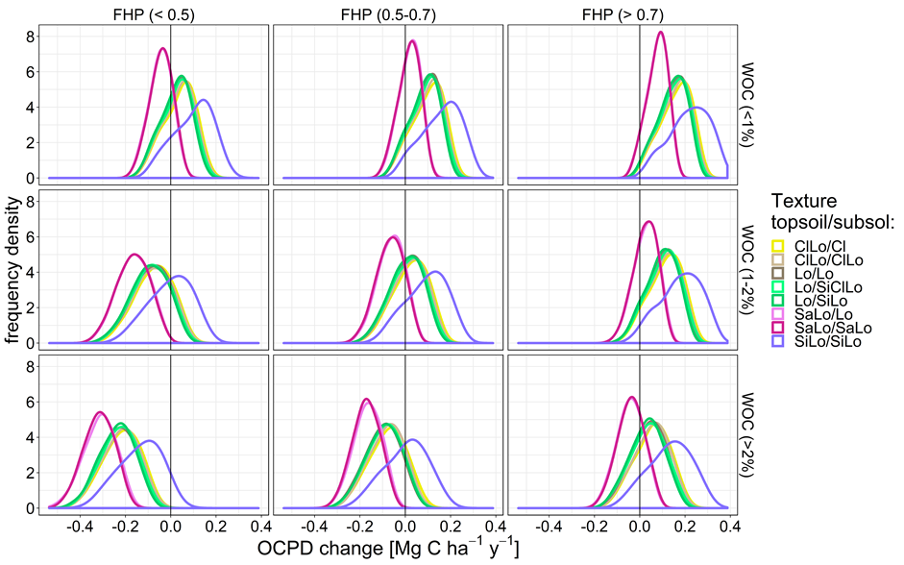
Fig. A.6. Distribution of ΔOCPD (in Mg C ha^{–1} y^{–1}) simulated for different initial conditions of topsoil SOC concentration (WOC in %), fraction of SOC in passive pool (FHP), and soil texture in the Hradec Králové region with Trutnov experimental crop management and weather. ClLo: clay loam, Cl: clay , Lo: loam, SiClLo: silty clay loam, SiLo: silty loam, SaLo: sandy loam

Fig. A.7. Distribution of ΔOCPD simulated for the entire crop treatment gradient (Mx) and the total regional soil diversity (TSD) resulted from the uncertainty analysis runs with the top-down (T3) regionalization approach using crop monocultures (CMon) and crop rotations (CRot).

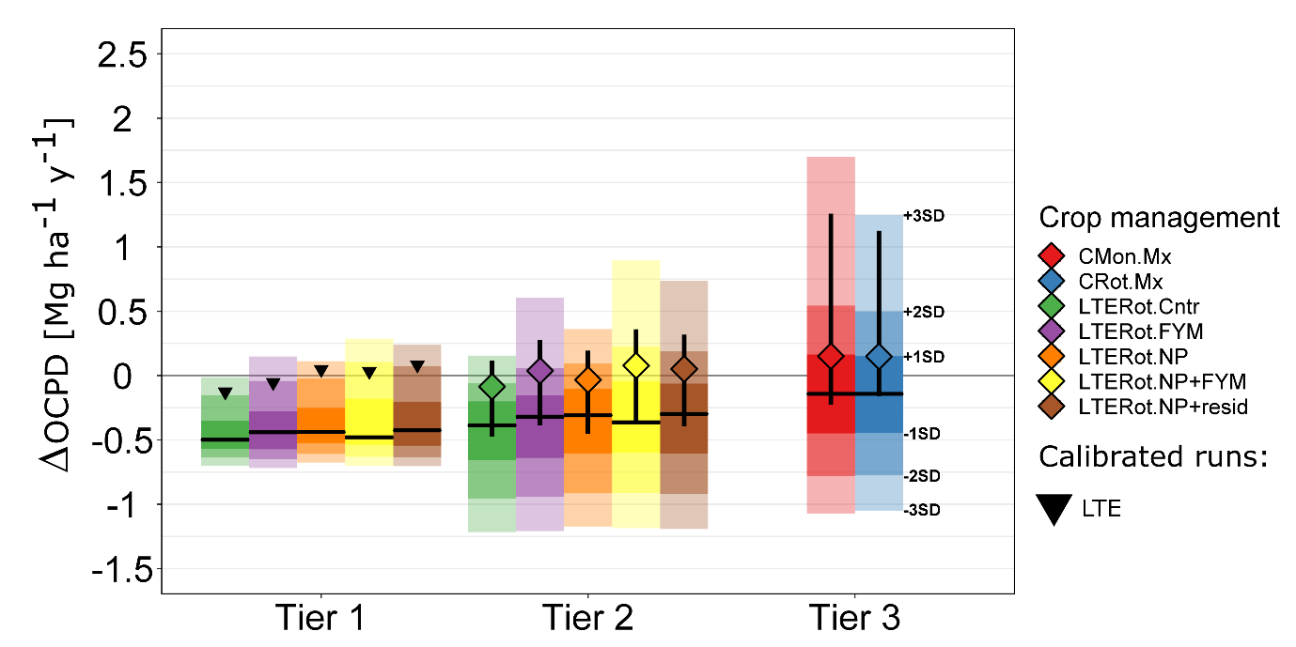
Fig. A.8. Soil organic carbon impact uncertainty range (ΔOCPD, in Mg ha^{–1} y^{–1}) calculated in tier 1 to 3 (crossbars, horizontal lines are medians, shading represents +/– SD intervals). Triangle datapoints in tier 1 represent the calibrated EPIC runs with the LTE field data; point ranges (median and 25/75th percentiles) in tier 2 represent the calibrated EPIC runs for all soil grids in the region, assuming experimental rotation systems and treatments; point ranges in tier 3 represent the calibrated EPIC runs carried out with experimental soils (AF) using regionalized crop rotation (CRot) and monocrop (CMon) systems combined with the entire range of crop treatments (Mx). Example of Trutnov LTE.

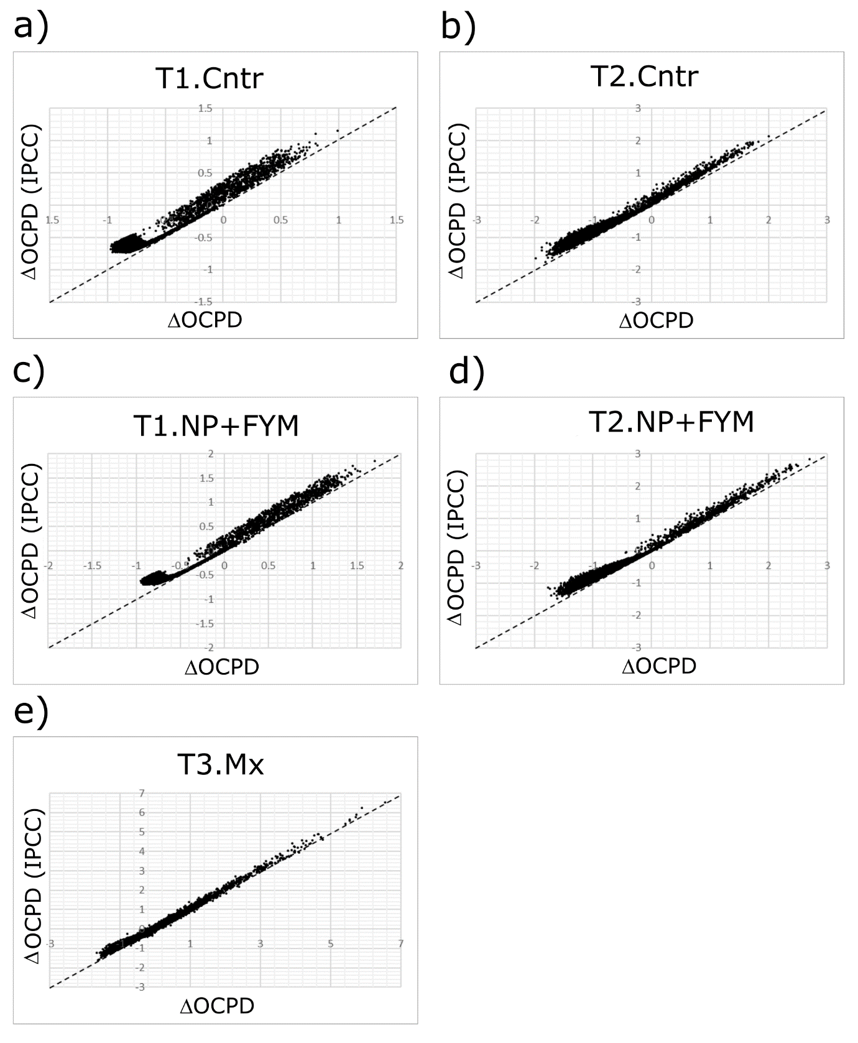
Figure A.9. A comparison between annual rates in soil organic carbon stock change (ΔOCPD in Mg ha^{–1} y^{–1}) calculated by Eq. (1) (x-axis) and the values calculated using a standard method proposed by IPCC (y-axis), where SOC change is calculated as the difference in SOC stocks in the first and last year divided by the number of years over the simulation period. An average of the first and the last 5 years in a time series, and a corresponding correction for the period duration, were used to smooth SOC fluctuations in the IPCC-based method. A sample from the Uherský Ostroh simulations, exemplary for tier 1 to 3 (T1-T3) approaches with examples of experimental crop treatments (a-d) and perturbed crop management (e).

References
Balkovič, J., van der Velde, M., Schmid, E., Skalský, R., Khabarov, N., Obersteiner, M., Stürmer, B., Xiong, W., 2013. Pan-European crop modelling with EPIC: Implementation, up-scaling and regional crop yield validation. Agric. Syst. 120, 61–75. https://doi.org/10.1016/j.agsy.2013.05.008
Izaurralde, R.C., Williams, J.R., McGill, W.B., Rosenberg, N.J., Jakas, M.C.Q., 2006. Simulating soil C dynamics with EPIC: Model description and testing against long-term data. Ecol. Model. 192, 362–384. https://doi.org/10.1016/j.ecolmodel.2005.07.010
Kunzová, E., 2013. The effect of crop rotation and fertilization on dry matter yields and organic C content in soil in long-term field experiments in Prague. Arch. Agron. Soil Sci. 59, 1177–1191. https://doi.org/10.1080/03650340.2012.708734
Lipavský, J., Kubát, J., Zobač, J., 2008. Long-term effects of straw and farmyard manure on crop yields and soil properties. Arch. Agron. Soil Sci. 54, 369–379. https://doi.org/10.1080/03650340802022852
Madaras, M., Koubová, M., Smatanová, M., 2014. Long-term effect of low potassium fertilization&nbsp;on its soil fractions. Plant Soil Environ. 60, 358–363. https://doi.org/10.17221/290/2014-PSE
Madaras, M., Lipavský, J., 2009. Interannual dynamics of available potassium in a long-term fertilization experiment. Plant Soil Environ. 55, 334–343. https://doi.org/10.17221/34/2009-PSE
Parton, W.J., Ojima, D.S., Cole, C.V., Schimel, D.S., 1994. A General Model for Soil Organic Matter Dynamics: Sensitivity to Litter Chemistry, Texture and Management, in: SSSA Special Publication. Soil Science Society of America. https://doi.org/10.2136/sssaspecpub39.c9
Schönhart, M., Schmid, E., Schneider, U.A., 2011. CropRota – A crop rotation model to support integrated land use assessments. Eur. J. Agron. 34, 263–277. https://doi.org/10.1016/j.eja.2011.02.004
Sharpley, A.N., Williams, J.R. (eds), 1990. EPIC, Erosion/Productivity Impact Calculator: 1. Model documentation. U.S. Department of Agriculture Technical Bulletin No. 1768.
Šimon, T., Czakó, A., 2014. Influence of long-term application of organic and inorganic fertilizers on soil properties. Plant Soil Environ. 60, 314–319. https://doi.org/10.17221/264/2014-PSE
Williams, J.R., 1995. The EPIC model, in: Singh, V.P. (Ed.), Computer models of watershed hydrology. Water resources publisher, Colorado, pp. 909–1000.
Williams, J.R., Jones, C.A., Dyke, P.T., 1984. A modelling approach to determining the relationship between erosion and soil productivity. Trans ASAE 27, 129–144.

