Supplementary Material for A Cost-Benefit Analysis of Implementing Climate Change Adaptation Measures in Small and Medium-Sized Cities in Austria

Figure S1. Spatially explicit (250m x 250m) plots of population in 2017 (top left), current average number of hot days (top right), average number of reduced hot days with a combination of measures (bottom left) and reduced mortality as a result of the combination of measures for Mödling (bottom right).
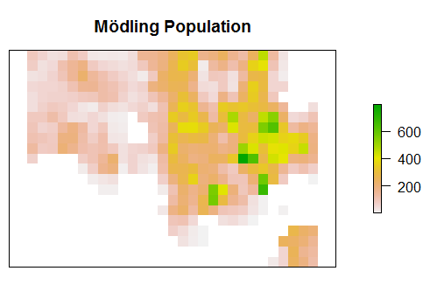 | 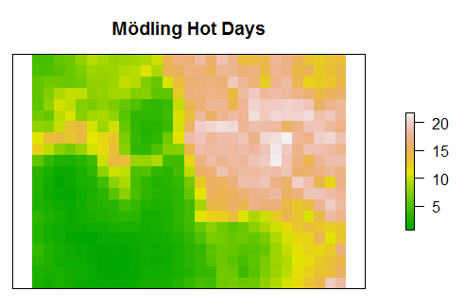
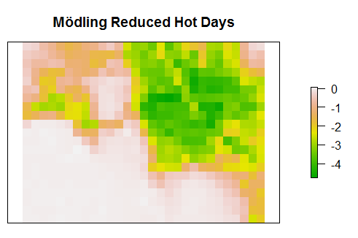 | 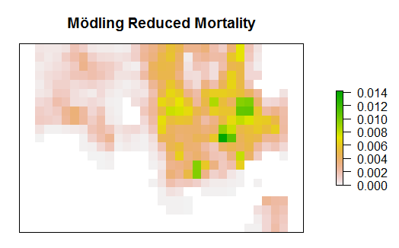

Figure S2. Cumulative probability distributions of the combined scenario for (a) Mödling, (b) Klagenfurt and (c) Salzburg.

