Supplementary Information for A map of the extent and year of detection of oil palm plantations in Indonesia, Malaysia and Thailand

Authors
Olga Danylo¹, Johannes Pirker^{1,2}, Guido Lemoine³, Guido Ceccherini³, Linda See¹, Ian McCallum¹, Hadi¹, Florian Kraxner¹, Frédéric Achard³, Steffen Fritz¹

Affiliations
1 Ecosystems Services and Management Program, International Institute for Applied Systems Analysis, Schlossplatz 1, A-2361, Laxenburg, Austria.
2 KU Leuven, Department of Earth and Environmental Sciences, Leuven, Belgium
3 European Commission, Joint Research Centre, I-21027 Ispra (VA), Italy
Corresponding author: Olga Danylo (danylo@iiasa.ac.at)

115.085884 -1.845399
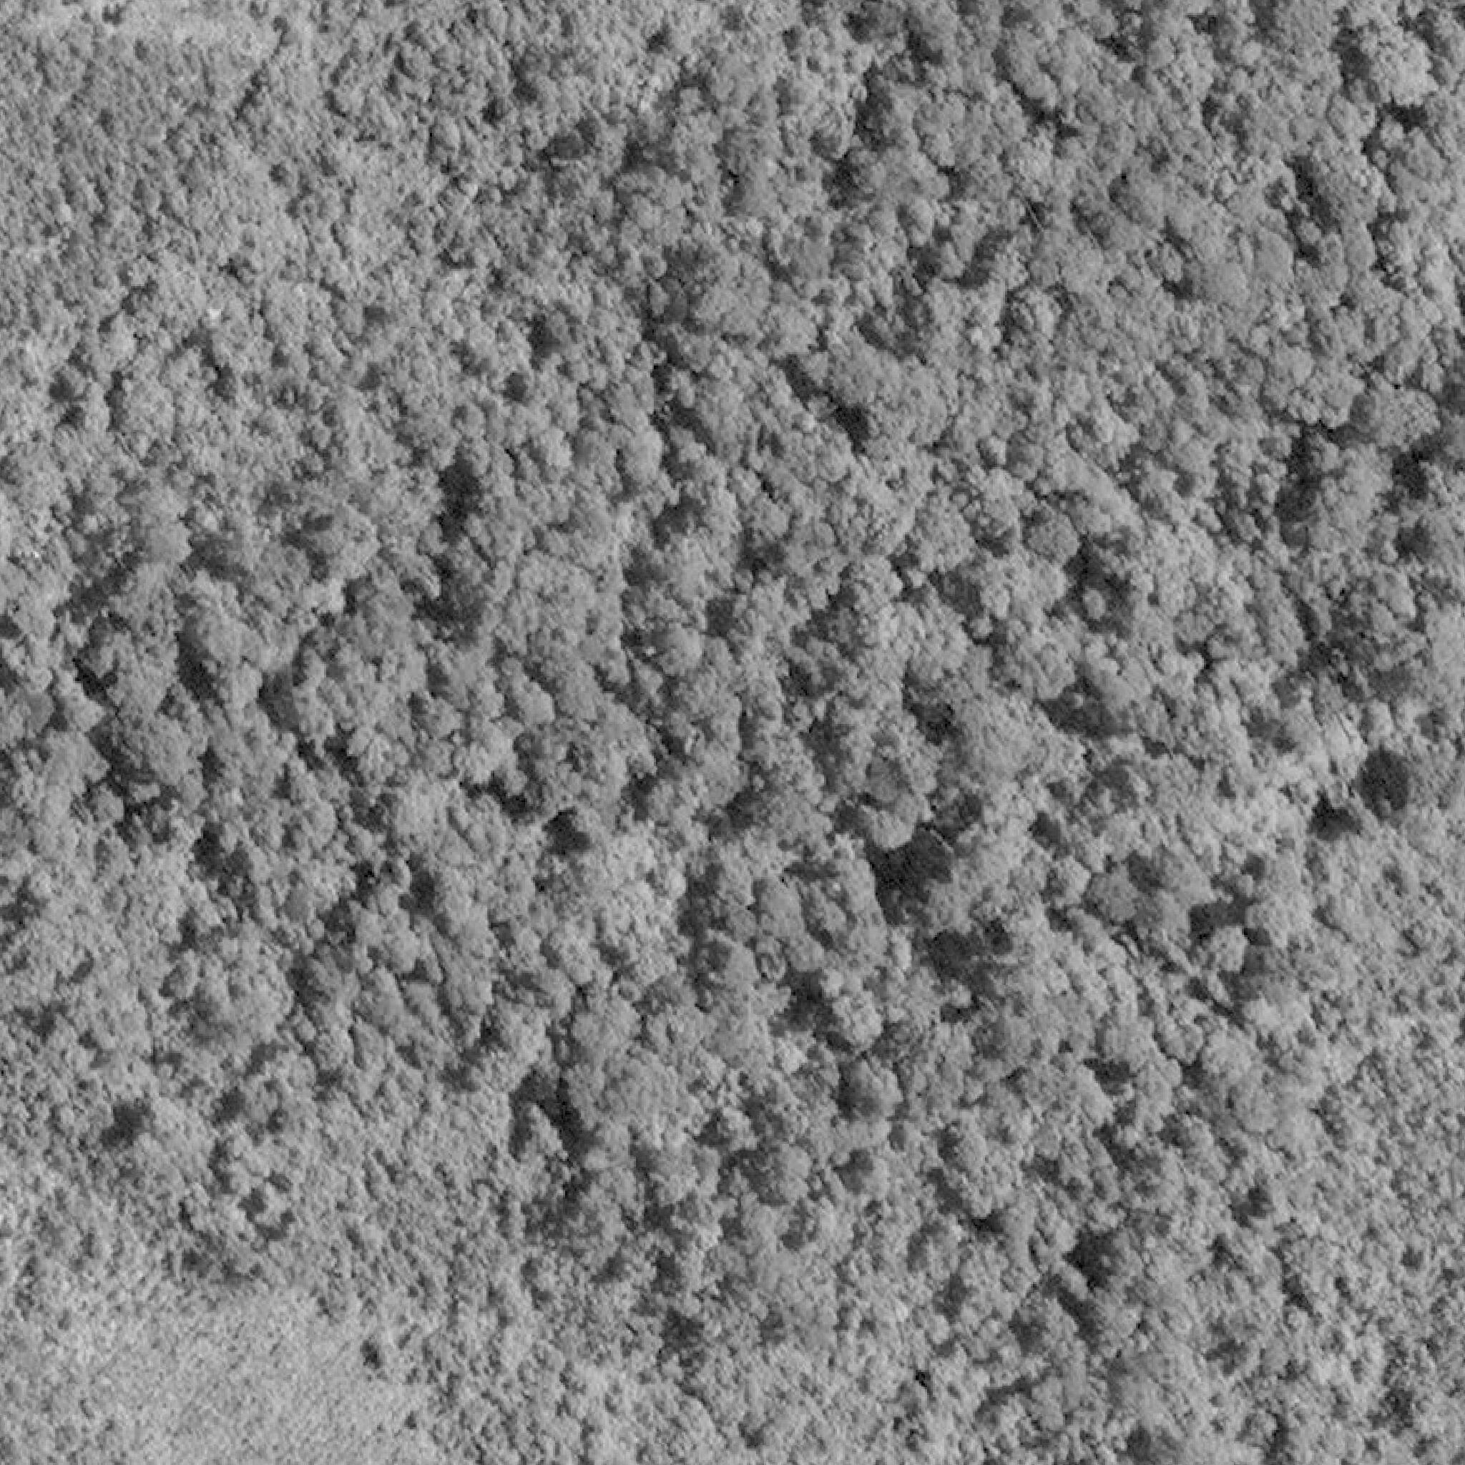  2008/06/22 | 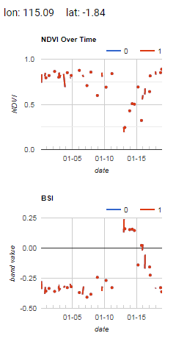
2016/07/05
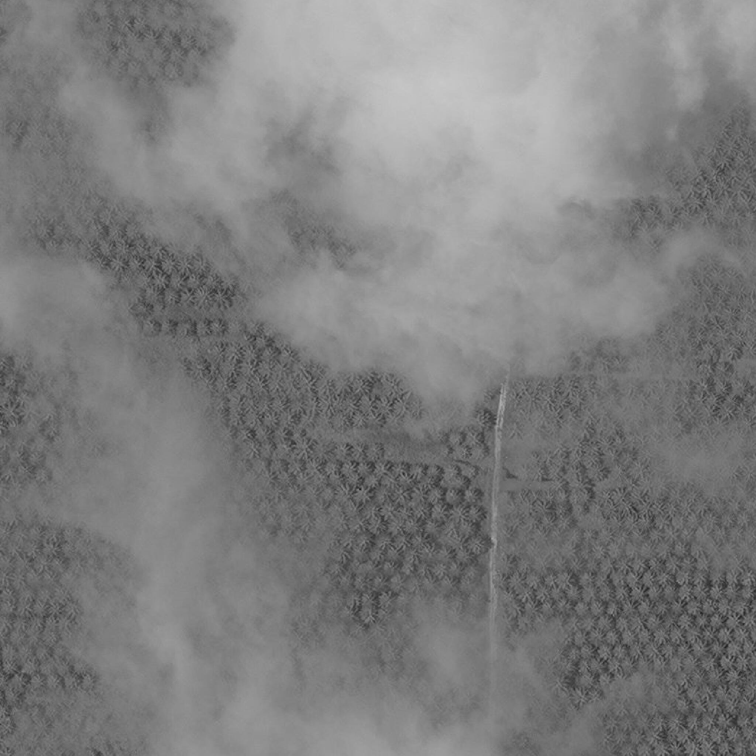  2017/10/13 | 2018/03/11

Figure S1: Very high-resolution satellite imagery from Google Maps of a sample location, changing from forest in 2008 to oil palm in 2016, 2017 and 2018. Time series of the Normalized Difference Vegetation Index (NDVI) and the Bare Soil Index (BSI) indicate the year of detection as 2012.

