APPENDIX B - Sensitivity analysis

In the beginning, we can imagine that each principle has the same importance in the resilience of the SES. From Biggs et al. (2012) there is no explicit ranking among principles and the authors state, and we eco, the multiplicity of meanings and processes embedded in each principle enhance the uncertainties about their participation in resilience. Therefore it is important to understand which principle is more important to the overall resilience because this can lead actions of management in all scales, considering the idea that these principles can act as leverage points in the resilience of the system. We tackle this problem with the numerical simulation followed by a sensitivity analysis. Our understanding of each principle is as broader as possible, considering this lack of precision the price to make a quantitative, not an extensive qualitative, analysis about the issue.
The analysis of a model’s sensitivity allows evaluating the variation of which of its inputs (independent variables) explains the most the variation of one of its outputs (dependent variable) (Cariboni et al., 2007). As different inputs are considered together, the point usually is to compare them rather than getting an absolute measure of how their changes influence changes in the output, although this depends on the used method (here, we are in the first case).
The results of sensitivity analysis (SA) can serve different purposes depending on the stage of the model’s life at which it is performed. During the development of the model, it serves to 1) understand its general behavior, identifying which input influences which output; 2) focus other types of analysis, such as calibration or uncertainty analysis, since it allows to select which inputs should be first studied (typically the most influential ones); 3) provide a sort of validation of the model (although incomplete), since the relationships that it highlights among variables should make sense when compared to the theory creating the possibility for the modeler to explain them.
In our SA, we assess the sensitivity of each resilience principle’s output individually and in a preliminary version of the integration between those principles (without the ecosystem services). This integrative variable was called preliminary DRI (preDRI) and it is different from the index itself once this one does not uses weighted exponents as demanded by Cobb Douglas equation (actually the exponents are there with value 1 for every variable) and also do not account for ecosystem services. PreDRI then was obtained by simple multiplication of every principle (equation II):

$PreDRI= \prod_{i=1}^{7}{Pi}$ (II)

PreDRI was necessary because we could not test the whole ecosystem services model in our SA due to two technical unfeasibility: 1) the size of the whole model; 2) the fact that part of the ecosystem model uses some stochastic variables (e.g. wind speed and direction, cloud cover, rainy days, etc.) that our present version of the R package responsible for the SA cannot manage. A more comprehensive package is being built and further results will be published as soon as they are available.
We did the analysis using the Morris method (Morris, 1991). This method is global, meaning it looks at variations in all the inputs simultaneously, considering their whole possible value range. We chose this method because it is more computationally efficient than other SA methods, like the calculation of Sobol indices for instance (Saltelli et al., 2008). Also, it doesn’t require to set distributions for the input variables (unlike Sobol indices again), which we don’t know in the case of the principle’s limits of our model.
The results of the Morris method are best communicated in the form of a graph where the influence of each input on a chosen output is depicted by a point. For a given input (point), its coordinate on the x–axis (indicator $μ^{*}$) indicates the importance of its direct linear influence on the output. The higher is $μ^{*}$, the more sensitive the output is to this input. The coordinate of the point (input) on the y–axis (indicator σ) indicates either the indirect influence of the input (its interaction with other inputs causes the output’s variation) or a non–linear effect on the output. The higher is $σ$, the more the input interacts with others or the more non-linear is its influence on the output. The absolute values of $μ^{*}$ and $σ$ are “meaningless” and are just meant to be compared among inputs (Figure 2 a–h).
Settings-wise, we run the model from 0 to 33000 days (representing the period from 2010 to 2100). Each input can take a value between 0 and 1 (possible range) with a step of 0.01. The value of the other model’s inputs, i.e., the initial values of the principles, are set to 0.5. The Morris method has a single parameter ($r$) where the value of which defines the number of performed simulations of the model. While the Morris method is usually used for models with a large number of inputs, in which case $r$ is set to a small value (below 100), we only considered 7 inputs (7 principles). Therefore, we could use larger values of $r$ to obtain a more accurate result. To ensure the quality of our results, we repeat our SA with an increasing $r$ (200k) until we observed a convergence in the results. In the main text, we present the results obtained with $r$ = 200k. To conduct our SA, we used the R package sensitivity (R Core Team, 2018; Iooss et al., 2018) that we nested in a package of our design (similR, in prep.) that serves to manage, analyze and run Simile models in R.

Figure B1: sensitivity analysis
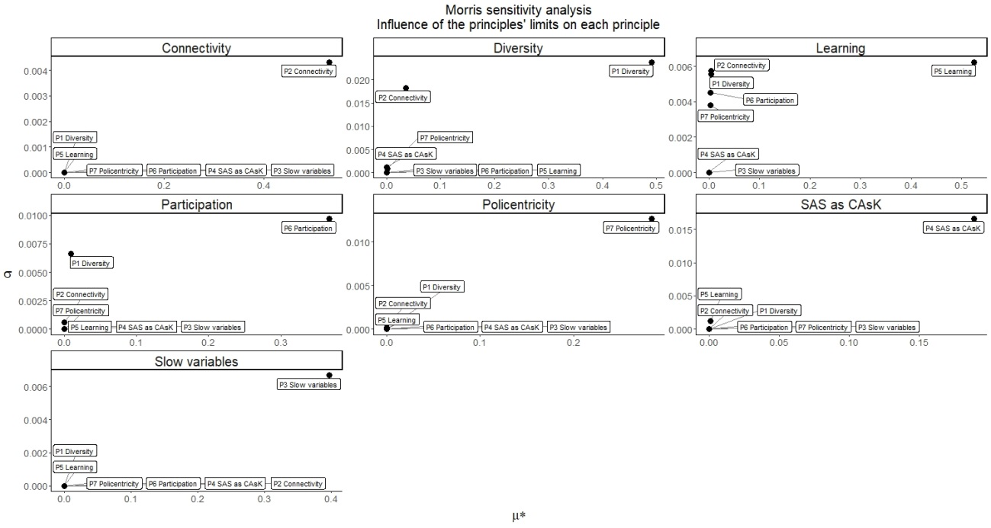
g
f
e
d
c
b
a
The results of the resilience sub–model (pre-DRI): X–axis (μ^* - muStar) indicates the importance of its direct linear influence on the output. The higher is μ^*, the more sensitive is the output to this input. Y–axis (σ – sigma) indicates either the indirect influence.

Figure B1 “a” shows P2 (connectivity) as having the higher σ compared to P1 (diversity) (Figure B1 “b”), showing those variables are highly connected through feedbacks. P4 (SES as CAsK) and P7 (policentricity) showed a very small influence on P1 as well; Figure B1 “c” shows P5 (learning) being indirectly influenced by almost all principles, but strongly by P2 (connectivity) followed by P1 (diversity). Figure B1 “d” shows that P6 (participation) depends on P1 (diversity) and P2 (connectivity); Figure D1 “e” showed P7 (policentricity) is slightly dependent on P2 (connectivity).
Figure B1 “f” showed P4 being influenced indirectly by P5 (learning), pointing that learning is responsible for the understanding of SES as CAs; finally figure B1 “g” showed none of the principles influences heavily P3 (management of slow variables) (direct or indirect) which happens to occur only by variables influencing principles (P1 growth), not by principles themselves.
Figure B2 shows the participation of each principle on the overall PreDRI index. From that we can see the higher $μ^{*}$ of P2 (connectivity) which is the most relevant principle for determining the overall resilience behavior, followed close by P1 (diversity). That is coherent with the model and the theory because as pointed before, some of the principles don’t have a variable direct influencing their decreasing rate, and usually, the feedbacks responsible for decreasing the resilience when those principles surpassed the desired point are embedded in P1 or P2. That fact is also corroborated by P1 and P2 having the higher σ, meaning they are more sensitive to an indirect influence of the input (principles values) than the others.
Figure B2: Main contributions to resilience.
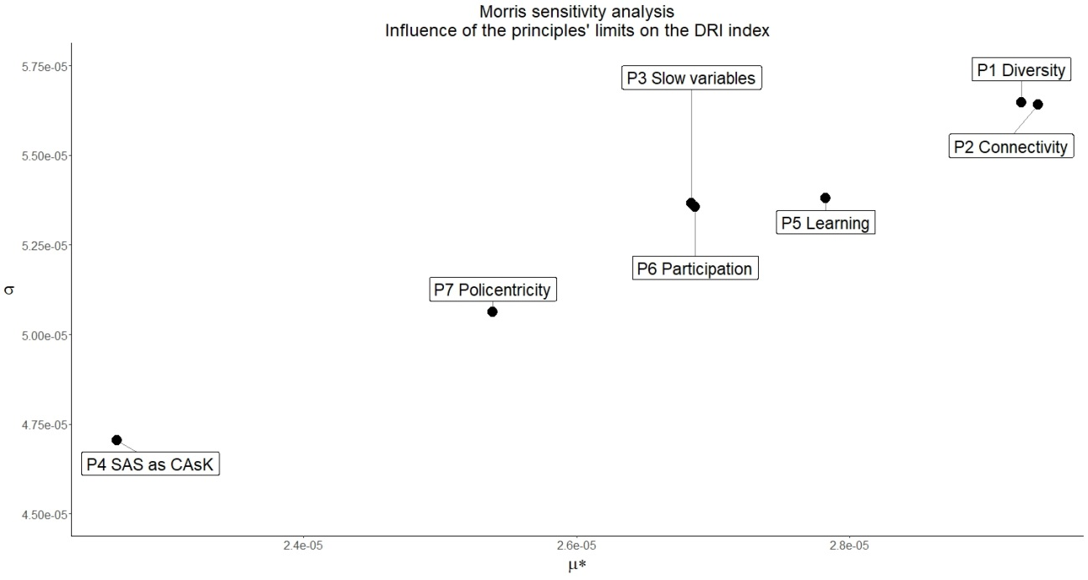
X–axis (μ^* - muStar) indicates the importance of its direct linear influence on the output. The higher is μ^*, the more sensitive is the output to this input. Y–axis (σ – sigma) indicates either the indirect influence. Source: the author.
In the middle of the figure B2 it’s shown the participation of P3 (management of slow variables)(intermediate $μ^{*}$ and intermediate σ); P5 (learning)(higher $μ^{*}$ and intermediate σ); P6 (participation)(lower $μ^{*}$ and lower σ) and P7 (policentricity)(intermediate $μ^{*}$ and higher σ) showing that the participation of these variables in resilience occurs at the same scale, with small variances of direct ($μ^{*}$) and indirect ($σ$) influence in the overall result. Away from this central group, is P4 (SES as CAsK)(low $μ^{*}$ and low σ) showing its influence in resilience is the smallest.
In an overall view, we consider these results highly corroborative of the model and the theory, pointing the relevance of the limits to every principle and showing part of the intricate network of feedbacks that connect them.

