Supplementary Information
Beyond emissions trading to a negative carbon economy
The Carbon Removal Obligation and its implementation

Johannes Bednar, Justin Macinante, Artem Baklanov, Jim W Hall, Fabian Wagner, Navraj S. Ghaleigh, Michael Obersteiner

- Comparison between Original and Updated Proposals
In this supplementary information (SI) document, we use the term 'Original Proposal' to refer to the policy framework proposed by Bednar et al. (2021). In contrast, the 'Updated Proposal,' which is described in the main article, represents our revised approach.

The Original Proposal aimed to incentivize net carbon removals or net negative CO₂ emissions in order to address the carbon budget overshoot. It considered carbon debt as the result of net CO₂ emissions exceeding a 'temporally distributed instantaneous' (TDI) carbon budget, as explained in section 2 of this SI. The compensation for this carbon debt relied on net negative CO₂ emissions. Concurrently, the Original Proposal suggested incorporating carbon dioxide removal (CDR) activities, aimed at offsetting residual emissions (see Figure 1a in the main article for an explanation of the terminology), through an emissions trading scheme (ETS) alongside the main CRO mechanisms. This integration of the CDR market into both the ETS and the CRO framework was referred to as the 'CRO-ETS,' as illustrated in Figure S1e.

In contrast, the Updated Proposal in the main article considers carbon debt as the result of gross CO₂ emissions, which is then compensated for by gross removals over time. Carbon debt can be defined either as gross emissions occurring after depleting the remaining cumulative (RC) carbon budget (Figure S1a) or as gross emissions contemporaneously exceeding a pathway reflecting a TDI carbon budget (Figure S1c), as discussed in more detail in section 2. This adjustment to the principal CRO mechanism has significant implications:

- By extending its scope from net to gross emissions, CROs are no longer restricted to financing net removals only. CROs now address CDR in general, regardless of entering the realm of net negative emissions. CROs aim to promote early uptake and innovation of CDR while managing the associated risks of CDR-based mitigation strategies.
- The CDR market is disentangled from conventional carbon pricing, reducing the regulatory burden implied by the Original Proposal significantly.
- A separate market for CDR allows for the possibility of diverging price levels between CDR and ERs, potentially influenced by different technological learning rates, as discussed in the main article. This divergence in price levels forms the basis for setting separate targets for ERs and CDR.
- Unlike the Original Proposal, the separation of the CDR market from the ETS means that CROs and emission allowances are not fungible, as detailed in section 2.
- The CRO pricing instrument in the Updated Proposal adjusts price levels separately for ERs and CDR, impacting gross emissions and removals rather than net (negative) emissions. This is a departure from the Original Proposal, which aimed to control the net CO₂ emissions path in the CRO-ETS.
- Maturities under the Updated Proposal, calculated based on gross emissions and removals, are significantly shorter compared to the Original Proposal. As gross removals typically ramp up before net removals, CRO holders can terminate their obligations earlier. For a comparison, refer to panels b and d of Figure S1, illustrating the repayment term structures under the Updated Proposal, and panel f, reflecting the Original Proposal.

An extended comparison between elements of the Original and Updated Proposals is provided in Table S1.

Table S1. Similarities and differences between the Original Proposal and the Updated Proposal.
Element | Original Proposal | Updated Proposal
Carbon budget | There are two options for implementing carbon budgets into the CRO framework: Either (1) emissions following in time the date of depletion of the remaining cumulative (RC) carbon budget, or (2) emissions contemporaneously overshooting a temporally distributed instantaneous (TDI) carbon budget are considered carbon debt. The TDI carbon budget in sum equals the RC carbon budget.
Carbon debt generation | Generated by net emissions overshooting the RC or TDI carbon budget. | Generated by gross emissions overshooting the RC or TDI carbon budget.
Carbon debt compensation | Compensated by net removals. | Compensated by gross removals (total CDR).
Role of conventional carbon pricing (ETS, carbon tax) | Charge a price for depleting the carbon budget. Required for offsetting of emissions with removals to achieve net zero transition and offsetting of residual emissions after net zero. | Charge a price for depleting the carbon budget. Ceases to exist when the RC carbon budget gets depleted, or when the TDI carbon budget becomes zero.
CDR market integration. | CDR market integration into conventional carbon pricing scheme and CRO framework. CROs can be discharged against emission allowances. | CDR market integration only into CRO framework. ‘Removal units’ are non-fungible with emission allowances.
Additionality | Credits generated by additionality principle are excluded from conventional pricing and CRO framework.
Price of ERs | Established in ETS, equals CDR price, adjusted by CRO pricing. | After phase-out of conventional pricing only as shadow price induced by principal CRO mechanism and adjusted by CRO pricing.
Price of CDR | Established on CDR market integrated into ETS, equals ER price, adjusted by CRO pricing. | Established on CDR market. CDR market price depends on the amount of CROs (demand) and the marginal costs of removal units (supply). Demand for CROs adjusted by CRO pricing, which thus impacts on CDR price.
CRO pricing | Adjusts the single price path of ERs and CDR, thus, has an impact on the path of net emissions/removals. | Adjusts the separate prices of ERs and CDR, thus, has an impact on the paths of gross emissions and gross removals.
Target setting | Target setting is limited to net emissions/removals due to the single price path of ERs and CDR. | Separate targets for ERs and CDR can be achieved by inducing adequate price signals for ERs and CDR.
CRO maturities | Maturities reflect time horizon between net emissions and net removals, resulting in rather long maturities. | Maturities reflect time horizon between gross emissions and gross removals, resulting in much shorter maturities

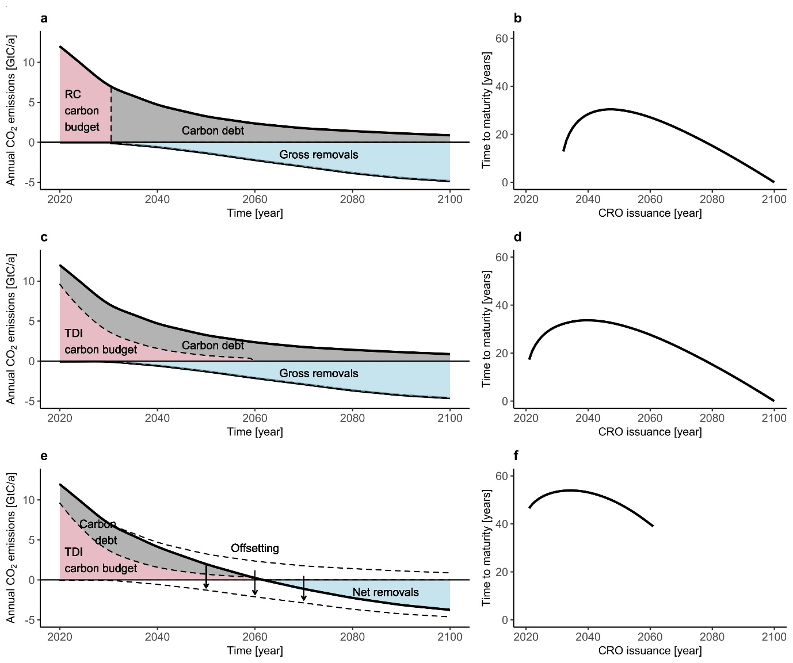
Figure S1: Panel a, c, e: Elements characterizing different versions of the CRO policy framework. Panels: b, d, e: Repayment term structures showing the time to maturity in years as a function of the date of CRO issuance for the profiles shown in panels a, c, e. For an analytical definition see Bednar, Baklanov, and Macinante (2023). Panel a: Elements characterizing the CRO framework of the Updated Proposal as discussed in the main article of this Supplementary Information document. Carbon debt is generated by gross emissions once the remaining cumulative (RC) carbon budget has been depleted, here around 2030. Carbon debt is compensated intertemporally by gross removals. Panel c: Elements of the CRO framework according to the Updated Proposal given a temporally distributed instantaneous (TDI) carbon budget. The cumulative sum of the TDI carbon budget equals the RC carbon budget. Carbon debt is generated by gross emissions exceeding the TDI carbon budget (pink area). Carbon debt is compensated intertemporally by gross removals. In case a conventional carbon pricing scheme, like an emissions trading scheme (ETS) is operating in parallel to the CRO framework, the conventional pricing scheme is bound to the TDI carbon budget (pink). Panel e: Elements of the CRO-ETS according to the Original Proposal (Bednar et al. 2021). Carbon debt is generated by net emissions exceeding the TDI carbon budget (pink area). Carbon debt is intertemporally compensated by net removals. The emission caps over time of the linked ETS equal the TDI carbon budget. CDR integration into the ETS is required for contemporaneously offsetting gross emissions minus net emissions (blank part of gross emissions) with gross removals minus net removals (blank part of gross removals).

- Transition scenarios for implementing the CRO framework with a positive RC carbon budget
In the main article, we make the assumption that gross emissions are equivalent to carbon debt, indicating the operationalization of the CRO framework upon depleting the RC carbon budget (see Figure S1a). Existing carbon pricing arrangements would cease to exist with the initialization of the CRO framework, for instance, the EU-ETS would require earlier retirement than currently anticipated. Here, we present two scenarios for implementing the CRO framework before the RC carbon budget is exhausted (see Figure S1c). It is assumed that economies derive benefits from fully utilizing the RC carbon budget, hence, its depletion needs to be coordinated with the operation of the CRO framework:
Scenario 1: In this scenario, there is no carbon pricing scheme is in place. The depletion of a regional RC carbon budget is projected to occur several decades into the future. The duration of depletion depends on the size of the RC carbon budget, which can be influenced by burden sharing arrangements (e.g., developing nations with limited responsibility for climate change have a relatively larger carbon budge than industrial nations) or the stringency of the climate target (a 2°C climate goal implies a larger RC carbon budget than 1.5°C). While an overshoot of the carbon budget is likely in this scenario, it is not certain. There is a political will to initiate efforts for CDR. The CRO framework is chosen as the preferred policy tool, regardless of the necessity for net carbon removals, due to its advantages in promoting CDR uptake and innovation through a standalone CDR market. Several integration options for the RC carbon budget are available:
Option 1: Sector-by-Sector Integration
Sectors are progressively integrated into the CRO framework while the remaining sectors are allowed to emit without paying for their emissions. This gradual integration leads to the depletion of the RC carbon budget over time, ensuring all sectors are integrated into the CRO framework when the carbon budget is fully depleted.
Option 2: Increasing Emissions-to-Carbon Debt Ratio
All sectors are integrated into the CRO framework, with the ratio of gross emissions to carbon debt gradually increasing. Initially, one tonne of gross CO₂ emissions may result in 0.5 tonnes of carbon debt, requiring the emitter to remove 0.5 tonnes of CO₂ in the future. Over time, this ratio is increased until it reaches one, indicating the depletion of the carbon budget.
Scenario 2: In this scenario, an ETS is already in operation, and the depletion of the regional RC carbon budget is estimated to occur within approximately a decade based on current emissions. It is highly likely that gross CO₂ emissions will surpass the RC carbon budget. The transition involves aligning emissions allowed under the ETS with the RC carbon budget, which would necessitate significant reductions in future allowances. Simultaneously, the CRO framework is gradually introduced alongside the ETS, and demand for the CDR market solely comes from CROs. The transition options are as follows:
Option 1: Sector-by-Sector Transition
Sectors are progressively transferred from the ETS to the CRO framework. Taking into account sector-specific marginal abatement costs, it is anticipated that the ETS price does not converge with the marginal costs associated with a CRO (i.e., the CRO Premium plus discounted future CDR price).
Option 2: Hybrid Approach
Emitters are mandated to cover a fraction of their gross CO₂ emissions with allowances under the ETS, while the remaining emissions are considered carbon debt and addressed through CROs. Over time, the ratio of CROs to allowances increases until it reaches one, indicating the depletion of the RC carbon budget and the discontinuation of the ETS.
Option 3: Emitter Choice
Emitters are granted flexibility to choose between obtaining allowances or acquiring CROs, providing a range of compliance options tailored to individual circumstances and promoting participation in both the ETS and the CRO framework.
Integrating the depletion of the RC carbon budget into the CRO framework or operating an ETS in parallel for that purpose (or a carbon tax, following a similar approach as described in Scenario 2) necessitates the definition of a TDI carbon budget, as shown in Figure S1c. The RC carbon budget is reflected by summing up the TDI carbon budget over time. Hence, the amount of carbon debt generated at each point in time is determined by gross emissions that exceed the TDI carbon budget at each point in time. The TDI carbon budget is needed for determining the time varying Emissions-to-Carbon Debt Ratio (Scenario 1) and for setting emission caps over time in an ETS (Scenario 2).
To ensure a smooth parallel operation between an ETS and a CRO framework, several considerations need to be addressed. Firstly, there might be a moral hazard associated with the continued issuance of allowances to emitters once the carbon budget has been depleted. It is crucial that the sum of emission caps over time accurately reflects the RC carbon budget, rather than simply continuing with the existing and scheduled caps.
During the gradual phase-out of the existing ETS sufficient notice to participant emitters should be provided to unwind their forward positions and utilize any remaining ETS allowances. It is anticipated that such a transitional period would run for a period of several years, while ETS allowances are typically surrendered on an annual basis. Hence, depending on the profile of the particular ETS in question, the transition period needs to be set to minimize any impacts resulting from the transition.
Furthermore, it is important to exclude credits generated through ERs or emission avoidance based on the principle of additionality from both the ETS and the CRO framework. This exclusion is vital to prevent double counting and maintain environmental integrity, ensuring accurate price signals and facilitating the achievement of climate targets set by the global RC carbon budget.
Moreover, it is crucial to note that in parallel operation, CROs and emission allowances are not fungible. If an ETS is still operational when a CRO reaches maturity, it would not be possible to discharge a CRO using an allowance. Allowing such trade would lead to convergence between the CDR market price and the ETS price, undermining the pricing mechanism of the CRO framework, which aims to incentivize separate price paths for ERs and CDR, as discussed in the main article.

- Implementation
Interaction of public and private sector actors in implementation of the proposed CRO policy framework, as discussed at section 3.3 of the main article, is elaborated in Table S2 in terms of the particular element of the proposal and the actors’ respective roles.

Table S2: public sector and private sector roles and their interaction
Element | Primary roles | Instrument or mechanism | Detail
Emissions = carbon debt | Government | Legislation | Created by primary legislation, establishes concept of carbon debt as financial debt.
Scheduled categories of emitters must measure emissions, report, have audited | Government/regulatory body/registry/carbon accounting and auditing bodies | Legislation/regulation/accounting and auditing rules | Part of new primary legislation; and amended corporate financial reporting regime.
Audited emissions included in emitters’ accounts/balance sheet | Government/accounting bodies | Legislation/regulation | Rules to set out how emissions should be included in accounts as carbon debt/CROs.
Carbon debt formalised as a legal instrument in the form of Carbon Removal Obligation (CRO) | Government | Legislation | CRO instruments created by primary legislation to represent carbon debt in accounts of emitters;  CRO legislatively defined as financial instrument;  CRO measured in tonnes CO₂;  CRO subject to a CRO Premium (i.e., interest).
Central bank mandate to implement government economic policy clarified to include carbon debt management in the economy | Government/central bank | Legislation/administrative action | Central bank given responsibility and the tools to manage carbon debt in the economy going forward.
CROs issued by commercial banks to emitter-customers; commercial banks must hold reserve accounts with central bank, on balance of which base rate interest (a CRO Base Premium) paid, hypothecated to future funding | Central bank | Legislation/central bank regulation | Commercial banks must ensure that sufficient CROs issued each year to cover emitter-customer annual carbon debt liability;  Commercial banks run CRO reserve accounts with central bank, pay base rate interest (CRO Base Premium) on CRO balance held in reserve account (thus a function of how much their customer base is emitting at any point in time).
Commercial banks establish CRO accounts for their emitter-customers (at CRO Commercial Premium set in accordance with normal financial risk assessment but also climate risk assessment) (CRO Commercial Premium possibly subject to control by government policy or % also hypothecated to future funding) | Commercial banks | Legislation/regulation/ commercial banks’ T&Cs for business customers. Commercial banks will need to hedge risk of defaulting customers. | Emitter-customers have obligation to show CROs in balance sheet commensurate with emissions; pay CRO Commercial Premium to commercial bank until CROs removed from balance sheet by retiring removal units. Commercial banks liable to central bank for defaulting customers.
CRO repayment in standard-based removal units. | Government/national or international standards bodies | Legislation/regulation, including adoption of national or international standard for bundling CDR projects, standard-based removal units generated by projects that meet standard | Removal units generated by CDR projects;  Removal units legislatively defined as financial instrument and also as a ‘property right’, in a legal sense;  Removal units measured in tonnes CO₂.
Emitter-customers of banks buy standard-based removal units in the market and cancel them to acquit CRO liabilities | CDR trading market platform, market participants, especially holders of CROs, project management companies selling standard-based removal units) | Trading rules, financial markets regulation. Potential for distributed ledger trading platform, with settlement in CBDC would enhance central bank carbon debt management capacity. Application of DLT would enable the provenance of removal units to be traced throughout their existence from issuance by the project to retirement, irrespective of how much they are traded (thus operates to prevent double counting, fraud, etc.) | Normal trading market;  purchase/cancellation of standard-based removal units by emitter-customer reflected in adjustment to CROs in balance sheet;  CRO Price payment by emitter-customer to CRO issuer bank, and by bank on its account with central bank reduced to reflect reduction in CRO liability on balance sheet.

As noted in section 3.4 of the main article, subject to resolution of some preliminary elements, the legal framework to implement the CRO policy proposal might comprise a package of three instruments: an enactment of primary legislation; development of a national (or international) standard; and secondary legislation (a regulation) to adopt the standard and implement the primary legislation. Details of these three instruments are set out in the following sections.

Primary legislation
Thus, assuming a date, or time period, can be pinpointed when the global RC carbon budget, for the chosen temperature target, is determined to be expended and from which date (or period) emissions = carbon debt, the primary legislation might include elements set out in Table S3.

Table S3: Provisions in primary legislation
Element | Detail
- Legal framework overview
- Legal framework objective
- Introduce concept of carbon debt into law
- Establish the related legal obligations, instruments and mechanisms to give effect to the legislative objective
- set out roles and responsibilities of various parties
- provide for parties/entities to which obligations apply to be prescribed by regulation
- related matters, including | - expanded monitoring, reporting and verification (MRV) – carbon removal obligations (CROs) might be based on scope 1 emissions only, but reporting obligations might include scope 1, 2 and 3 emissions;  - provide for service providers in MRV to be certified and achieve specific skill, capacity, integrity levels;  - that legal entities in prescribed categories must (a) report emissions; (b) hold CROs in respect of reported scope 1 emissions; (c) pay CRO Commercial Premium; and (d) disclose CRO holdings in their financial reporting and balance sheet;  - that commercial banks (a) be authorized to issue CROs to customers that have obligations to hold CROs in respect of their reported emissions; (b) must each set up a CRO reserve account with the central bank; and (c) pay CRO Base Premium;  - carbon debt is extinguished by CRO holders acquiring and retiring removal units; in the event that the CRO holder becomes insolvent without extinguishing their carbon debt, that obligation defaults to the commercial bank that issued the CROs;  - removal units are generated and issued by CDR projects, in accordance with the Standard;  - to generate and issue standard-based removal units, CDR projects must be accredited as satisfying the Standard; and  - the project management company would be required to carry responsibility to ensure viability of the storage arrangements long-term, and this might be subject to formal legal ability to lift the corporate veil (that is, liability being passed through to company officers and/or shareholders in the event of fraud or mismanagement).

Standard
The purpose of the standard (‘Standard’) would be to define minimum criteria for CDR projects and specify outcomes that the projects should achieve in order to be able to generate standard-based removal units. The mechanism put forward for implementation is proposed as one illustration of how it might proceed, rather than as the only one. All the same, it is noted that there is much activity in the EU, UK and other governments examining the introduction of such standards, as well as in standards organizations (BSI) and in the VCM (see ICVCM and also Climate Impact Exchange, Singapore (CIX)). As such, while the ultimate form of any such standard is yet to be determined, it seems reasonable to assume that a standard-based approach should form part of the proposed mechanism.

The objectives would be to: ensure uniformity and consistency of outcomes across all projects; to identify risks and shortcomings of individual methods, in order to facilitate high integrity removal units; to apply an agreed taxonomy covering all CDR methods; and to ensure appropriate governance and high-level oversight and management of CDR project development within the jurisdiction (e.g., to avoid inappropriate application of resources; to avoid imbalances in land uses and/or CDR methods; ensure distribution of CDR projects conforms to objectives of local and national planning policies and laws).

Elements that the Standard might relate to: a minimum set of criteria for constituting the CDR project; minimum criteria for the outcomes the project would need to achieve; criteria addressing long-term management of the project; and elements addressing governance requirements. Table 4 sets out illustrations of what those elements might include.

Table 4S: Illustrations of minimum criteria elements of the Standard
Element | Minimum criteria
- Elements addressing a baseline for how a project might be constituted | - Agreed scientific/technical community taxonomy: for example, The Royal Society; or other taxonomies proposed in the academic literature;  - project lifetime say, at least [100] years (depends on definition of ‘permanence’);
- Elements addressing a baseline for the outcomes the project might achieve | - requirement that removals must all be real, permanent (as defined), verified;  - project must be able to guarantee a minimum volume of removals over its lifetime at a more or less consistent rate;  - Storage must be for say, at least [100] years, but this also depends on the accepted definition of ‘permanence’;  - co-benefits (such as environmental, social, biodiversity-related, nature-enhancing) must be measured and reported annually;  - prescribed actions for minimizing negative impacts (externalities, such as through conflicting land use issues).
- Elements addressing long-term management | - Operational management – must be planned; funded; annually audited;  - Risk management – risks identified; management planned; funded; annually audited;
- Elements addressing governance | - MRV baseline, disclosure and transparency requirements (noting that MRV will vary according to the CDR method, so standard can only set out generic requirements unless each method addressed individually)

Additionally, it is expected that the Standard would indicate: how the number of removal units that a project might issue would be calculated; set out delivery risk management requirements; set out any other risk management requirements; and indicate requirements pertaining to formation and management of the project. Table S5 sets out examples indicating what might be included in these requirements.

Table S5: Examples of further criteria required by the Standard
Further criteria | Detail
- Issuance of outcomes (standard-based removal units) | Formula to determine how many standard-based removal units result from the project, based on removal and storage criteria, possibly other factors needing to be included.
- Delivery risk management | Requirements might include:  - physical – % of removal units held as reserve buffer  - financial - insurance
- Other business and commercial risk management | Requirements might include:  - physical – % of removal units held as reserve buffer  - financial - insurance
- Project company formation and management | Requirements might include:  - individual CDR project developers need to form a legal structure (e.g. management company) which will be governed by the terms of the agreement reached between the developers of the project;  - management company applies for certification under the Standard in order to be able to issue standard-based removal units;  - application sets out how the project satisfies all the requirements of the Standard;  - how the standard-based removal units are split between the project participants will be a matter for agreement between them in forming the project.

Secondary legislation
The regulation would implement and give effect to the primary legislation, including by adopting the Standard; prescribing categories of emitter entities whose emissions = carbon debt, represented by CROs that must be disclosed in their financial accounts; setting out operative elements of CROs; and defining concepts such as ‘permanence’ and ‘co-benefits’.

The regulation could elaborate the meaning given to a standard-based removal unit constituting a property right, that is, that the project that issues the removal unit has an obligation to maintain the storage for the specified period, and that this obligation is enforceable not just by the administrator of the scheme for issuing removal units, but also by the party that acquires the unit. If the unit is cancelled, the party cancelling the unit would have a continuing right to enforce the obligation for the length of storage time associated with that removal unit. It might provide also that rights attaching to the removal unit would be distinct from any rights in the land or infrastructure associated with the project, or any other off-take from the project (biomass, energy, timber, etc.). The regulation could also prescribe minimum management measures (physical and financial) for storage, e.g., including against leakage risk/saturation risk/reversal risk – for instance, insurance or buffers for losses.

While these legislative instruments may be expressed only to become operational at a future date when the global RC carbon budget will be expended, it is both feasible and essential they are put in place expeditiously, ready for such future activation. Doing so would provide clarity and certainty to investors and other stakeholders, helping to incentivize the scaling up of the CDR sector. In the case of the Standard, steps to develop and promulgate it as soon as practicable would provide direction and guidance to future market participants.

Mechanism for issuing CROs
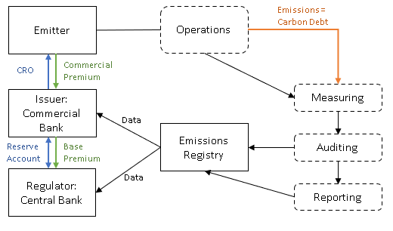
Figure S2. Mechanism for issuing carbon removal obligations (CROs) in relation to carbon debt: Legislation/regulation provides that prescribed categories of legal entities (‘emitters’) must reflect emissions as carbon debt on their balance sheet; Emissions (carbon debt) measured/reported/audited as it would be under an emission trading scheme (ETS), however, reporting is via financial accounts, as emitter must hold a CRO (legal instrument reflecting carbon debt in accounts) in respect of each tonne CO2 emitted per annum; Commercial banks issue CROs to their emitter-customers, just as they would in a deposit account when lending to a customer. Thus, emitters must hold CRO accounts in respect of their annual emissions/carbon debt; Commercial banks charge interest (a ‘CRO Commercial Premium’) on CROs in the account; Role of central bank: CRO issuance initiated by each commercial bank, but commercial bank must hold reserve account with central bank, on which it pays interest (a ‘CRO Base Premium’).

- Bibliography

Bednar, Johannes, Artem Baklanov, and Justin Macinante. 2023. “The Carbon Removal Obligation: Updated Analytical Model and Scenario Analysis.” IIASA Working Paper WP-23-001 (January). https://pure.iiasa.ac.at/id/eprint/18572/.
Bednar, Johannes, Michael Obersteiner, Artem Baklanov, Marcus Thomson, Fabian Wagner, Oliver Geden, Myles Allen, and Jim W. Hall. 2021. “Operationalizing the Net-Negative Carbon Economy.” Nature 596 (7872): 377–83. https://doi.org/10.1038/s41586-021-03723-9.

European Securities and Markets Authority (ESMA) regulation of credit reference agencies (CRAs) provides one model for this.

