Appendix A: Supplementary figures, and tables

Regional topsoil organic carbon content in agricultural soils of Slovakia and its drivers as revealed by the most recent national soil monitoring data
Rastislav Skalský, Gabriela Barančíková, Jarmila Makovníková, Štefan Koco, Ján Halas, Jozef Kobza

Contents:
A: Supplementary figures 2
B: Supplementary tables 10

A: Supplementary figures

a)
b)
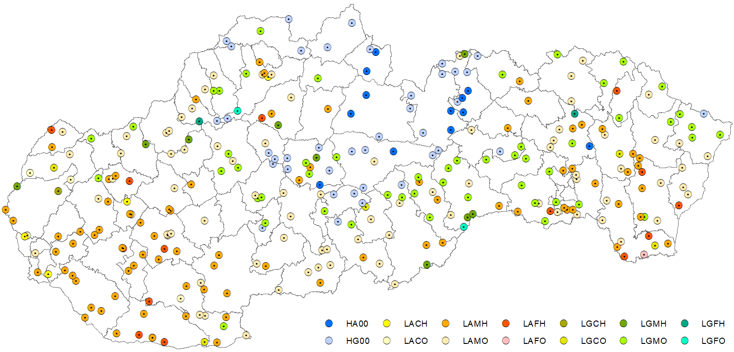

Figure A.1. Map of the geographical macro-scale regions of agricultural land of Slovakia with respect to homogenous condition for topsoil SOC accumulation (a), and location of the CMS-P monitoring sites used in this study (N = 306) classified according to the same macro-scale stratification criteria (b), the letters used in the codes of macro-regions are ordered as follows: 1) altitude class (H – above 600 m, L – bellow 600 m), 2 ) land cover class (A – arable land, G – grassland), 3) topsoil texture class (C – coarse, M – medium, F – fine), and 4) soil type class (H – humus-rich, O – other), 0 used for topsoil texture class and soil type class in all regions with altitude above 600 m (these two stratification levels not used for final stratification in these regions due to less agricultural land presented in a higher mountain areas).

a)
b)
c)
d)
Figure A.2. Individual stratification levels used for macro-scale stratification of agricultural land of Slovakia with respect to main drivers of topsoil SOC accumulation: altitude class (a), land cover class (b), topsoil texture class (c), and soil type class (d).

Figure A.3. Map of topsoil stone content class used for calculation of spatially explicit topsoil SOC stocks (t/ha) for agricultural land of Slovakia (source BPEJ, available online: https://data.gov.sk/en/dataset/bonitovane-podnoekologicke-jednotky-bpej).
a) | b)
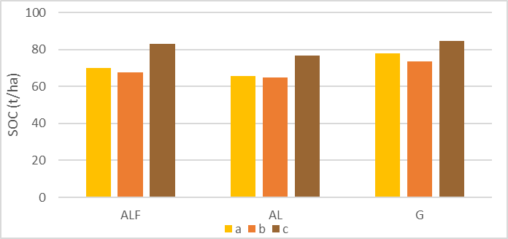 | 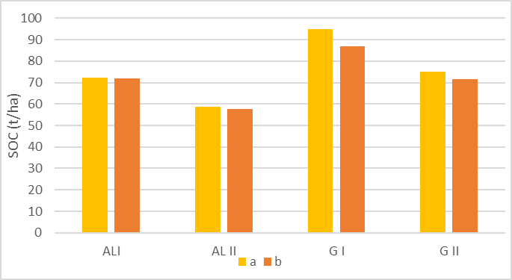
c) | d)
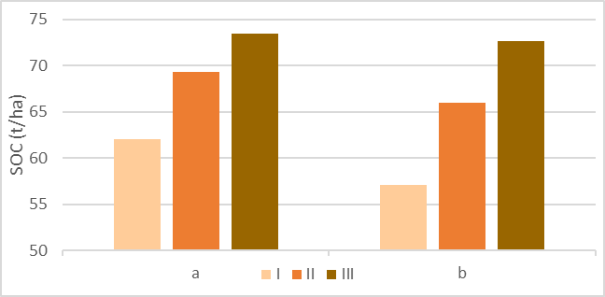 | 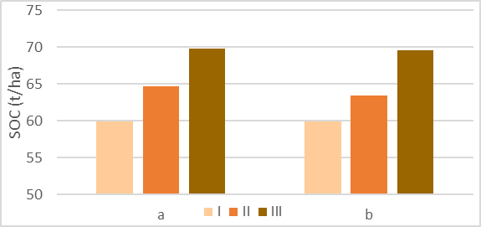
e)
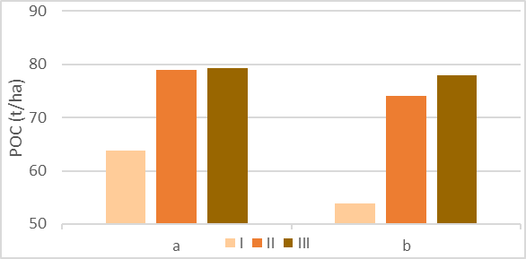

Figure A.4. Average topsoil SOC stock (t/ha) in agricultural soils of Slovakia for combinations of assumed topsoil accumulation drivers, a) altitude class and land cover class, b) altitude class, land cover class, and soil type class, c) soil texture class and altitude class, d) soil texture class, altitude class, and land cover class (arable land), and e) soil texture class, altitude class, and land cover class (grassland), ALF – agricultural land, AL – arable land, G – grassland, I – humus-rich soil types (or coarse textured soils), II – other soil types (or medium textured soils), III – fine textured soils, a – all altitudes, b – altitude < 600 m, c – altitude > 600 m.
a)
b)
c)
Figure A.5. Topsoil (0 – 30 cm) SOC content in agricultural soils of Slovakia as estimated from the 2018 CMS-P data for stratified macro-scale geographical regions with a 25-th percentile (a), median (b), and 75-th percentile (c) estimates.
a) | b) | c)
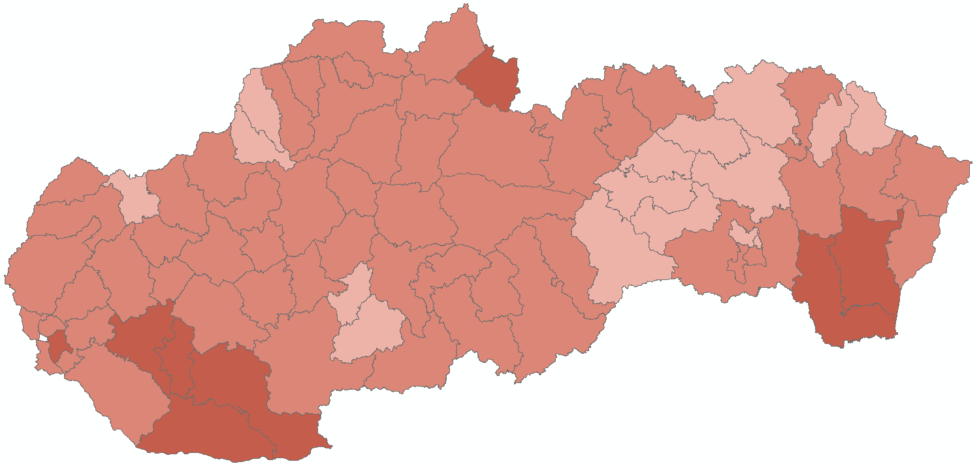 | 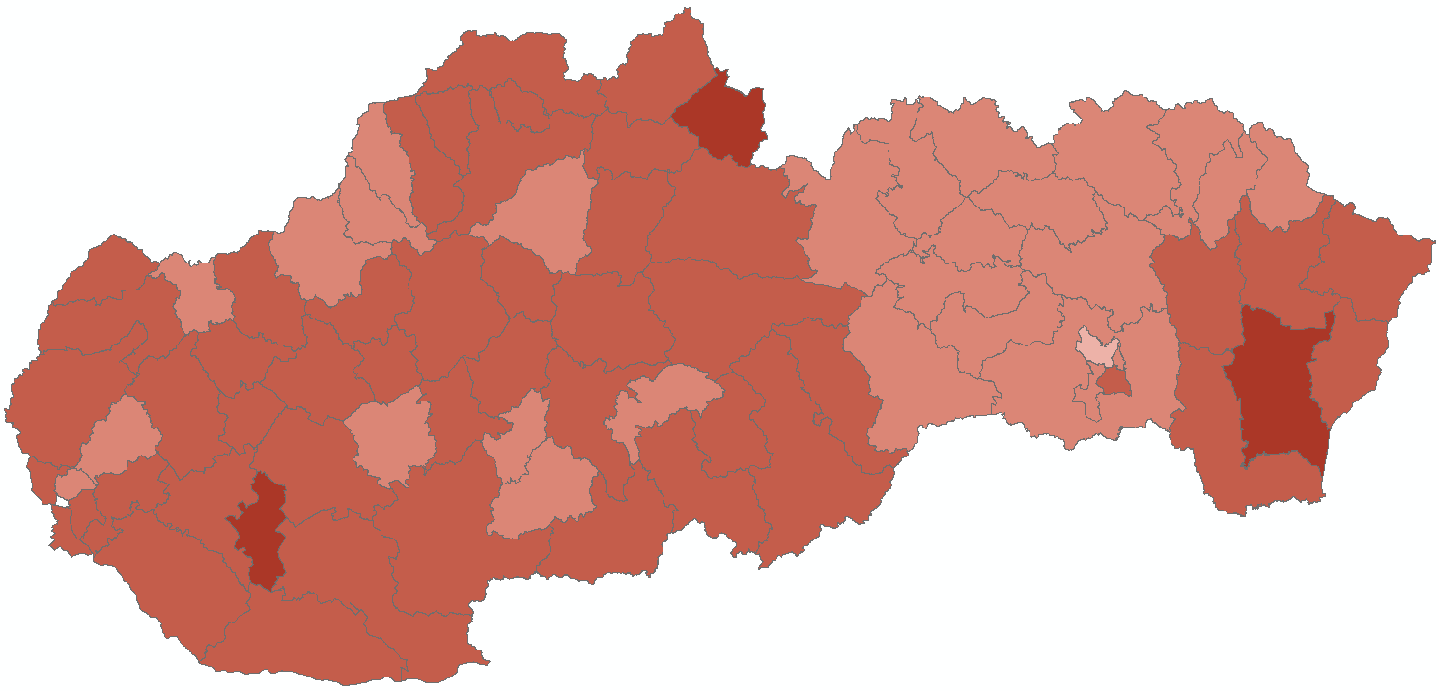 | 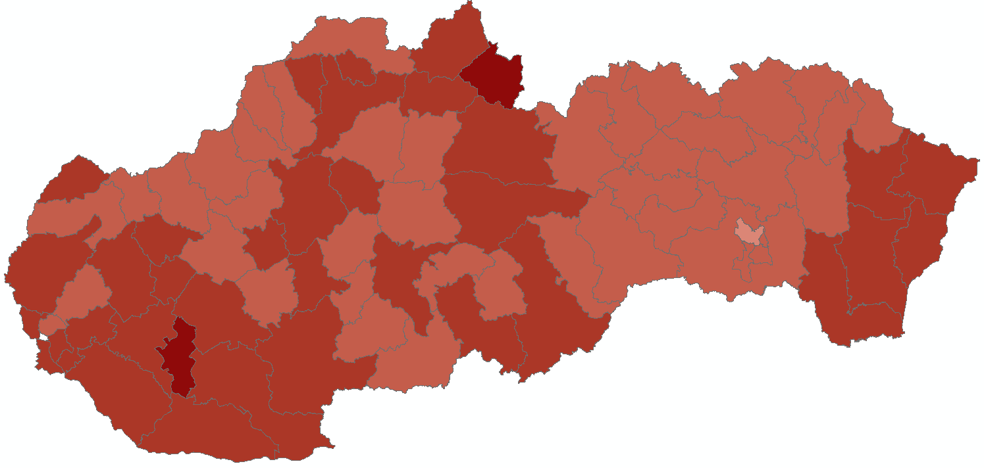
d) | e) | f)
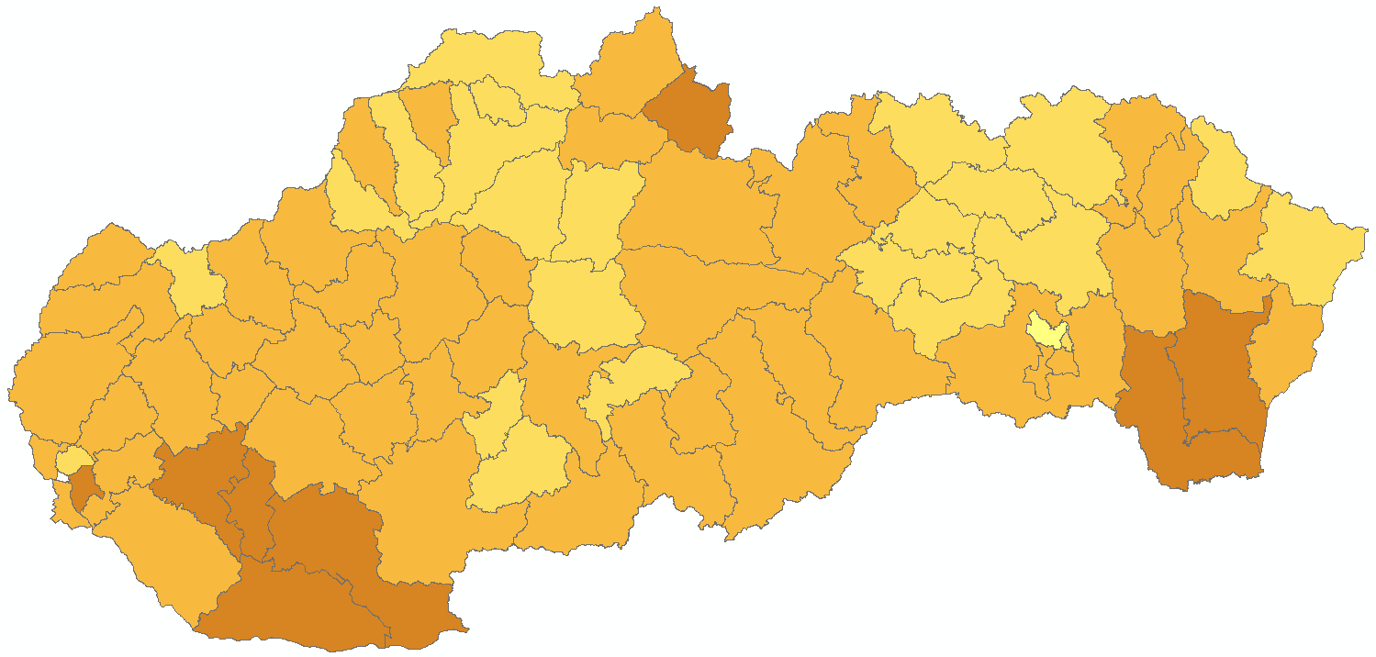 | 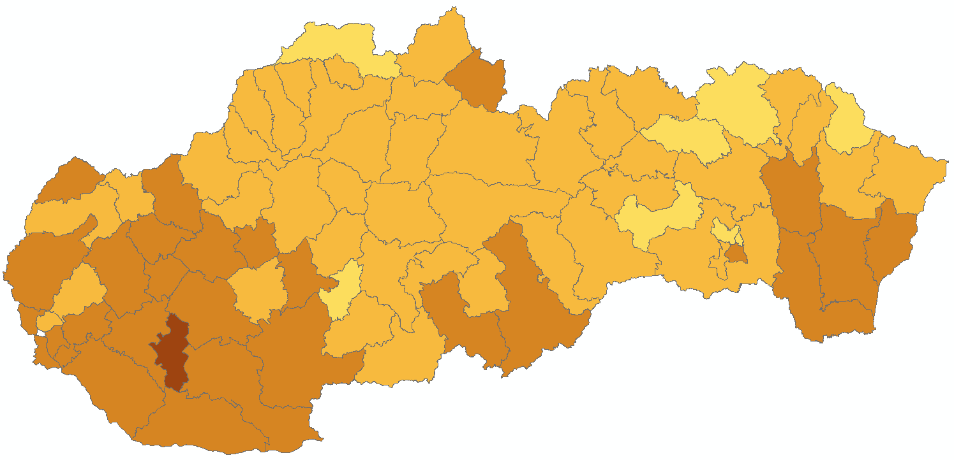 | 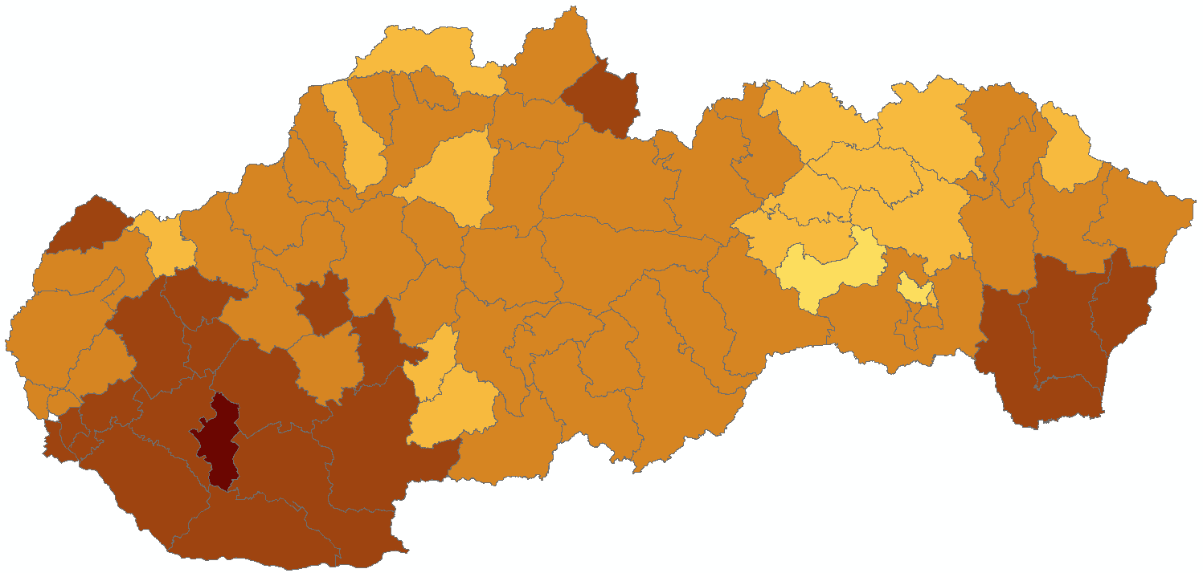
g) | h) | i)
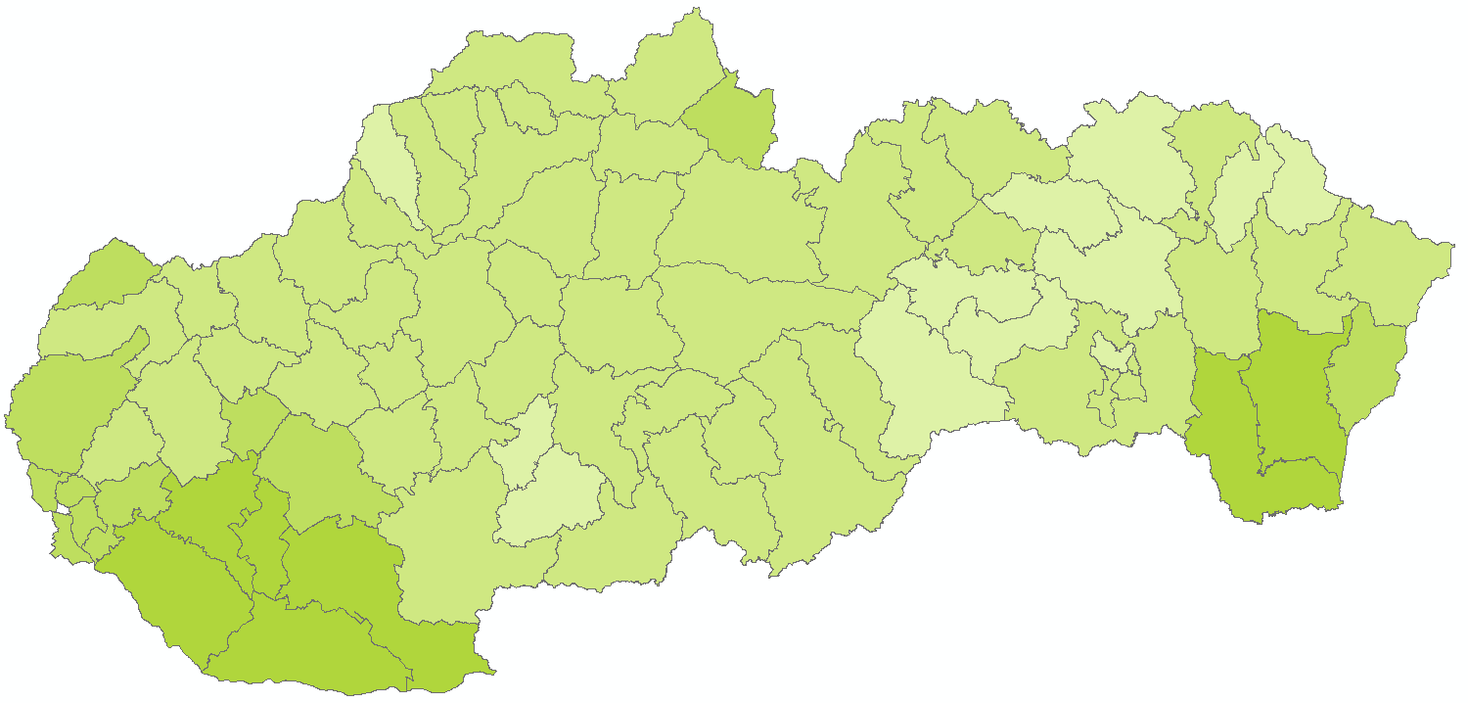 | 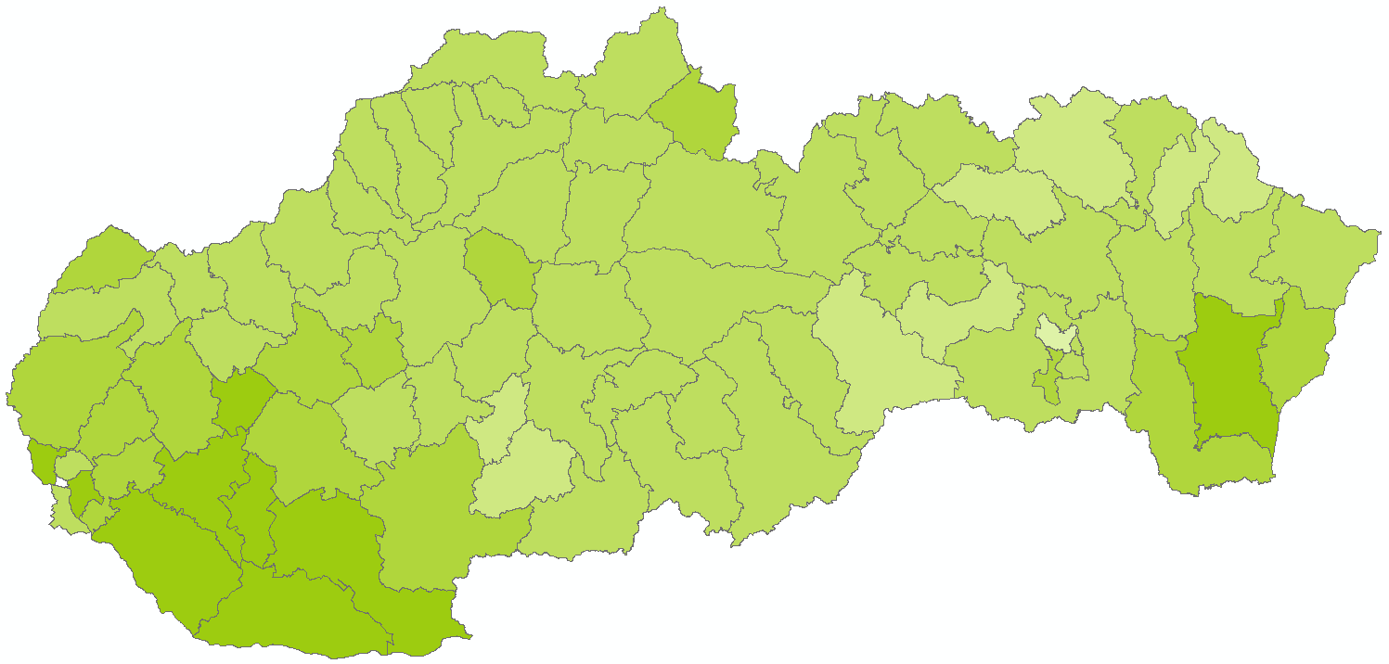 | 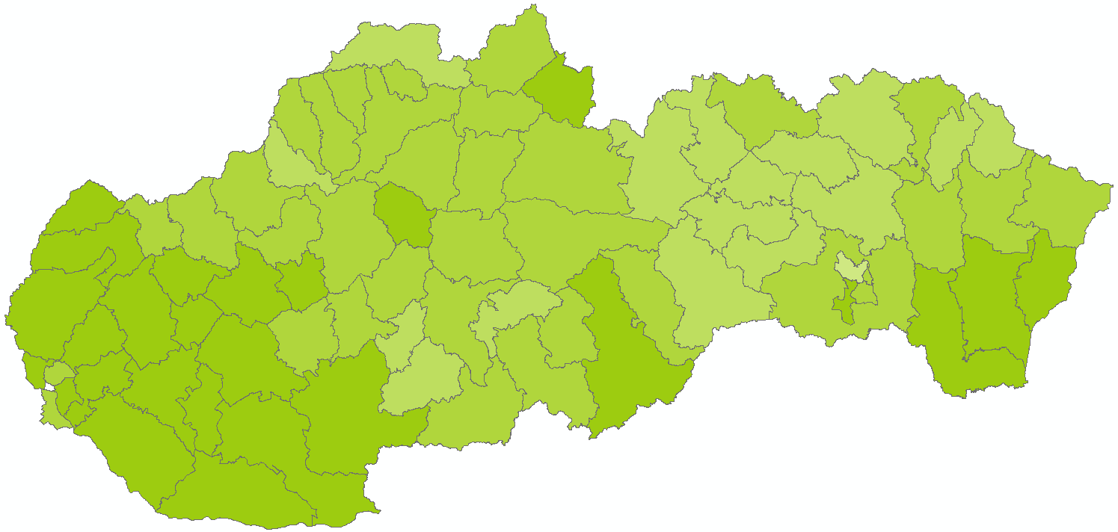
AGL: (t/ha) | AL: (t/ha) | G: (t/ha)
Figure A.6. Average topsoil SOC stock (t/ha) in agricultural soils of Slovakia as estimated from CMS-P data for the stratified geographical regions combined with the national LPIS areas of agricultural land (AGL), arable land (AL), and grassland (G) in individual LAU1 administrative regions, agricultural land (a, b, c), arable land (d, e, f), and grassland (g, h, i), median topsoil SOC values (b, e, h), 25-th percentile (Q25) values (a, d, h), and 75-th percentile (Q75) values (c, f, i).
a)
b)
c)
Figure A.7. Integral topsoil SOC stock (Mt) in agricultural soils of Slovakia as estimated from CMS-P data for the stratified geographical regions combined with the national LPIS areas of agricultural land (AGL), arable land (AL), and grassland (G) in individual LAU1 administrative regions, a) integral topsoil stock using the median estimate, b) integral topsoil SOC stock (Mt) using the 25-th percentile (Q25) estimate, c) integral topsoil SOC stock (Mt) using the 75-th percentile (Q75) estimate. The size of the pie chart reflects the total (AGL) topsoil SOC stock (Mt), colors are for the respective AL and G topsoil SOC stocks and their spatial ratio.

a)
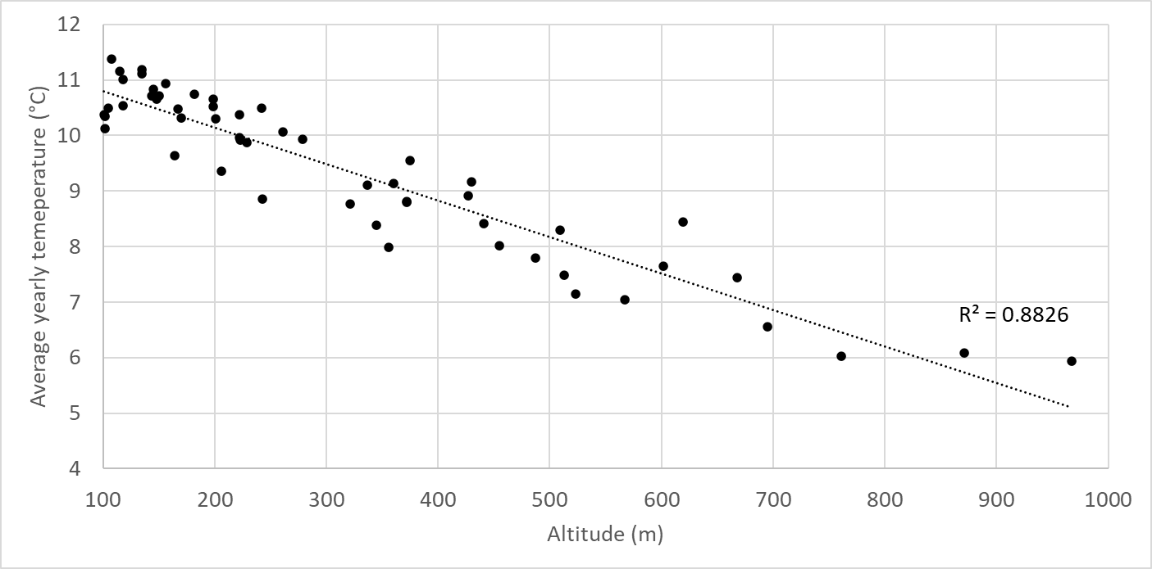

b)
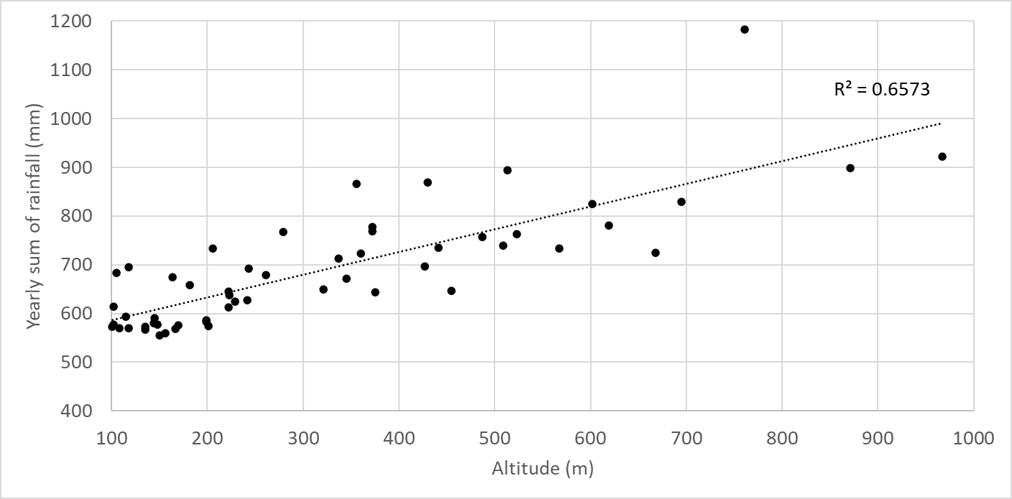

Figure A.8. Relationships between yearly average temperature (°C) and yearly precipitation sum (mm), and altitude Slovakia for 10k spatial resolution climate grids at approximate locations of climate stations (N = 55) representative for agricultural land of Slovakia, a) average yearly temperature 1991 - 2020, b) average yearly sum of rainfall 1991 – 2020.
B: Supplementary tables

Table A.1. Definition of macro-scale regions for stratifying agricultural soils of Slovakia with respect to homogenous condition for topsoil SOC accumulation.
Region | Altitude class | Land cover class | Topsoil texture class | Soil type class
HA00 | > 600 (H) | arable land (A) | 0 | 0
HG00 | > 600 (H) | grassland (G) | 0 | 0
LACH | < 600 (L) | arable land (A) | coarse (C) | humic (H)
LACO | < 600 (L) | arable land (A) | coarse (C) | other (O)
LAMH | < 600 (L) | arable land (A) | medium (M) | humic (H)
LAMO | < 600 (L) | arable land (A) | medium (M) | other (O)
LAFH | < 600 (L) | arable land (A) | fine (F) | humic (H)
LAFO | < 600 (L) | arable land (A) | fine (F) | other (O)
LGCH | < 600 (L) | grassland (G) | coarse (C) | humic (H)
LGCO | < 600 (L) | grassland (G) | coarse (C) | other (O)
LGMH | < 600 (L) | grassland (G) | medium (M) | humic (H)
LGMO | < 600 (L) | grassland (G) | medium (M) | other (O)
LGFH | < 600 (L) | grassland (G) | fine (F) | humic (H)
LGFO | < 600 (L) | grassland (G) | fine (F) | other (O)

