Demographic and labor force impacts of future immigration flows into Europe: Does immigrants’ region of origin matter?
Supplementary Information

Authors:

Guillaume Marois*
International Institute for Applied Systems Analysis, Wittgenstein Centre for Demography and Global Human Capital (IIASA, OeAW, University of Vienna), Vienna, Austria
Asian Demographic Research Institute, Shanghai University, China
Email: marois@iiasa.ac.at
https://orcid.org/0000-0002-2701-6286

Michaela Potancokova
International Institute for Applied Systems Analysis, Wittgenstein Centre for Demography and Global Human Capital (IIASA, OeAW, University of Vienna), Vienna, Austria
Email: potancok@iiasa.ac.at
https://orcid.org/0000-0001-6115-5952

Miguel Gonzalez-Leonardo
International Institute for Applied Systems Analysis, Wittgenstein Centre for Demography and Global Human Capital (IIASA, OeAW, University of Vienna), Vienna, Austria
https://orcid.org/0000-0003-2508-7977
Email: miguel.gonzalez@colmex.mx

*Corresponding author: marois@iiasa.ac.at

Figure S1. Heatmap of the country of destination for immigrants arrived in Europe between 2011 and 2019
(1 = as likely as all migrants to settle in the country)
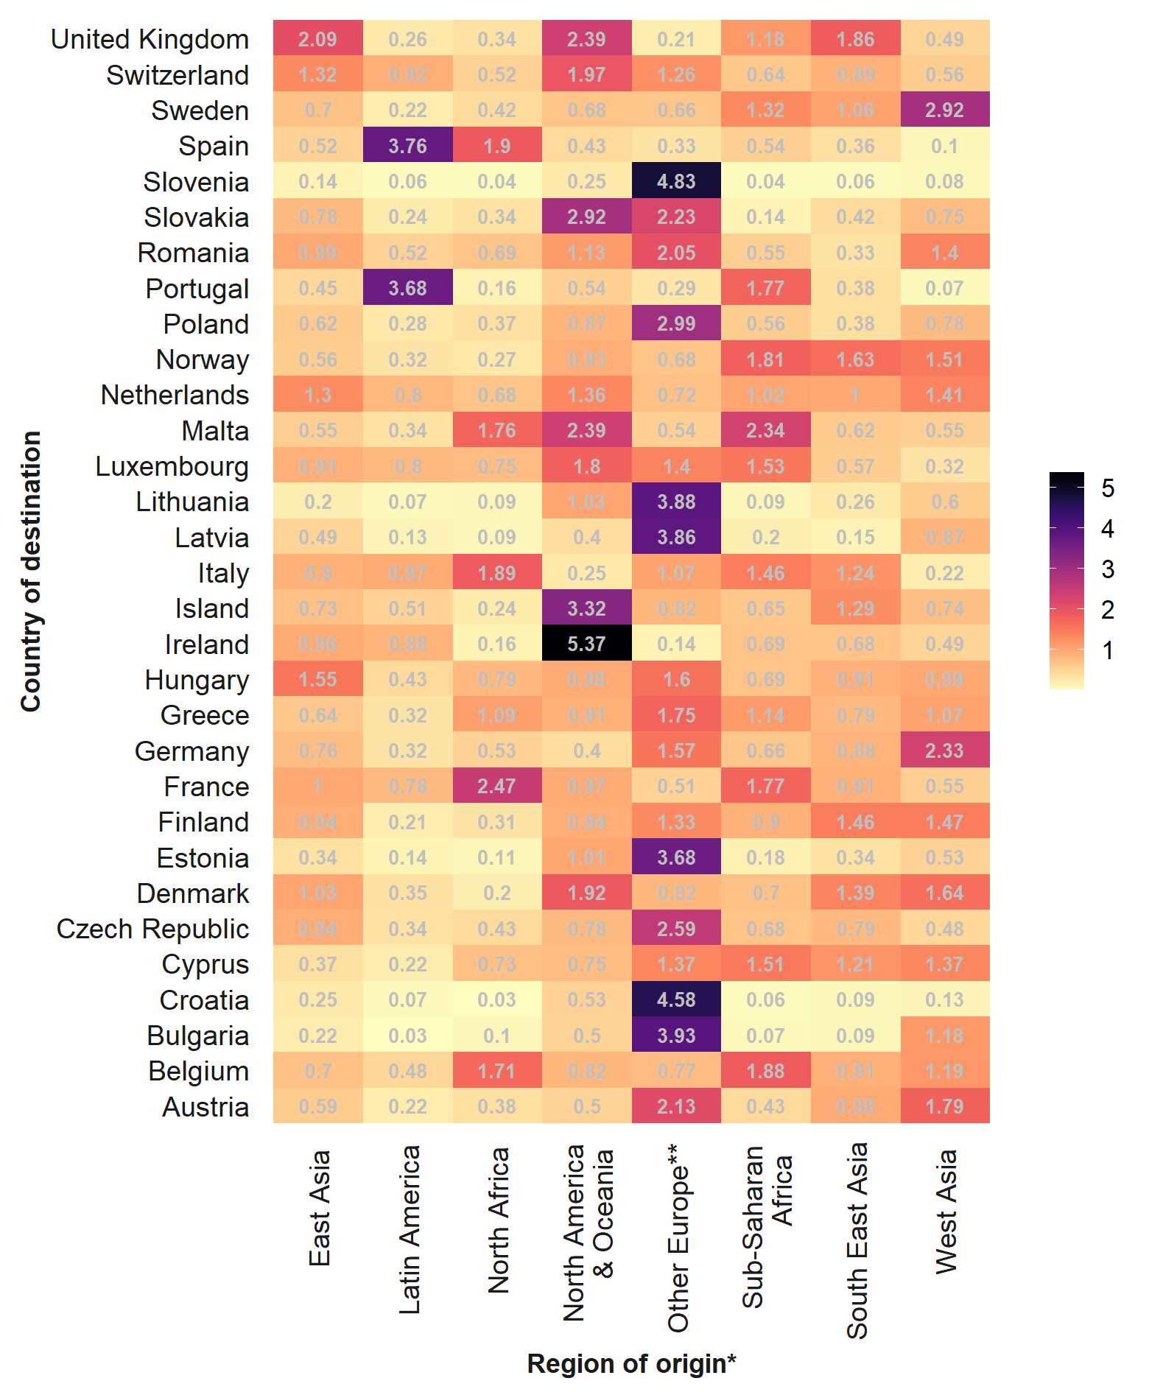
*Regions of origin are set according to those provided by the European Labor Force Survey, which used for the modeling of the labor force participation.
**Other Europe refers to countries not included in the model, such as Russia, Ukraine, Moldova, Belarus, Turkey
Source: Marois et al. (2023)

Figure S2. Odds of having a child* by region of origin, age at arrival and duration of stay (1=Born in Europe)
* Control for age, education and country of residence
Source: Marois et al. (2023)

Figure S3. Educational attainment of the immigrants (age 15+) arrived in Europe between 2011 and 2019 by region of birth
Source: Marois et al. (2023)

Figure S4. Odds of participating in the labor force by place of birth and duration of stay of immigrants arrived at age 15 and over (1=Born in Europe)¹

x Not significant
1. Statistical control for age, country of residence and education
Source: Marois et al. (2023)

Table S1. Population (in millions) in 2020 and 2060 by scenario
Country | 2020 | 2060
 |  | Reference | Europe+ | SSA+ | MENA+ | Asia+
AT | 9.0 | 10.0 | 11.0 | 9.8 | 10.3 | 9.9
BE | 11.5 | 12.6 | 12.3 | 13.2 | 12.8 | 12.4
BG | 6.5 | 4.4 | 4.8 | 4.2 | 4.3 | 4.3
CH | 8.4 | 10.1 | 10.3 | 10.0 | 10.0 | 10.0
CY | 0.9 | 1.0 | 1.0 | 1.0 | 1.0 | 1.0
CZ | 10.3 | 9.4 | 9.9 | 9.3 | 9.4 | 9.4
DE | 81.4 | 83.2 | 87.6 | 81.5 | 87.5 | 82.3
DK | 5.7 | 6.2 | 6.2 | 6.1 | 6.3 | 6.4
EE | 1.3 | 1.2 | 1.3 | 1.1 | 1.2 | 1.2
ES | 47.1 | 42.1 | 40.4 | 41.3 | 41.8 | 40.6
FI | 5.5 | 5.5 | 5.7 | 5.5 | 5.5 | 5.6
FR | 67.4 | 71.5 | 69.2 | 73.8 | 72.2 | 70.7
GR | 10.4 | 8.8 | 9.1 | 8.8 | 8.9 | 8.7
HR | 3.8 | 2.6 | 3.1 | 2.5 | 2.6 | 2.6
HU | 9.3 | 7.1 | 7.2 | 7.0 | 7.1 | 7.1
IE | 4.8 | 5.3 | 5.2 | 5.4 | 5.3 | 5.4
IS | 0.4 | 0.6 | 0.5 | 0.5 | 0.5 | 0.5
IT | 59.8 | 54.8 | 55.0 | 56.6 | 54.7 | 54.9
LT | 2.6 | 1.9 | 2.2 | 1.9 | 1.9 | 1.9
LU | 0.6 | 0.9 | 0.9 | 0.9 | 0.9 | 0.9
LV | 1.9 | 1.3 | 1.6 | 1.3 | 1.4 | 1.4
MT | 0.4 | 0.5 | 0.5 | 0.5 | 0.5 | 0.5
NL | 17.3 | 17.7 | 17.5 | 17.8 | 18.0 | 17.8
NO | 5.5 | 7.3 | 7.0 | 7.5 | 7.2 | 7.6
PL | 36.7 | 28.8 | 30.1 | 28.8 | 28.9 | 28.7
PT | 10.3 | 8.8 | 8.5 | 9.2 | 8.5 | 8.7
RO | 17.6 | 12.6 | 12.8 | 12.5 | 12.7 | 12.5
SE | 10.4 | 14.5 | 13.8 | 14.8 | 15.8 | 14.4
SI | 2.1 | 1.9 | 2.5 | 1.8 | 1.8 | 1.8
SK | 5.4 | 4.9 | 5.1 | 4.9 | 4.9 | 5.0
UK | 66.8 | 74.2 | 69.8 | 75.6 | 71.7 | 78.1
Total | 520.9 | 511.8 | 511.8 | 515.4 | 515.2 | 512.1

Table S2. Age dependency ratio in 2020 and 2060 by scenario
Country | 2020 | 2060
 |  | Reference | Europe+ | SSA+ | MENA+ | Asia+
AT | 0.5 | 0.8 | 0.8 | 0.8 | 0.8 | 0.8
BE | 0.6 | 0.8 | 0.8 | 0.8 | 0.8 | 0.8
BG | 0.6 | 0.9 | 0.8 | 0.9 | 0.9 | 0.9
CH | 0.5 | 0.8 | 0.8 | 0.8 | 0.8 | 0.8
CY | 0.5 | 0.8 | 0.8 | 0.8 | 0.8 | 0.8
CZ | 0.6 | 0.9 | 0.9 | 0.9 | 0.9 | 0.9
DE | 0.5 | 0.8 | 0.8 | 0.8 | 0.8 | 0.8
DK | 0.6 | 0.8 | 0.8 | 0.8 | 0.7 | 0.8
EE | 0.6 | 0.8 | 0.8 | 0.8 | 0.8 | 0.8
ES | 0.5 | 1.0 | 1.1 | 1.0 | 1.0 | 1.1
FI | 0.6 | 0.8 | 0.8 | 0.8 | 0.8 | 0.8
FR | 0.6 | 0.8 | 0.8 | 0.8 | 0.8 | 0.8
GR | 0.6 | 0.9 | 0.9 | 0.9 | 0.9 | 0.9
HR | 0.6 | 0.9 | 0.8 | 0.9 | 0.9 | 0.9
HU | 0.5 | 0.8 | 0.8 | 0.8 | 0.8 | 0.8
IE | 0.5 | 0.8 | 0.8 | 0.8 | 0.8 | 0.8
IS | 0.5 | 0.7 | 0.7 | 0.7 | 0.7 | 0.7
IT | 0.6 | 0.9 | 0.9 | 0.9 | 0.9 | 0.9
LT | 0.6 | 0.8 | 0.8 | 0.8 | 0.8 | 0.8
LU | 0.5 | 0.7 | 0.8 | 0.7 | 0.7 | 0.7
LV | 0.6 | 0.9 | 0.8 | 0.8 | 0.9 | 0.8
MT | 0.6 | 0.8 | 0.9 | 0.9 | 0.8 | 0.8
NL | 0.5 | 0.8 | 0.8 | 0.8 | 0.8 | 0.8
NO | 0.5 | 0.7 | 0.7 | 0.7 | 0.8 | 0.7
PL | 0.5 | 0.9 | 0.9 | 0.9 | 0.9 | 0.9
PT | 0.6 | 0.9 | 0.9 | 0.9 | 0.9 | 0.9
RO | 0.6 | 0.8 | 0.8 | 0.8 | 0.8 | 0.8
SE | 0.6 | 0.7 | 0.8 | 0.7 | 0.7 | 0.7
SI | 0.5 | 0.9 | 0.8 | 0.9 | 0.9 | 0.9
SK | 0.5 | 0.8 | 0.8 | 0.8 | 0.8 | 0.8
UK | 0.6 | 0.7 | 0.8 | 0.7 | 0.8 | 0.7
Total | 0.6 | 0.8 | 0.8 | 0.8 | 0.8 | 0.8

Table S3. Labor force dependency ratio in 2020 and 2060 by scenario
Country | 2020 | 2060
 |  | Reference | Europe+ | SSA+ | MENA+ | Asia+
AT | 1.0 | 1.3 | 1.2 | 1.3 | 1.3 | 1.3
BE | 1.3 | 1.4 | 1.4 | 1.4 | 1.4 | 1.4
BG | 1.2 | 1.4 | 1.4 | 1.4 | 1.4 | 1.4
CH | 0.8 | 1.1 | 1.1 | 1.1 | 1.1 | 1.1
CY | 1.0 | 1.2 | 1.3 | 1.2 | 1.3 | 1.2
CZ | 1.0 | 1.4 | 1.4 | 1.4 | 1.4 | 1.4
DE | 1.0 | 1.2 | 1.2 | 1.2 | 1.3 | 1.2
DK | 1.0 | 1.1 | 1.1 | 1.1 | 1.1 | 1.1
EE | 1.0 | 1.1 | 1.1 | 1.1 | 1.1 | 1.1
ES | 1.1 | 1.7 | 1.7 | 1.7 | 1.8 | 1.7
FI | 1.1 | 1.2 | 1.2 | 1.2 | 1.3 | 1.2
FR | 1.3 | 1.3 | 1.3 | 1.3 | 1.4 | 1.3
GR | 1.3 | 1.6 | 1.6 | 1.7 | 1.7 | 1.6
HR | 1.4 | 1.6 | 1.6 | 1.6 | 1.6 | 1.6
HU | 1.2 | 1.4 | 1.4 | 1.4 | 1.4 | 1.4
IE | 1.1 | 1.3 | 1.3 | 1.3 | 1.3 | 1.3
IS | 0.7 | 0.9 | 0.9 | 0.8 | 0.8 | 0.9
IT | 1.4 | 1.6 | 1.6 | 1.6 | 1.7 | 1.6
LT | 1.1 | 1.2 | 1.2 | 1.3 | 1.2 | 1.2
LU | 1.1 | 1.5 | 1.5 | 1.4 | 1.5 | 1.5
LV | 1.0 | 1.3 | 1.3 | 1.2 | 1.3 | 1.2
MT | 1.1 | 1.3 | 1.3 | 1.3 | 1.3 | 1.3
NL | 0.9 | 1.0 | 1.0 | 1.0 | 1.1 | 1.0
NO | 0.9 | 1.1 | 1.1 | 1.1 | 1.2 | 1.1
PL | 1.2 | 1.5 | 1.5 | 1.5 | 1.5 | 1.5
PT | 1.1 | 1.2 | 1.2 | 1.2 | 1.2 | 1.2
RO | 1.3 | 1.4 | 1.4 | 1.4 | 1.4 | 1.4
SE | 0.9 | 1.0 | 1.0 | 1.0 | 1.1 | 1.0
SI | 1.1 | 1.5 | 1.4 | 1.5 | 1.5 | 1.5
SK | 1.0 | 1.4 | 1.4 | 1.4 | 1.4 | 1.4
UK | 1.0 | 1.1 | 1.1 | 1.1 | 1.1 | 1.1
Total | 1.1 | 1.3 | 1.3 | 1.3 | 1.3 | 1.3

Table S4. Productivity-weighted labor force dependency ratio in 2020 and 2060 by scenario
Country | 2020 | 2060
 |  | Reference | Europe+ | SSA+ | MENA+ | Asia+
AT | 0.9 | 1.0 | 0.9 | 1.0 | 1.0 | 1.0
BE | 1.0 | 1.0 | 1.0 | 1.0 | 1.0 | 1.0
BG | 1.0 | 1.1 | 1.1 | 1.1 | 1.1 | 1.1
CH | 0.7 | 0.8 | 0.8 | 0.8 | 0.8 | 0.8
CY | 0.8 | 0.9 | 0.9 | 0.9 | 0.9 | 0.9
CZ | 0.9 | 1.2 | 1.2 | 1.2 | 1.2 | 1.2
DE | 0.8 | 0.9 | 0.9 | 0.9 | 1.0 | 0.9
DK | 0.8 | 0.8 | 0.8 | 0.8 | 0.9 | 0.9
EE | 0.8 | 0.9 | 0.9 | 0.9 | 0.9 | 0.8
ES | 1.0 | 1.2 | 1.2 | 1.2 | 1.3 | 1.2
FI | 0.9 | 0.9 | 0.9 | 1.0 | 1.0 | 1.0
FR | 1.0 | 1.0 | 1.0 | 1.0 | 1.0 | 0.9
GR | 1.1 | 1.1 | 1.1 | 1.2 | 1.2 | 1.2
HR | 1.2 | 1.3 | 1.2 | 1.3 | 1.3 | 1.2
HU | 1.0 | 1.1 | 1.1 | 1.1 | 1.1 | 1.1
IE | 0.9 | 0.9 | 0.9 | 0.9 | 0.9 | 0.9
IS | 0.6 | 0.7 | 0.7 | 0.6 | 0.7 | 0.7
IT | 1.3 | 1.2 | 1.2 | 1.2 | 1.2 | 1.2
LT | 0.8 | 0.9 | 0.9 | 0.9 | 0.9 | 0.9
LU | 1.0 | 1.1 | 1.1 | 1.1 | 1.1 | 1.1
LV | 0.8 | 1.0 | 1.0 | 0.9 | 1.0 | 1.0
MT | 1.0 | 0.9 | 1.0 | 1.0 | 0.9 | 0.9
NL | 0.7 | 0.8 | 0.8 | 0.8 | 0.8 | 0.8
NO | 0.8 | 0.9 | 0.9 | 0.9 | 0.9 | 0.9
PL | 1.0 | 1.1 | 1.1 | 1.1 | 1.1 | 1.1
PT | 1.1 | 0.9 | 0.9 | 0.9 | 0.9 | 0.9
RO | 1.2 | 1.1 | 1.1 | 1.1 | 1.1 | 1.1
SE | 0.7 | 0.8 | 0.8 | 0.8 | 0.8 | 0.8
SI | 1.0 | 1.1 | 1.1 | 1.1 | 1.1 | 1.1
SK | 0.9 | 1.1 | 1.1 | 1.1 | 1.1 | 1.1
UK | 0.8 | 0.8 | 0.8 | 0.9 | 0.9 | 0.8
Total | 0.9 | 1.0 | 1.0 | 1.0 | 1.0 | 1.0

