SUPPLEMENTARY INFORMATION
The marker quantification of the shared socioeconomic pathway 2:
a middle-of-the-road scenario for the 21st century
- in review for Global Environmental Change –

Contents
Supplementary text 3
Supplementary text 1: literature context for SSP2 3
Supplementary text 2: future energy demand methodology 3
Supplementary text 3: regional fossil fuel resources 4
Supplementary text 4: nuclear power assumptions in SSP1 and SSP3 4
Supplementary text 5: commercial biomass resources 4
Supplementary text 6: food consumption, and losses & wastes assumptions 4
Supplementary text 7: structural information on IIASA IAM framework 5
Supplementary text 8: livestock consumption background 6
Supplementary text 9: biomass sources 6
Supplementary text 10: livestock improvements 6
Supplementary text 11: forests and plantations developments 7
Supplementary boxes 8
Supplementary box 1: SSP1 Narrative 8
Supplementary box 2: SSP3 Narrative 9
Supplementary tables 10
Convergence parameters 10
Fossil resources 13
Energy demands in MESSAGE 13
Regional definitions in MESSAGE 14
SPA overview 14
Supplementary figures 15
Technology cost evolution 15
Dietary Composition across SSPs 18
Land-use resources 19
MESSAGE-GLOBIOM integration 20
Energy carriers evolution 22
Sectorial final energy evolutions 24
Primary energy evolution in SSP1 and SSP3 baselines 27
Primary energy evolution in SSP2 mitigation cases 29
CO₂ mitigation 30
Carbon price SSP-RCP matrix 34
Supplementary References 35

Supplementary text

Supplementary text 1: literature context for SSP2
The SSP2 follows the tradition of earlier dynamics-as-usual or middle-of-the-road scenarios, such as the SRES B2 (Riahi and Roehrl, 2000) or the IS92a scenario (Pepper et al., 1992). Dynamics-as-usual (or business-as-usual) scenarios often share intermediate assumptions about basic drivers of global change, such as intermediate assumptions for demographic and population change as well as economic growth. They are generally useful for exploring the response of the system assuming central trends for the determinants of greenhouse gas emissions. For example, the SRES B2 and the IS92a scenario both resulted in GHG emissions trends close to the median of the literature. Also SSP2 features intermediate levels of GHG emissions, however, an important distinction from the earlier scenarios is that SSP2 has been designed primarily to lie in the center with respect to socio-economic challenges for mitigation and adaptation. The intermediate GHG emissions in SSP2 are thus an outcome or finding from the scenario analysis rather than an input to the scenario design. For a mapping of the SSPs to different other archetypical scenarios from the past see also van Vuuren and Carter (2013).

Supplementary text 2: future energy demand methodology
Baseline future energy demands for the SSPs are derived from the population (KC and Lutz, 2015) and GDP projections (Dellink et al., 2015) as well as historical data regarding population (UN, 2010), GDP in purchasing power parity (World Bank, 2012), and final energy (IEA, 2012). They take into account historical developments of final energy intensity, sectorial final energy shares for the industrial, buildings and transport sectors as well as non-energy use (mostly as feedstock in petrochemical industry) and electrification rates in industry and buildings for the period 1971 to 2010. We perform quantile regressions on combined cross-sectional and time series data at the country level for final energy intensity, sectorial shares and electrification rates against GDP (PPP) per capita. For final energy intensity we utilize a linear functional form in log-log space, for the sectorial shares we follow development patterns as identified by Schaefer (Schäfer, 2005) (e.g., a humpback shape for industry, growing share of transportation), and for electrification rates a logistic (S-shaped) functional form. Across the SSPs, we then assume that regions converge to a certain quantile at a particular income per capita level in the future. For example, while final energy intensity converges quickly to the lowest quantile (0.001) in SSP1, it converges more slowly to a larger quantile (0.5 to 0.7 depending on the region) in SSP3. Convergence quantiles and incomes are provided for each SSP and region in Table S1.

Supplementary text 3: regional fossil fuel resources
At the regional level, particularly conventional oil and gas are unevenly distributed. A small number of regions dominates large shares of the reserves. Some 50% of the reserves of conventional oil is found in the Middle East and North Africa, while almost 40% of conventional gas is found in Russia and other former Soviet Union states. The situation is somewhat different for unconventional oil of which North and Latin America potentially possess significantly higher global shares. Unconventional gas in turn is distributed quite well throughout the world, with North America holding most (roughly 25% of global resources). The distribution of coal reserves shows the highest geographical diversity which in the more fragmented SSP3 world contributes to increased overall reliance on this resource.

Supplementary text 4: nuclear power assumptions in SSP1 and SSP3
Costs are assumed to decrease by 15% over the 2010 to 2100 time frame in SSP1 (compared to 30% in SSP2), lower than other non-CCS conversion technologies. SSP3, on the other hand, emphasizes the development of conventional, especially coal-based, fossil fuel conversion technologies. This means we assume that it is unlikely for countries who are leading nuclear developments today, yet have access to large fossil resources, to further pursue the development and deployment of nuclear technologies. Since most developing countries would need to import nuclear technologies in order to introduce (Jewell, 2011) or expand it, we assume that it is unlikely that nuclear power would grow In a world with low international cooperation. As a result, developing countries with projected growth in energy demand, and limited domestic fossil resources would have to resort to importing coal and gas.

Supplementary text 5: commercial biomass resources
Global commercial bioenergy resources considered are forest biomass, forest industry residues and short rotation tree plantations biomass. Biophysical and economic parameters of these feedstock for the base year (2000) are derived as described in Havlík et al. (2011). The potential availability over time is calculated in GLOBIOM in terms of quantities of commercial biomass available at certain prices. For the highest considered price of USD 13 per GJ of primary energy, the available biomass in SSP2 is estimated at 250 EJ by 2100.
GLOBIOM endogenously computes bilateral trade flows within its spatial equilibrium approach, based on the principal of total trading cost minimization. Net trade for the base year (2000) is computed from the FAO food commodity balance. We use the BACI database to compute average bilateral trade flows for 2000 in quantity based on international HS6 product nomenclature (Gaulier and Zignago, 2008). Tariffs are included in the model based on the MacMap database for the year 2001 (Bouët et al., 2008). Transportation costs are informed by Hummels’ econometric estimates (2001). Distance data between each capital is taken from CEPII. To implement trade costs in GLOBIOM, we convert all ad-valorem trade costs (percentage of the import price) in fixed amounts paid per physical unit. Non-linear trade cost functions are used to better mimic the stylized fact of some inertia in trade patterns and indirectly represent the temporary capacity constraints in the transport sector.

Supplementary text 6: food consumption, and losses & wastes assumptions
The environmental impact of food consumption is low, medium and high in SSP1, SSP2, and SSP3, respectively. Developments in future consumption preferences are captured by income elasticity values (Valin et al., 2014). These vary across SSPs to reflect a different level of requirements for the land-use sector and therewith a different level of mitigation challenges.
SSP2 income elasticities of future food consumptions are calibrated to FAO data (Alexandratos and Bruinsma, 2012). For SSP1 these are recalibrated to better reflect management of domestic waste in developed countries. Regional consumption per capita is assumed to be almost constant. Animal protein demand is reduced in regions where more than 75 g prot/cap/day are consumed for animal and vegetal products. In these cases, a minimum consumption of 25 g prot/cap/day of animal calories is being ensured, but red meat consumption is reduced to 5 g prot/cap/day. For developing regions, we assume an increase in animal protein intake to 75 g prot/cap/day and a reduction of root consumption to a level of 100 kcal/cap/day. For SSP3, SSP2 income elasticities of food consumption are used, but the difference in GDP developments still results in different demands (see Supplementary Figure S4).
Generally, the processing chains between production and consumption result in losses and waste, both of which increase pressure on primary production. Also these pressures are considered. The relationship between GDP and development of losses and wastes arising during "Postharvest handling and storage, Processing, Distribution/Retail" is based on (Gustavsson et al., 2011). For two groups of products, a strong relationship to GDP was identified, “Oilseeds & Pulses” and “Milk”, and the corresponding efficiency increases were represented accordingly.

Supplementary text 7: structural information on IIASA IAM framework
Several steps in a typical SSP scenario development cycle with the IIASA IAM framework rely on information that is extracted from more complex modelling components and is accessed by MESSAGE during its optimization. This limits overall computational costs, as expensive real-time model runs are limited to an absolute minimum. Both GLOBIOM (combined with G4M) and GAINS provide such information. They are run during preparatory steps which either provide a set of options or specific parameters to MESSAGE, and which do not have to be repeated during each scenario development cycle. For instance, GLOBIOM is used to compute an extensive range of possible land-use development pathways. For each SSP, a multi-dimensional matrix is created containing the land-use implications for six different bioenergy price levels (up to 13 USD/GJ) combined with eleven different carbon price levels ranging from zero to 1000 USD per tonne of CO₂-equivalent emissions (tCO₂e). The 66 resulting GLOBIOM pathways cover an extensive space of land-use developments and this for each SSP. They are available offline and integrated in a GLOBIOM emulator, and thus without significant additional computational cost, and are integrated into the MESSAGE optimization iterations. During its energy-system optimization, MESSAGE can hence select and combine emulated land-use pathways for each of its geographical regions based on the modelled bioenergy requirements, but it can also immediately take into account estimated GHG emissions and bio-energy prices that result from these chosen land-use pathways (see Supplementary Figures S6 and S7). Exploration of trade-offs and possible synergies between bioenergy availability and reductions of GHG emissions from land use is therewith facilitated. A second model which is run in an offline mode is GAINS. GAINS is used independently to produce a set of regional air pollution coefficients for different air pollution control scenarios. These regional coefficients are then aggregated for integration to the technology resolution available in MESSAGE. Once computed with GAINS, the provided air pollution coefficients are integrated in MESSAGE, and GAINS is not further used in an online mode.

Supplementary text 8: livestock consumption background
In 2010, 82% of all human consumption of crop products occurred in the South, where also 80% of global population lived. However, the South only accounted for 55% of the livestock products, because livestock products are a luxury good related to higher incomes. Therefore livestock product demand is also more dynamic than demand for crop products. For example, by 2050, it increases 67% and it continues to grow steadily until the end of the century. In 2100 it is estimated to be 94% higher than in 2010. The dynamics come again predominantly from the South, where the livestock product consumption increases by 137% compared to 36% in the North. The increase in livestock production globally corresponds to the increase in the livestock product demand for human consumption since no other uses are considered in our framework.

Supplementary text 9: biomass sources
Two sources of biomass are considered – biomass, including processing by-products, from traditional forests and biomass from dedicated short rotation tree plantations. Industrial round wood demand is assumed to be satisfied only from the forest biomass. Energy wood demand can be satisfied both from forests, including from forest industry residues and short rotation plantations. Global aggregate supply of total biomass from both forests and plantations increases by 119% by 2050 and by an additional 49% by 2100 in SSP2. Biomass from traditional forests represents 34% of the supply in 2100 while biomass for energy production from short rotation plantations takes up the remainder. This is almost exactly the opposite of the situation in 2050, mostly because of the transition from traditional biomass use to modern bioenergy in the second half of the 21st century.

Supplementary text 10: livestock improvements
Livestock production is projected to almost double in SSP2 while utilized grassland area is projected to expand by 17% only. This is first of all the result of the assumed feed conversion efficiency improvements, in particular in the ruminant meat sector, where they increase by 40%. Another reason is the ruminant production expansion in regions with more productive grasslands; while the overall ruminant numbers increase by 39%, they increase by 16% only in the most extensive grazing systems in arid zones, while they more than double in the grazing systems in humid zones and in temperate zones and highlands, and they increase by more than 70% also in the semi-intensive systems supplemented by concentrate feed in the humid zones.

Supplementary text 11: forests and plantations developments
Industrial round wood production and biomass use for energy will impact the level of forest management and the area of short rotation plantations. In SSP2, the total forest area at the end of the century recovers to its initial level after a slow decline in the early decades. However, the share of the area of the forest used for forestry would increase from 20% in 2010 to 26% in 2100. Over the same period, short rotation plantations are projected to quadruple, from 51 million hectares to 205 million hectares. The total forest area is projected to be overall very similar across SSPs: 3% higher in SSP1 and 6% lower in SSP3 compared to SSP2. At the same time also the area of other natural land, which in SSP2 decreases by 16% by the end of the century, would be similarly low in SSP3 (decreases by 13%), while it would reach the early-century values after a small decline in SSP1.

Supplementary boxes

Supplementary box 1: SSP1 Narrative
Supplementary Box 1 – SSP1 Narrative: Sustainability—Taking the green road

“The world shifts gradually, but pervasively, toward a more sustainable path, emphasizing more inclusive development that respects perceived environmental boundaries. Increasing evidence of and accounting for the social, cultural, and economic costs of environmental degradation and inequality drive this shift. Management of the global commons slowly improves, facilitated by increasingly effective and persistent cooperation and collaboration of local, national, and international organizations and institutions, the private sector, and civil society. Educational and health investments accelerate the demographic transition, leading to a relatively low population. Beginning with current high-income countries, the emphasis on economic growth shifts toward a broader emphasis on human well-being, even at the expense of somewhat slower economic growth over the longer term. Driven by an increasing commitment to achieving development goals, inequality is reduced both across and within countries. Investment in environmental technology and changes in tax structures lead to improved resource efficiency, reducing overall energy and resource use and improving environmental conditions over the longer term. Increased investment, financial incentives and changing perceptions make renewable energy more attractive. Consumption is oriented toward low material growth and lower resource and energy intensity. The combination of directed development of environmentally friendly technologies, a favorable outlook for renewable energy, institutions that can facilitate international cooperation, and relatively low energy demand results in relatively low challenges to mitigation. At the same time, the improvements in human well-being, along with strong and flexible global, regional, and national institutions imply low challenges to adaptation.”(O’Neill et al., 2015)

Supplementary box 2: SSP3 Narrative
Supplementary Box 2 – SSP3 Narrative: Regional rivalry—A rocky road

“A resurgent nationalism, concerns about competitiveness and security, and regional conflicts push countries to increasingly focus on domestic or, at most, regional issues. This trend is reinforced by the limited number of comparatively weak global institutions, with uneven coordination and cooperation for addressing environmental and other global concerns. Policies shift over time to become increasingly oriented toward national and regional security issues, including barriers to trade, particularly in the energy resource and agricultural markets. Countries focus on achieving energy and food security goals within their own regions at the expense of broader-based development, and in several regions move toward more authoritarian forms of government with highly regulated economies. Investments in education and technological development decline. Economic development is slow, consumption is material-intensive, and inequalities persist or worsen over time, especially in developing countries. There are pockets of extreme poverty alongside pockets of moderate wealth, with many countries struggling to maintain living standards and provide access to safe water, improved sanitation, and health care for disadvantaged populations. A low international priority for addressing environmental concerns leads to strong environmental degradation in some regions. The combination of impeded development and limited environmental concern results in poor progress toward sustainability. Population growth is low in industrialized and high in developing countries. Growing resource intensity and fossil fuel dependency along with difficulty in achieving international cooperation and slow technological change imply high challenges to mitigation. The limited progress on human development, slow income growth, and lack of effective institutions, especially those that can act across regions, implies high challenges to adaptation for many groups in all regions.”(O’Neill et al., 2015)

Supplementary tables

Convergence parameters
Table S1 – part1: Convergence quantile and income for each parameter and region for SSP1
SSP1 | AFR | CPA | EEU | FSU | LAM | MEA | NAM | PAO | PAS | SAS | WEU
Convergence Quantile
Final Energy Intensity (FEI) | 0.001 | 0.001 | 0.001 | 0.001 | 0.001 | 0.001 | 0.001 | 0.001 | 0.001 | 0.001 | 0.001
Share NC Biomass | 0.01 | 0.25 | 0.01 | 0.75 | 0.01 | 0.3 | 0.01 | 0.01 | 0.01 | 0.01 | 0.01
Share Transport | 0.05 | 0.02 | 0.2 | 0.05 | 0.2 | 0.05 | 0.2 | 0.2 | 0.04 | 0.03 | 0.2
Share Res/Com | 0.25 | 0.25 | 0.2 | 0.2 | 0.28 | 0.3 | 0.25 | 0.2 | 0.28 | 0.3 | 0.2
Share Industry | 0.1 | 0.2 | 0.1 | 0.5 | 0.28 | 0.2 | 0.3 | 0.3 | 0.28 | 0.2 | 0.3
Elec Share Res/Com | 0.45 | 0.45 | 0.45 | 0.45 | 0.63 | 0.62 | 0.4 | 0.63 | 0.62 | 0.64 | 0.43
Feedstock Share Industry | 0.18 | 0.2 | 0.24 | 0.24 | 0.2 | 0.26 | 0.26 | 0.23 | 0.26 | 0.22 | 0.24
Elec Share Industry | 0.4 | 0.4 | 0.42 | 0.36 | 0.4 | 0.33 | 0.36 | 0.36 | 0.4 | 0.4 | 0.4
Convergence Income
Final Energy Intensity (FEI) | 112295 | 98603 | 299177 | 112307 | 100188 | 113404 | 112356 | 112261 | 106323 | 112300 | 107636
Share NC Biomass | 5981 | 46015 | 34405 | 40951 | 20038 | 34894 | 112356 | 112261 | 16357 | 11105 | 48153
Share Transport | 99676 | 32868 | 112341 | 71664 | 112310 | 113404 | 123018 | 94337 | 112293 | 97169 | 141627
Share Res/Com | 119611 | 112276 | 179506 | 153565 | 112310 | 112270 | 123018 | 157229 | 112293 | 112300 | 141627
Share Industry | 39870 | 105177 | 164547 | 92139 | 40075 | 112270 | 123018 | 112261 | 126769 | 83288 | 127464
Elec Share Res/Com | 112295 | 112276 | 112341 | 112307 | 112310 | 87234 | 131219 | 132072 | 112293 | 112300 | 112168
Feedstock Share Industry | 112295 | 112276 | 112341 | 112307 | 112310 | 112270 | 123018 | 125783 | 112293 | 112300 | 112168
Elec Share Industry | 112295 | 98603 | 299177 | 112307 | 100188 | 113404 | 112356 | 112261 | 106323 | 112300 | 107636

Table S1 – part2: Convergence quantile and income for each parameter and region for SSP2
SSP2 | AFR | CPA | EEU | FSU | LAM | MEA | NAM | PAO | PAS | SAS | WEU
Convergence Quantile
Final Energy Intensity (FEI) | 0.03 | 0.03 | 0.03 | 0.04 | 0.04 | 0.04 | 0.05 | 0.02 | 0.03 | 0.03 | 0.02
Share NC Biomass | 0.6 | 0.6 | 0.75 | 0.75 | 0.25 | 0.75 | 0.75 | 0.75 | 0.6 | 0.6 | 0.75
Share Transport | 0.05 | 0.04 | 0.15 | 0.1 | 0.5 | 0.3 | 0.5 | 0.14 | 0.2 | 0.05 | 0.15
Share Res/Com | 0.15 | 0.28 | 0.5 | 0.5 | 0.3 | 0.5 | 0.3 | 0.35 | 0.3 | 0.28 | 0.33
Share Industry | 0.25 | 0.4 | 0.15 | 0.25 | 0.15 | 0.25 | 0.25 | 0.25 | 0.25 | 0.6 | 0.25
Elec Share Res/Com | 0.42 | 0.4 | 0.35 | 0.22 | 0.58 | 0.6 | 0.14 | 0.57 | 0.6 | 0.51 | 0.18
Feedstock Share Industry | 0.15 | 0.22 | 0.26 | 0.26 | 0.18 | 0.27 | 0.32 | 0.27 | 0.3 | 0.22 | 0.27
Elec Share Industry | 0.39 | 0.38 | 0.4 | 0.45 | 0.35 | 0.4 | 0.4 | 0.4 | 0.4 | 0.43 | 0.35
Convergence Income
Final Energy Intensity (FEI) | 200009 | 200033 | 299177 | 266179 | 199975 | 139574 | 246036 | 141506 | 199968 | 200002 | 199977
Share NC Biomass | 19935 | 26294 | 77786 | 40951 | 20038 | 94649 | 94724 | 132072 | 12268 | 18046 | 48153
Share Transport | 49838 | 105177 | 94540 | 94596 | 80150 | 94649 | 94724 | 94652 | 81787 | 27763 | 99139
Share Res/Com | 119611 | 65735 | 89753 | 71664 | 94577 | 69787 | 94724 | 110060 | 81787 | 83288 | 113301
Share Industry | 31896 | 105177 | 44877 | 102377 | 100188 | 78511 | 94724 | 141506 | 98144 | 13881 | 94607
Elec Share Res/Com | 69773 | 94593 | 94540 | 102377 | 94577 | 87234 | 123018 | 141506 | 94627 | 55525 | 113301
Feedstock Share Industry | 19935 | 94593 | 94540 | 94596 | 94577 | 94649 | 94724 | 94652 | 94627 | 94615 | 94607
Elec Share Industry | 200009 | 200033 | 299177 | 266179 | 199975 | 139574 | 246036 | 141506 | 199968 | 200002 | 199977

Table S1 – part3: Convergence quantile and income for each parameter and region for SSP3
SSP3 | AFR | CPA | EEU | FSU | LAM | MEA | NAM | PAO | PAS | SAS | WEU
Convergence Quantile
Quantile: FEI | 0.6 | 0.55 | 0.5 | 0.7 | 0.7 | 0.5 | 0.7 | 0.5 | 0.5 | 0.7 | 0.6
Quantile: Share NC Biomass | 0.9 | 0.6 | 0.75 | 0.75 | 0.25 | 0.75 | 0.75 | 0.75 | 0.6 | 0.9 | 0.75
Quantile: Share Transport | 0.1 | 0.05 | 0.7 | 0.2 | 0.45 | 0.5 | 0.7 | 0.25 | 0.5 | 0.1 | 0.7
Quantile: Share Res/Com | 0.25 | 0.25 | 0.55 | 0.55 | 0.3 | 0.5 | 0.35 | 0.6 | 0.25 | 0.2 | 0.5
Quantile: Share Industry | 0.1 | 0.6 | 0.2 | 0.1 | 0.2 | 0.2 | 0.1 | 0.1 | 0.6 | 0.2 | 0.1
Quantile: Elec Share Res/Com | 0.4 | 0.6 | 0.45 | 0.4 | 0.9 | 0.9 | 0.25 | 0.65 | 0.9 | 0.6 | 0.33
Quantile: Feedstock Share Industry | 0.2 | 0.22 | 0.26 | 0.24 | 0.2 | 0.3 | 0.32 | 0.29 | 0.3 | 0.22 | 0.27
Quantile: Elec Share Industry | 0.3 | 0.43 | 0.37 | 0.45 | 0.3 | 0.4 | 0.35 | 0.45 | 0.4 | 0.35 | 0.4
Convergence Income
Final Energy Intensity (FEI) | 200009 | 200033 | 200000 | 200044 | 199975 | 200027 | 200109 | 199995 | 199968 | 200002 | 199977
Share NC Biomass | 13955 | 26294 | 80927 | 40951 | 12023 | 80953 | 80782 | 132072 | 12268 | 12771 | 48153
Share Transport | 13955 | 46015 | 59835 | 51188 | 70131 | 69787 | 80782 | 132072 | 32715 | 55525 | 81010
Share Res/Com | 23922 | 65735 | 59835 | 61426 | 80952 | 52340 | 80782 | 80816 | 199968 | 80512 | 81010
Share Industry | 5981 | 52588 | 200000 | 122852 | 18034 | 43617 | 200109 | 199995 | 81787 | 30539 | 198277
Elec Share Res/Com | 80976 | 80986 | 80927 | 61426 | 80952 | 69787 | 80782 | 80816 | 80969 | 80956 | 81010
Feedstock Share Industry | 19935 | 26294 | 80927 | 80980 | 80952 | 80953 | 80782 | 80816 | 80969 | 80956 | 81010
Elec Share Industry | 200009 | 200033 | 200000 | 200044 | 199975 | 200027 | 200109 | 199995 | 199968 | 200002 | 199977

Fossil resources
Table S2: Fossil resource availability in ZJ (2010-2100) for coal, oil, and gas, for SSP1, SSP2, and SSP3, respectively. A comparison is provided with other values from the literature (Rogner et al., 2012) as initially reported in Table 17.C.1 of Riahi et al. (2012). Resource availability in MESSAGE covers both reserves and resources.
Resource Availability in ZJ |  |  |  | Literature range
Type | SSP1 | SSP2 | SSP3 | Reserves | Resources
Coal | 93 | 92 | 243 | 17.3 – 21.0 | 291 – 435
Oil | 17 | 40 | 17 | 4.0 – 7.6 (conventional)  3.8 – 5.6 (unconventional) | 4.2 – 6.2 (conventional)  11.3 – 14.9 (unconventional)
Gas | 39 | 37 | 24 | 5.0 – 7.1 (conventional)  20.1 – 67.1 (unconventional) | 7.2 – 8.9 (conventional)  40.2 – 122 (unconventional)

Energy demands in MESSAGE
Table S3: Energy demands represented in MESSAGE
Energy demands represented in MESSAGE
- specific industrial
- thermal industrial
- feedstocks
- thermal residential and commercial
- specific residential and commercial
- transport
- non-commercial biomass

Regional definitions in MESSAGE
Table S4: Classification of regions into North and South. The individual countries grouped into the aggregated regions below can be found under https://tntcat.iiasa.ac.at/SspDb/dsd?Action=htmlpage&page=about#regiondefs.
North
- OCED - Includes the OECD 90 and EU member states and candidates.
- REF - Countries from the Reforming Economies of Eastern Europe and the Former Soviet Union.
South
- ASIA - The region includes most Asian countries with the exception of the Middle East, Japan and Former Soviet Union states.
- MAF - This region includes the countries of the Middle East and Africa.
- LAM - This region includes the countries of Latin America and the Caribbean.
MESSAGE region codes
NORTH  EEU = Eastern Europe  FSU = Former Soviet Union  NAM = North America  PAO = Pacific OECD  WEU = Western Europe | SOUTH  AFR = Sub-Saharan Africa  CPA = Central Planned Asia and China  LAM = Latin America  MEA = Middle East and North Africa  PAS = Other Pacific Asia  SAS = South Asia

SPA overview
Table S5: Overview SPA and SSP combinations. Adapted from Riahi et al. (in review).
Near term stringency and timing of regional participation | Relative effectiveness of land policies
SSP1, SSP4  Early accession with global collaboration  as of 2020 | SSP1, SSP5  Highly effective
SSP2, SSP5  Some delays in establishing global action with regions transitioning to global cooperation between 2020-40 | SSP2, SSP4  Intermediately effective (limited REDD)
SSP3  Late accession – higher income regions join global regime between 2020-2040, while lower income regions follow between 2030-2050 | SSP3  Low effectiveness (implementation failures and high transaction costs)

Supplementary figures

Technology cost evolution

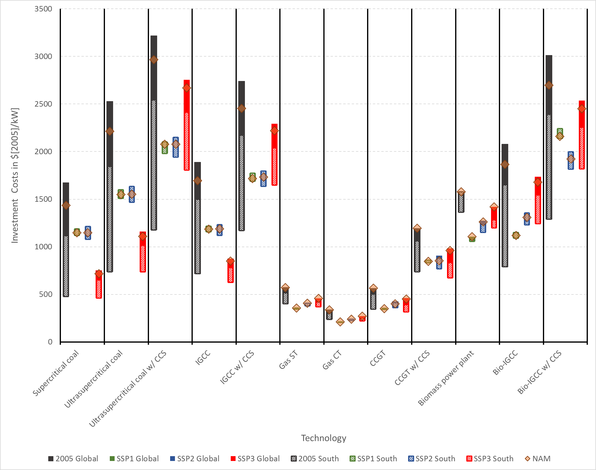
Figure S1: Cost indicators for thermoelectric power-plant investment. Black ranges show historical cost ranges for 2005. Green, blue, and red ranges show cost ranges in 2100 for SSP1, SSP2, and SSP3, respectively. Global values are represented by solid ranges. Values in the global South are represented by dashed ranges. The diamonds show the costs in the “North America” region. CCS – Carbon Capture and Storage; IGCC – Integrated gasification combined cycles; ST – Steam turbine; CT – Combustion turbine; CCGT – Combined cycle gas turbine
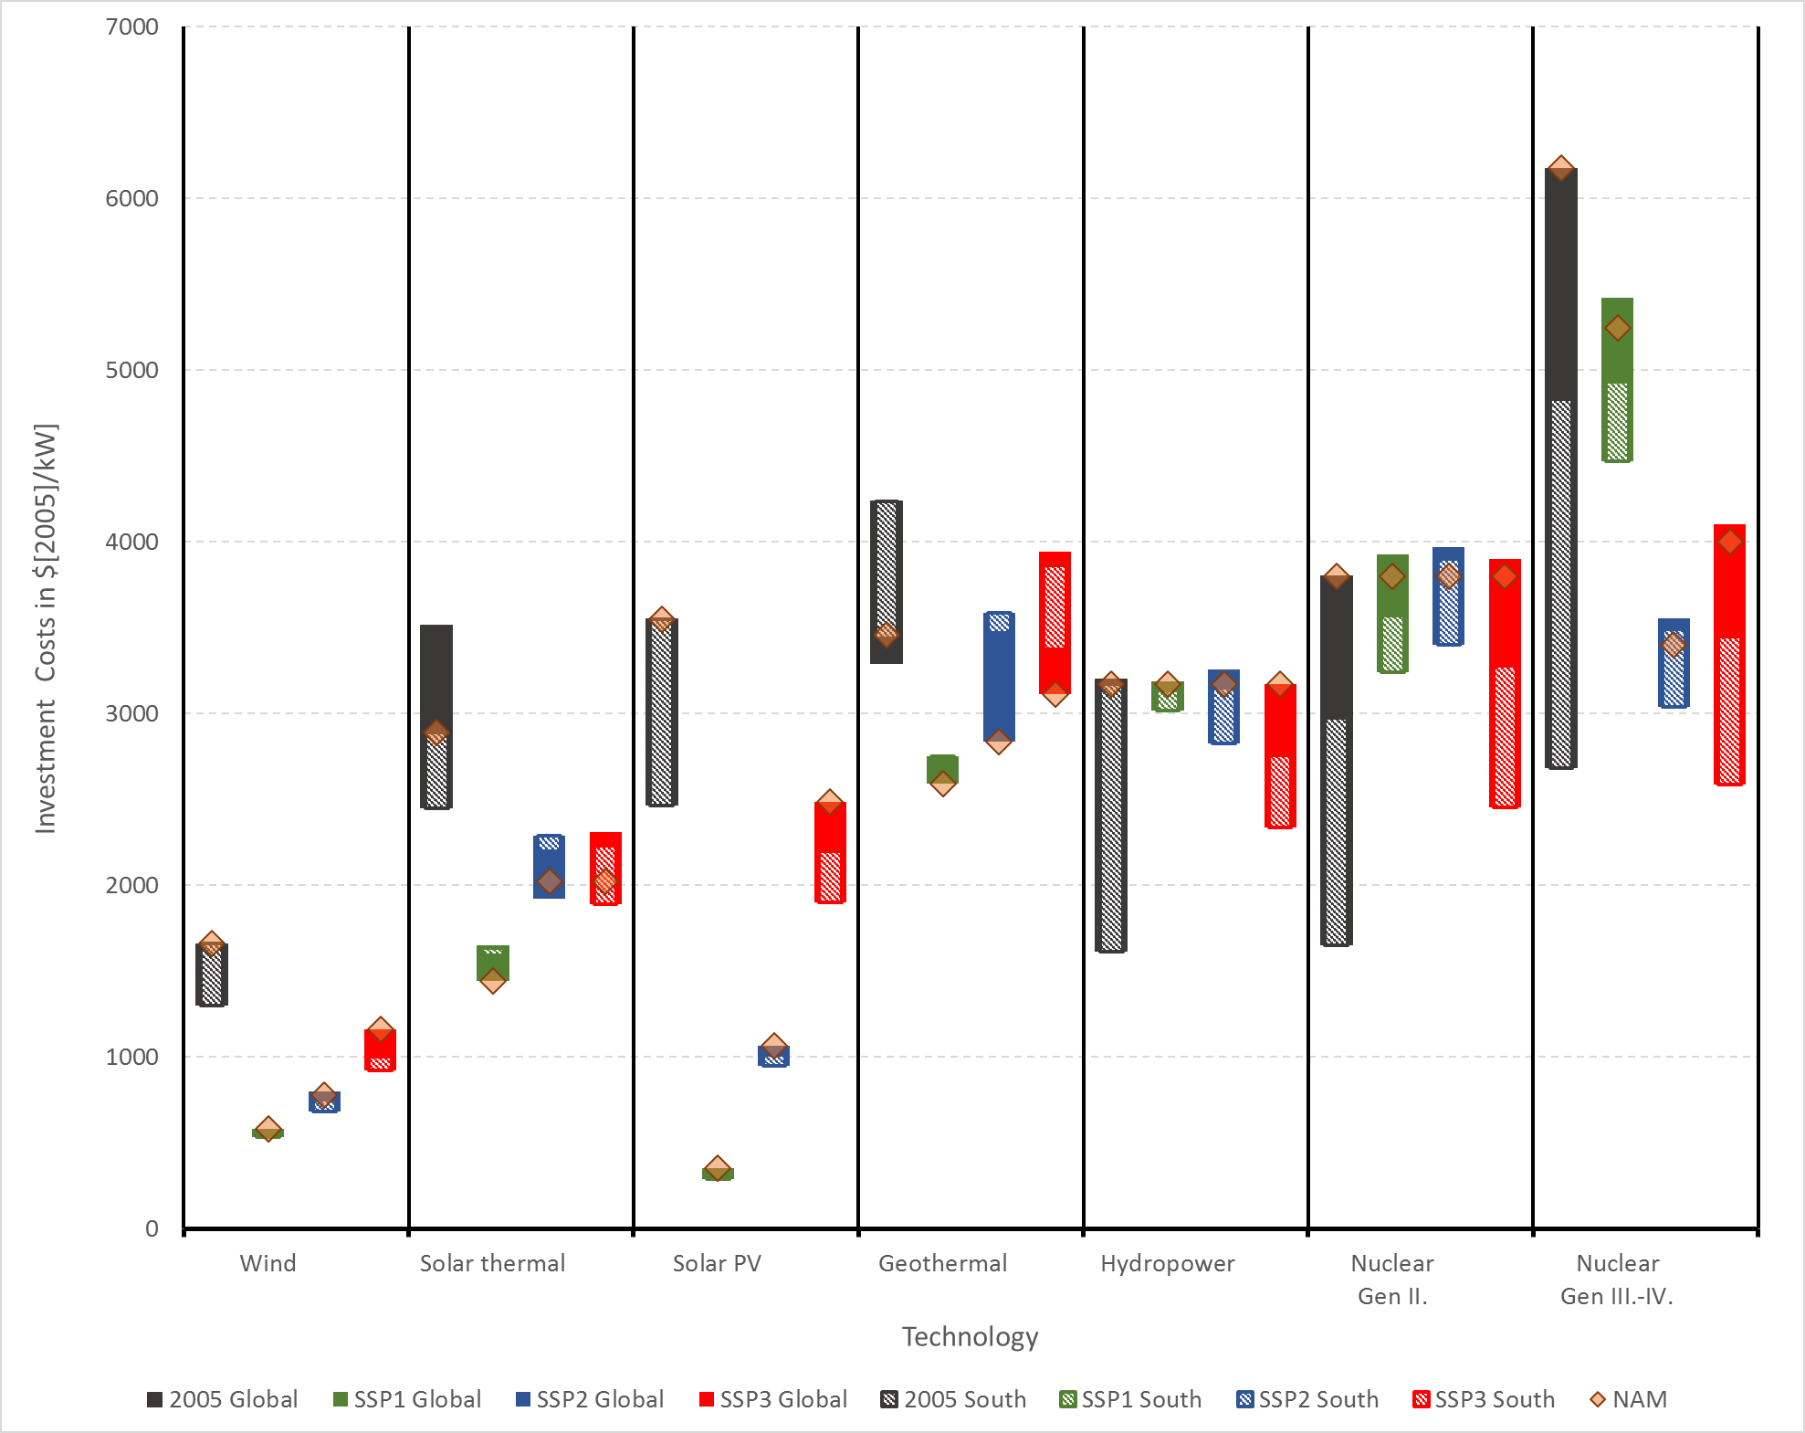
Figure S2: Cost indicators for non-thermoelectric power-plant investment. Black ranges show historical cost ranges for 2005. Green, blue, and red ranges show cost ranges in 2100 for SSP1, SSP2, and SSP3, respectively. Global values are represented by solid ranges. Values in the global South are represented by dashed ranges. The diamonds show the costs in the “North America” region. PV – Photovoltaic;
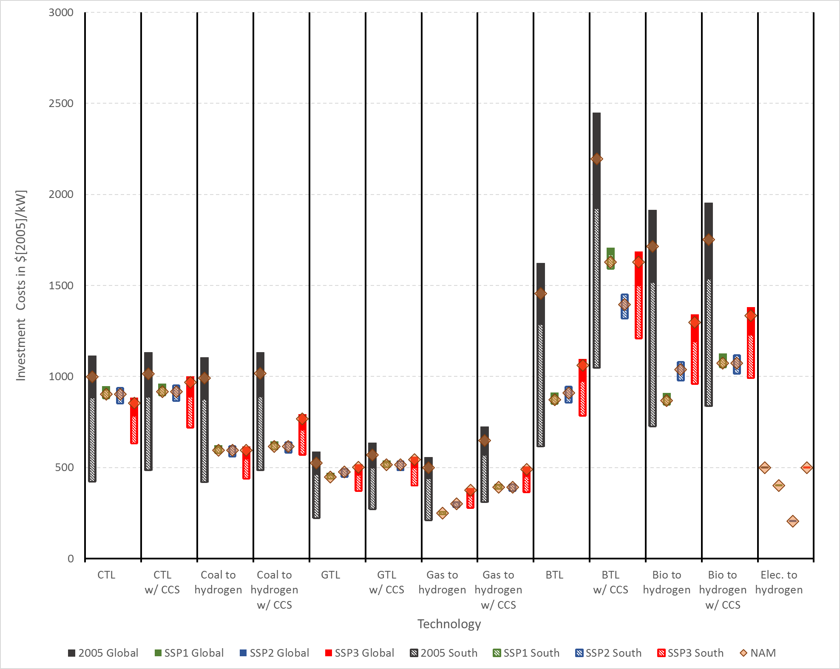
Figure S3: Cost indicators for other conversion technology investment. Black ranges show historical cost ranges for 2005. Green, blue, and red ranges show cost ranges in 2100 for SSP1, SSP2, and SSP3, respectively. Global values are represented by solid ranges. Values in the global South are represented by dashed ranges. The diamonds show the costs in the “North America” region. CCS – Carbon capture and storage; CTL – Coal to liquids; GTL – Gas to liquids; BTL – Biomass to liquids.

Dietary Composition across SSPs

Figure S4: Global dietary composition by type (split between crops and livestock) for the baseyear (2010), 2050 and 2100 for SSP1, SSP2 and SSP3, respectively. Note that although SSP3 is assumed to allow for a higher environmental impact of food consumption, the contribution of livestock in the average diet is lower than in SSP1 and SSP2, due to overall lower income levels.

Land-use resources

Figure S5: Global bioenergy potentials by feedstock type for the baseyear (2010), 2050 and 2100 for SSP1, SSP2 and SSP3, respectively.

MESSAGE-GLOBIOM integration

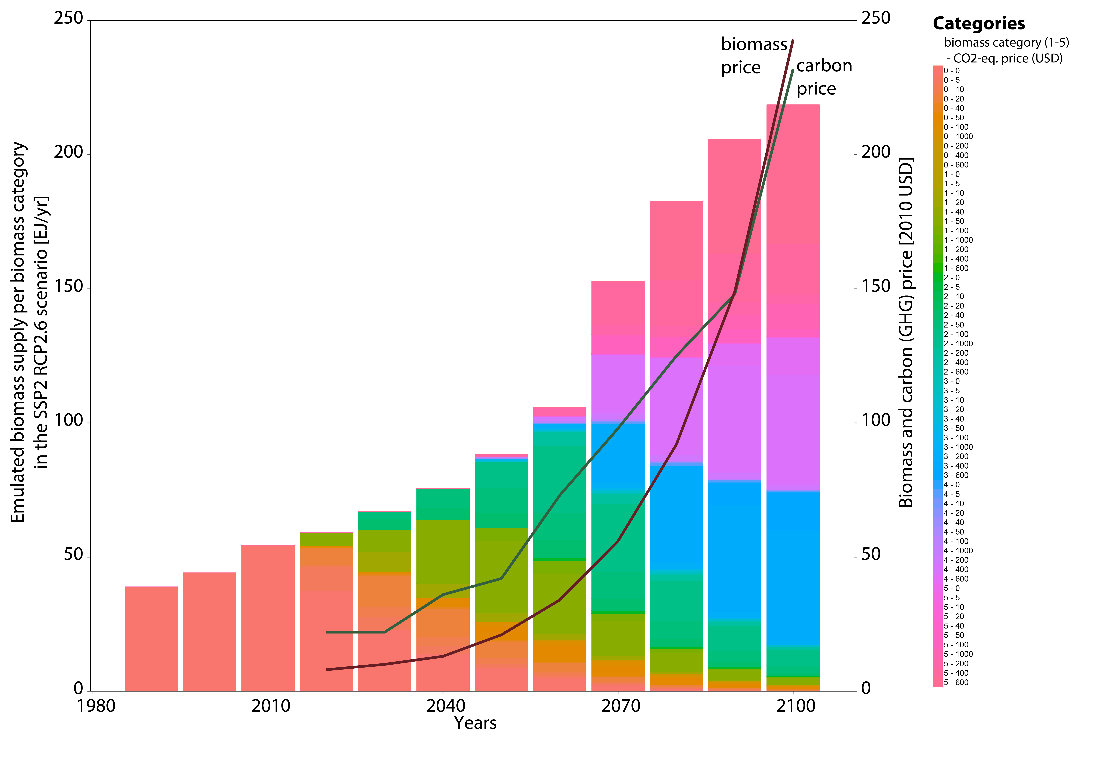
Figure S6: Emulated biomass supply per biomass category as used in the SSP2 RCP2.6 scenario. Biomass categories are based on the type of biomass and the assumed CO₂-equivalent price at which they become available.

Figure S7: Comparison of global land use emissions as emulated by the GLOBIOM emulator (dashed lines) and finally with the fully coupled feedback run (solid lines) for the SSP2 reference baseline (orange) and the corresponding RCP4.5 (yellow) and RCP2.6 (green) scenarios.

Energy carriers evolution

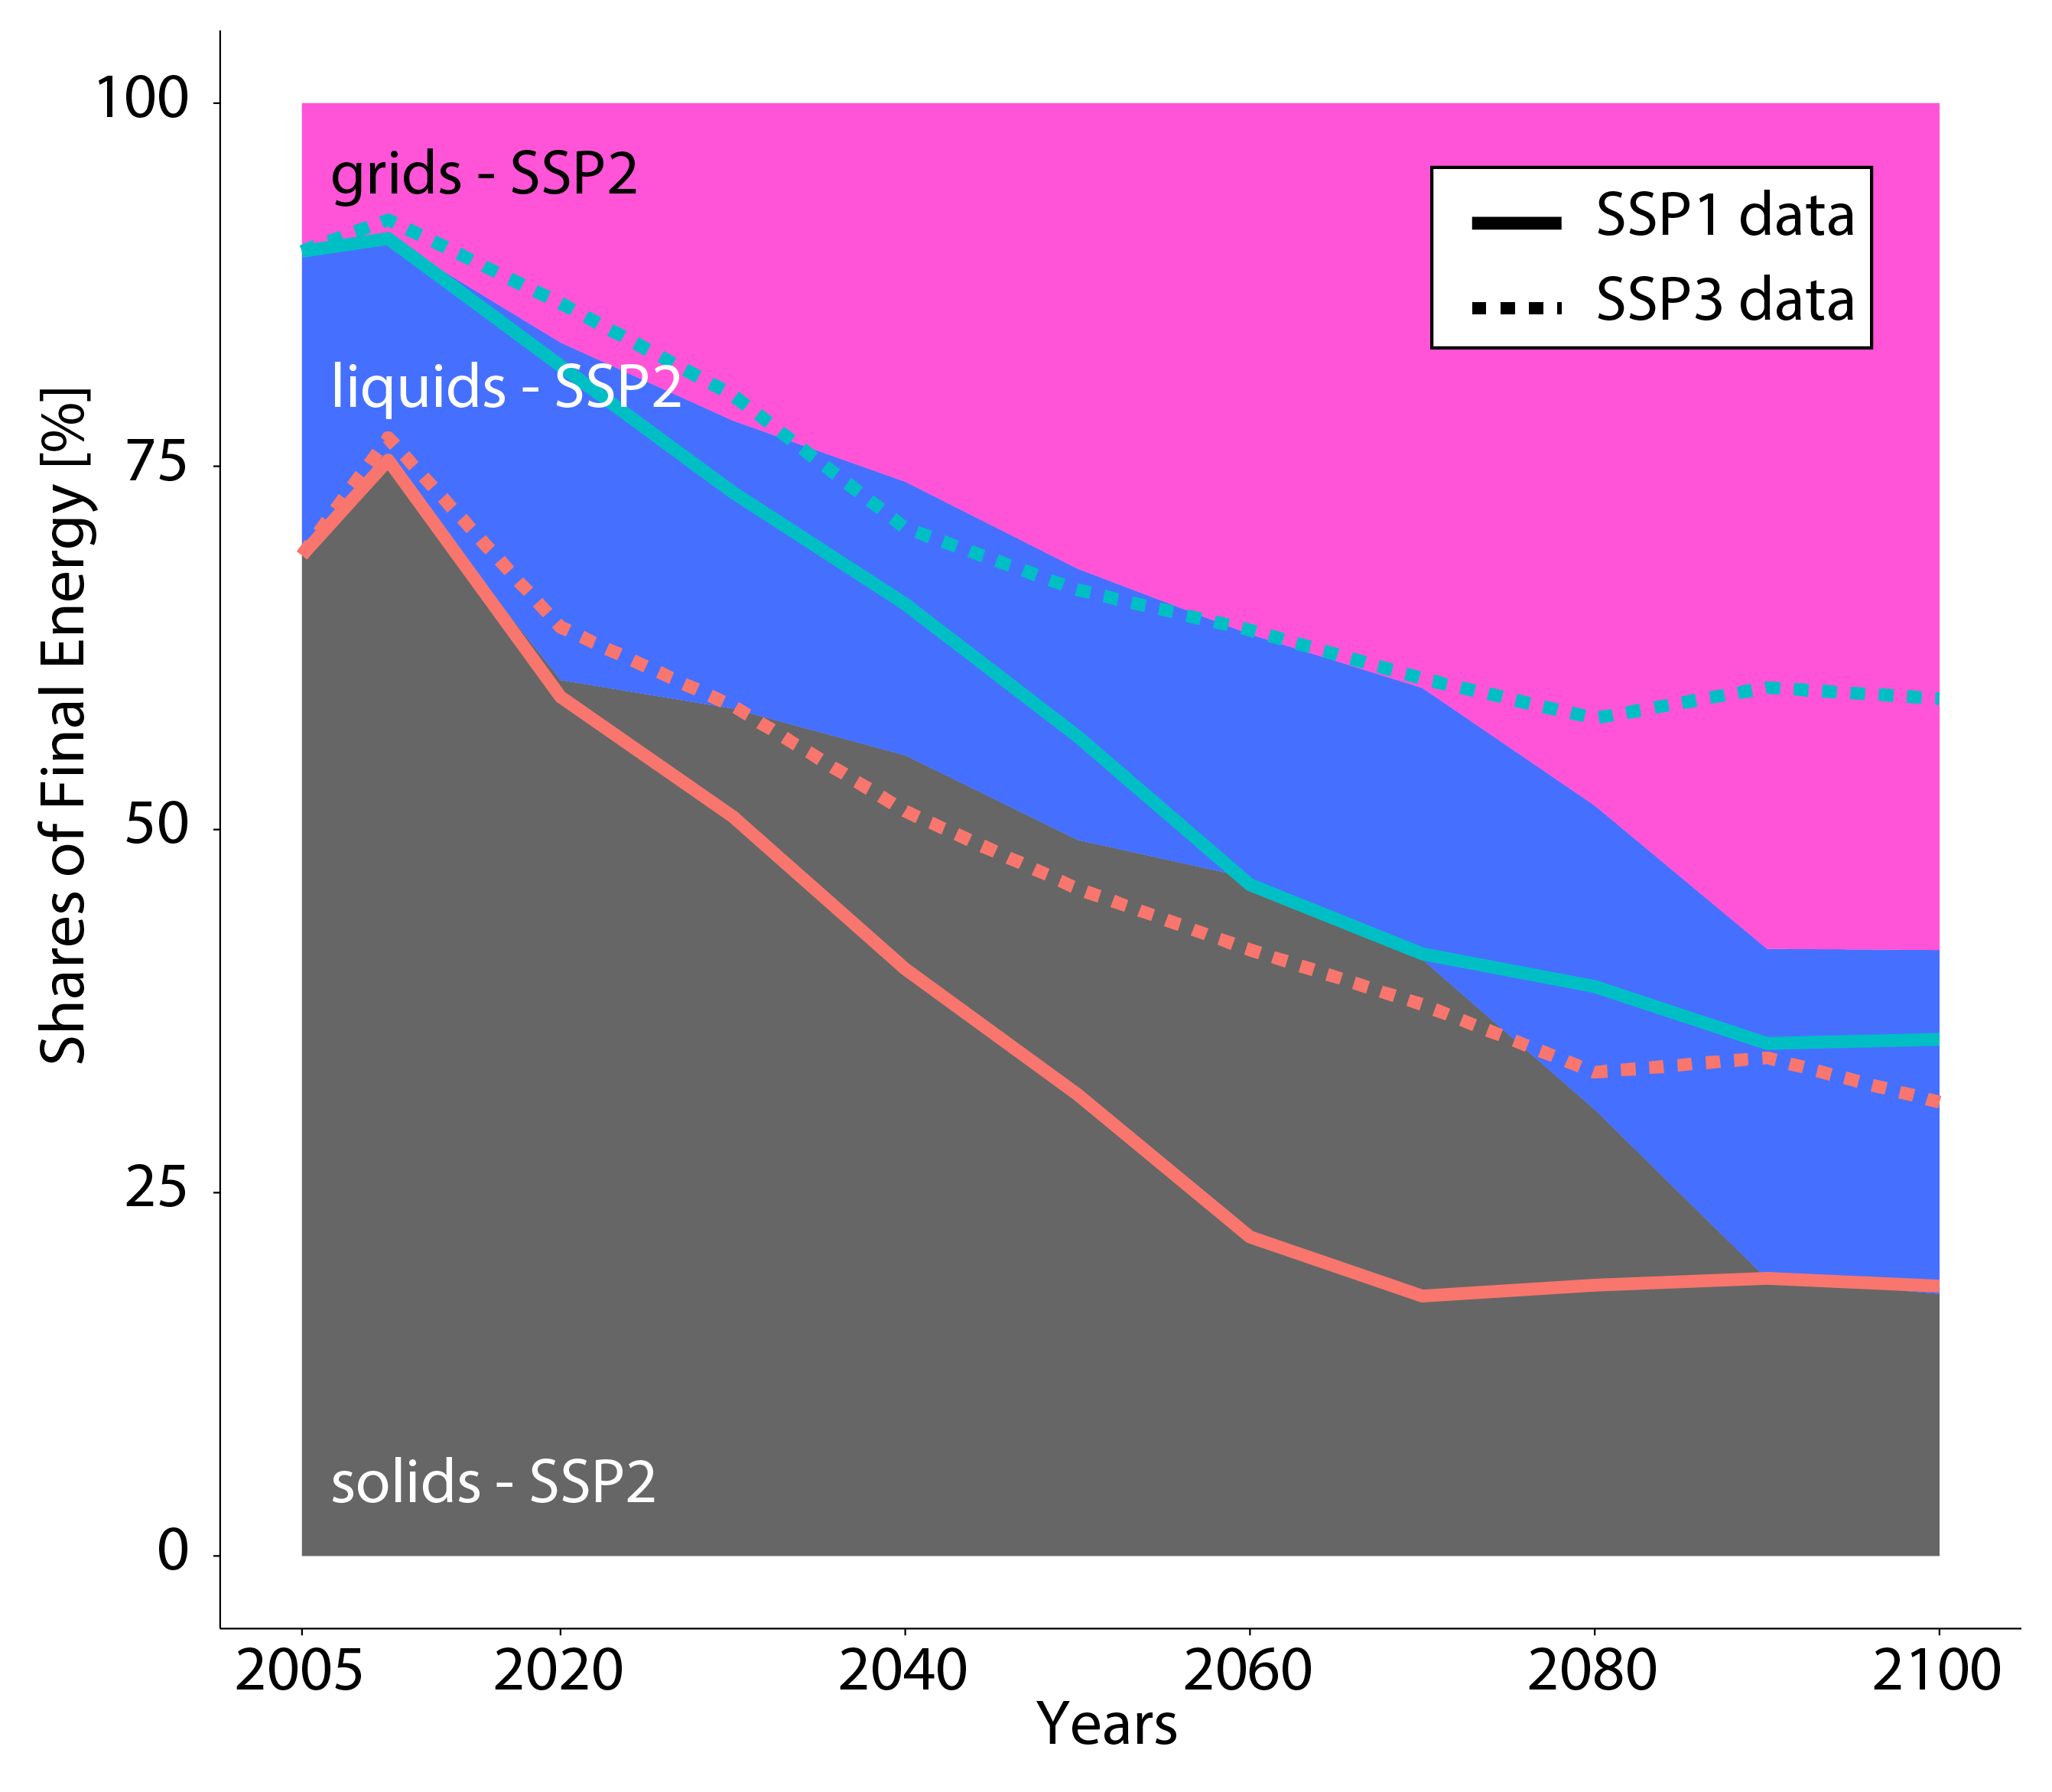
Figure S8: Shares of final energy by form, in percent, as solids, liquids and grids for Sub-Saharan Africa. The shaded area depicts the shares for the SSP2 baseline. Solid lines show the variations for the SSP1 baseline, while dashed lines show the variations for the SSP3 baseline.

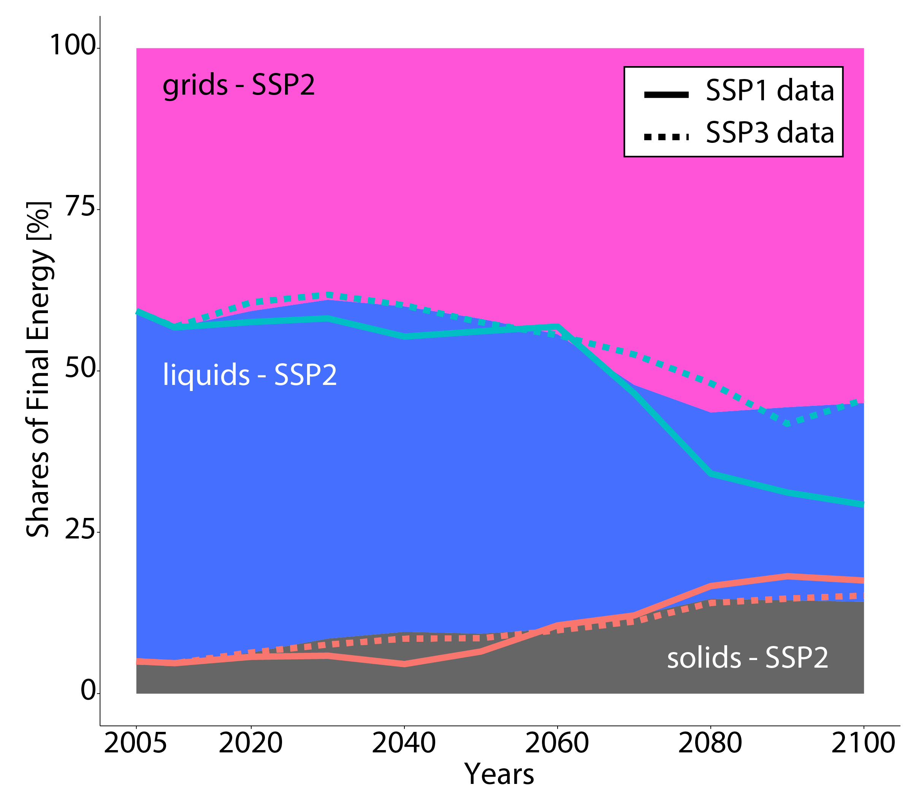
Figure S9: Shares of final energy by form, in percent, as solids, liquids and grids for North America. The shaded area depicts the shares for the SSP2 baseline. Solid lines show the variations for the SSP1 baseline, while dashed lines show the variations for the SSP3 baseline.

Sectorial final energy evolutions

Figure S10: Final energy by sector for SSP1 for the regions north and south, where TRN=Transport sector; RC=Residential and commercial sector; IND=Industry sector.

Figure S11: Final energy by sector for SSP2 for the regions north and south, where TRN=Transport sector; RC=Residential and commercial sector; IND=Industry sector

Figure S12: Final energy by sector for SSP3 for the regions north and south, where TRN=Transport sector; RC=Residential and commercial sector; IND=Industry sector

Primary energy evolution in SSP1 and SSP3 baselines

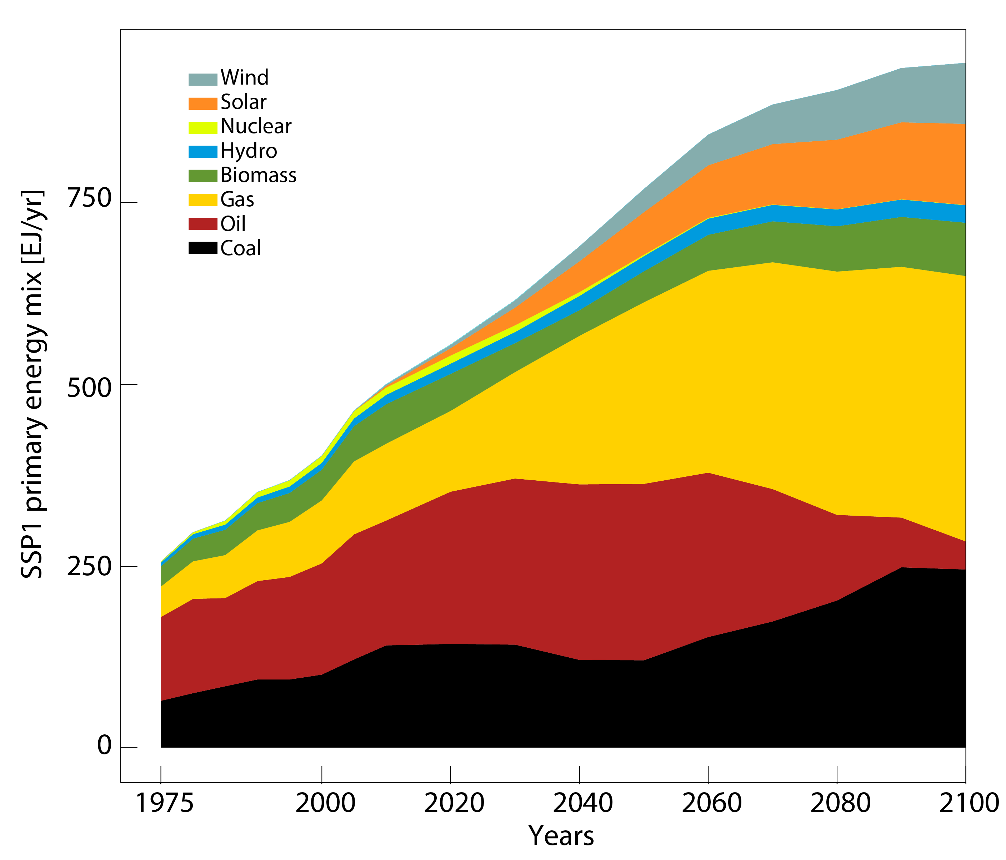
Figure S13: Primary energy mix evolution for the SSP1 baseline, modelled by the IIASA IAM framework.

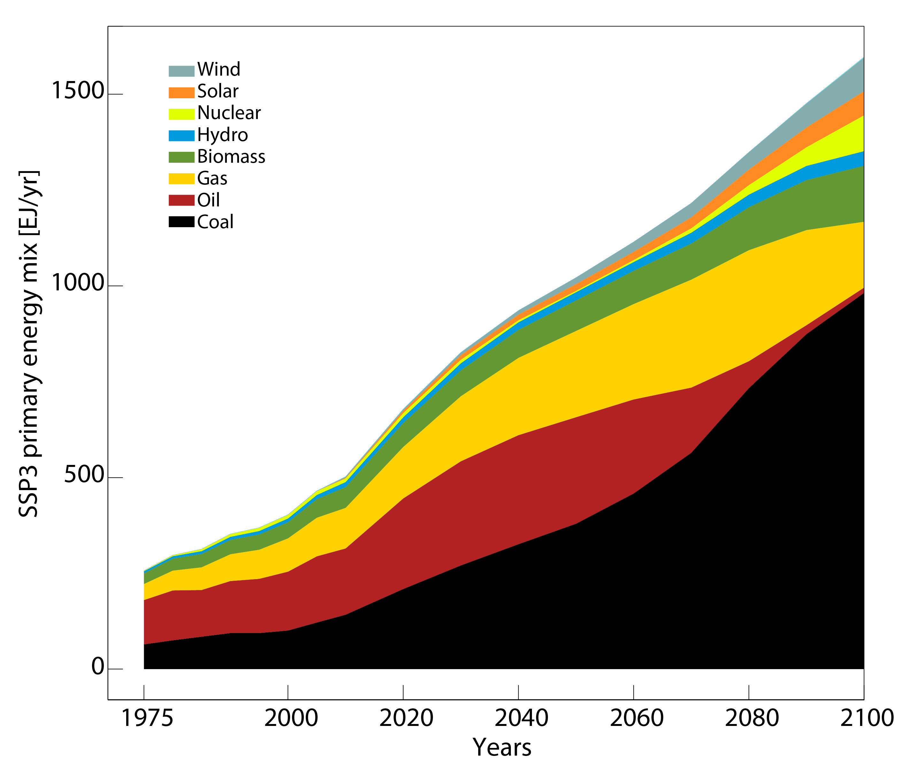
Figure S14: Primary energy mix evolution for the SSP3 baseline, modelled by the IIASA IAM framework.

Primary energy evolution in SSP2 mitigation cases
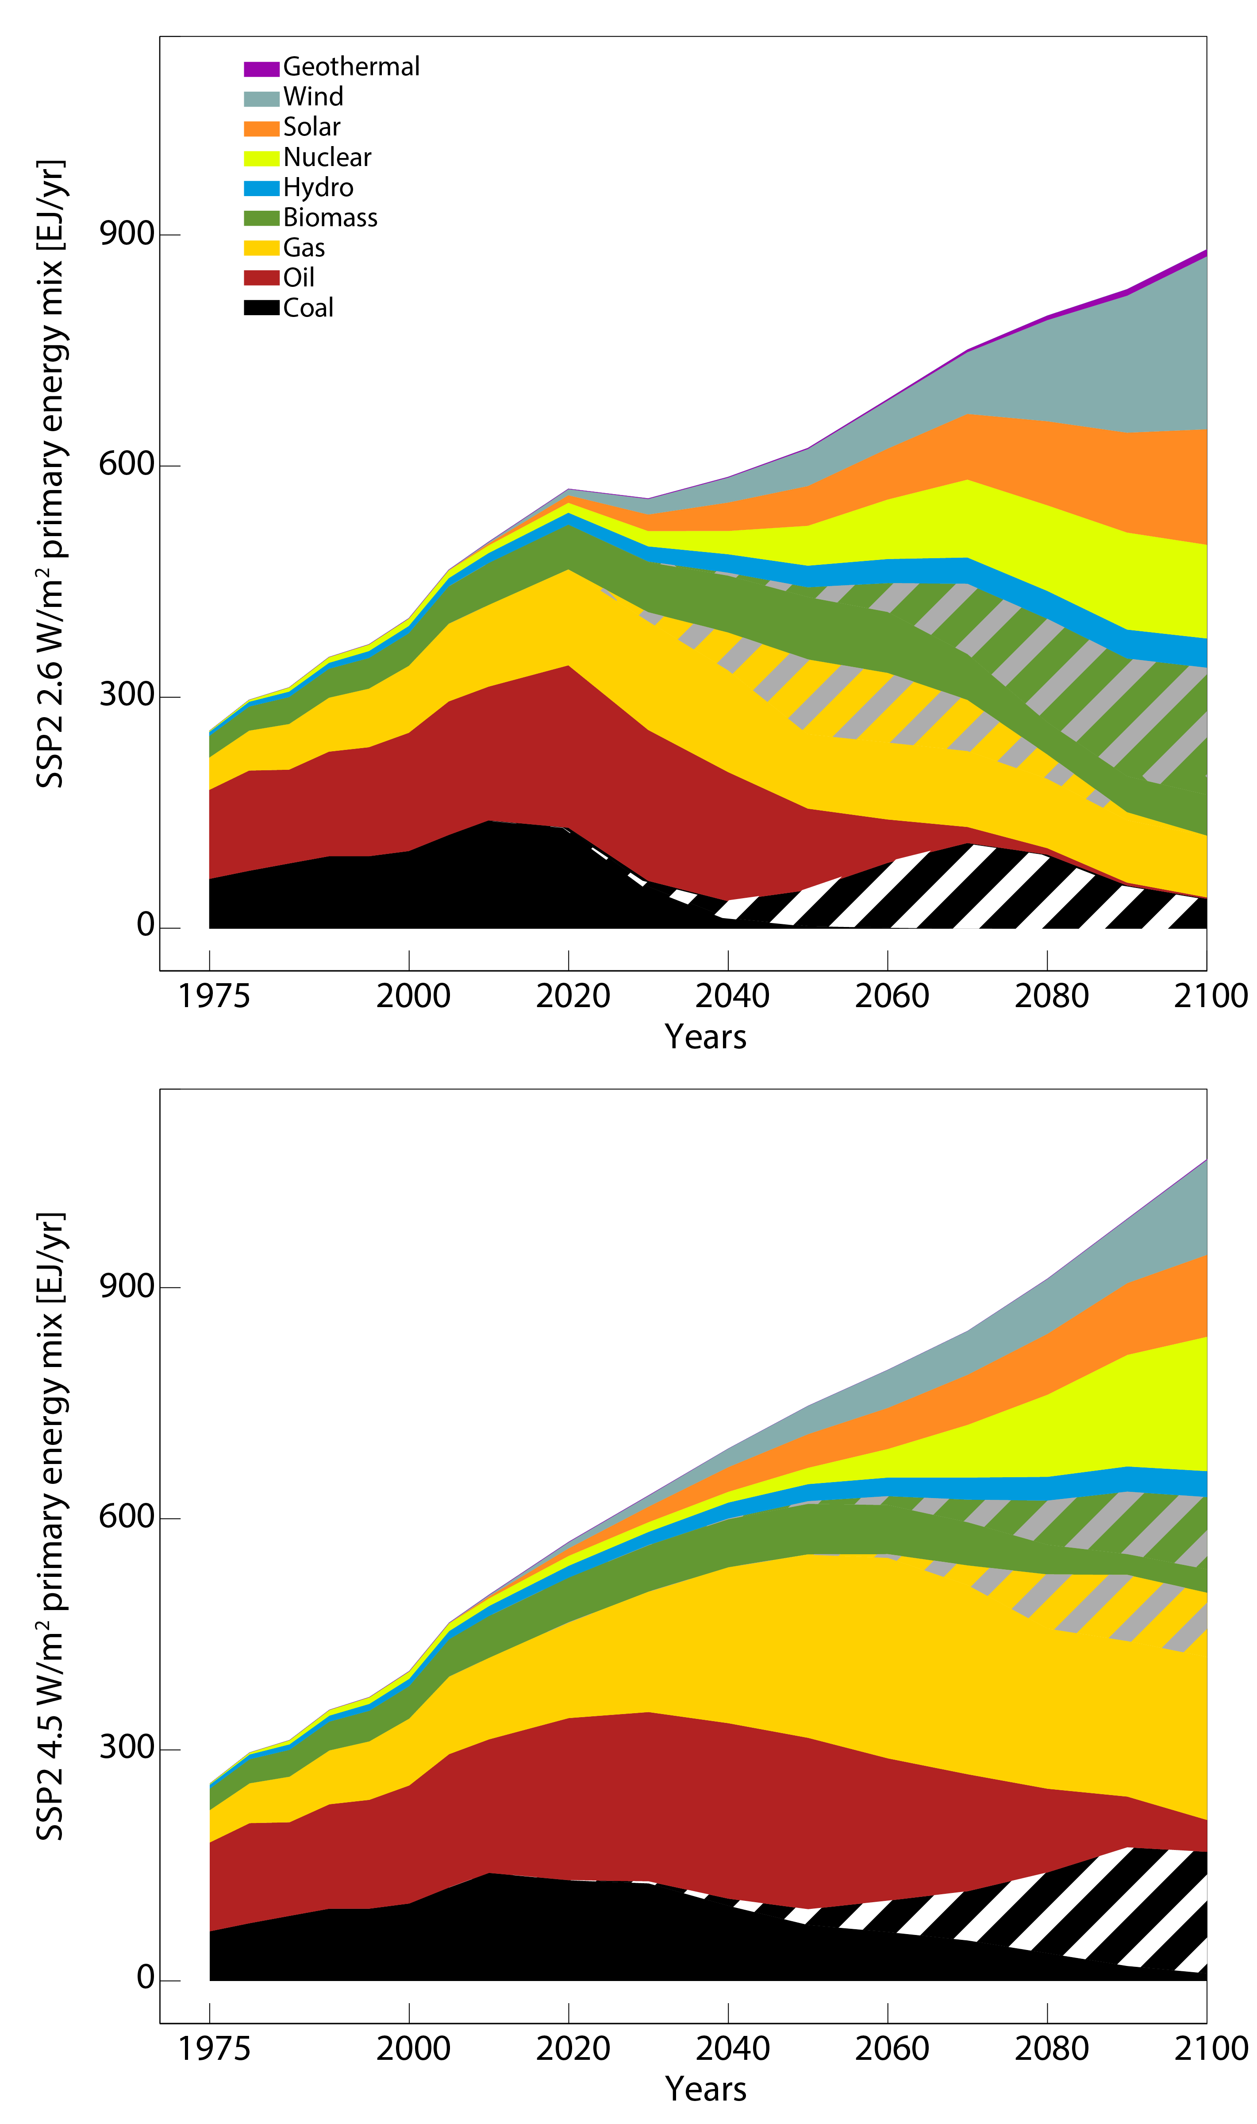
Figure S15: Primary energy mix evolution for two SSP2 mitigation cases leading to an end-of-century total anthropogenic radiative forcing of 2.6 (upper panel) and 4.5 (lower panel) W/m², as modelled by the IIASA IAM framework. Hatched areas represent the shares of primary energy that are combined with carbon capture and storage (CCS).

CO₂ mitigation

Figure S16: Annual amounts of CO₂ removed by the deployment of bioenergy combined with carbon capture and storage (BECCS) versus annual land-use CO₂ emissions for an illustrative set of mitigation cases in SSP1, SSP2, and SSP3.
The label “SSP2-26” refers to the SSP2 mitigation scenario which limits total anthropogenic radiative forcing in 2100 to 2.6 W/m².

Figure S17: Annual amounts of CO₂ removed by the deployment of bioenergy combined with carbon capture and storage (BECCS) versus annual amount of CO₂ stored from fossil energy sources with carbon capture and storage (CCS) for an illustrative set of mitigation cases in SSP1, SSP2, and SSP3. The label “SSP2-26” refers to the SSP2 mitigation scenario which limits total anthropogenic radiative forcing in 2100 to 2.6 W/m².

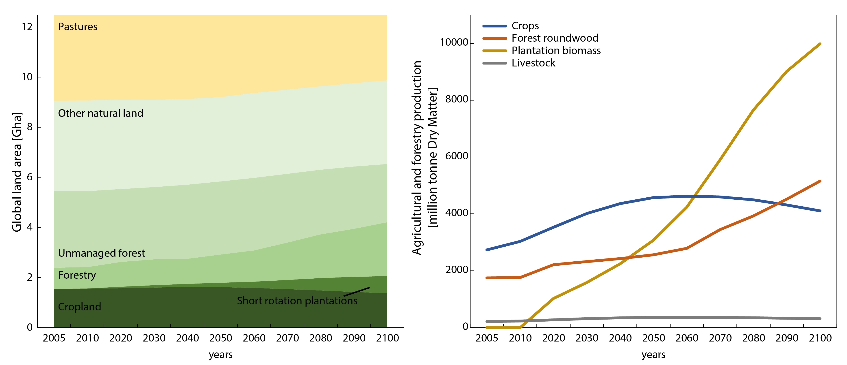
Figure S18: Land use development in the marker SSP2 scenario in line with a 2.6 W/m² climate target. Left panel: evolution of global land area over time. Right panel: agricultural and forestry production over time in units of million tonnes of dry matter.

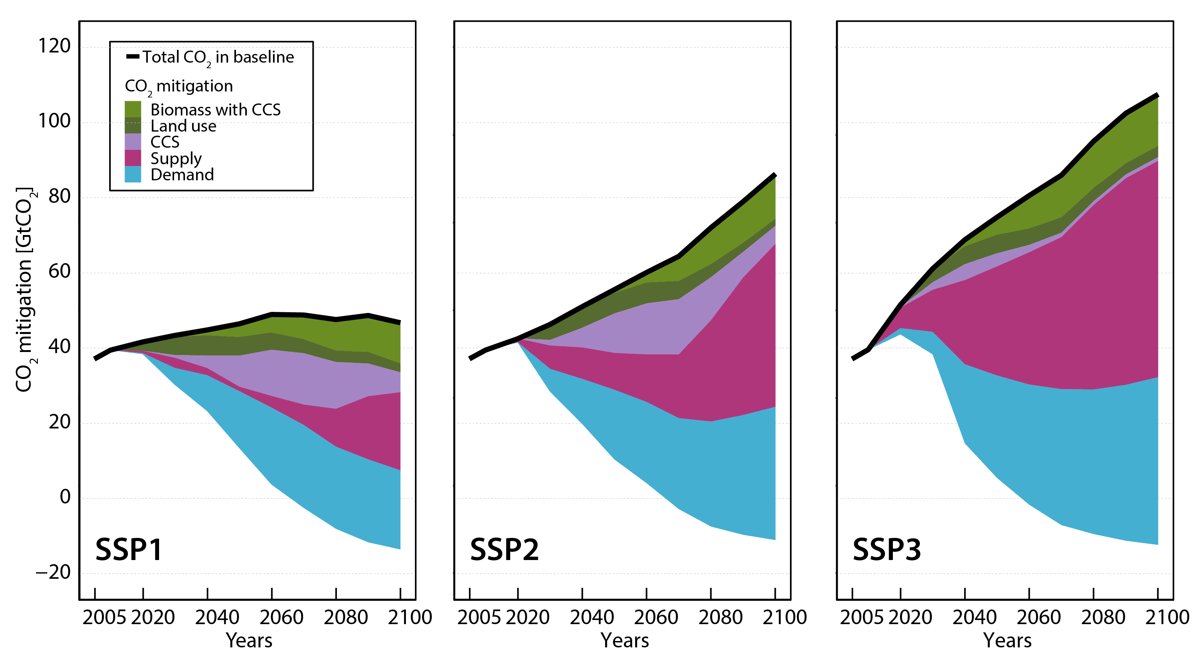
Figure S19: Mitigation of CO₂ from baseline CO₂ emission levels in SSP1, SSP2, and SSP3 for achieving a global radiative forcing target in 2100 of 4.5 W/m² (left) and 2.6 W/m² (right), respectively). Emissions reductions are calculated from direct emissions from different sectors.

Carbon price SSP-RCP matrix

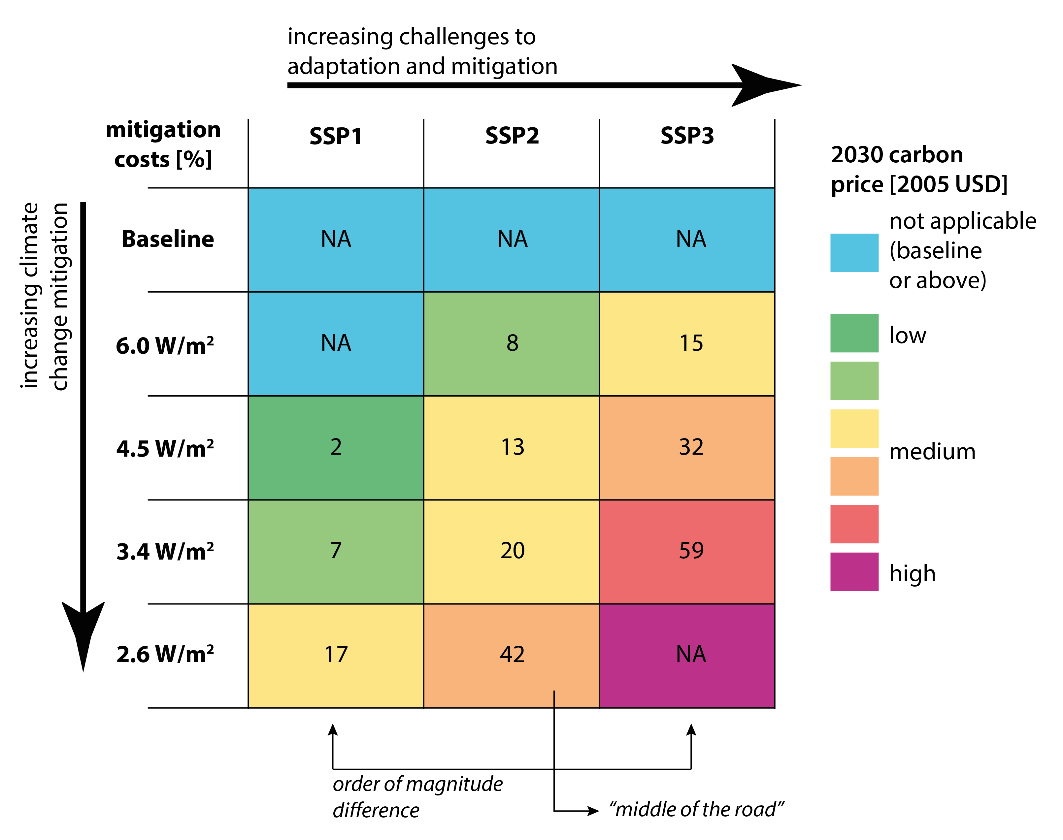
Figure S20: Carbon prices costs across SSPs and different levels of climate change mitigation. Carbon prices represent the year-2030 carbon price in 2005 USD. Cases marked with NA cannot be achieved in the IIASA IAM implementation of the SSPs. A carbon price is already imposed before 2030, but because of the various SPAs, their difference becomes clearer over time. The full carbon price trajectories can be explored in the online database accompanying the SSP Special Issue.

Supplementary References
Alexandratos N and Bruinsma J 2012 World Agriculture Towards 2030/2050: The 2012 Revision. ESA Working Paper. (Rome, Italy: Food and Agriculture Organization of the United Nations (FAO)) pp 1-154
Bouët A, Decreux Y, Fontagné L, Jean S and Laborde D 2008 Assessing Applied Protection across the World* Review of International Economics 16 850-63
Dellink R, Chateau J, Lanzi E and Magné B 2015 Long-term economic growth projections in the Shared Socioeconomic Pathways Global Environmental Change
Gaulier G and Zignago S 2008 BACI: A World Database of International Trade at the Product-level (The 1995-2004 Version). MPRA Paper.
Gustavsson J, Cederberg C, Sonesson U, van Otterdijk R and Meybeck A 2011 Global food losses and food waste. Extent, causes and prevention. (Rome, Italy: Food and Agricultural Organisation of the United Nations (FAO))
Havlík P, Schneider U A, Schmid E, Böttcher H, Fritz S, Skalský R, Aoki K, Cara S D, Kindermann G, Kraxner F, Leduc S, McCallum I, Mosnier A, Sauer T and Obersteiner M 2011 Global land-use implications of first and second generation biofuel targets Energy Policy 39 5690-702
Hummels D 2001 Toward a Geography of Trade Costs (Working Papers). Department of Economics, Purdue University, US)
IEA 2012 World energy balances. In: IEA World Energy Statistics and Balances (database), ed I E Agency (Paris, France
Jewell J 2011 Ready for nuclear energy?: An assessment of capacities and motivations for launching new national nuclear power programs Energy Policy 39 1041-55
KC S and Lutz W 2015 The human core of the shared socioeconomic pathways: Population scenarios by age, sex and level of education for all countries to 2100 Global Environmental Change
O’Neill B C, Kriegler E, Ebi K L, Kemp-Benedict E, Riahi K, Rothman D S, van Ruijven B J, van Vuuren D P, Birkmann J, Kok K, Levy M and Solecki W 2015 The roads ahead: Narratives for shared socioeconomic pathways describing world futures in the 21st century Global Environmental Change
Pepper W, Leggett J, Swart R, Wasson J, Edmonds J and Mintzer I 1992 Climate Change 1992: Supplementary Report to the IPCC Scientific Assessment, ed J Houghton, et al. (Cambridge, UK: Cambridge University Press)
Riahi K, Dentener F, Gielen D, Grubler A, Jewell J, Klimont Z, Krey V, McCollum D, Pachauri S, Rao S, van Ruijven B, van Vuuren D P and Wilson C 2012 Global Energy Assessment - Toward a Sustainable Future: Cambridge University Press, Cambridge, UK and New York, NY, USA and the International Institute for Applied Systems Analysis, Laxenburg, Austria) pp 1203-306
Riahi K and Roehrl R A 2000 Greenhouse gas emissions in a dynamics-as-usual scenario of economic and energy development Technological Forecasting and Social Change 63 175-205
Riahi K, van Vuuren D P, Kriegler E, Edmonds J, O’Neill B, Fujimori S, Bauer N, Calvin K, Dellink R, Fricko O, Lutz W, Popp A, Cuaresma J C, Leimbach M, Kram T, Rao S, Emmerling J, Hasegawa T, Havlik P, Humpenöder F, Aleluia Da Silva L, Smith S, Stehfest E, Bosetti V, Eom J, Gernaat D, Masui T, Rogelj J, Strefler J, Drouet L, Krey V, Luderer G, Harmsen M, Takahashi K, Wise M, Baumstark L, Doelman J, Kainuma M, Klimont Z, Marangoni G, Moss R, Lotze-Campen H, Obersteiner M, Tabeau A and Tavoni M in review The Shared Socioeconomic Pathways: An Overview Global Environmental Change
Rogner H-H, Aguilera R F, Bertani R, Bhattacharya S C, Dusseault M B, Gagnon L, Haberl H, Hoogwijk M, Johnson A, Rogner M L, Wagner H and Yakushev V 2012 Global Energy Assessment - Toward a Sustainable Future, (Cambridge University Press, Cambridge, UK and New York, NY, USA and the International Institute for Applied Systems Analysis, Laxenburg, Austria pp 423-512
Schäfer A 2005 Structural change in energy use Energy Policy 33 429-37
UN 2010 World Population Prospects: The 2010 Revision. (New York: United Nations, Department of Economic and Social Affairs, Population Division)
Valin H, Sands R D, van der Mensbrugghe D, Nelson G C, Ahammad H, Blanc E, Bodirsky B, Fujimori S, Hasegawa T, Havlik P, Heyhoe E, Kyle P, Mason d'Croz D, Paltsev S, Rolinski S, Tabeau A, van Meijl H, von Lampe M and Willenbockel D 2014 The future of food demand: understanding differences in global economic models Agricultural Economics 45 51-67
Vuuren D P and Carter T R 2013 Climate and socio-economic scenarios for climate change research and assessment: reconciling the new with the old Climatic Change 122 415-29
World Bank 2012 World Development Indicators.

