Supplementary C: MCA Stakeholder Tree
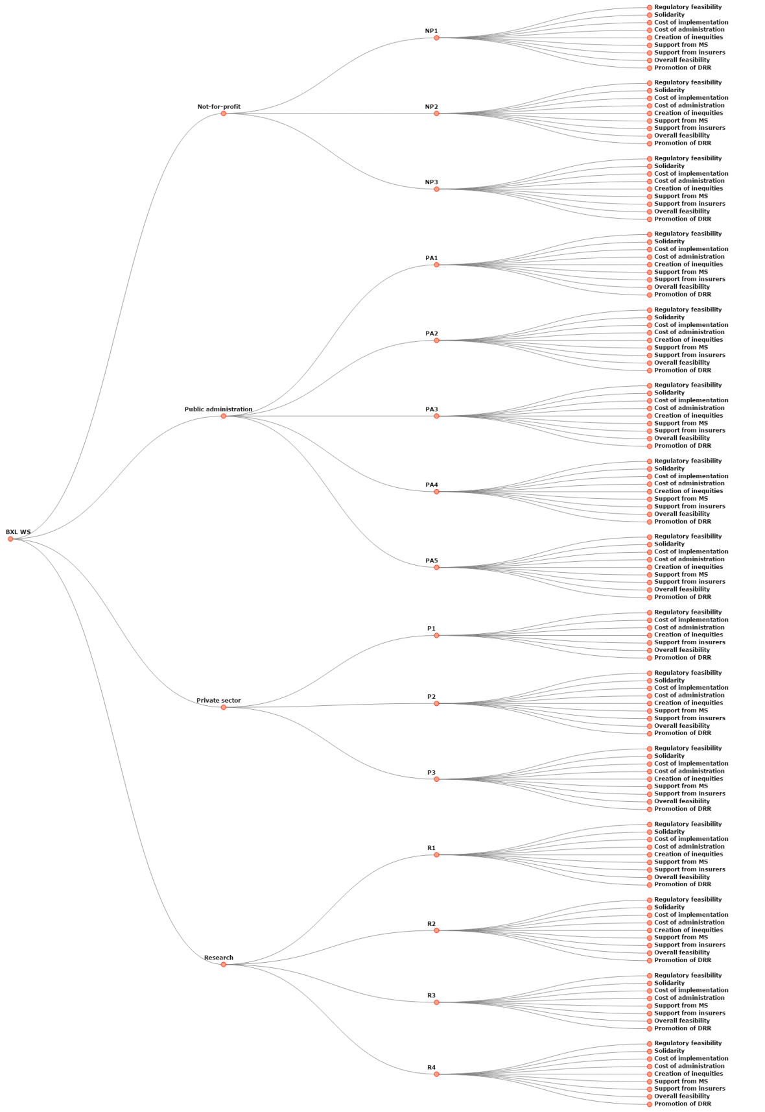

All | Stakeholder Groups | Stakeholders (abbreviated) | Questions Asked

