**Supplementary information**

**A Comprehensive Provincial-Level VOCs Emission Inventory and Scenario Analysis for China: Enhanced Sectoral Resolution through GAINS-China Model**

Yuhang Zhao a, b, Hong Sun a, *, Younha Kim c, Yun Shu b, *, Han Wang b, Hui Li b, Yinhe Deng a, b

a School of Transportation Engineering, Dalian Jiaotong University, Dalian 116028, China.

b State Key Laboratory of Environmental Criteria and Risk Assessment, Chinese Research Academy of Environmental Sciences, Beijing 100012, China.

c International Institute for Applied Systems Analysis, Schlossplatz 1, A‑2361 Laxenburg, Austria.

* Corresponding author:

Hong Sun, E-mail address: [sunhonglzg@163.com](mailto:sunhonglzg@163.com) (H. Sun)

Yun Shu, E-mail address: shuyun@craes.org.cn (Y. Shu)

This material provided the detail calculation process, parameters, the scenarios assumptions and results in the GAINS model applied in this study.

# **1. Methods for estimating VOCs emission for different sources**

### 1.1 Activity data and emission factors

In this work, the activity data were obtained from provincial statistics covering 31 provinces, excluding Taiwan, Hong Kong and Macao due to limited data availability. Emission factors were collected from national-level statistical data. The unabated emission factors are listed in Table S1. Previous studies have conducted a comprehensive overview of available emission factors in China. We updated the emission factors from recent literature published by Chinese researchers.

**Solvent use**

Solvent use is a significant source of anthropogenic VOCs emissions, contributing more than 30% of VOCs emissions in China. This sector was divided into five subsectors based on the characteristics of each subsector: paint use, other industrial applications, household solvent use, manufacturing industry, and printing use. Ultimately, all subsectors were further classified into 22 types of sources.

For paint use, including vehicle refinishing and industrial paint use (continuous processes and other), GAINS model uses paint consumption as the activity unit for these activities. Provincial data for these activities are collected from the China Statistical Yearbook, the China Paint and Coatings Industry Yearbook, and the China Industry Economy Statistical Yearbook. The corresponding emission factors are derived from the Air Pollutant Emission Factors (AP42 Report)[1] combined with source information from local investigations where available[2, 3]. Regarding the source of paint use in vehicles manufacturing, the number of vehicles produced for each province obtained from the China Transportation and Communications Yearbook and the China Automotive Industry Yearbook, is used as activity rate. The emission factor is referred to the AP42 report due to information limitation. In addition, the annual variation of activity for each source is considered, which is related to changes in the sectoral gross domestic product.

For other industrial applications (industrial application of adhesives, wood preservation and waxing and underbody treatment of vehicles), the GAINS model uses the consumption of solvents of these processes, the volume of wood treated, and the number of new vehicle registration as the activity unit. Activity data for these sources are gathered from the same data sources as paint use, as well as the China Forestry Statistical Yearbook. The change in the activity rate for vehicle treatment over years is linked to changes in GDP per capita.

Another important source of solvent-based VOCs emissions is the household use of solvents, which includes domestic use of solvents (other than paint) and dry cleaning. Solvent consumption amounts are estimated using proxies such as provincial population. For dry cleaning, the volume of textiles cleaned serves as the activity unit. Due to the absence of reliable and detailed information, the GAINS model, like many other emission inventories, applies a straightforward approach based on per capita emission factors.

As for manufacturing industry, including sources such as the pharmaceutical industry, manufacturing of shoes, type production and products incorporating solvents, the amount of manufactured goods is used as the activity unit. The yield of industrial products is collected from various officially released statistics for the specific economic sector, such as the China Chemical Industry Yearbook, the China Rubber Industry Yearbook, the China Light Industry Yearbook. These emission factors are derived from the European Environment Agency Guidebook[4], the AP42 Report, and literatures[3, 5, 6].

For printing use, including offset printing, flexography & rotogravure-packaging, rotogravure in publication and screen printing, ink consumption is used as the activity level. Emission factors for these sources are derived from information contained in the AP42 Report. The annual variation of activity data for printing and packaging is related to the annual sectoral gross domestic product.

**Residential**

The residential sector was divided into five subsectors based on combustion facilities: cooking stoves, heating stoves, three-stone stoves, boilers, and commercial boilers. Each subsector was further classified based on fuel types, including coal, fuel oil, natural gas and biomass. The consumption of fossil fuels and biofuels, obtained from the provincial energy balance spreadsheets in the China Energy Statistical Yearbook, is used as the activity unit. Emission factors for these sources are referenced from European studies and supplemented with information from local investigations where available[3]. Changes in the activity levels for fuel combustion in the future are obtained from energy scenarios used as exogenous input to the model.

**Transportation**

According to the actual situation in China, the transportation sector was classified into three subsectors of light on-road mobile, heavy on-road mobile and non-road mobile. Vehicles in road transport were further classified into seven types covering gasoline and diesel vehicles and two performance categories (light-duty and heavy-duty). Non-road mobile subsector was divided into airport, shipping, railways, agriculture and construction machinery. The gasoline/diesel consumption, which depends on the specific fuel consumption averaged over driving regimes, annual vehicle miles travelled and the number of vehicles, serves as the activity unit. Here, the specific fuel consumption averaged over driving regimes is taken from technical reports or national transport models. Annual vehicle miles travelled is estimated based on the annual average data reported in literatures[7]. The number of vehicles is taken from the Chinese annual statistical yearbooks. Each emitting process, including pollutant exhaust during the running mode and VOCs evaporation, is considered. VOCs emission factors for the transport sector are based on European experience, as China’s dominant vehicle manufacturing technologies are rooted in European practices, and the country’s vehicle emission regulations closely align with those implemented in Europe. Emission factors for each transport category are presented in Table S1.

**Industry and power**

Industry and power sector was divided into four subsectors: industrial processes, industrial combustion, power and fuel conversion. As for industrial processes, including sources such as coke production, steel production, cement production and food production, the amount of manufactured goods is used as the activity unit. The yield of industrial products is collected from various officially released statistics for the specific economic sector, such as the China Statistical Yearbook, the China Light Industry Yearbook, and the China Food Industry Yearbook. The temporal development of the food industry is assumed to be proportional to population growth. Industrial combustion, power and fuel conversion were further divided into four sources based on different fuel types consumed: coal, fuel oil, natural gas and biomass fuels. Activity data for these sources are gathered from the same data sources as residential sector. Table S1 presents the VOCs emission factors for specific fuel categories.

**Others**

The sector of others contains agriculture, fuel production & distribution, and waste. Agriculture was further divided into three sources: livestock, grassland and soils, and agricultural waste burning. The fuel production & distribution subsector is a potential source for NMVOCs emissions, as volatilization and leakage of organic solvents occur during the distribution and marketing of gasoline. Thus, gasoline service stations and gasoline storage & distribution were identified as sources for VOCs emissions in this work. The aggregated quantities of gasoline from importation, exportation, refinery and vehicle refueling are used as the activity data. The emission factors measured under the same situation in AP42 Report are selected, as shown in Table S1. The subsector of waste is divided into solid waste incineration and composting and, solid waste landfills.

### 1.2 Control strategies

Existing national legislation to limit VOCs emissions covers the solvent use, industry, transport and residential sectors. Commonly employed methods of reducing VOCs emissions from stationary sources can be grouped into three basic classes: use of environmentally friendly substitutes (e.g., low-VOC or water-based products), end-of-pipe control technologies (e.g., adsorption or catalytic incineration), and emission management techniques (e.g., leak detection and repair-LDAR or storage tank technology). For instance, the Chinese government has released a series of standards to limit the solvent content of certain products, including wood paint (GB18581-2020)[8], architecture paints (GB18582-2020)[9], vehicle paint (GB24409-2020)[10], and indoor adhesives (GB18583-2008)[11]. Driven by these standards, the solvent content of some products has declined, and the penetration of low-solvent products has gradually increased. Table S3 shows the penetrations of major control measures for solvent use.

VOCs emission reductions from the transportation sector are mainly achieved through fleet turnover, which involves replacing old vehicles with newer models that are subjected to stricter emission standards[12]. The latest China VI emission standards were implemented in 2019, and newly registered vehicles must comply with these more stringent emission standards[13, 14]. In addition, all “yellow label” vehicles, referring to older gasoline and diesel vehicles with higher emissions, were eliminated by the end of 2017, further reducing VOCs emissions[15].

# **Tables**

Table S1 List of source classification

|  |  |  |  |  |  |  |
| --- | --- | --- | --- | --- | --- | --- |
| Level 1 | Level 2 | Level 3 | EFs | Reference | EFs in references | Unit |
| Solvent use | Paint use | Vehicle manufacturing | 0.022 | [16] | 0.0015-0.0855 | kt/kveh a |
| Coil coating | 0.0432 | [16] | 0.0432-0.500 | kt/mln m2 b |
| Vehicle refinishing | 0.72 | [16] | 0.46-0.85 | kt/kt c |
| Decorative paints | 0.1396 | [16] | 0.12-0.45 | kt/kt c |
| Industrial paint use (continuous processes) | 0.69 | [16] | 0.44-0.69 | kt/kt c |
| Industrial paint use (other) | 0.7475 | [16] | 0.44-0.7475 | kt/kt c |
| Other industrial applications | Industrial application of adhesives | 0.78 | [16] | 0.09-0.78 | kt/kt c |
| Wood preservation | 8.5 | [16] | 5.62-21.56 | kt/mln m³ d |
| Waxing and underbody treatment of vehicles | 0.05 | [16] | 0.002-0.1 | kt/kveh a |
| Household solvent use | Domestic use of solvents (other than paint) | 0.2 | [16] | 0.1-0.5 | kt/M people e |
| Dry cleaning | 0.125 | [17] | 0.05-0.177 | kt/kt TEX f |
| Manufacturing industry | Pharmaceutical industry | 300 | [1] | 260-300 | g/kg Output g |
| Polystyrene processing | 5.4 | [1] | 5.4-12.74 | g/kg Output g |
| Manufacturing of shoes | 70.56 | [1] | 60.00-70.56 | g/kg Output g |
| Synthetic rubber production | 7.17 | [1] | 7.1-8.00 | g/kg Output g |
| Tyre production | 0.28 | [18] | 0.16-0.29 | kg/unit Output h |
| Products incorporating solvents | 0.00715 | [16] | 0.003-0.045 | kt/kt c |
| Fat and oil extraction (seeds) | 0.003 | [16] | 0.0025-0.010 | kt/kt c |
| Printing use | Offset printing | 0.45 | [19] | 0.45-0.49 | kt/kt INK i |
| Flexography & rotogravure - packaging | 0.72 | [19] | 0.51-1.30 | kt/kt INK i |
| Rotogravure in publication | 0.18 | [19] | 0.18-0.36 | kt/kt INK i |
| Screen printing | 0.36 | [19] | 0.36-0.54 | kt/kt INK i |
| Residential | Cooking stoves | Coal | 0.200 | [16] | 0.038-0.200 | kt/PJ j |
| Fuel oil | 0.003 | [16] | 0.002-0.008 | kt/PJ j |
| Natural gas | 0.130 | [16] | 0.088-0.180 | g/m³ k |
| Biomass fuels | 0.600 | [16] | 0.174-0.600 | kt/PJ j |
| Heating stoves | Coal | 0.200 | [16] | 0.038-0.200 | kt/PJ j |
| Fuel oil | 0.003 | [16] | 0.002-0.008 | kt/PJ j |
| Natural gas | 0.130 | [16] | 0.088-0.180 | g/m³ k |
| Biomass fuels | 0.600 | [16] | 0.174-0.600 | kt/PJ j |
| Three-stone stove | Coal | 0.200 | [16] | 0.038-0.200 | kt/PJ j |
| Biomass fuels | 0.600 | [16] | 0.174-0.600 | kt/PJ j |
| Boilers | Coal | 0.200 | [16] | 0.038-0.200 | kt/PJ j |
| Fuel oil | 0.003 | [16] | 0.002-0.008 | kt/PJ j |
| Natural gas | 0.130 | [16] | 0.088-0.180 | g/m³ k |
| Commercial boilers | Coal | 0.200 | [16] | 0.038-0.200 | kt/PJ j |
| Fuel oil | 0.003 | [16] | 0.002-0.008 | kt/PJ j |
| Natural gas | 0.130 | [16] | 0.088-0.180 | kt/PJ j |
| Transportation | Light on-road mobile | Cars | 1.000 | [16] | 0.65-1.48 | kt/PJ j |
| Light duty gasoline truck | 1.000 | [16] | 0.65-1.48 | kt/PJ j |
| Light duty diesel truck | 0.060 | [16] | 0.65-1.48 | kt/PJ j |
| Motorcycle | 8.000 | [16] | 2.65-10.00 | kt/PJ j |
| Heavy on-road mobile | Heavy duty gasoline truck | 0.650 | [16] | 0.560-1.410 | kt/PJ j |
| Heavy duty diesel truck | 0.120 | [16] | 0.560-1.410 | kt/PJ j |
| Bus | 0.650 | [16] | 0.560-1.410 | kt/PJ j |
| Non-road mobile | Airport | 0.007 | [16] | - | kt/PJ j |
| Shipping | 0.060 | [19] | 0.060-0.092 | kt/PJ j |
| Railways | 0.190 | [16] | 0.100-0.190 | kt/PJ j |
| Agriculture machinery | 3.542 | [15] | 3.542-9.380 | kg/t l |
| Construction machinery | 3.377 | [15] | 3.200-5.460 | kg/t l |
| Industry and power | Industrial processes | Coke production | 1.440 | [20] | 1.440-3.065 | kg/t l |
| Steel production | 0.060 | [20] | 0.055-0.138 | kg/t l |
| Cement production | 0.180 | [20] | 0.177-0.180 | kg/t l |
| Vegetable oil processing | 2.450 | [20] | 2.45-10.35 | kg/t l |
| Beer | 0.350 | [20] | 0.25-0.35 | kg/t l |
| Liquor | 65.53 | [20] | 25.00-65.53 | kg/t l |
| Sugar | 10.00 | [20] | 8.00-10.00 | kg/t l |
| Bread | 4.50 | [20] | 1.00-10.62 | kg/t l |
| Pastry | 1.00 | [20] | 1.00-10.00 | kg/t l |
| Industrial combustion | Coal | 0.180 | [7] | 0.180-0.390 | kg/tm |
| Fuel oil | 0.130 | [7] | 0.109-0.350 | kg/tm |
| Natural gas | 0.180 | [7] | 0.088-0.180 | g/m³ k |
| Biomass fuels | 3.130 | [20] | 3.130-8.270 | kg/tm |
| Power and heating plants | Coal | 0.150 | [7] | 0.025-0.18 | kg/tm |
| Fuel oil | 0.130 | [7] | 0.109-0.20 | kg/tm |
| Natural gas | 0.180 | [7] | 0.045-0.18 | g/m³ k |
| Biomass fuels | 3.130 | [20] | 3.13-8.27 | kg/tm |
| Fuel conversion | Brown coal | 0.020 | [16] | 0.005-0.05 | kt/PJ j |
| Coke | 0.015 | [16] | 0.005-0.05 | kt/PJ j |
| Natural gas | 0.0025 | [16] | 0.001-0.005 | kt/PJ j |
| Gasoline | 0.0025 | [16] | 0.002-0.008 | kt/PJ j |
| Hard coal | 0.015 | [16] | 0.005-0.05 | kt/PJ j |
| Heavy fuel oil | 0.005 | [16] | 0.005-0.06 | kt/PJ j |
| Others | Agriculture | Livestock (dairy cattle, other cattle, sheep, horses, pigs, poultry) | 8.88/7.403/0.1748/  0.00432/0.2773/0.0516 | [16] | - | kt/M animals p |
| Grassland and soils | 1.12545 | [16] | - | kt/M ha q |
| Agricultural waste burning | 8.5 | [16] | 7.25-11.02 | kg/t n |
| Fuel production & distribution | Gasoline service stations | 0.05623 | [16] | 0.05623-0.0643 | kt/PJ j |
| Gasoline storage & distribution | 0.04638 | [16] | 0.0012-0.07 | kt/PJ j |
| Waste | Solid waste incineration and composting | 0.740 | [21] | 0.020-0.740 | kg/t o |
| Solid waste landfills | 0.230 | [21] | 0.230-1.560 | kg/t o |

Note: kt/kveh a = kt VOCs/Thousand vehicles; kt/mln m2 b = kt VOCs/Million square meters; kt/kt c = kt VOCs/Thousand tons of paint used; kt/mln m³ d = kt VOCs/Million cubic meters; kt/M people e = kt VOCs/Million inhabitants; kt/kt TEX f = kt VOCs/Thousand tons of textiles (clothing) cleaned; g/kg Output g = g VOCs/kg Output; kg/unit Output h = kg VOCs/unit Output; kt/kt INK i = kt VOCs/Thousand tons of printing ink used; kt/PJ j = kt VOCs/10^15 Joules’s consumption; g/m³ k = g VOCs/ m³ natural gas; kg/t l = kg VOCs/ ton production; kg/t m = kg VOCs/ ton fuel consumption; kg/t n = kg VOCs/ ton agricultural waste burning; kg/t o = kg VOCs/ ton solid waste incineration and composting or landfills; kt/M p animals = kt VOCs/Million animals; kt/M ha q = kt VOCs/Million hectares.

Table S2 Summary of air pollution control policies for China as a reference for CLE scenario settings

|  |  |
| --- | --- |
| **Policy** | **Main requirements** |
| The 14th Five-Year Plan (2021-2025) for National Economic and Social Development and the Long-Range Objectives Through the Year 2035. | Accelerate the comprehensive remediation of volatile organic compounds (VOC) emissions and reduce total VOC emissions by more than 10%. |
| Action Plan for Continuous Improvement of Air Quality | Strictly control the production and use of high VOCs content coatings, inks, adhesives, cleaning agents and other construction projects, and increase the proportion of low (no) VOCs content products. Increase the substitution of raw and auxiliary materials with low (no) VOCs content in industrial coating, packaging and printing, and electronics industries. Promote the use of low (no) VOCs content coatings. Strictly enforce VOCs content limit standards. |
| Notice on Issuing the 2020 VOCs Tackling Plan | Promote the substitution of raw and auxiliary materials with low (no) VOCs content. Improve the efficiency of exhaust gas collection. Appropriate and efficient treatment technology. Starting and stopping treatment facilities at the same time. |
| Comprehensive Action Plan for VOCs in Key Industries | Petrochemical industry: Comprehensively increase VOCs control in the petroleum refining and organic chemicals industries. Focus on strengthening the sealing point leakage, storage tanks, process exhaust and other VOCs management. Deepen leak detection and repair (LDAR) work.  Chemical industry: strengthen the pharmaceutical, pesticide, paint, ink, adhesives and other industries VOCs management efforts. Strengthen the collection of disorganized emissions, increase the VOCs-containing materials storage and loading and unloading management efforts  Industrial Painting: Increase VOCs treatment in automobile, furniture, electronic products, engineering machinery and other industries. Strengthen source control, promote compact coating process, advanced coating technology and equipment  Packaging and printing industry: focusing on promoting the VOCs treatment of plastic flexible packaging printing, printing iron canning, etc., and actively promoting the use of raw and auxiliary materials with low (no) VOCs content. Construct efficient end purification facilities. |
| Three-Year Action Plan for Winning the Battle for the Blue Sky | Formulate a comprehensive remediation program for key VOCs-emitting industries, introduce standards for LDAR, and prohibit the construction of projects in key areas for the production and use of solvent-based paints, printing inks, adhesives, etc. with high VOCs content. |
| The 13th Five-Year Plan for VOCs Pollution Prevention and Control Work Plan | Enhancing VOC emission standards, promoting low-VOC materials. Comprehensively implement leak detection and repair, and develop and use clean technologies |
| Air Pollution Prevention and Control Action Plan | The petrochemical industry has carried out the technical transformation of LDAR. Improve the VOC limit standards for paints, adhesives and other products, promote the use of water-based paints, and encourage the production, sale and use of low-toxicity and low-VOC solvents. |

Table S3 Technology implication rate for each scenario year, Guangdong as example

|  |  |  |  |  |  |  |  |  |  |  |
| --- | --- | --- | --- | --- | --- | --- | --- | --- | --- | --- |
| **Solvent use** | | | | | | | | | | |
| Activity | | Subsector | Technology | 2020 | 2025 | 2030 | 2035 | 2040 | 2045 | 2050 |
| ADH | GLUE_INT | | HOTM | 10 | 10 | 10 | 15 | 15 | 20 | 20 |
| CRU | PR_REF | | COWS | 10 | 5 | 0 | 0 | 0 | 0 | 0 |
| CRU | PR_REF | | LDAR_I | 20 | 5 | 0 | 0 | 0 | 0 | 0 |
| CRU | PR_REF | | LDAR_I+COWS | 70 | 90 | 100 | 100 | 100 | 100 | 100 |
| INK | PRT_OFFS | | PMOF | 10 | 20 | 20 | 25 | 30 | 30 | 30 |
| INK | PRT_OFFS_NEW | | INC | 10 | 20 | 20 | 20 | 20 | 20 | 20 |
| INK | PRT_PACK | | ENC+ACA | 10 | 20 | 20 | 20 | 20 | 20 | 20 |
| INK | PRT_PACK_NEW | | INC | 10 | 20 | 20 | 20 | 20 | 20 | 20 |
| INK | PRT_PUB | | ENC+ACA | 10 | 20 | 20 | 20 | 20 | 20 | 20 |
| INK | PRT_PUB_NEW | | WBI | 10 | 20 | 20 | 20 | 25 | 30 | 35 |
| INK | PRT_SCR | | WBI | 10 | 20 | 20 | 20 | 25 | 30 | 35 |
| INK | PRT_SCR_NEW | | WBI | 10 | 20 | 20 | 20 | 25 | 30 | 35 |
| PNT | DECO_P | | BASE | 20 | 30 | 40 | 40 | 40 | 40 | 40 |
| PNT | DECO_P | | FSED | 10 | 20 | 20 | 25 | 30 | 35 | 40 |
| PNT | IND_P_CNT | | ISBP | 10 | 10 | 20 | 20 | 25 | 30 | 35 |
| PNT | IND_P_CNT | | WBP | 2 | 2 | 5 | 10 | 15 | 20 | 25 |
| PNT | IND_P_OT | | ISBP | 5 | 10 | 15 | 15 | 15 | 15 | 15 |
| PNT | IND_P_OT | | POWDER | 5 | 10 | 10 | 10 | 10 | 10 | 10 |
| PNT | IND_P_OT | | WBP | 5 | 10 | 10 | 15 | 20 | 25 | 30 |
| PNT | IND_P_PL | | POWDER | 2 | 2 | 2 | 5 | 5 | 10 | 10 |
| PNT | IND_P_PL | | WBP | 2 | 2 | 2 | 10 | 15 | 15 | 20 |
| PNT | VEHR_P | | HAMP | 20 | 30 | 30 | 30 | 30 | 30 | 30 |
| PNT | VEHR_P | | HAMP+SUB1 | 10 | 10 | 10 | 10 | 15 | 20 | 25 |
| POP | DOM_OS | | REF1 | 10 | 10 | 10 | 15 | 20 | 25 | 25 |
| SC | WOOD_P | | HSS | 5 | 10 | 10 | 10 | 10 | 10 | 10 |
| SC | WOOD_P | | LSS+PRM | 5 | 10 | 10 | 10 | 10 | 10 | 10 |
| SC | WOOD_P | | LSS+PRM+INC | 5 | 10 | 15 | 15 | 20 | 20 | 20 |
| SD | FATOIL | | SHM+ACA | 30 | 40 | 50 | 50 | 50 | 50 | 50 |
| SLV | DEGR | | CLSD_A3 | 15 | 15 | 20 | 20 | 20 | 20 | 20 |
| TEX | DRY | | CCCM | 5 | 5 | 5 | 5 | 10 | 10 | 10 |
| VEH | AUTO_P | | A_INC | 20 | 25 | 45 | 45 | 45 | 45 | 45 |
| VEH | AUTO_P | | PRM+SUB | 25 | 30 | 35 | 40 | 40 | 45 | 50 |
| **Residential** | | | | | | | | | | |
| HC3 | DOM_SHB_M | | SHB_NEW_C | 10 | 20 | 30 | 30 | 30 | 30 | 30 |
| HC3 | DOM_STOVE_C | | STV_IMP_C | 5 | 15 | 20 | 20 | 20 | 20 | 20 |
| HC3 | DOM_STOVE_H | | STV_IMP_C | 5 | 15 | 20 | 20 | 20 | 20 | 20 |
| FWD | DOM_SHB_M | | SHB_IMP_B | 10 | 20 | 30 | 30 | 30 | 30 | 30 |
| ARD | DOM_STOVE_C | | STV_IMP_B | 5 | 10 | 15 | 15 | 15 | 15 | 15 |
| FWD | DOM_STOVE_C | | NSC_PM | 50.05624297 | 47.4244941 | 44.49996072 | 44.49996072 | 44.49996072 | 44.49996072 | 44.49996072 |
| ARD | DOM_STOVE_H | | STV_IMP_B | 5 | 10 | 15 | 15 | 15 | 15 | 15 |
| FWD | DOM_STOVE_H | | STV_IMP_B | 10 | 20 | 30 | 30 | 30 | 30 | 30 |
| **Transportation** | | | | | | | | | | |
| GSL | TRA_RD_HDB | | HDSEI | 4.725 | 0.945 | 0 | 0 | 0 | 0 | 0 |
| GSL | TRA_RD_HDB | | HDSEII | 1.18125 | 0.23625 | 0 | 0 | 0 | 0 | 0 |
| GSL | TRA_RD_HDB | | HDSEIII | 69.125 | 86.84375 | 100 | 100 | 100 | 100 | 100 |
| MD | TRA_RD_HDB | | HDEUI | 4.5 | 1.8 | 0 | 0 | 0 | 0 | 0 |
| MD | TRA_RD_HDB | | HDEUII | 5.25 | 2.625 | 1.05 | 0 | 0 | 0 | 0 |
| MD | TRA_RD_HDB | | HDEUIII | 10.5 | 5.25 | 2.1 | 0 | 0 | 0 | 0 |
| MD | TRA_RD_HDB | | HDEUIV | 50 | 33.33333333 | 25 | 12.5 | 5 | 0 | 0 |
| MD | TRA_RD_HDB | | HDEUV | 20 | 13.33333333 | 10 | 5 | 2 | 0 | 0 |
| MD | TRA_RD_HDB | | HDEUVI | 0 | 43.65833333 | 61.85 | 82.5 | 93 | 100 | 100 |
| GSL | TRA_RD_HDT | | HDSEI | 4.725 | 0.945 | 0 | 0 | 0 | 0 | 0 |
| GSL | TRA_RD_HDT | | HDSEII | 1.18125 | 0.23625 | 0 | 0 | 0 | 0 | 0 |
| GSL | TRA_RD_HDT | | HDSEIII | 69.125 | 86.84375 | 100 | 100 | 100 | 100 | 100 |
| MD | TRA_RD_HDT | | HDEUI | 4.5 | 1.8 | 0 | 0 | 0 | 0 | 0 |
| MD | TRA_RD_HDT | | HDEUII | 5.25 | 2.625 | 1.05 | 0 | 0 | 0 | 0 |
| MD | TRA_RD_HDT | | HDEUIII | 10.5 | 5.25 | 2.1 | 0 | 0 | 0 | 0 |
| MD | TRA_RD_HDT | | HDEUIV | 50 | 33.33333333 | 25 | 12.5 | 5 | 0 | 0 |
| MD | TRA_RD_HDT | | HDEUV | 20 | 13.33333333 | 10 | 5 | 2 | 0 | 0 |
| MD | TRA_RD_HDT | | HDEUVI | 0 | 43.65833333 | 61.85 | 82.5 | 93 | 100 | 100 |
| GSL | TRA_RD_LD4C | | LFEUI | 19.25 | 0 | 0 | 0 | 0 | 0 | 0 |
| GSL | TRA_RD_LD4C | | LFEUII | 5.75 | 2.875 | 1.15 | 0 | 0 | 0 | 0 |
| GSL | TRA_RD_LD4C | | LFEUIII | 12.5 | 6.25 | 2.5 | 0 | 0 | 0 | 0 |
| GSL | TRA_RD_LD4C | | LFEUIV | 47.5 | 29.875 | 12.6 | 6.5 | 0 | 0 | 0 |
| GSL | TRA_RD_LD4C | | LFEUV | 15 | 9.434210526 | 3.978947368 | 2.052631579 | 0 | 0 | 0 |
| GSL | TRA_RD_LD4C | | LFEUVI | 0 | 51.56578947 | 79.77105263 | 91.44736842 | 100 | 100 | 100 |
| MD | TRA_RD_LD4C | | MDEUI | 19.25 | 0 | 0 | 0 | 0 | 0 | 0 |
| MD | TRA_RD_LD4C | | MDEUII | 5.75 | 2.875 | 1.725 | 0 | 0 | 0 | 0 |
| MD | TRA_RD_LD4C | | MDEUIII | 12.5 | 6.25 | 3.75 | 0 | 0 | 0 | 0 |
| MD | TRA_RD_LD4C | | MDEUIV | 47.5 | 29.875 | 8.75 | 0 | 0 | 0 | 0 |
| MD | TRA_RD_LD4C | | MDEUV | 15 | 9.434210526 | 9.625 | 1.5 | 0 | 0 | 0 |
| MD | TRA_RD_LD4C | | MDEUVI | 0 | 25.78289474 | 56.81282895 | 81.48328947 | 94.38448553 | 100 | 100 |
| MD | TRA_RD_LD4C | | MDEUVIp | 0 | 25.78289474 | 19.33717105 | 17.01671053 | 5.615514474 | 0 | 0 |
| GSL | TRA_RD_LD4T | | LFEUI | 19.25 | 0 | 0 | 0 | 0 | 0 | 0 |
| GSL | TRA_RD_LD4T | | LFEUII | 5.75 | 2.875 | 1.15 | 0 | 0 | 0 | 0 |
| GSL | TRA_RD_LD4T | | LFEUIII | 12.5 | 6.25 | 2.5 | 0 | 0 | 0 | 0 |
| GSL | TRA_RD_LD4T | | LFEUIV | 47.5 | 29.875 | 12.6 | 6.5 | 0 | 0 | 0 |
| GSL | TRA_RD_LD4T | | LFEUV | 15 | 9.434210526 | 3.978947368 | 2.052631579 | 0 | 0 | 0 |
| GSL | TRA_RD_LD4T | | LFEUVI | 0 | 51.56578947 | 79.77105263 | 91.44736842 | 100 | 100 | 100 |
| MD | TRA_RD_LD4T | | MDEUI | 19.25 | 0 | 0 | 0 | 0 | 0 | 0 |
| MD | TRA_RD_LD4T | | MDEUII | 5.75 | 2.875 | 1.725 | 0 | 0 | 0 | 0 |
| MD | TRA_RD_LD4T | | MDEUIII | 12.5 | 6.25 | 3.75 | 0 | 0 | 0 | 0 |
| MD | TRA_RD_LD4T | | MDEUIV | 47.5 | 29.875 | 8.75 | 0 | 0 | 0 | 0 |
| MD | TRA_RD_LD4T | | MDEUV | 15 | 9.434210526 | 9.625 | 1.5 | 0 | 0 | 0 |
| MD | TRA_RD_LD4T | | MDEUVI | 0 | 25.78289474 | 56.81282895 | 81.48328947 | 94.38448553 | 100 | 100 |
| MD | TRA_RD_LD4T | | MDEUVIp | 0 | 25.78289474 | 19.33717105 | 17.01671053 | 5.615514474 | 0 | 0 |
| GSL | TRA_RD_OTH | | OTHI | 23.4375 | 9.375 | 1.875 | 0 | 0 | 0 | 0 |
| GSL | TRA_RD_OTH | | OTHII | 46.875 | 23.4375 | 8 | 1 | 0 | 0 | 0 |
| GSL | TRA_RD_OTH | | OTHIII | 11.25 | 56.625 | 90 | 99 | 100 | 100 | 100 |
| MD | TRA_OT_AGR | | NSC_TRA | 14.81505891 | 0.355747498 | 0 | 0 | 0 | 0 | 0 |
| MD | TRA_OT_AGR | | CAGEUI | 8.184941088 | 4 | 2.728313696 | 1.364156848 | 0 | 0 | 0 |
| MD | TRA_OT_AGR | | CAGEUII | 34.4070875 | 20.6442525 | 13.762835 | 6.881417501 | 3.44070875 | 0 | 0 |
| MD | TRA_OT_AGR | | CAGEUIII | 42.5929125 | 75 | 83.5088513 | 91.75442565 | 96.55929125 | 100 | 100 |
| MD | TRA_OT_CNS | | NSC_TRA | 8.940618421 | 1.69712956 | 0.34856478 | 0 | 0 | 0 | 0 |
| MD | TRA_OT_CNS | | CAGEUI | 9.059381579 | 3.623752632 | 1.811876316 | 0 | 0 | 0 | 0 |
| MD | TRA_OT_CNS | | CAGEUII | 37.01867671 | 19.67911781 | 9.839558904 | 3.935823562 | 0 | 0 | 0 |
| MD | TRA_OT_CNS | | CAGEUIII | 44.98132329 | 75 | 88 | 96.06417644 | 100 | 100 | 100 |
| MD | TRA_OTS_L | | STLMCM | 23.41 | 32.52 | 39.02 | 39.02 | 39.02 | 39.02 | 39.02 |
| MD | TRA_OTS_M | | STMCM | 23.41 | 32.52 | 39.02 | 39.02 | 39.02 | 39.02 | 39.02 |
| GSL | D_GASST | | ST(II+IB) | 75 | 87.5 | 100 | 100 | 100 | 100 | 100 |
| GSL | D_REFDEP | | IFC+ST_IAD | 75 | 87.5 | 100 | 100 | 100 | 100 | 100 |
| GSL | D_REFDEP_S | | IFC+ST_IAD | 75 | 87.5 | 100 | 100 | 100 | 100 | 100 |

Table S4 Definitions of abbreviations in Table S3

|  |  |  |  |  |  |
| --- | --- | --- | --- | --- | --- |
| **Activity** |  | **Subsector** |  | **Technology** |  |
| ADH | Adhesives | GLUE_INT | Industrial application of adhesives (traditional) | HOTM | Hot melts or UV cross-linking acrylates or electron beam curing systems (solids content 100%) |
| CRU | Crude oil | PR_REF | Petroleum refineries | COWS | Covers on oil/water separators |
| CRU | Crude oil | PR_REF | Petroleum refineries | LDAR_I | Leak detection and repair program, stage I |
| CRU | Crude oil | PR_REF | Petroleum refineries | LDAR_I+COWS | Combination of the above options |
| INK | Printing inks | PRT_OFFS | Offset printing (existing) | PMOF | Primary measures in offset printing, incl. enclosure |
| INK | Printing inks | PRT_OFFS_NEW | Offset printing (new) | INC | Incineration |
| INK | Printing inks | PRT_PACK | Flexography & rotogravure - packaging | ENC+ACA | Enclosure and adsorption |
| INK | Printing inks | PRT_PACK_NEW | Flexography & rotogravure - packaging (new inst.) | INC | Incineration |
| INK | Printing inks | PRT_PUB | Rotogravure in publication (existing) | ENC+ACA | Enclosure and adsorption |
| INK | Printing inks | PRT_PUB_NEW | Rotogravure in publication (new) | WBI | Water based inks |
| INK | Printing inks | PRT_SCR | Screen printing (existing) | WBI | Water based inks |
| INK | Printing inks | PRT_SCR_NEW | Screen printing (new) | WBI | Water based inks |
| PNT | Paint use | DECO_P | Decorative paints | BASE | Simulation of changes in paint formulation and application patterns between 1990 and 2000 |
| PNT | Paint use | DECO_P | Decorative paints | FSED | Simulation of possible developments beyond Product Directive |
| PNT | Paint use | IND_P_CNT | Industrial paint use (continuous processes) | ISBP | Use of improved solvent based paints (55%), application efficiency as above |
| PNT | Paint use | IND_P_CNT | Industrial paint use (continuous processes) | WBP | Use of water based paints (5%): application efficiency as above |
| PNT | Paint use | IND_P_OT | Industrial paint use (other) | ISBP | Use of improved solvent based paints (55%), application efficiency as above |
| PNT | Paint use | IND_P_OT | Industrial paint use (other) | POWDER | Powder coating system (solvent free) |
| PNT | Paint use | IND_P_OT | Industrial paint use (other) | WBP | Use of water based paints (5%): application efficiency as above |
| PNT | Paint use | IND_P_PL | Industrial paint use (plastic parts) | POWDER | Powder coating system (solvent free) |
| PNT | Paint use | IND_P_PL | Industrial paint use (plastic parts) | WBP | Use of water based paints (5%): application efficiency as above |
| PNT | Paint use | VEHR_P | Vehicle refinishing | HAMP | Improved application (HVLP), gunwash, SMP |
| PNT | Paint use | VEHR_P | Vehicle refinishing | HAMP+SUB1 | Primary measures and 25% of high solids and water based paints |
| POP | Population | DOM_OS | Domestic use of solvents (other than paint) | REF1 | Reformulation of products (stage 1 - see BIPRO, 2002 study; researched options) |
| SC | Coated surface | WOOD_P | Wood coating | HSS | High solids coating systems (20% solvent content), application process with an efficiency of 35% |
| SC | Coated surface | WOOD_P | Wood coating | LSS+PRM | Low solids systems (80% solvent content) and application process with an efficiency of 75% (electrostatic, roller coating, curtain coating, dipping) |
| SC | Coated surface | WOOD_P | Wood coating | LSS+PRM+INC | Combination of the above options |
| SD | Seeds | FATOIL | Fat and oil extraction (seeds) | SHM+ACA | Schumacher type desolventiser-toaster-dryer-cooler plus an old hexane recovery section |
| SLV | Solvent use | DEGR | Degreasing | CLSD_A3 | Closed (sealed) degreaser: use of A3 solvents |
| TEX | Textiles (clothing) | DRY | Dry cleaning | CCCM | Conventional closed circuit machine |
| VEH | Vehicles | AUTO_P | Vehicles manufacturing | A_INC | Adsorption, incineration |
| VEH | Vehicles | AUTO_P | Vehicles manufacturing | PRM+SUB | Process modification and substitution |
| Activity |  | Subsector |  | Technology |  |
| HC3 | Hard coal, grade 3 | DOM_SHB_M | Single house boilers (<50 kW) - manual | SHB_NEW_C | Coal single house boiler new |
| HC3 | Hard coal, grade 4 | DOM_STOVE_C | Cooking stoves | STV_IMP_C | Improved stove - coal |
| HC3 | Hard coal, grade 5 | DOM_STOVE_H | Heating stoves | STV_IMP_C | Improved stove - coal |
| FWD | Fuelwood | DOM_SHB_M | Single house boilers (<50 kW) - manual | SHB_IMP_B | Biomass single house boiler improved |
| ARD | Agricultural residues | DOM_STOVE_C | Cooking stoves | STV_IMP_B | Improved stove - biomass |
| FWD | Fuelwood | DOM_STOVE_C | Cooking stoves | NSC_PM | Stock not suitable for control |
| ARD | Agricultural residues | DOM_STOVE_H | Heating stoves | STV_IMP_B | Improved stove - biomass |
| FWD | Fuelwood | DOM_STOVE_H | Heating stoves | STV_IMP_B | Improved stove - biomass |
| Activity |  | Subsector |  | Technology |  |
| GSL | Gasoline | TRA_RD_HDB | Buses | HDSEI | Stage 1 |
| GSL | Gasoline | TRA_RD_HDB | Buses | HDSEII | Stage 2 |
| GSL | Gasoline | TRA_RD_HDB | Buses | HDSEIII | Stage 3 |
| MD | Diesel | TRA_RD_HDB | Buses | HDEUI | EURO I |
| MD | Diesel | TRA_RD_HDB | Buses | HDEUII | EURO II |
| MD | Diesel | TRA_RD_HDB | Buses | HDEUIII | EURO III |
| MD | Diesel | TRA_RD_HDB | Buses | HDEUIV | EURO IV |
| MD | Diesel | TRA_RD_HDB | Buses | HDEUV | EURO V |
| MD | Diesel | TRA_RD_HDB | Buses | HDEUVI | EURO VI |
| GSL | Gasoline | TRA_RD_HDT | Heavy duty vehicles | HDSEI | Stage 1 |
| GSL | Gasoline | TRA_RD_HDT | Heavy duty vehicles | HDSEII | Stage 2 |
| GSL | Gasoline | TRA_RD_HDT | Heavy duty vehicles | HDSEIII | Stage 3 |
| MD | Diesel | TRA_RD_HDT | Heavy duty vehicles | HDEUI | EURO I |
| MD | Diesel | TRA_RD_HDT | Heavy duty vehicles | HDEUII | EURO II |
| MD | Diesel | TRA_RD_HDT | Heavy duty vehicles | HDEUIII | EURO III |
| MD | Diesel | TRA_RD_HDT | Heavy duty vehicles | HDEUIV | EURO IV |
| MD | Diesel | TRA_RD_HDT | Heavy duty vehicles | HDEUV | EURO V |
| MD | Diesel | TRA_RD_HDT | Heavy duty vehicles | HDEUVI | EURO VI |
| GSL | Gasoline | TRA_RD_LD4C | Cars | LFEUI | EURO 1 |
| GSL | Gasoline | TRA_RD_LD4C | Cars | LFEUII | EURO 2 |
| GSL | Gasoline | TRA_RD_LD4C | Cars | LFEUIII | EURO 3 |
| GSL | Gasoline | TRA_RD_LD4C | Cars | LFEUIV | EURO 4 |
| GSL | Gasoline | TRA_RD_LD4C | Cars | LFEUV | EURO 5 |
| GSL | Gasoline | TRA_RD_LD4C | Cars | LFEUVI | EURO 6 |
| MD | Diesel | TRA_RD_LD4C | Cars | MDEUI | EURO 1 |
| MD | Diesel | TRA_RD_LD4C | Cars | MDEUII | EURO 2 |
| MD | Diesel | TRA_RD_LD4C | Cars | MDEUIII | EURO 3 |
| MD | Diesel | TRA_RD_LD4C | Cars | MDEUIV | EURO 4 |
| MD | Diesel | TRA_RD_LD4C | Cars | MDEUV | EURO 5 |
| MD | Diesel | TRA_RD_LD4C | Cars | MDEUVI | EURO 6 |
| MD | Diesel | TRA_RD_LD4C | Cars | MDEUVIp | EURO 6a/b |
| GSL | Gasoline | TRA_RD_LD4T | Light duty vehicles | LFEUI | EURO 1 |
| GSL | Gasoline | TRA_RD_LD4T | Light duty vehicles | LFEUII | EURO 2 |
| GSL | Gasoline | TRA_RD_LD4T | Light duty vehicles | LFEUIII | EURO 3 |
| GSL | Gasoline | TRA_RD_LD4T | Light duty vehicles | LFEUIV | EURO 4 |
| GSL | Gasoline | TRA_RD_LD4T | Light duty vehicles | LFEUV | EURO 5 |
| GSL | Gasoline | TRA_RD_LD4T | Light duty vehicles | LFEUVI | EURO 6 |
| MD | Diesel | TRA_RD_LD4T | Light duty vehicles | MDEUI | EURO 1 |
| MD | Diesel | TRA_RD_LD4T | Light duty vehicles | MDEUII | EURO 2 |
| MD | Diesel | TRA_RD_LD4T | Light duty vehicles | MDEUIII | EURO 3 |
| MD | Diesel | TRA_RD_LD4T | Light duty vehicles | MDEUIV | EURO 4 |
| MD | Diesel | TRA_RD_LD4T | Light duty vehicles | MDEUV | EURO 5 |
| MD | Diesel | TRA_RD_LD4T | Light duty vehicles | MDEUVI | EURO 6 |
| MD | Diesel | TRA_RD_LD4T | Light duty vehicles | MDEUVIp | EURO 6a/b |
| GSL | Gasoline | TRA_RD_OTH | Generic road vehicles as 3-wheelers and others | OTHI | Generic technology I for TRA_RD_OTH sector |
| GSL | Gasoline | TRA_RD_OTH | Generic road vehicles as 4-wheelers and others | OTHII | Generic technology II for TRA_RD_OTH sector |
| GSL | Gasoline | TRA_RD_OTH | Generic road vehicles as 5-wheelers and others | OTHIII | Generic technology III for TRA_RD_OTH sector |
| MD | Diesel | TRA_OT_AGR | Agriculture | NSC_TRA | Stock not suitable for control - transport sources |
| MD | Diesel | TRA_OT_AGR | Agriculture | CAGEUI | Stage 1 |
| MD | Diesel | TRA_OT_AGR | Agriculture | CAGEUII | Stage 2 |
| MD | Diesel | TRA_OT_AGR | Agriculture | CAGEUIII | Stage 3A |
| MD | Diesel | TRA_OT_CNS | Construction machinery | NSC_TRA | Stock not suitable for control - transport sources |
| MD | Diesel | TRA_OT_CNS | Construction machinery | CAGEUI | Stage 1 |
| MD | Diesel | TRA_OT_CNS | Construction machinery | CAGEUII | Stage 2 |
| MD | Diesel | TRA_OT_CNS | Construction machinery | CAGEUIII | Stage 3A |
| MD | Diesel | TRA_OTS_L | Coastal shipping, large vessels | STLMCM | Combustion modification on large vessels using marine diesel fuel |
| MD | Diesel | TRA_OTS_M | Coastal shipping, medium vessels | STMCM | Combustion modification on medium vessels using marine diesel fuel |
| GSL | Gasoline | D_GASST | Gasoline distribution - service stations | ST(II+IB) | Stage II and IB at service station |
| GSL | Gasoline | D_REFDEP | Gasoline storage & distribution (excl. gasoline stations) | IFC+ST_IAD | IFC and Stage IA (double stage) controls |
| GSL | Gasoline | D_REFDEP_S | Gasoline storage & distribution (excl. transport sector) | IFC+ST_IAD | IFC and Stage IA (double stage) controls |

# **Figures**



Figure S1 Proportion of VOCs emissions from sub-sectors in each province in 2020.



Figure S2 Assumed baseline trends of macro-economic development

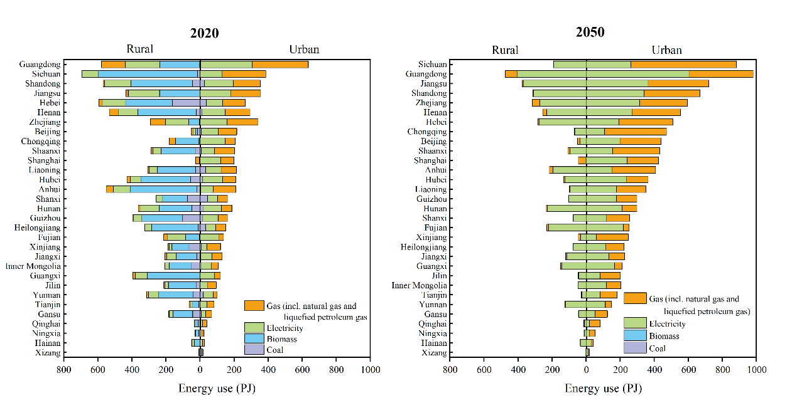

Figure S3 Residential energy use by key fuels in urban and rural areas for 2020 and 2050.



Figure S4 China paint consumption from 2020 to 2050



Figure S5 VOCs emission reductions by sectors from 2020 to 2050 in China’s provinces under the REF scenario.



Figure S6 Temporal Changes in China's VOCs Emissions from 2020 to 2050 under the CLE scenario：(a) Total, (b) Solvent use, (c) Residential, (d) Transportation, (e) Industry and power, (f) Others.

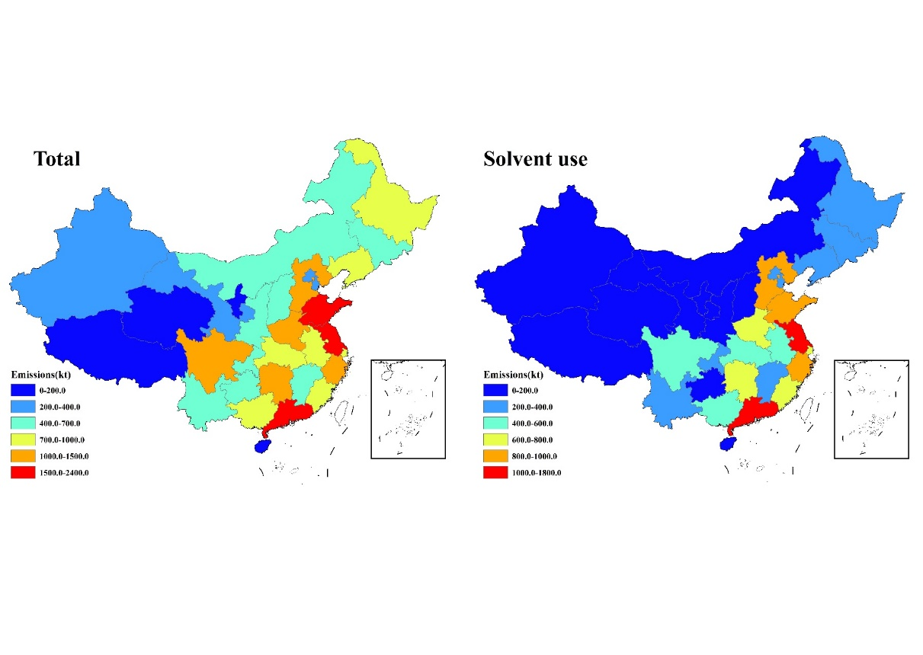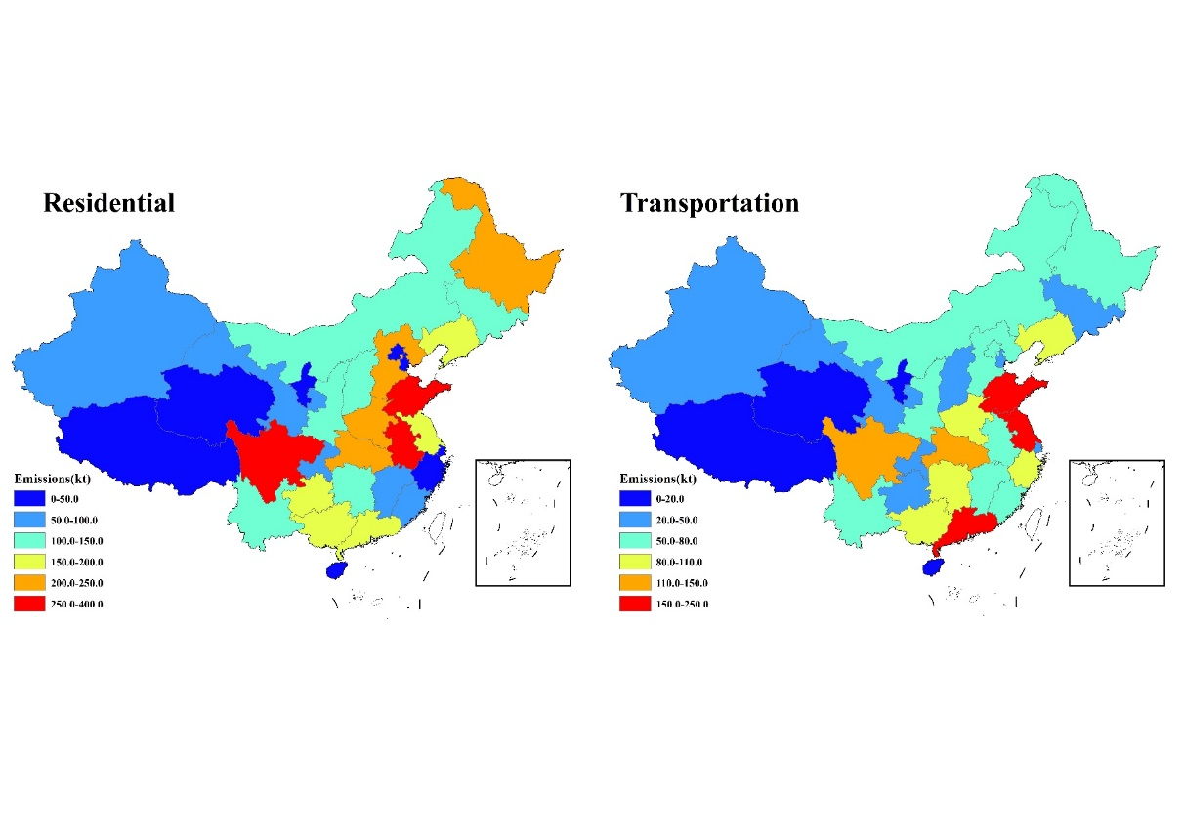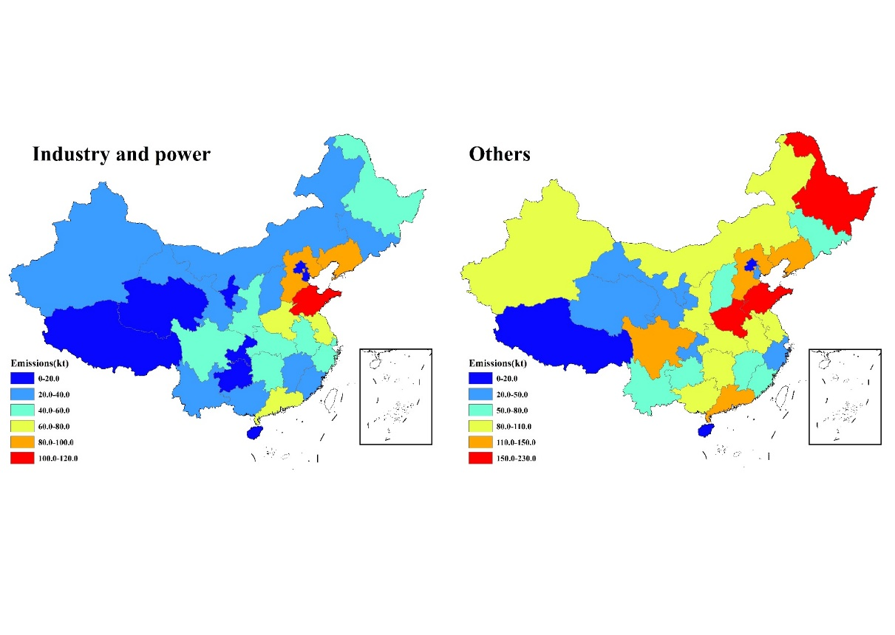

Figure S7 VOCs emissions in 2020 for the five sectors.

## **Reference:**

[1] Environmental Protection Agency Compilation of Air Pollutant Emissions Factors from Stationary Sources (AP-42). <https://www.epa.gov/air-emissions-factors-and-quantification/ap-42-compilation-air-emissions-factors-stationary-sources> (31-October 2024)

[2] Wang Q, Geng C, Lu S, Chen W, Shao M. Emission factors of gaseous carbonaceous species from residential combustion of coal and crop residue briquettes. Frontiers of Environmental Science Engineering. 2013; 7: 66-76.

[3] Tsai S M, Zhang J, Smith K R, Ma Y, Rasmussen R, Khalil M. Characterization of non-methane hydrocarbons emitted from various cookstoves used in China. Environmental science & technology. 2003; 37: 2869-77.

[4] European Environment Agency. EMEP/EEA Air Pollutant Emission Inventory Guidebook 2023. <https://www.eea.europa.eu//publications/emep-eea-guidebook-2023> (31-October 2024)

[5] Wei W, Wang S, Hao J. Estimation and forecast of volatile organic compounds emitted from paint uses in China. Huanjing Kexue. 2009; 30: 2809-15.

[6] Zheng B, Huo H, Zhang Q, Yao Z, Wang X, Yang X, et al. High-resolution mapping of vehicle emissions in China in 2008. Atmospheric Chemistry Physics. 2014; 14: 9787-805.

[7] Bo Y, Cai H, Xie S. Spatial and temporal variation of historical anthropogenic NMVOCsemission inventories in China. Atmospheric Chemistry Physics. 2008; 8: 7297–316.

[8] GB 18581-2020, "Limits of Harmful Substances of Woodenware Coatings". <Http://openstd.samr.gov.cn>.

[9] GB 18582-2020, "Limits of Harmful Substances of Architectural Wall Coatings". <Http://openstd.samr.gov.cn>.

[10] GB 24409-2020, "Limits of Harmful Substances of Vehicle Coatings". <Http://openstd.samr.gov.cn>.

[11] GB 18583-2008, "Indoor Decorating and Refurbishing Materials-Limits of Harmful Substances in Adhesives". <Http://openstd.samr.gov.cn>.

[12] Zheng B, Tong D, Li M, Liu F, Hong C, Geng G, et al. Trends in China's anthropogenic emissions since 2010 as the consequence of clean air actions. Atmospheric Chemistry and Physics. 2018; 18: 14095-111.

[13] Ministry of Ecology and Environment of the People's Republic of China. Limits and measurement methods for emissions from light-duty vehicles（CHINA VI）. <https://www.mee.gov.cn/ywgz/fgbz/bz/bzwb/dqhjbh/dqydywrwpfbz/201612/t20161223_369476.shtml>

[14] Ministry of Ecology and Environment of the People's Republic of China. Limits and measurement methods for emissions from diesel fuelled heavy-duty vehicles (CHINA VI). <https://www.mee.gov.cn/ywgz/fgbz/bz/bzwb/dqhjbh/dqydywrwpfbz/201807/t20180703_445995.shtml>

[15] Li M, Zhang Q, Zheng B, Tong D, Lei Y, Liu F, et al. Persistent growth of anthropogenic non-methane volatile organic compound (NMVOC) emissions in China during 1990–2017: drivers, speciation and ozone formation potential. Atmospheric Chemistry and Physics. 2019; 19: 8897-913.

[16] Klimont Z, Kupiainen K, Heyes C, Purohit P, Cofala J, Rafaj P, et al. Global anthropogenic emissions of particulate matter including black carbon. Atmospheric Chemistry and Physics. 2017; 17: 8681-723.

[17] Zbigniew Klimont, David G. Streets, Shalini Gupta, Janusz Cofala, Fu Lixin, Ichikawa Y. Anthropogenic emissions of non-methane volatile organic compounds in China. Atmospheric Environment. 2002; 36: 1309-22.

[18] Simayi M, Shi Y, Xi Z, Ren J, Hini G, Xie S. Emission trends of industrial VOCs in China since the clean air action and future reduction perspectives. Science of the Total Environment. 2022; 826: 153994.

[19] Klimont Z, Amann M, Cofala J. Estimating costs for controlling emissions of volatile organic compounds (VOC) from stationary sources in Europe. 2000.

[20] Yin S, Zheng J, Lu Q, Yuan Z, Huang Z, Zhong L, et al. A refined 2010-based VOC emission inventory and its improvement on modeling regional ozone in the Pearl River Delta Region, China. Science of The Total Environment. 2015; 514: 426-38.

[21] Ministry of Ecology and Environment of the People's Republic of China. Technical Guidelines for the Compilation of Atmospheric Volatile Organic Compounds Emission Inventory. <https://www.mee.gov.cn/gkml/hbb/bgg/201408/W020140828351293705457.pdf>